11 March 2014

Commentary: Labour Market Development in Q4 2013
Results of statistical surveys for Q4 2013 indicate an uncertain recovery at the Czech labour market. Data of the Labour Force Sample Survey (LFSS) in households show that total employment rate continues to grow and the trend of the unemployment rate also passed its peak, when seasonally adjusted. On the other hand, results of business surveys have been showing a permanent decline in the registered number of employees. This is evidence that employment grows solely in marginal areas of the labour market. This uncomfortable fact is also accompanied with stagnation of nominal wages. The still existing excess of labour force supply over demand, when the number of vacant jobs is a mere fraction of the number of the unemployed, presses the labour price down in most economic activities. And when combined with inflation they reduce the population purchasing power.
Analytical results of the LFSS show the number of hours worked in the national economy declined by about 1% due to, first of all, an increase of part-time jobs (their number increased by 15%) and an increasing number of employment contracts for definite period (these increased by 11%). The total number of the employed persons in the economy increased, year-on-year, by 41.1 thous. persons (i.e. by 0.8%) to reach 4 957.7 thous. persons. This growth was, however, not contributed by entrepreneurs but persons in the position of employees. What increases is rather small jobs of precarious work character instead of quality jobs, which provide the employees with long-term prospects and personal development.

In 2013, concerning business statistics, the registered number of employees FTE declined by 43.4 thous. persons i.e. by 1.2%. Respective economic activities demonstrated varied trends: construction (-6.9%) and accommodation and food service activities (-6.2%). experienced the highest year-on-year decrements, the Czech Republic’s largest economic activity – manufacturing – lost 12.9 thous. of occupied jobs (-1.2%); wholesale and retail trade; repair of motor vehicles and motorcycles and agriculture, forestry and fishing showed a year-on-year drop in the number of employees by 2.0% and 0.9%, respectively. Public administration and defence; compulsory social security exhibited an opposite development increasing the number of employees by 6 thous. persons, i.e. by 2.2%.

The development in public administration and defence; compulsory social security was however, caused mostly by effects of beneficial public works subsidised from European funds, especially in the second half of the year. In the mere Q4 2013 bodies of the central government (ministries) demonstrated a decrease in the number of employees by 1.9 thous. persons, while bodies of regional and municipal governments grew by 5.6 thous. persons. In 2012 these works were provided by persons out of the registered number of employees within so-called public service. The announced increase in the capacity of labour offices to combat unemployment had a lower influence when over 950 jobs emerged in Q4 2013.
Concerning wages it is almost impossible to evaluate the development of average wages in Q4 2013, because data are distorted due to the effect of prepaid managerial bonuses at the end of 2012. Then enterprises paid in advance bonuses to top managers because of anticipated introduction of so-called solidary tax from the highest earnings. So such a high basis has a significant impact when calculating arithmetic average index and thus brings a nominal decline of the average wage by 1.8% and thus a corresponding drop by 2.9% in real terms. This way the data for Q4 2013 became the worst data, for which there are fully comparable quarterly time series, in the last decade. This distortion affects solely the business sphere. Evidence for is a year-on-year decline in the share of extraordinary aggregate bonuses (except for agriculture). On the other hand, effects of overtime work increased in a significant manner there.

Yet the News Release also includes data on the median wage, calculated from a mathematical model of earnings distribution. The model shows the wage of a middle employee, that means a common wage level. In Q4 2013 the median wage was CZK 22 288, that means by CZK 15 (i.e. by 0.1%) higher than in the same period of the previous year. Thus the wage level of the middle employee remained essentially stuck at the previous year level and demonstrated stagnation of earnings.

The wage interval remained quite wide: 80% of employees earned from CZK 10 546 to CZK 43 413. The year-on-year development indicates a minute narrowing of the distribution, which may be caused either by the introduced solidary tax, either by an increased minimum wage to CZK 8 500 since 1 August 2013, which helped to those earning the worst rewards. From the sex point of view the increase in the lowest wages logically had the major effect on women who have a lower level of earnings. Taking it from the overall point of view, however, the dominant trend of the last period is stagnation, see graph below.

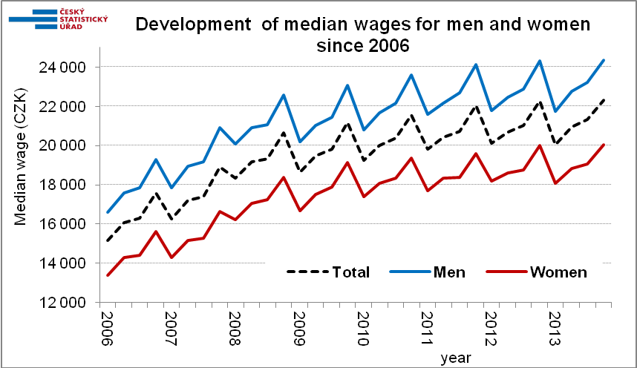

A drop in the average wage in Q4 2013 was most significant in the Capital City of Prague
(-4.8% nominally), on the contrary, in the Ústecký Region and Liberecký Region wages nominally grew. Yet there was the lowest decline in the number of employees (-0.3%) in Prague.

Concerning the whole year 2013 average wages further declined in real terms, this time by 1.3%. The evaluation of the development of the real purchasing power of the population is also troublesome although there is a positive message that the growth in consumer prices (inflation) slowed down to 1.4% for the whole year 2013. This, however, concerns items which are rather dispensable, while prices of foodstuffs, that must be purchased regularly, rose by 4.9%, that means three times faster than other commodities.

A drop in purchasing power affected in 2013 employees of both the spheres while being less significant in non-business sphere, in which the average wage decreased by 0.5% in real terms. The business sphere saw a worse result – a real drop in the average wage was 1.5% – yet also due to in advance moved managerial bonuses, which marked the whole year results as well.

Concerning respective economic activities development is much differentiated. In 2013 the average nominal monthly wage increased solely in eight sections and decreased in eleven sections of the classification of CZ-NACE. The most significant drop occurred in financial and insurance activities (-8.6%), in which managerial bonuses were at a massive scale moved into 2012. A similar effect, of course at a lesser extent, was also shown in economic activities of electricity, gas, steam and air conditioning supply (-3.9%) and in construction (-2.4%). A rather substantial growth can be found in accommodation and food service activities (+3.5%) and in agriculture, forestry and fishing (+2.9%), in which, however, the overall wage level still stay deep below the total average wage in the Czech Republic. In the economic activities of education, in which there is the highest share of employees with educational attainment of higher education, the average wage is below the total average wage although it grew by 1.6%, year-on-year.

* * *

Data on the median wage, wage distributions, and personal breakdown for the whole 2013 can be acquired from preliminary results of the Average Earnings Information System (ISPV), which applies a different methodology of the calculation of the personal earnings of an employee. Therefore these data cannot be compared to values given in the News Release of the Czech Statistical Office.
The median wage according to the ISPV methodology reached CZK 22 529 in 2013. Eighty per cent of employees earned wages within the interval of CZK 11 961 and CZK 41 637, and the decile ratio remained at the level of the previous year (3.5).
The wage level for women (median wage CZK 20 500) was substantially lower than that for men (median wage CZK 24 243); and earnings inequality in women was also lower than that in men: the decile ratio for women was 3.1 while the men decile ratio was 3.7.

The highest earnings by educational attainment went to employees with higher education, their median wage was CZK 33 350. Lowest earnings went to employees with basic and/or incomplete education (median wage CZK 16 005). Employees with secondary education with A-level examination earned more than (CZK 23 482) than employees without A-level examination (CZK 19 041) but less that employees with a degree from a higher professional education or bachelor degree (CZK 26 488).

Variability of earnings also grows with the higher wage level: 80% of higher education graduates earned wages within the interval of CZK 20 347 and CZK 73 751 and thus their decile ratio was 3.6. Conversely, 80% employees with basic education earned in between CZK 10 013 and CZK 25 801. Ninety per cent of employees with secondary school without A-level examination earned wages below CZK 30 000 as well.

According to the valid Classification of Occupations (CZ-ISCO) managers had the highest earnings with the median wage of CZK 41 530, but within a wide decile interval from CZK 19 282 through CZK 107 308. Managerial occupations also recorded a significant year-on-year increase (the median wage grew by 3.5%). This, however, did not hold to the best paid persons (i.e. those in the top decile) where probably the effect of the solidary tax brought a decline by 0.7%.
The highest year-on-year increase (by 3.9%) can be found in a small group of skilled agricultural, forestry and fishery workers whose median wage increased to CZK 18 713. An above-average growth in wages (by 2.2%) can also be found in highly qualified professionals, 80% of which earned between CZK 21 195 and 61 800 and their median wage was CZK 30 122.
Conversely, clerical occupations saw the lowest increase and their wage level remained at the value of CZK 21 000. A minimum increase also occurred at employees of armed forces whose median wage was CZK 23 746. The wage level of technicians and associate professionals measured by a middle employee was CZK 26 330. Craft and related trades workers earned the median wage of CZK 21 066 and plant and machine operators and assemblers had CZK 20 686. The lowest wages over a long term can be found at elementary occupations, which decile range in 2013 was from CZK 9 203 through CZK 22 393 and the median wage was CZK 13 560.

Author: Dalibor Holý
Labour Market and Equal Opportunities Statistics Department of the CZSO
Tel.: +420 274 052 694
E-mail: dalibor.holy@czso.cz

