INCAPACITY FOR WORK DUE TO DISEASE OR INJURY IN THE YEAR FOR THE FIRST HALF OF 2014

The trend in temporary incapacity for work due to disease or injury in the Czech Republic in the first half of 2014 was significantly affected by changes to legal regulations of the sickness insurance effective since 1 January 2011 and since 1 January 2012, which were valid in 2013 as well. Changes to provisions establishing amounts of the sickness insurance benefits have shown the strongest effect on the trend.

Since 1 January 2009 sickness insurance has been regulated by the Act No. 187/2006 Sb. on sickness insurance as amended. It provides a complete regulation of sickness insurance, which includes both the circle of persons participating in sickness insurance (i.e. employees, members of armed forces, and own-account workers), their claims from this insurance and determination of amounts of benefits provided, assessment of health status for purposes of sickness insurance, and organisation of sickness insurance, as well as management of the sickness insurance. Insurance premiums for sickness insurance are regulated by the Act No. 589/1992 Sb. on premiums for social security and contribution to the State Employment Policy as amended.

On 1 January 2014 the temporary measure in sickness insurance when in 2011 – 2013 the employers were providing wage compensation for the period of the first 21 days of a temporary incapacity for work and District Offices of the Czech Social Security Administration were paying sickness benefits since the 22nd calendar day of the temporary incapacity for work duration. Employees, who will be acknowledged to be incapacitated for work since 1 January 2014, shall receive wage compensation for the first 14 days of incapacity for work and since the 15th calendar day they will receive sickness benefits from District Offices of the Czech Social Security Administration. The reduction limits for the calculations of the daily chargeable basis to determine amounts of sickness benefits were increased.

Basic indicators of the statistical survey on temporary incapacity for work due to disease or injury in the Czech Republic for the first half of 2014, processed from data from the administrative data source of the CSSA Information System, are given here below.

The average number of sickness-insured persons in the first half of 2014 was 4 413.5 thousand persons, which is by almost 1.9 thousand persons less than in the first half of 2013 (4 415.4 thousand persons).

The number of new notified cases of incapacity for work in total decreased from 754.6 thousand in the first half of 2013 to 664.1 thousand in the first half of 2014, year-on-year. This number included 579.3 thousand cases of incapacity for work due to disease, 22.2 thousand cases of incapacity for work due to occupational injury, and 62.6 thousand cases of incapacity for work due to other injury.

The number of new notified cases of incapacity for work per 100 sickness insured persons decreased year-on-year from 17.09 cases in the first half of 2013 to 15.05 cases in the first half of 2014. In the first half of 2014 the highest number of cases of incapacity for work per 100 sickness insured persons was notified in the Plzeňský Region (18.20 cases), then followed the Liberecký Region (17.67 cases), Karlovarský Region (17.65 cases), Jihočeský Region (17.10 cases), and Středočeský Region (16.08 cases). The least number of cases was notified in the Hlavní město Praha Region (13.00 cases), and then in the Olomoucký Region (13.54 cases). The differentiation of the incapacity for work rate by territory is in a great manner affected by the employment structure, character of prevailing economic activities, and unemployment rate in the given region.

The average duration of one case of incapacity for work increased year-on-year from 42.24 days in the first half of 2013 to 45.94 days in the first half of 2013. The average duration of one case of temporary incapacity for work grew longer by 3.7 days. The longest average duration of one case of the temporary incapacity for work in the first half of 2014 was recorded in the Zlínský Region (56.36 days), the shortest one remained recorded in the Hlavní město Praha Region (40.29 days).

The average percentage of incapacity for work decreased year-on-year from 3.99% in the first half of 2013 to 3.82% in the first half of 2014. The average percentage of incapacity for work gives the number of persons out of 100 sickness insured persons that is on average every day incapacitated for work due to disease or injury. The average percentage of incapacity for work takes into account both the total number of cases of incapacity for work (how often persons become incapacitated for work) and the average duration of one case of incapacity for work (how long persons remain incapacitated for work).

In the first half of 2014 there were 168.58 thousand sickness-insured persons missing at their workplaces in the Czech Republic, which was by 7.52 thousand sickness-insured persons less compared to the same period of the previous year (176.10 thousand sickness-insured persons).

Table 1: Basic indicators of temporary incapacity for work due to disease or injury in the first half of 2014 by region and in the Czech Republic
Territory | Average number of sickness-insured persons | Number of new notified cases of incapacity for work | Number of calendar days of incapacity for work | Number of new notified cases of incapacity for work per 100 sickness-insured persons | Average percentage of incapacity for work  (%) | Number of calendar days of incapacity for work per 1 newly notified case | Average daily number of the incapacitated for work
Hl. m. Praha Region | 1 152 754 | 149 807 | 6 035 161 | 13.00 | 2.893 | 40.29 | 33 344
Středočeský Region | 411 508 | 66 179 | 2 867 954 | 16.08 | 3.850 | 43.34 | 15 845
Jihočeský Region | 221 136 | 37 816 | 1 827 577 | 17.10 | 4.566 | 48.33 | 10 097
Plzeňský Region | 215 097 | 39 157 | 1 640 790 | 18.20 | 4.214 | 41.90 | 9 065
Karlovarský Region | 87 011 | 15 357 | 631 969 | 17.65 | 4.013 | 41.15 | 3 491
Ústecký Region | 277 765 | 42 840 | 2 062 956 | 15.42 | 4.103 | 48.15 | 11 398
Liberecký Region | 146 225 | 25 842 | 1 115 383 | 17.67 | 4.214 | 43.16 | 6 163
Královéhradecký Region | 186 816 | 29 406 | 1 284 782 | 15.74 | 3.800 | 43.69 | 7 098
Pardubický Region | 188 449 | 29 766 | 1 355 054 | 15.80 | 3.973 | 45.52 | 7 486
Vysočina Region | 172 634 | 28 394 | 1 322 392 | 16.45 | 4.232 | 46.57 | 7 305
Jihomoravský Region | 467 624 | 68 844 | 3 252 128 | 14.72 | 3.842 | 47.24 | 17 968
Olomoucký Region | 219 493 | 29 720 | 1 629 604 | 13.54 | 4.102 | 54.83 | 9 003
Zlínský Region | 212 577 | 31 286 | 1 763 272 | 14.72 | 4.583 | 56.36 | 9 742
Moravskoslezský Region | 454 414 | 69 705 | 3 723 162 | 15.34 | 4.527 | 53.41 | 20 570
Czech Republic, total | 4 413 503 | 664 119 | 30 512 184 | 15.05 | 3.820 | 45.94 | 168 575
Table 2: Basic indicators of temporary incapacity for work due to disease or injury by CZ-NACE activity in the Czech Republic in the first half of 2014
CZ-NACE groups  of activities | Average number of sickness-insured persons | Number of new notified cases of incapacity for work | Number of calendar days of incapacity for work | Number of new notified cases of incapacity for work per 100 sickness-insured persons | Average percentage of incapacity for work  (%) | Number of calendar days of incapacity for work per 1 newly notified case | Average daily number of the incapacitated for work
A. Agriculture, forestry and fishing | 111 277 | 15 428 | 956 787 | 13.86 | 4.750 | 62.02 | 5 286
B. Mining and quarrying | 32 347 | 5 657 | 281 043 | 17.49 | 4.800 | 49.68 | 1 553
C. Manufacturing | 1 150 224 | 217 927 | 9 648 010 | 18.95 | 4.634 | 44.27 | 53 304
D. Electricity, gas, steam and air conditioning supply | 32 692 | 3 202 | 130 199 | 9.79 | 2.200 | 40.66 | 719
E. Water supply; sewerage, waste management and remediation activities | 57 243 | 8 522 | 414 913 | 14.89 | 4.005 | 48.69 | 2 292
F. Construction | 236 198 | 32 581 | 2 103 016 | 13.79 | 4.919 | 64.55 | 11 619
G. Wholesale and retail trade; repair of motor vehicles and motorcycles | 597 137 | 80 061 | 4 076 044 | 13.41 | 3.771 | 50.91 | 22 520
H. Transportation and storage | 274 259 | 37 599 | 1 975 265 | 13.71 | 3.979 | 52.54 | 10 913
I. Accommodation and food service activities | 133 637 | 16 149 | 956 339 | 12.08 | 3.954 | 59.22 | 5 284
J. Information and communication | 115 866 | 12 870 | 357 383 | 11.11 | 1.704 | 27.77 | 1 974
K. Financial and insurance activities | 90 524 | 11 697 | 400 971 | 12.92 | 2.447 | 34.28 | 2 215
L. Real estate activities | 73 932 | 5 332 | 299 377 | 7.21 | 2.237 | 56.15 | 1 654
M. Professional, scientific and technical activities | 196 620 | 18 659 | 765 815 | 9.49 | 2.152 | 41.04 | 4 231
N. Administrative and support service activities | 241 287 | 46 707 | 1 974 816 | 19.36 | 4.522 | 42.28 | 10 911
O. Public administration and defence; compulsory social security | 255 552 | 34 506 | 1 308 758 | 13.50 | 2.829 | 37.93 | 7 231
P. Education | 341 961 | 45 177 | 1 582 256 | 13.21 | 2.556 | 35.02 | 8 742
Q. Human health and social work activities | 330 809 | 43 806 | 2 228 516 | 13.24 | 3.722 | 50.87 | 12 312
R. Arts, entertainment and recreation | 63 108 | 6 642 | 298 248 | 10.52 | 2.611 | 44.90 | 1 648
S. Other service activities | 61 834 | 7 378 | 372 371 | 11.93 | 3.327 | 50.47 | 2 057
U. Activities of extraterritorial organisations and bodies | 62 | 1 | 191 | 1.61 | 1.702 | 191.00 | 1
Not identified | x | x | x | x | x | x | x
Total | 4 413 503 | 664 119 | 30 512 184 | 15.05 | 3.820 | 45.94 | 168 575
- means that there was no such phenomenon
x means that no record can be made due to logical reasons

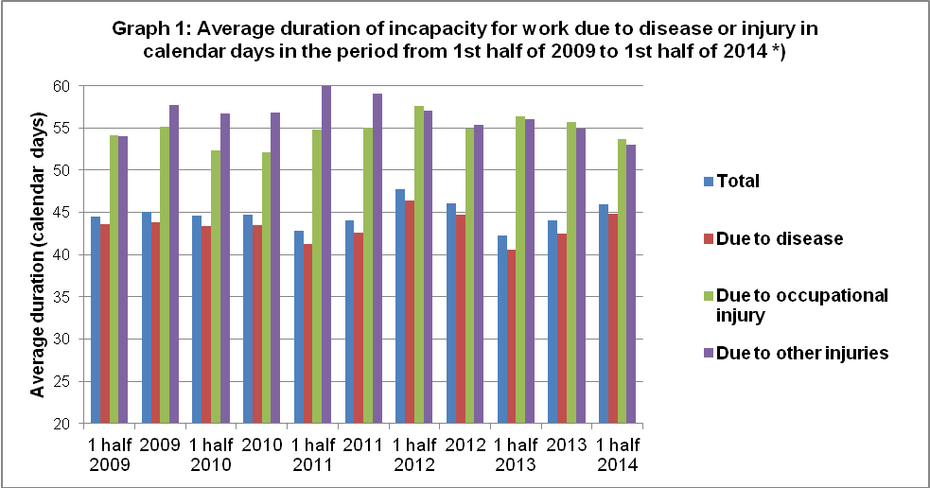

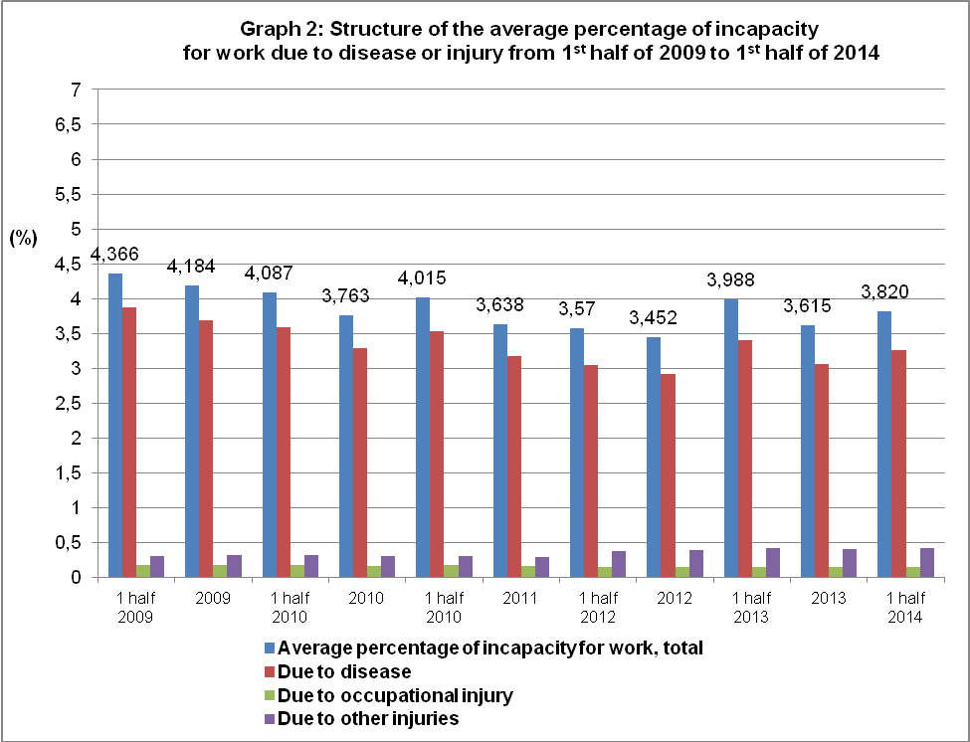

*) Time series and data measured by the state statistical questionnaire on incapacity for work due to disease or injury of ‘Nem Úr 1-02’ can be compared till 2011. Starting in 2012 the Czech Statistical Office has been providing data for the Statistics of Temporary Incapacity for Work due to Disease or Injury by processing of data from the administrative data source of the Czech Social Security Administration information system (see methodological notes).

Sickness Insurance in 2014

General Information

Participation in sickness insurance

Participants in sickness insurance are employees (including members of armed forces) and own-account workers (hereinafter as “the OSVC”). It is mandatory for the employees to participate in the sickness insurance plan, on the contrary to the OSVC for whom the participation in sickness insurance remains voluntary.

Since 1 January 2014 certain terms have had new definitions as follows:

- The employment contract is no longer the legal relation on the basis of which the employee was performing the job. As a novelty, the employment contract shall mean an activity performed by the employee for the employer, from which the employee receives or may receive income generated from a dependent activity from the employer with no regard to the type of the employment relation.
- The employees shall mean persons in time of employment contract, if they receive or may receive income from a dependent activity, which are or may be subject to taxation and are not free of tax, if taxable in the Czech Republic.

The mandatory participation in sickness insurance is formed for an employee (except for an employee active on the basis of an agreement for work) if he and/or she meets conditions established by the Act on Sickness Insurance. These are two fundamental conditions as follows:
- performance of work on the territory of the Czech Republic (hereinafter as “the CR”) in a job carried out under an employment contract or employment relation, which may give rise to sickness insurance; and
- minimum amount of the contracted income (this is so-called decisive income, limit of which was determined to CZK 2 000 since 1 January 2009. The amount was increased to CZK 2 500 since 1 January 2012).
Since 1 January 2014 the special regulation of conditions for participation in sickness insurance for short-term jobs, i.e. the jobs, which were not to last longer than and did not last longer than 14 days. Therefore jobs shall be subdivided, concerning conditions for the participation in sickness insurance, into jobs performed on the basis of a contract for work and jobs of a small scale, and other jobs.
If the job performed is of a small scale then special conditions are established for the participation of employees in sickness insurance. The small scale job shall mean a job meeting conditions of the job performance on the territory of the Czech Republic yet the condition of that income from the job is agreed in a predetermined amount is not complied with. These are situations when agreed monthly amount of chargeable income is lower than the decisive income, or those when monthly income was not agreed at all. When performing a small scale job the employees are covered by sickness insurance only in those calendar months, which they have reached at least income of the appropriate decisive amount.
In case of employees working on the basis of an agreement on work they are obliged to participate in sickness insurance if they meet two conditions as follows:
This amendment broadens the circle of the sickness-insured persons with employees active on the basis of an agreement on work and with other persons given in Section 5 a) under points 16-20.
An employee active on the basis of an agreement on work has the obligation to participate in the sickness insurance born if he/she complies with two conditions as follows:
- performance of work on the territory of the Czech Republic; and
- in the calendar month, in which the agreement on work is effective, he/she reached chargeable income in the amount over CZK 10 000.
Since 1 January 2014 sickness insurance performance of contractual employees has been simplified there is no longer monitored if the employees are insured in a third state or not, which their employers may have their registered office in.
Participation of OSVCs in sickness insurance is created on the basis of an application for sickness insurance and payment of sickness insurance premiums.

Since 1 January 2014 an OSVC participating in the OSVC sickness insurance has not been considered for this reason to be an OSVC performing an independent main gainful activity. A side OSVC may be participating in sickness insurance as an OSVC, even though the person is not obliged to pay premiums for pension insurance. Minimum monthly basis, which an OSVC may determine for payments of sickness insurance premiums, has been CZK 5 000 since 1 January 2012. The minimum premium for sickness insurance is CZK 115 per calendar month at premium rate of 2.3%.

Sickness benefits
Employees or OSVCs, who their physician recognised as temporary incapacitated for work, are entitled to sickness benefits starting since 15th calendar day of the duration of their temporary incapacity for work till the end of the temporary incapacity for work, however, for 380 calendar days as maximum, counted since the beginning of the duration of temporary incapacity for work (including added periods of previous durations of temporary incapacity for work). OSVCs, however, must be participating in voluntary sickness insurance of OSVCs for, at least, 3 months immediately prior to the day, on which the temporary incapacity for work occurred.
The employee (not OSVC), which has an employment relation establishing their participation in sickness insurance, is secured by a compensation of wage for the period of the first 14 calendar days and the compensation is provided by the employer in accord with the Labour Code. The compensation of wage is for work days in the case of temporary incapacity for work starting from 4th work day (in the case of quarantine then since the first work day thereof).
A recipient of old-age pension or disability pension of the third level receives sickness benefits since 15th calendar day of the duration of temporary incapacity for work (quarantine) for the period of 70 calendar days, as maximum, yet the longest to the day on which the activity insured has been terminated.
The sickness insured are also entitled to sickness benefits in predetermined cases when temporary incapacity for work (quarantine) occurred after the insured employment relation has expired in so called protective period. The purpose of the protective period is to secure the former employee for a predetermined period since the insurance termination for the case of a social security event (temporary incapacity for work) occurrence prior he/she joins a next employment. The protective period for claiming entitlement for sickness benefits is 7 calendar days since the day the employment establishing the participation in sickness insurance was terminated.

Amount of sickness benefit and its calculation
The amount of sickness benefit is 60% of the daily chargeable basis since 15th calendar day of the duration of temporary incapacity for work.

Determination of the daily chargeable basis
Sickness benefits are calculated from the chargeable daily basis, which is determined the way the chargeable income accounted by employees in the decisive period (as a rule the period of 12 calendar months prior the calendar month, in which the social security event has happened) is subdivided by the number of “chargeable“ calendar days of the decisive period. This way determined average daily income is modified (reduced) by means of three reduction limits to give the daily chargeable basis.

Reduction of the daily chargeable basis
The level of the three reduction limits effective since 1 January of the given year is announced by the Ministry of Social and Labour Affairs of the CR in the form of a communication in the Sbírka zákonů (Gazette).

In 2013 1st reduction limit was CZK 863, 2nd reduction limit was CZK 1 295, and 3rd reduction limit was CZK 2 589.
In 2014 1st reduction limit has been CZK 865, 2nd reduction limit has been CZK 1 298, and 3rd reduction limit has been CZK 2 595.
The reductions shall be carried out the way that
- up to the first reduction limit
  - there are 90% of the daily chargeable basis of sickness benefit and carer’s allowance counted in; and
  - there are 100% of the daily chargeable basis of maternity statutory pay and pregnancy and maternity compensation benefit counted in,
- there are 60%of the portion of the daily chargeable basis in between the first and second reduction limits counted in,
- there are 30%of the portion of the daily chargeable basis in between the second and third reduction limits counted in, and
- the portion above the third reduction limit is not taken into account.

More detailed information on sickness insurance are published on the website of the Ministry of Labour and Social Affairs of the CR (MLSA CR:
- http://www.mpsv.cz/cs/7;
or on the website of the Czech Social Security Administration (CSSA):
- http://www.cssz.cz/cz/nemocenske-pojisteni/.

