16 November 2015

External Trade Price Indices Development  
in Q3 2015

Export prices in Q3 2015, compared to Q2 2015, decreased by 1.6%, import prices declined by 1.9% and terms of trade reached 100.3%. Compared year-on year (y-o-y), export prices in Q3 2015 decreased by 2.7%, import prices fell by 2.6%, and terms of trade reached the value of 99.9%.

# Quarter-on-quarter (q-o-q) comparison

**Export prices** in **Q3 2015**, compared to **Q2 2015**, decreased by 1.6% (in Q2 2015 they fell by 0.3%). The more important price decreases were observed in 'crude materials, inedible, except fuels' by 6.1%, 'mineral fuels, lubricants and related materials' by 3.0%, 'manufactured goods classified chiefly by material' by 1.5%, and in 'machinery and transport equipment’ by 1.3%. Inexports the only growing prices were those of ‘animal and vegetable oils, fats and waxes’ by 2.3%.

**Import prices** in **Q3 2015**, compared to **Q2 2015**, fell by 1.9% (in Q2 2015 they grew by 0.7%). Among import prices of important groups of goods price decreases were recorded, from the highest one, for 'mineral fuels, lubricants and related materials' by 8.2%, 'manufactured goods classified chiefly by material' by 1.9%, ‘chemicals and related products’ by 1.4%, and 'machinery and transport equipment’ by 1.0. Inimports the only growing prices were those of ‘animal and vegetable oils, fats and waxes’ by 2.3%.

The **terms of trade** figures in **Q3 2015**, compared to **Q2 2015**, reached the value of 100.3% (in Q2 2015 they were 99.0%). The highest positive values of terms of trade were recorded namely in 'mineral fuels, lubricants and related materials' (105.7%), ‘food and live animals’ (101.0%), and in 'manufactured goods classified chiefly by material' (100.4%). Negative values of terms of trade were recorded especially in 'crude materials, inedible, except fuels' (95.0%) and in 'machinery and transport equipment’ (99.7%).

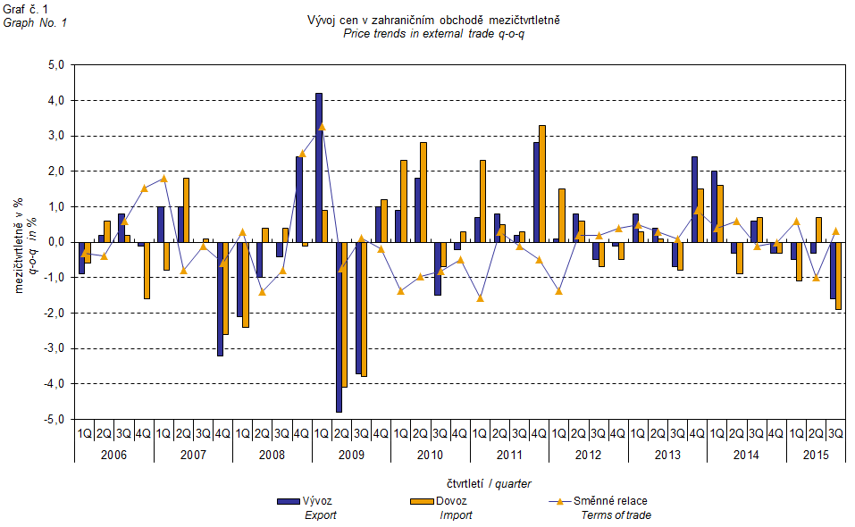

The external trade price development was also significantly affected by the CZK exchange rate to the major foreign currencies. The q-o-q exchange rate index includes two most important currencies from the Czech Republic’s external trade point of view, i.e. EUR and USD. Q-o-q indices of the CZK exchange rate to these currencies were weighted by the weight, which pertains to those foreign currencies in the export price index and import price index, respectively.

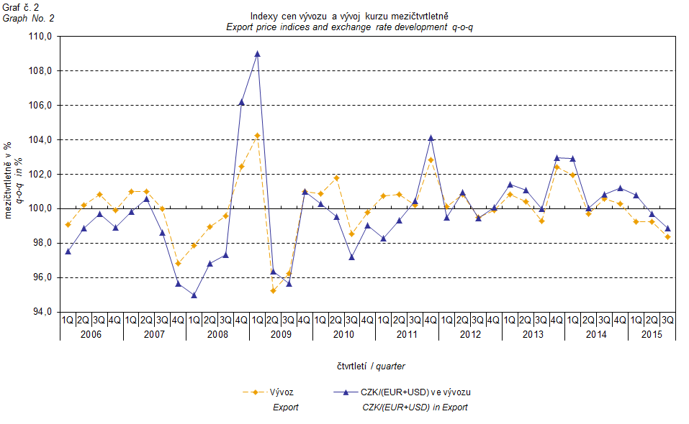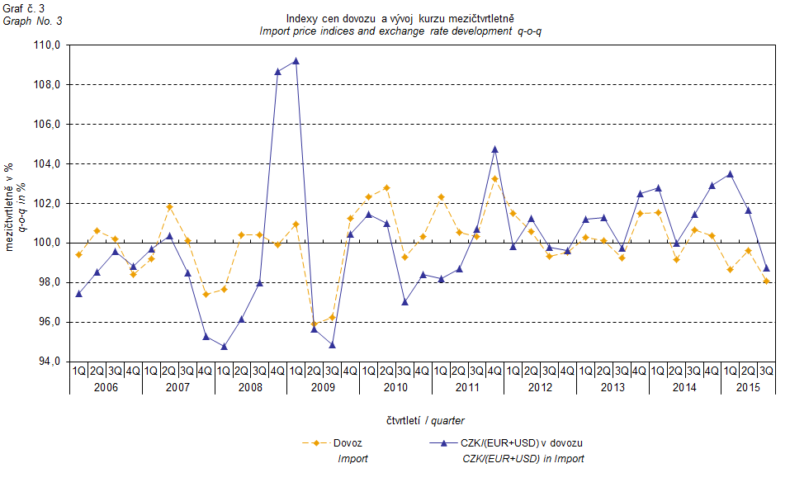

It can be seen from Graphs Nos. 2 and 3 above that in both cases of imports and exports external trade prices have a strong relation to exchange rate impacts. Contracts with foreign entities are, as a rule, signed for a longer period of time and the longer the contract period is, the stronger the relation to exchange rates is.

# Year-on-year (y-o-y) comparison

**Export prices** in **Q3 2015** decreased by 2.7% (in Q2 2015 they fell by 0.5%), year-on-year. Among more important groups of goods, the highest drop was reported for prices of 'mineral fuels, lubricants and related materials' by 12.3%, then for those of 'crude materials, inedible, except fuels' by 10.1%, 'chemicals and related products’ by 4.6%, and 'machinery and transport equipment’ by 1.4%. The only prices growing were those of ‘beverages and tobacco' by 1.1%.

**Import prices** in **Q3 2015** decreased by 2.6% (in Q2 2015 they stayed the same), year-on-year. The highest decline in prices was recorded for 'mineral fuels, lubricants and related materials' by 24.2%, then for 'crude materials, inedible, except fuels' by 6.8%, and for ‘chemicals and related products’ by 3.1%. Prices of 'miscellaneous manufactured articles' grew by 2.9%, those of 'machinery and transport equipment’ rose by 1.9%.

**Terms of trade** in **Q3 2015** increased year-on-year to reach the value of 99.9% (in Q2 2015 they were 99.5%) yet they nevertheless remained in negative values in the second consecutive quarter – see Graph No. 4 below. More significant negative values of terms of trade were recorded for ‘food and live animals’ (93.6%), 'miscellaneous manufactured articles' (96.1%), 'machinery and transport equipment' (96.8%), and for 'chemicals and related products’ (98.5%). The highest positive value of terms of trade was recorded for 'mineral fuels, lubricants and related materials' (115.7%).

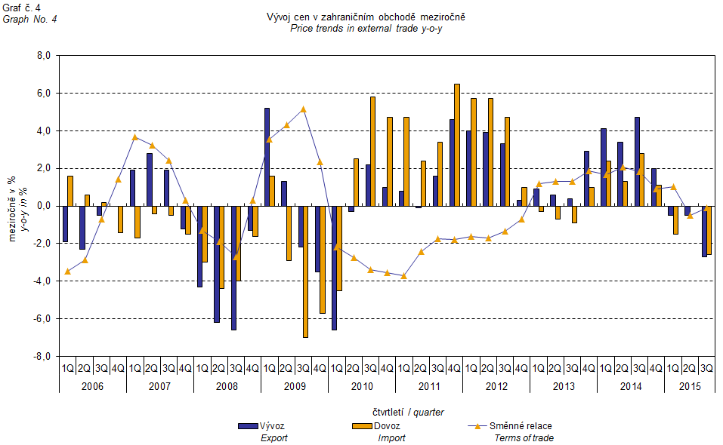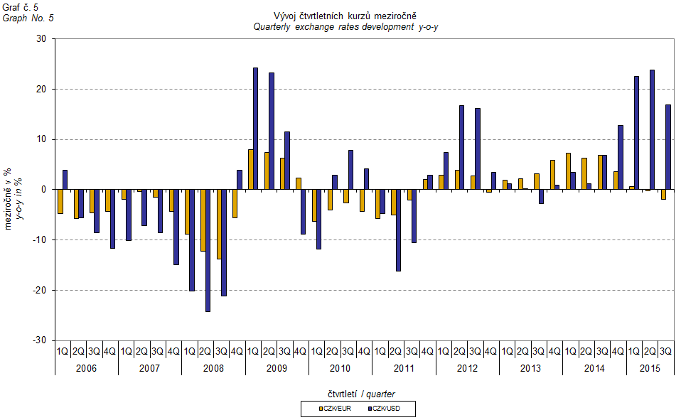

# External trade price indices adjusted y-o-y for exchange rate influence

The CZSO also carries out calculations of year-on-year external trade price indices adjusted for effects of exchange rate. The method is prices in foreign currencies reported in the current month are **converted** into Czech crowns by the **exchange rate** of the same month **of the last year**. Then they are used for the weighted mean calculation along with prices reported in CZK. The year-on-year adjusted price index is then calculated the way that this exchange rate adjusted base price index is related to the non-adjusted base price index of the same month of the last year. **Differences among adjusted and non-adjusted price indices may be substantial**. They can be clearly seen in Graphs Nos. 6 and 7 for November 2013 and December 2013, for instance.

The method employed does not enable, for many practical reasons, to carry out 100% exchange rate adjustment because all trade transactions concluded in foreign currencies are not reported in foreign currencies. This share is up to 30%. It follows from the aforementioned, that **at the full exchange rate adjustment differences** in between the price indices published and the exchange rate adjusted price indices would be **even larger**.

The aforementioned exchange rate adjusted indices can be used to form the exchange rate adjusted breakdown of price indices increments. Table 1, last but one page, gives the **published and exchange rate adjusted breakdowns of increments** of export and import price indices, expanded to the most important two-digit code groups of the SITC 7. These breakdowns illustrate, in a good manner, how many percentage points each of the groups “exchange rate contributed” to the index.

It holds in general that the effects of exchange rate decrease the value of price indices in external trade if CZK is strengthening to foreign currencies in total. Conversely, the effects of exchange rate push the price indices up if CZK is weakening to foreign currencies in total. It is obvious from following Graphs Nos. 6 and 7, how significant was the exchange rate impact on the value of export and import price indices.

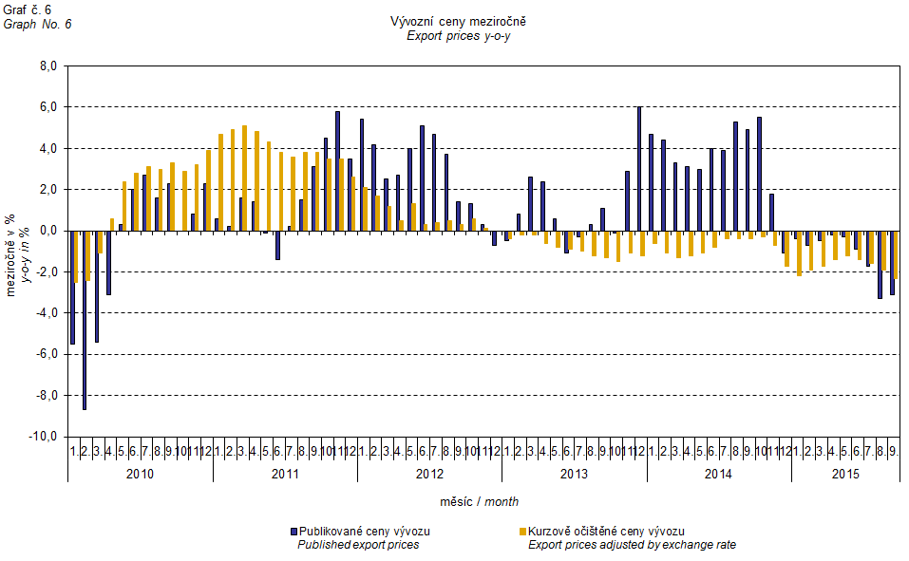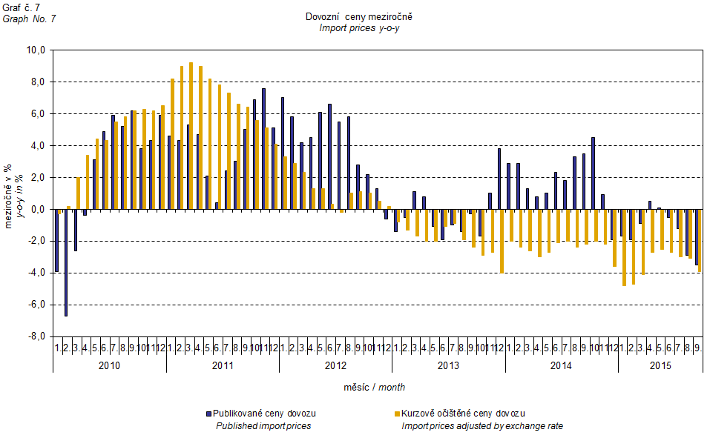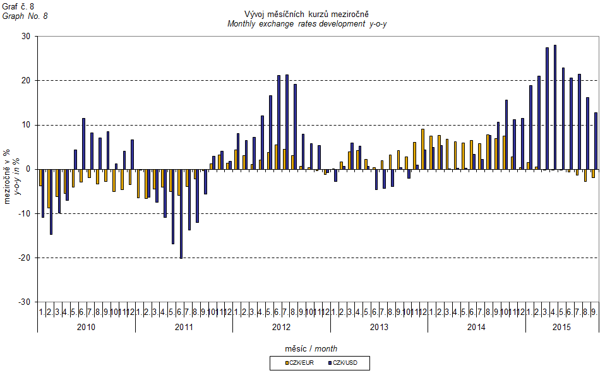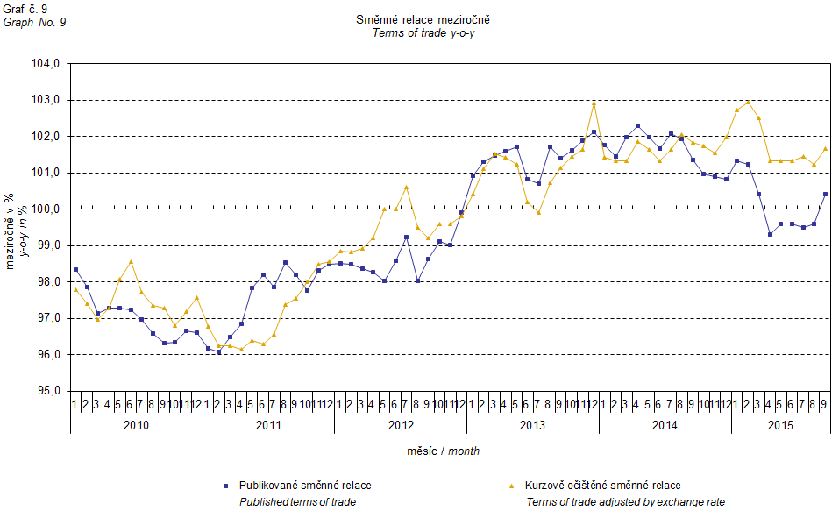

It can be seen from Graph No. 9 how the exchange rate influences the value of the year-on-year terms of trade.

Graph No. 10 demonstrates how the value of terms of trade would develop if the observed groups would not include that of 'mineral fuels, lubricants and related materials'.

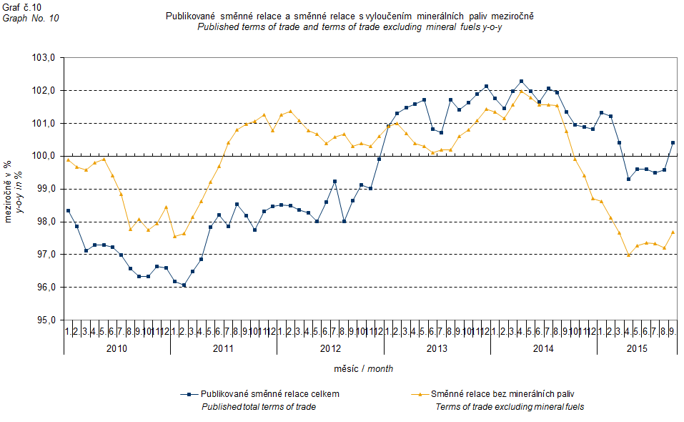

It can be observed in Graph No. 10 that 'mineral fuels, lubricants and related materials' decreased the overall value of y-o-y terms of trade till Q4 2012. In Q1 2013 the situation began to reverse and 'mineral fuels, lubricants and related materials' have had again an upward effect on the value of terms of trade. It is, of course, related to the world market price development, especially in crude oil. Import prices, which, compared to export prices, include a higher proportion of crude materials, respond in a more sensitive way to price turbulences and therefore when prices of crude materials go up, terms of trade, as a rule, go down and, conversely, when prices of crude materials fall, terms of trade grow.

# Closing summary

The exchange rate effects in **Q3 2015** caused a year-on-year decrease in export prices got deeper and, at the same time, a decline in import prices and was getting slower (the external trade export price fall would be less deep and the decline in import prices would be faster without exchange rate effects). Export prices decreased year-on-year more than import ones, and therefore terms of trade remained in negative values. Yet if exchange rate non-adjusted, terms of trade would be positive. Values free of the exchange rate effects correspond to exchange rate adjusted indices – see Graphs Nos. 6, 7, and 9.



Closing table gives published external trade price indices **without adjustment**.



**Developed by:** Vladimír Klimeš, Prices Statistics Department

**Director of the Department:** Jiří Mrázek, telephone: (+420) 274 052 533