16 February 2015

External Trade Price Indices Development  
in Q4 2014 and in the Year 2014

Export prices as well as import prices in Q4 2014, compared to Q3 2014, decreased identically by 0.3%, and terms of trade reached 100.0%. Compared year-on year (y-o-y) export prices in Q4 2014 increased by 2.0%, import prices grew by 1.1%, and terms of trade reached 100.9%.

On average for the whole year 2014 exports prices increased by 3.5% and import prices grew by 1.9%, both compared to those for 2013, and terms of trade attained 101.6%.

# Quarter-on-quarter (q-o-q) comparison:

**Export prices** in **Q4 2014**, compared to **Q3 2014**, decreased by 0.3% (in Q3 2014 they increased by 0.6%). The highest price decreases were observed in 'crude materials, inedible, except fuels' by 3.3%, ‘food and live animals’ by 3.2%, and ‘chemicals and related products’ by 1.8%. Inexport prices, among the more important groups of goods, prices increased most in 'miscellaneous manufactured articles' by 0.5%, 'machinery and transport equipment’ by 0.2%, and in 'manufactured goods classified chiefly by material' by 0.1%.

**Import prices** in **Q4 2014**, compared to **Q3 2014**, decreased by 0.3% (in Q3 2014 they increased by 0.7%). Highest prices drops were observed in 'mineral fuels, lubricants and related materials' by 7.9%, ‘food and live animals’ by 1.7% and in ‘chemicals and related products’ by 0.4%. Inimport prices highest price increases were recorded for 'miscellaneous manufactured articles' by 1.9%, 'machinery and transport equipment’ by 1.2%, and for 'manufactured goods classified chiefly by material' by 0.5%.

The **terms of trade figures** in **Q4 2014**, compared to **Q3 2014**, reached 100.0% (in Q3 2014 they were 99.9%). A positive value of terms of trade was recorded in 'mineral fuels, lubricants and related materials' (106.8%) only. Negative values of terms of trade were recorded namely in 'crude materials, inedible, except fuels' (97.0%), ‘food and live animals’ (98.5%), ‘chemicals and related products’ and 'miscellaneous manufactured articles' (identically 98.6%).

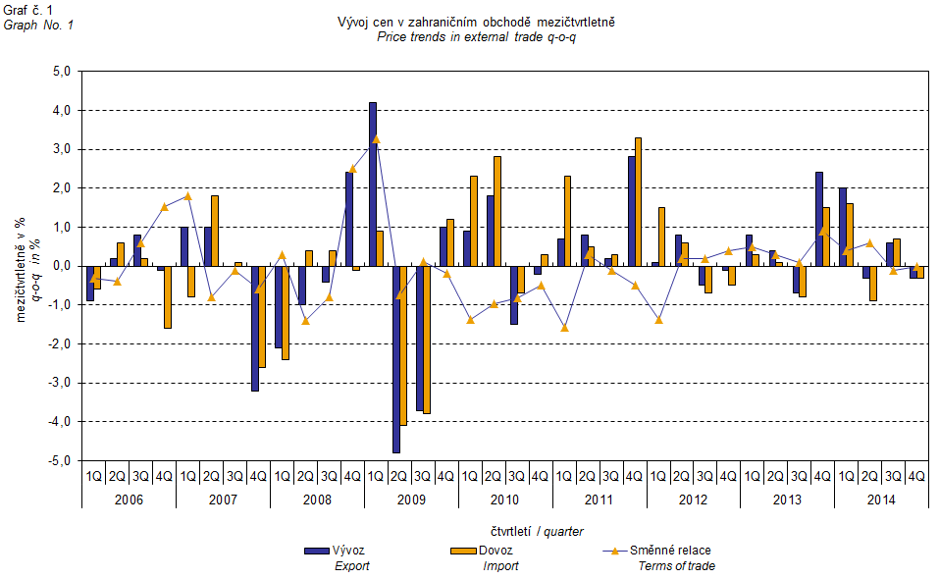

The external trade price development was also significantly affected by the CZK exchange rate to the major foreign currencies. The q-o-q exchange rate index includes two most important currencies from the Czech Republic’s external trade point of view, i.e. EUR and USD. Q-o-q indices of the CZK exchange rate to these currencies were weighted by the weight, which pertains to those foreign currencies in the export price index and import price index, respectively.

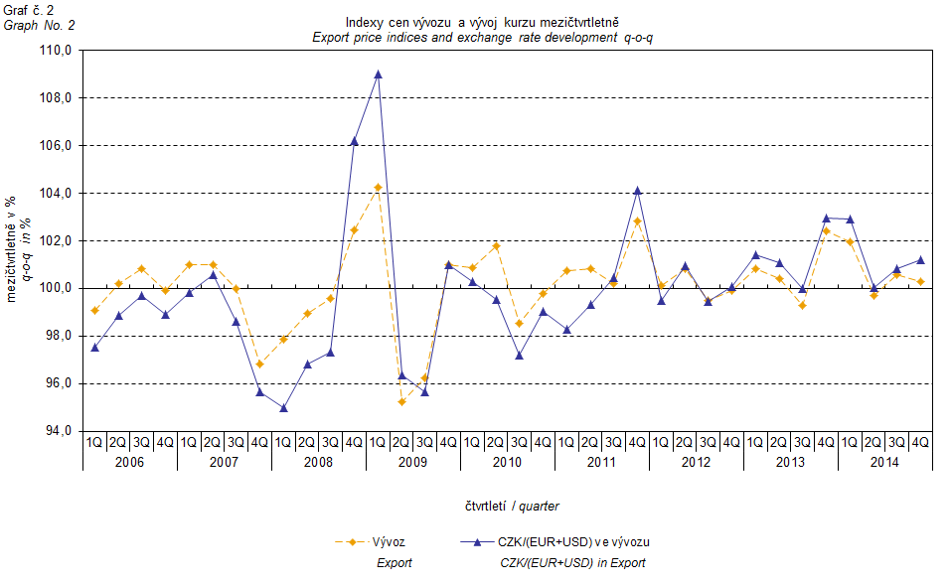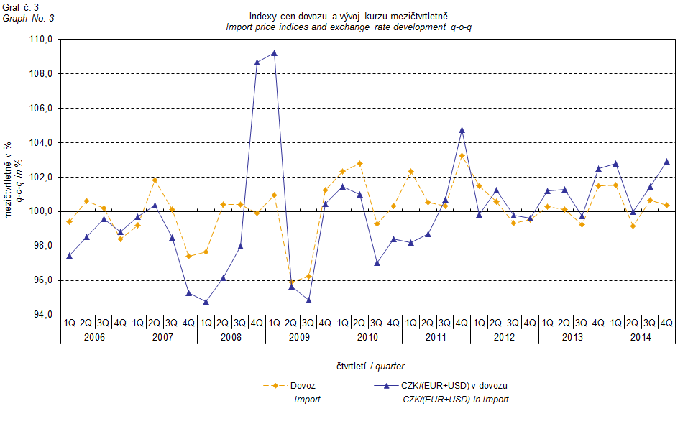

It can be seen from Graphs Nos. 2 and 3 above that in both cases of imports and exports external trade prices have a strong relation to exchange rate impacts. Contracts with foreign entities are, as a rule, signed for a longer period of time and the longer the contract period is, the stronger the relation to exchange rates is.

# Year-on-year (y-o-y) comparison:

**Export prices** in **Q4 2014** increased by 2.0% (in Q3 2014 they rose by 4.7%), year-on-year. Among more important groups of goods, the highest growth was reported for prices of 'manufactured goods classified chiefly by material' by 4.1%, 'miscellaneous manufactured articles' and of 'machinery and transport equipment’ identically by 2.5%, and ‘chemicals and related products’ by 2.2%. The highest drops were recorded in prices of 'mineral fuels, lubricants and related materials' by 8.4% and in ‘food and live animals’ by 3.5%.

**Import prices** in **Q4 2014** increased by 1.1% (in Q3 2014 they rose by 2.8%), year-on-year. A higher growth of prices among the more important groups was indicated for 'machinery and transport equipment’ by 4.2%, 'miscellaneous manufactured articles' by 3.4%, 'manufactured goods classified chiefly by material' by 3.2%, and for ‘chemicals and related products’ by 1.3%. There were highest drops in prices observed in 'mineral fuels, lubricants and related materials' by 12.9% and in 'crude materials, inedible, except fuels' by 5.6%.

**Terms of trade** in **Q4 2014** decreased year-on-year to reach the value of 100.9% (in Q3 2014 they were 101.8%), nevertheless they stayed in positive values for the eighth quarter – see Graph No. 4 below. More significant positive values of terms of trade were recorded in 'crude materials, inedible, except fuels' (107.0%), 'mineral fuels, lubricants and related materials' (105.2%), 'manufactured goods classified chiefly by material' and ‘chemicals and related products’ stayed at the same value (100.9%). More significant negative values of terms of trade were recorded for ‘food and live animals’ (95.8%) and in 'machinery and transport equipment' (98.4%).

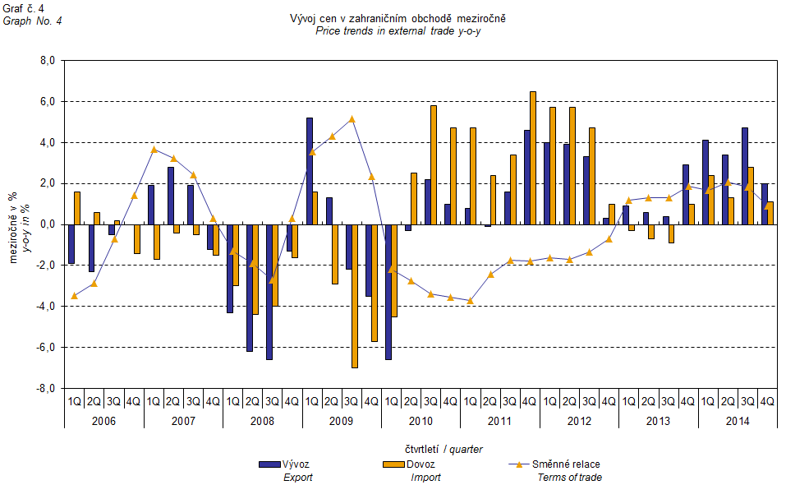

**Price development in 2014**

**On average over the whole year 2014 export prices** increased by 3.5% (in 2013 they rose by 1.2%). Import prices increased by 1.9% (in 2013 they decreased by 0.2%).

In**export prices** increases were noticed in groups of 'manufactured goods classified chiefly by material' by 5.2%, 'miscellaneous manufactured articles' by 4.4%, and 'machinery and transport equipment’ by 3.7%. Among the more important groups prices dropped in 'mineral fuels, lubricants and related materials' by 5.0% and in ‘food and live animals’ by 0.2%.

In**import prices** important price increases were recorded in ‘food and live animals’ by 4.4%, 'machinery and transport equipment’ by 3.5%, 'manufactured goods classified chiefly by material' by 3.2%, and in 'miscellaneous manufactured articles' by 2.5%. Prices of 'mineral fuels, lubricants and related materials' dropped by 5.6% and prices of 'crude materials, inedible, except fuels' declined by 3.3%.

**Terms of trade** reached in total in 2014 the value of 101.6% (they were 101.4% in 2013).

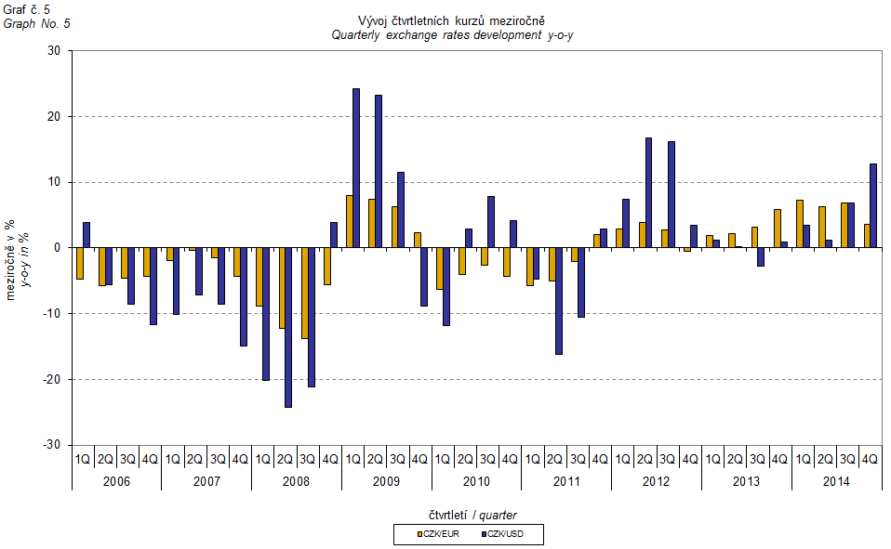

# External trade price indices adjusted y-o-y for exchange rate influence

The CZSO also carries out calculations of year-on-year external trade price indices adjusted for effects of exchange rate. The method is prices in foreign currencies reported in the current month are **converted** into Czech crowns by the **exchange rate** of the same month **of the last year**. Then they are used for the weighted mean calculation along with prices reported in CZK. The year-on-year adjusted price index is then calculated the way that this exchange rate adjusted base price index is related to the non-adjusted base price index of the same month of the last year. **Differences among adjusted and non-adjusted price indices may be substantial**. They can be clearly seen in Graphs Nos. 6 and 7 for November 2013 and December 2013, for instance.

The method employed does not enable, for many practical reasons, to carry out 100% exchange rate adjustment because all trade transactions concluded in foreign currencies are not reported in foreign currencies. This share is up to 30%. It follows from the aforementioned, that **at the full exchange rate adjustment differences** in between the price indices published and the exchange rate adjusted price indices would **be even larger**.

The aforementioned exchange rate adjusted indices can be used to form the exchange rate adjusted breakdown of price indices increments. Table 1, last but one page, gives the **published and exchange rate adjusted breakdowns of increments** of export and import price indices, expanded to the most important two-digit code groups of the SITC 7. These breakdowns illustrate, in a good manner, how many percentage points each of the groups “exchange rate contributed” to the index.

It holds in general that the effects of exchange rate decrease the value of price indices in external trade if CZK is strengthening to foreign currencies in total. Conversely, the effects of exchange rate push the price indices up if CZK is weakening to foreign currencies in total. It is obvious from following Graphs Nos. 6 and 7 how significant was the exchange rate impact on the value of export and import price indices.

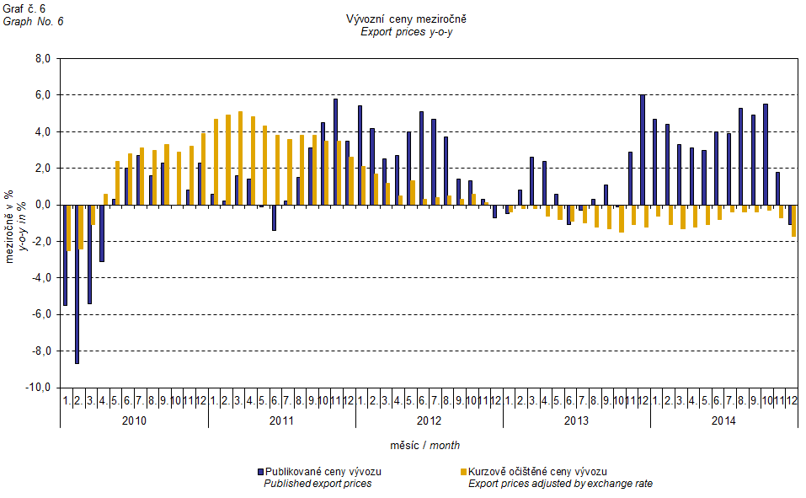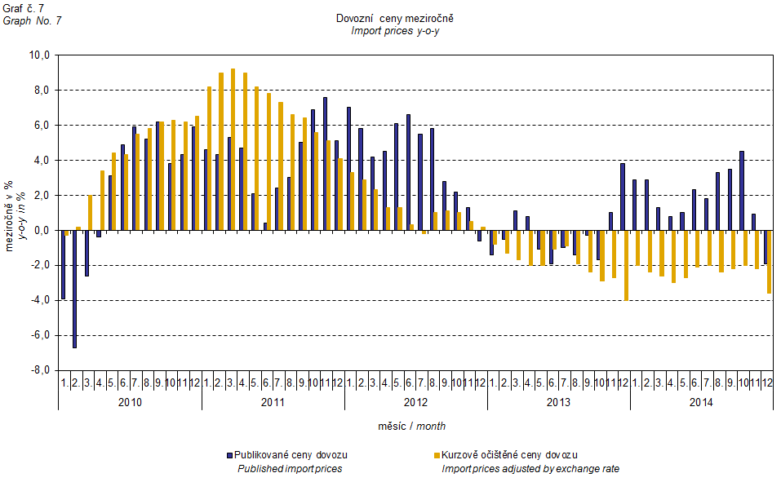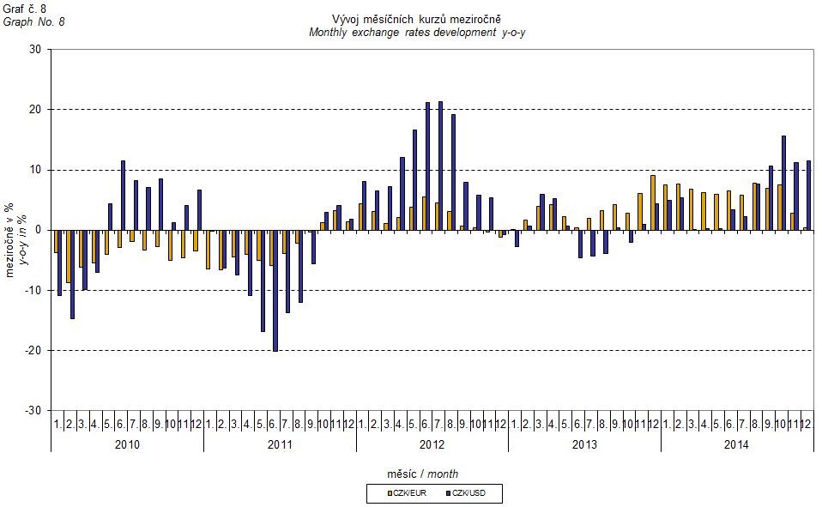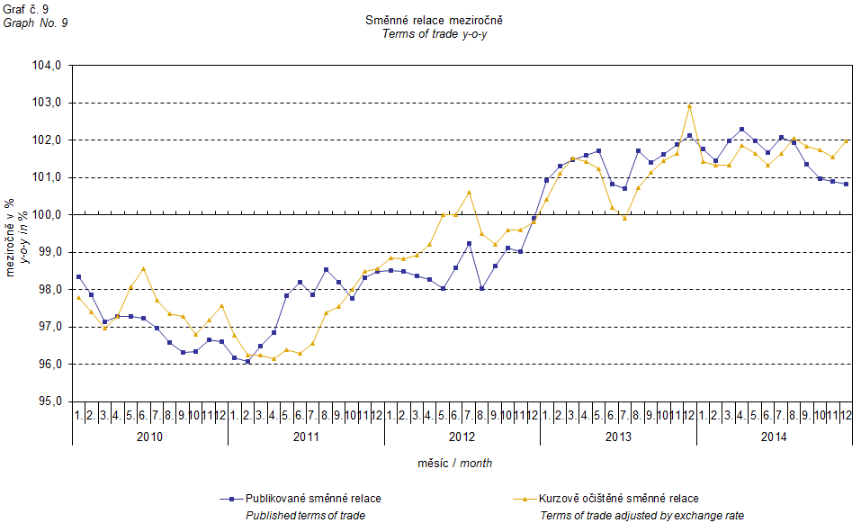

It can be seen from Graph No. 9 how the exchange rate influences the value of the year-on-year terms of trade.

Graph No. 10 demonstrates how the value of terms of trade would develop if the observed groups would not include that of 'mineral fuels, lubricants and related materials'.

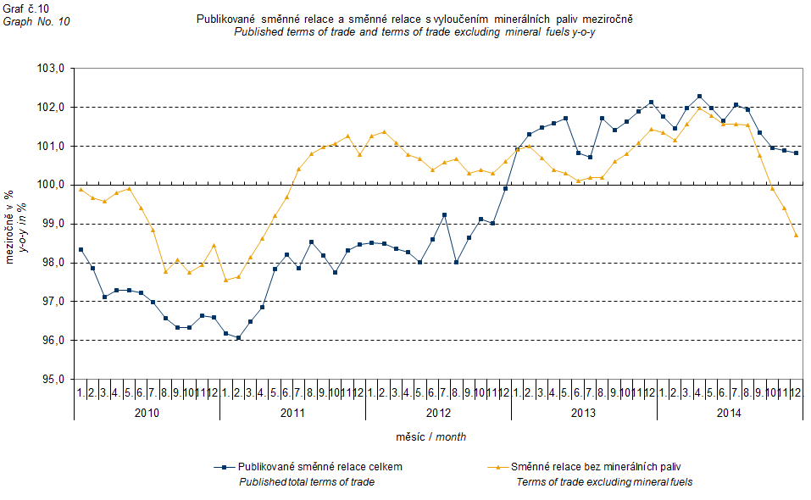

It can be observed in Graph No. 10 that 'mineral fuels, lubricants and related materials' decreased the overall value of y-o-y terms of trade till Q4 2012. In Q1 2013 the situation began to reverse and 'mineral fuels, lubricants and related materials' have had again an upward effect on the value of terms of trade. It is, of course, related to the world market price development, especially in crude oil. Import prices, which, compared to export prices, include a higher proportion of crude materials, respond in a more sensitive way to price turbulences and therefore when prices of crude materials go up, terms of trade, as a rule, go down and, conversely, when prices of crude materials fall, terms of trade grow.

# Closing summary

The exchange rate effects in **Q4 2014** caused a year-on-year increase in both import and export prices. If there would be no exchange rate effect, prices in external trade would be decreasing. Export prices were growing faster than the import ones, year-on-year, and therefore terms of trade remained in positive values. Yet if exchange rate non-adjusted, terms of trade would be growing faster. Values free of the exchange rate effects correspond to exchange rate adjusted indices – see graphs Nos. 6, 7, and 9.



Closing Table gives published external trade price indices **without adjustment**.



**Developed by:** Vladimír Klimeš, Prices Statistics Department

**Director of the Department:** Jiří Mrázek, telephone: (+420) 274 052 533