18 August 2014

External Trade Price Indices Development  
in Q2 2014

Export prices in Q2 2014, compared to Q1 2014, decreased by 0.3%, import prices declined by 0.9%, and terms of trade reached 100.6%. Compared year-on year (y-o-y) export prices in Q2 2014 increased by 3.4%, import prices grew by 1.3%, and terms of trade reached 102.1%.

# Quarter-on-quarter (q-o-q) comparison:

**Export prices** in **Q2 2014**, compared to **Q1 2014**, decreased by 0.3% (in Q1 2014 they increased by 2.0%). Inexport prices, among the more important groups of goods, prices decreased most in 'mineral fuels, lubricants and related materials' by 4.7%, 'crude materials, inedible, except fuels' by 0.8%, and in 'machinery and transport equipment’ by 0.3%. The prices of 'manufactured goods classified chiefly by material' increased by 0.5%, and those of ‘animal and vegetable oils, fats and waxes’ by 0.3%.

**Import prices** in **Q2 2014**, compared to **Q1 2014**, decreased by 0.9% (in Q1 2014 they increased by 1.6%). Inimport prices rather important price decreases were recorded for 'crude materials, inedible, except fuels' by 4.2%, 'mineral fuels, lubricants and related materials' by 4.1%, and for 'manufactured goods classified chiefly by material' by 0.4%. Increases were recorded for prices of ‘animal and vegetable oils, fats and waxes’ by 0.9% and for 'machinery and transport equipment’ by 0.1%.

The **terms of trade figures** in **Q2 2014**, compared to **Q1 2014**, reached 100.6% (in Q1 2014 they were 100.4%). Highest positive values of terms of trade were reached in 'crude materials, inedible, except fuels' (103.5%), ‘food and live animals’ (101.3%), and 'manufactured goods classified chiefly by material' (100.9%). Among important groups of goods, negative values of terms of trade were recorded namely in 'mineral fuels, lubricants and related materials' (99.4%) and in 'machinery and transport equipment' (99.6%).

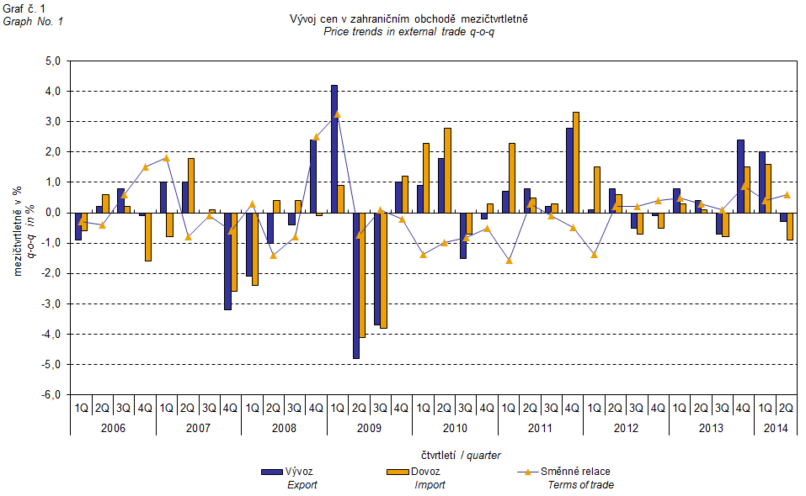

The external trade price development was also significantly affected by the CZK exchange rate to the major foreign currencies. The q-o-q exchange rate index includes two most important currencies from the Czech Republic’s external trade point of view, i.e. EUR and USD. Q-o-q indices of the CZK exchange rate to these currencies were weighted by the weight, which pertains to those foreign currencies in the export price index and import price index, respectively.

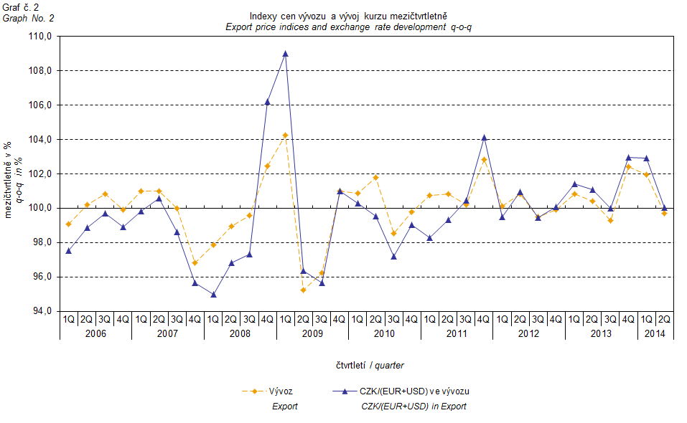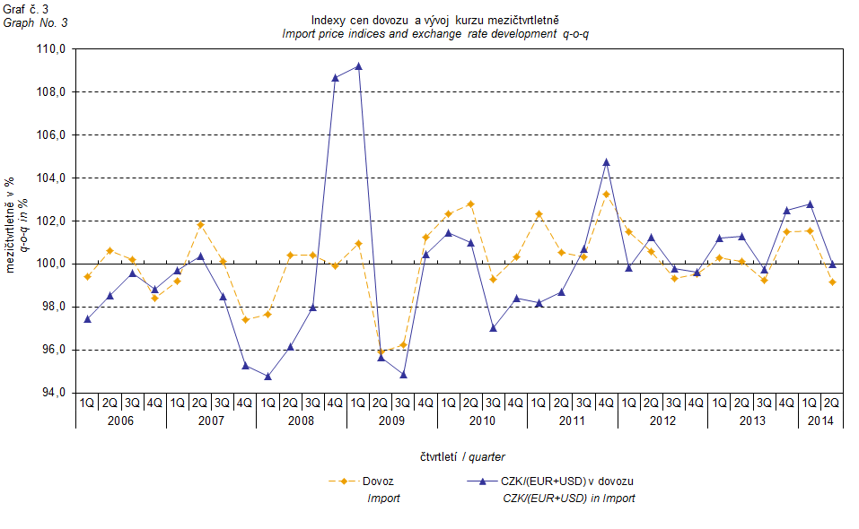

It can be seen from Graphs Nos. 2 and 3 above that in both cases of imports and exports external trade prices have a strong relation to exchange rate impacts. Contracts with foreign entities are, as a rule, signed for a longer period of time and the longer the contract period is, the stronger the relation to exchange rates is.

# Year-on-year (y-o-y) comparison:

**Export prices** in **Q2 2014** increased by 3.4% (in Q1 2014 they rose by 4.1%). Among more important groups of goods, the highest growth was reported for prices of 'beverages and tobacco' by 12.2%, then for 'manufactured goods classified chiefly by material' by 5.2%, 'miscellaneous manufactured articles' by 4.4%, and of 'machinery and transport equipment’ by 3.3%. On the contrary, prices of 'mineral fuels, lubricants and related materials' dropped by 4.5%.

**Import prices** in **Q2 2014** increased by 1.3% (in Q1 2014 they rose by 2.4%). A higher growth of prices among the more important groups was indicated for ‘food and live animals’ by 5.4%, 'manufactured goods classified chiefly by material' by 2.3%, and for 'machinery and transport equipment’ by 2.2%. There were drops in prices observed in ‘animal and vegetable oils, fats and waxes’ by 7.9%, 'crude materials, inedible, except fuels' by 4.7%, and in 'mineral fuels, lubricants and related materials' by 3.0%.

**Terms of trade** in **Q2 2014** increased year-on-year to reach the value of 102.1% (in Q1 2014 they were 101.7%) and thus stayed in positive values for the sixth quarter – see Graph No. 4 below. Significant positive values of terms of trade were recorded in 'crude materials, inedible, except fuels' (108.4%), 'miscellaneous manufactured articles' (103.6%), 'manufactured goods classified chiefly by material' (102.8%), and in 'machinery and transport equipment' (101.1%). The lowest negative value of terms of trade was recorded for ‘food and live animals’ (95.4%).

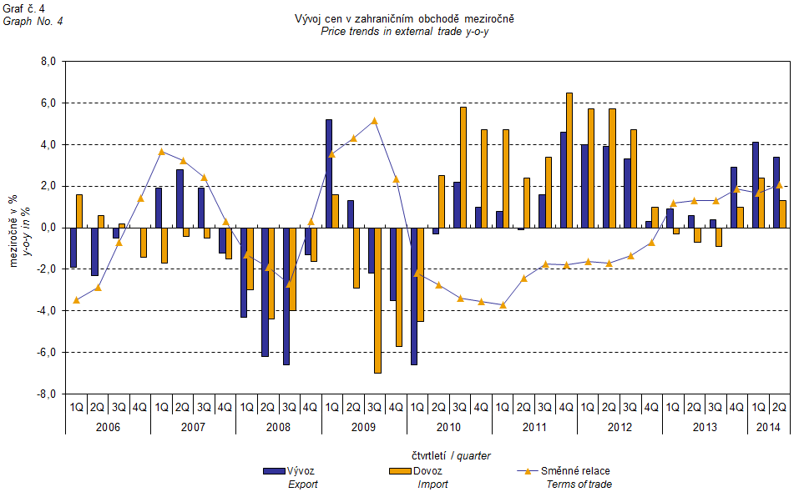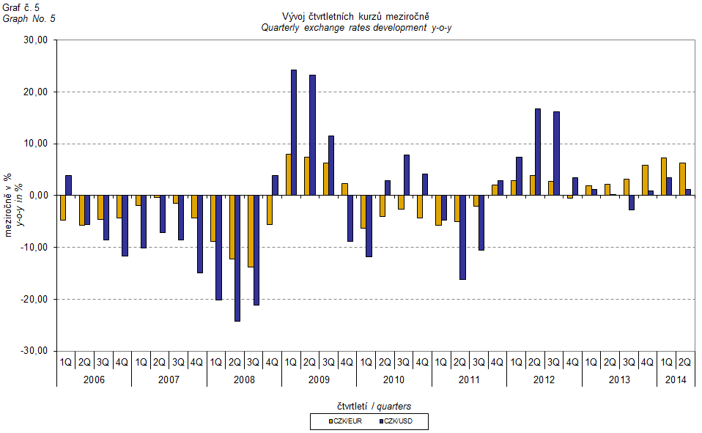

# External trade price indices adjusted y-o-y for exchange rate influence

The CZSO also carries out calculations of year-on-year external trade price indices adjusted for effects of exchange rate. The method is prices in foreign currencies reported in the current month are **converted** into Czech crowns by the **exchange rate** of the same month **of the last year**. Then they are used for the weighted mean calculation along with prices reported in CZK. The year-on-year adjusted price index is then calculated the way that this exchange rate adjusted base price index is related to the non-adjusted base price index of the same month of the last year. **Differences among adjusted and non-adjusted price indices may be substantial**. They can be clearly seen in Graphs Nos. 6 and 7 for November 2013 and December 2013, for instance.

The method employed does not enable, for many practical reasons, to carry out 100% exchange rate adjustment because all trade transactions concluded in foreign currencies are not reported in foreign currencies. This share is up to 30%. It follows from the aforementioned, that **at the full exchange rate adjustment differences** in between the price indices published and the exchange rate adjusted price indices would probably **be even larger**.

The aforementioned exchange rate adjusted indices can be used to form the exchange rate adjusted breakdown of price indices increments. Table 1, last but one page, gives the **published and exchange rate adjusted breakdowns of increments** of export and import price indices, expanded to the most important two-digit code groups of the SITC 7. These breakdowns illustrate, in a good manner, how many percentage points each of the groups “exchange rate contributed” to the index.

It holds in general that the effects of exchange rate decrease the value of price indices in external trade if CZK is strengthening to foreign currencies in total. Conversely, the effects of exchange rate push the price indices up if CZK is weakening to foreign currencies in total. It is obvious from following Graphs Nos. 6 and 7 how significant was the exchange rate impact on the value of export and import price indices.

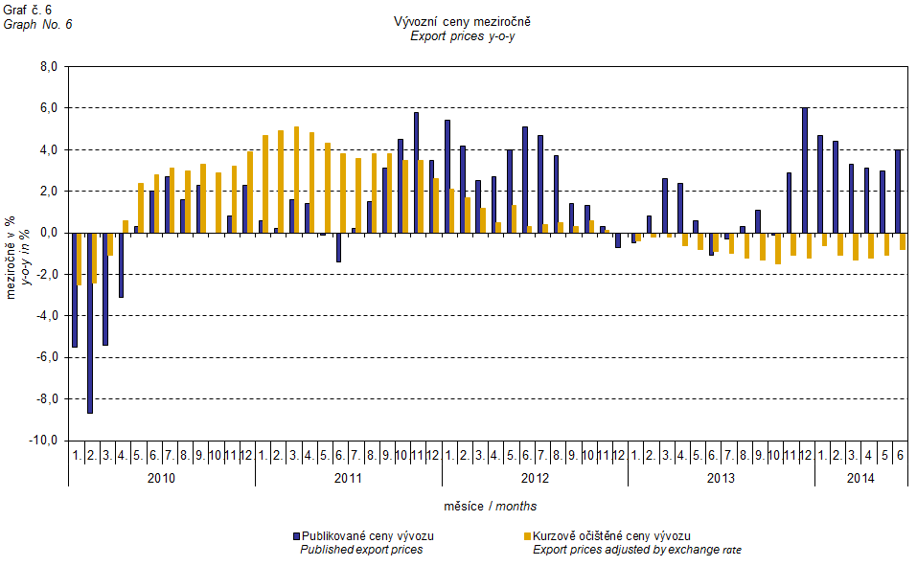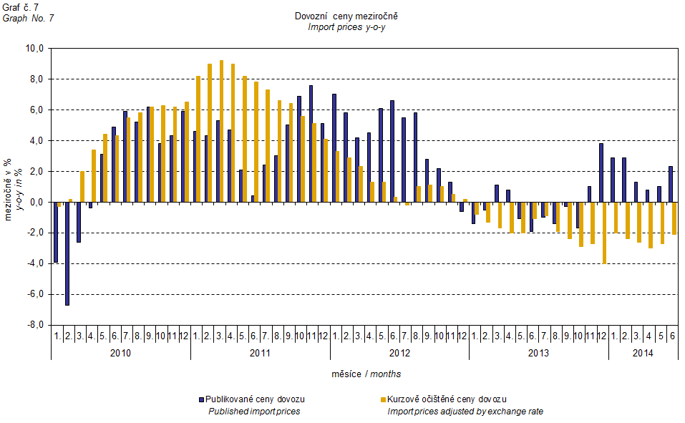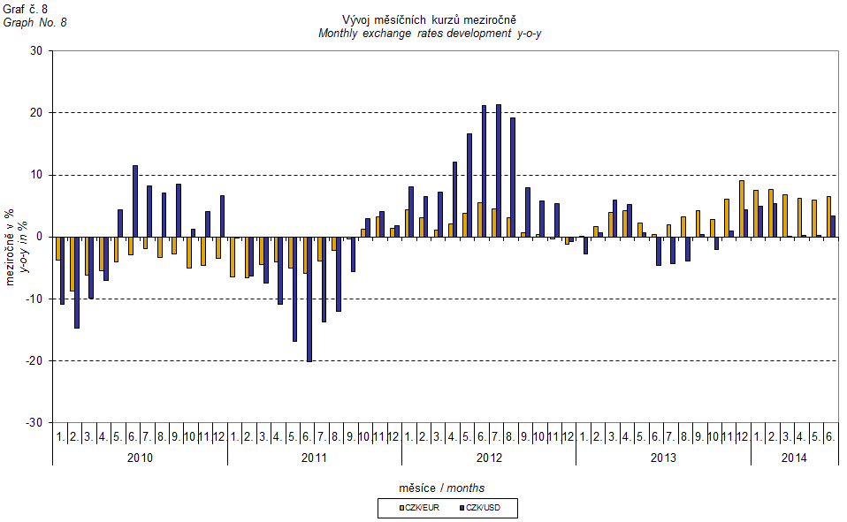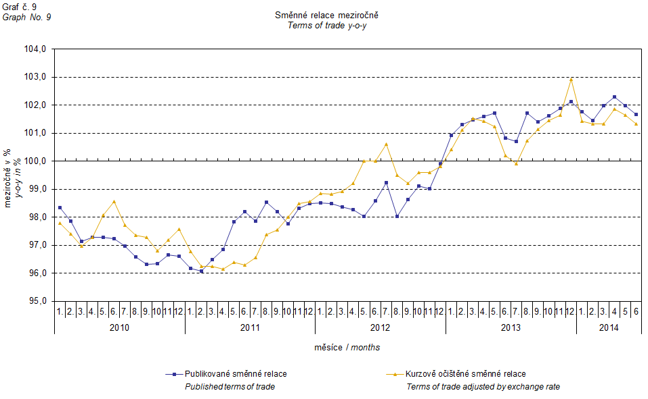

It can be seen from Graph No. 9 how the exchange rate influences the value of the year-on-year terms of trade.

Graph No. 10 demonstrates how the value of terms of trade would develop if the observed groups would not include that of 'mineral fuels, lubricants and related materials'.

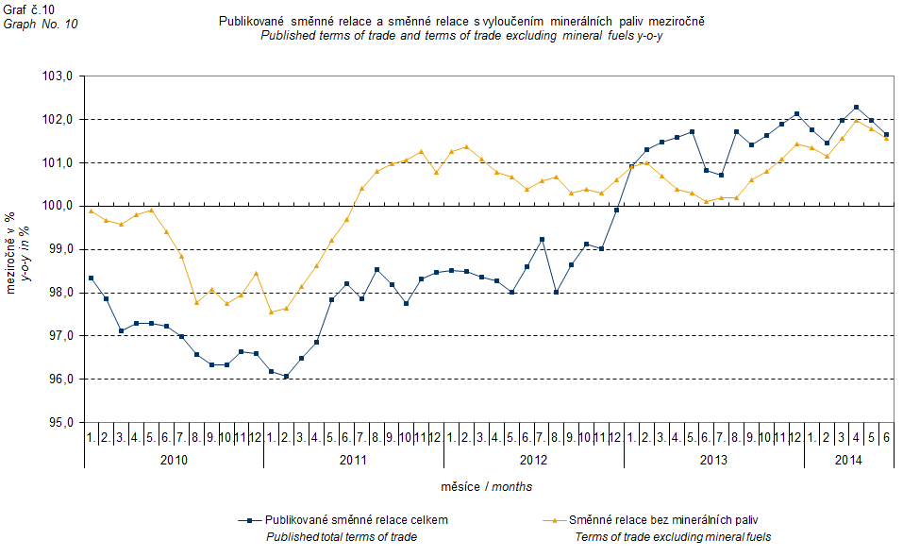

It can be observed in Graph No. 10 that 'mineral fuels, lubricants and related materials' were decreasing the overall value of y-o-y terms of trade till Q4 2012. In Q1 2013 the situation began to reverse and 'mineral fuels, lubricants and related materials' have had again an upward effect on the value of terms of trade. It is, of course, related to the world market price development, especially in crude oil. Import prices, which, compared to export prices, include a higher proportion of crude materials, respond in a more sensitive way to price turbulences and therefore when prices of crude materials go up, terms of trade, as a rule, go down and, conversely, when prices of crude materials fall, terms of trade grow.

# Closing summary

The exchange rate effects in **Q2 2014** caused a year-on-year increase in both import and export prices. If there would be no exchange rate effect prices in external trade would be decreasing. Export prices were growing faster than the import ones and therefore terms of trade increased year-on-year. Yet if exchange rate adjusted terms of trade would be growing slower. Values free of the exchange rate effects correspond to exchange rate adjusted indices – see graphs Nos. 6, 7, and 9.



Closing table gives published external trade price indices **without adjustment**.



**Developed by:** Vladimír Klimeš, Prices Statistics Department

**Director of the Department:** Jiří Mrázek, telephone: (+420) 274 052 533