Monetary Conditions
Key interest rates still close to zero, crown foreign exchange still kept above the level of 27 crowns per euro |  | Monetary conditions remained easy throughout the whole year 2015 and thus worked in the direction of growth of both the performance of the Czech economy and the price level. Key interest rates are practically zero since the end of year 2012, the crown foreign exchange is kept above the level of 27 crowns per euro since November 2013. A weaker economic growth of the euro area against the USA together with the quantitative easing of the ECB created pressure on the depreciation of euro against the US dollar. It depreciated significantly, however the Czech crown also lost with it. While it appreciated by 0.9% against the euro, it lost 18.5% of its value against the dollar. The money supply expressed by the monetary aggregate M2 increased by 6.9% year-on-year in December 2015. Even though it mildly slowed down, it grew faster than would correspond to the average for the whole year and also faster than in each month of years 2010–2014.
Velocity of money started to decrease in the second half of 2015 |  | The year-on-year dynamics of the monetary aggregate M2 is higher than the dynamics of the nominal GDP roughly since the half of year 2015. The growth of the harmonised aggregate M3 is also faster. Velocity of money is thus decreasing and the effectivity of easy monetary conditions is falling, the same way as in the recession years of 2012 and 2013.
Interest rates are low and households and businesses transform term deposits into the most liquid money, especially the overnight deposits |  | The money supply arrived at 3 668 CZK bn in the concept of the monetary aggregate M2 by the end of the last year. In that, 2 952 bn was assigned to the most liquid money (currency in circulation and overnight deposits) and 716 bn to quasi-money (deposits with agreed maturity, deposits redeemable at notice, repurchase agreements). Money supply rose by 238 CZK bn against December 2014, however only thanks to the increase in volume of the overnight deposits (+263 CZK bn) and currency in circulation (+35 bn). The volume of quasi-money is shrinking continuously since September 2012, it fell by 60 bn between December 2014 and 2015. It is the consequence of low interest rates, when the households and businesses are not motivated to hold these types of deposits and transform them in to the most liquid money, especially the overnight deposits. Households negotiated deposits with agreed maturity with an interest rate of 1.6% and deposits redeemable at notice with the rate of 1.37% in December 2015. The interest rates to non-financial corporations amounted to 0.21% and 0.78%.
Share of currency in circulation on the monetary aggregate M2 is stable in the CR. It oscillates between 12% and 14% |  | The share of currency in circulation on the monetary aggregate M2 is stable in the CR and oscillates only negligibly in time. It moves between 12% and 14% in the long-term. It jumped up only in the second half of year 2008, in connection with the difficulties of the banking sector of the USA, when also the Czech society started to worry about its money in banks. The volume of currency in circulation reached 467 CZK bn in December 2015 and arrived at 12.7% relative to the aggregate M2.
Total deposits of businesses grew always by more than 10% year-on-year during H2 2015. Businesses increased mainly the overnight deposits |  | Total volume of household deposits was higher by 5.7% year-on-year at the end of the last year, even by 10.3% in case of businesses. The rate of growth of household deposits gradually rises, for businesses it exceeded 10% level throughout the whole H2. Businesses strengthened mainly the overnight deposits significant by volume, they had 952 CZK bn in them in December, by 111 bn more than a year ago. The robust increase of the liquid resources of the businesses – given by high profits from own activity and growing loans to businesses – provides hope, that investment and volume of paid out wages will also grow in the future. They hide the potential of future growth of the economy of the Czech Republic.
Net credit to the government sector (incl. securities) fell by one fifth year-on-year in December 2015 |  | Loans to households and businesses increase faster than the total domestic credit. It occurs since August 2015. The difference in year-on-year rates was already marked in December. While the volume of loans to households and businesses increased by 6.5% year-on-year, the volume of domestic credit was higher only by 1.8% against the end of year 2014. It was caused by the notable drop of the net credit to the government sector (incl. securities), by one fifth year-on-year (-21.1%). This development was most likely associated for once with the fact, that the domestic banks were selling government bonds abroad, for second with the accelerated drawing from the European Union funds at the end of the year.
Share of non-performing loans in the CR does not decrease due to worsening payment morals of non-residents. Loans repayment on the part of residents however improves, in December 2015 it was even the best since the crisis |  | It is key from the view of the banking sector stability, how the share of non-performing loans is developing. It was the lowest in November 2007, when it constituted 2.61%. Nevertheless, it climbed up to the level of 6% due to the worsening of economic situation in the CR in years 2008 and 2009, where it basically remained till today. The share of non-performing loans did not decrease even in 2014 and 2015, when the economy was evidently flourishing. If we however study the detailed structure more, it becomes apparent, that a high proportion of non-performing loans is caused by the non-residents, whose payment morals is continuously worsening. On the other hand, the repayment of loans on the part of residents is improving already since the end of the year 2010. The proportion of non-performing loans for the non-residents amounted to 16.59% in December 2015. In case of residents, the banks had only 4.36% of total exposure in default and it was the best result since crisis. Not surprisingly, the households repaid their obligations better (4.07%) than the non-financial corporations (5.72%). However, especially the business sphere recorded the improvement with respect to the payment morals during the year 2015 – the proportion of non-performing loans of households decreased by 0,66 p.p. and by 0.99 p.p. for non-financial corporations.
Interest rates on loans for house purchase are very low and the households contract debts, … |  | Very low interest rates on loans for house purchase – in the environment of growing household income and low unemployment rate – motivated the households to acquire their own housing resp. to secure future income by a purchase of real estate for rent. The rates were low throughout the whole year 2015, regardless of the fixation period. Nevertheless, those who negotiated the loan in June with the fixation of the interest rate over 1 and up to 5 years (2.32%), reached the most advantageous conditions, even historically.
… mortgages rose by 8.8% year-on-year in December. The interest to finance real estates via consumer credit is also increasing |  | The volume of loans provided to households for the purchase of flat or house increased by 8% year-on-year at the end of 2015, the fastest since July 2010. The most often utilised mortgage loans increased by 8.8%, deviation from the standard credit from construction savings however continued (-9.6%) and the bridging credit were not convincing in their dynamics either (+3.2%). A higher interest of households to finance the real estate with the use of the consumer credit is apparent since Q2.
Non-financial corporations incur further debt, however only on longer time horizons |  | The increase of loans to non-financial corporations follows from the higher demand for longer-term financing. The volume of medium term loans grew at least by one tenth year-on-year in September to December, the volume of long term loans throughout the whole H2. Since these are commonly the investment loans, it can be assumed, that the high dynamics of these loans is associated with higher investment activity. However, the non-financial corporations likely start to prefer their own resources when financing the operational matters – the year-on-year additions to short term loans to non-financial corporations were weak for the whole year 2015, even negative at the end of the year.
Total debt of households increased by 76 CZK bn year-on-year to 1 391 bn at the end of the last year. It arrived at 31.1% of GDP |  | Total indebtedness of the Czech households rose by 76 CZK bn year-on-year at the end of 2015 and the households owed 1 391 bn. Mainly the debts originating from the house purchase (978 bn) represent a burden. Households owe approximately one quarter of a trillion (262 bn) in the form of consumer credit, 151 bn belongs to the other credit. Banks and credit unions are logically the biggest creditors of households, they hold 95.8% of the total household debt. The rest belongs to other financial institutions. The role of these institutions is zero in case of provision of loans for house purchase, the complete majority of these types of liabilities of households are held by banks and credit unions. However, the other financial institutions already cut a considerable slice from the consumer and other credit. Households owe to other financial institutions 18.6% from the consumer credit, 6.1% for other liabilities.

Chart 17 | Monetary aggregates and gross domestic product (y/y in %) | Chart 18 | Share of non-performing loans (in %, non-performing loans/total loans)
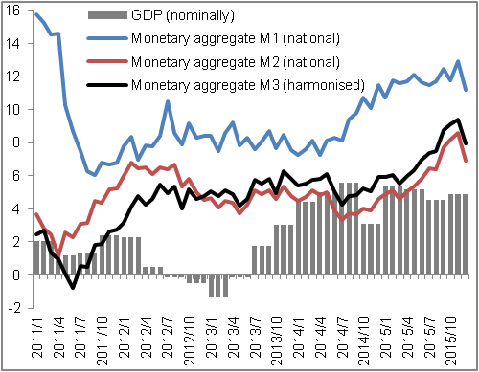 |  | 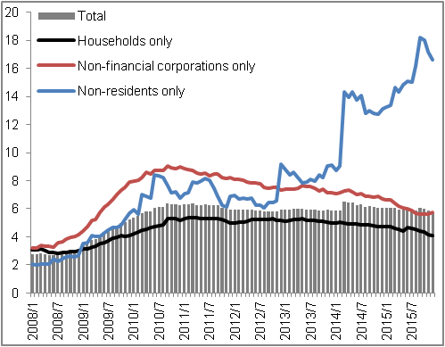
 |  |  |  | Source: CZSO, CNB

