Prices
Total price level increased only by 0.7% in 2015. The dynamics of all demand components lowered |  | The total price level increased based on the implicit GDP deflator only by 0.7% in 2015. It slowed down considerably, since it rose by 2.5% in 2014. The dynamics of all components of the domestic demand lowered and the terms of trade were also lower. Consumption was from the view of households more expensive only by 0.1%, goods and services paid by government by 1.2%. Although the prices of these products grew by 0.5% and 1.5% still in 2014. The addition to prices of investment shrank by 1 p.p. to +0.9%. The terms of trade in foreign trade with goods and services remained positive, already third year in a row, however their value fell to 100.4%. They were positive in case of goods, in case of services they did not reach the value of 100% already for four years.
Inflation rate fell to +0.3% in the last year and it was the lowest in the last twelve years (the prices grew by 0.1% in 2003), … |  | The inflation rate expressed by the year-on-year change of the consumer price index dropped to mere +0.3% in 2015 and it was the lowest since 2003 (+0.1%). It was falling already for a third year and its long-term development was thus apparent. The price dynamics during the year 2015 with respect to the individual quarters was nevertheless fluctuating. The consumer prices grew by 0.7% and 0.4% in the year-on-year comparison in Q2 and Q3. In Q1 and Q4 the Czech economy, however, balanced on the verge of deflation (prices grew equally only by 0.1%).
… supply side factors were mainly the cause |  | The dampened price development in 2015 was caused mainly by the supply side factors. The key factor was the slide of the oil price on the world commodity market, when the average price of the barrel of the Brent oil lowered from 99 US dollars in 2014 to 52.3 dollars in 2015. The lowering prices in manufacturing in the euro area affecting the prices of imports into the CR and also the falling prices of animals and animal products impacting the prices of food nevertheless also contributed to the disinflation. The dramatically weakening crown against the US dollar and growing demand of households for goods and services were hampering the established trend, nevertheless they did not manage to reverse it.
Prices of tobacco hiked by 7.6% in the last year and ensured, that the Czech economy did not descend into deflation |  | The price dynamics worsened (with respect to the most significant divisions of the consumer basket by weight) in case of food and non-alcoholic beverages (from +2% to -1.1%) and expenditure on transport (from +0.2 % to -4.2 %). Nevertheless, the deep fall of the prices of expenditure on health (deepened from -1.8% to -7.1%), which was linked to the cancelling of the regulation fees on dispensing of medicine on receipts and fees at the visit of a doctor, also contributed to the slowdown of the price development. The weaker growth of the prices of restaurants and hotels and prices of education also participated. Mostly the prices of tobacco worked in the direction of growth of consumer prices in 2015. They increased by 7.6%, thanks to the raising of the excise duty, and thus they contributed to a large extent to the fact, that the Czech economy remained in the positive inflation range and did not descend into deflation.
The price development in the last two years worked mildly in the direction of straightening of social inequalities |  | It is positive from the point of view of social inequality development, that the dynamics of prices for households of pensioners (+0.1%) was weaker compared to households in total (+0.3%) in the last year. The situation from the previous year was repeated. The long term increase of the social inequalities was thus slightly mitigated during the last two years, even though they still remained considerable. If the prices rose by 23.6% from the view of households in total in the last ten years, the cost of living for households of pensioners expanded by 32.4% in this period.
The prices of real estate dramatically increase in the environment of low interest rates. The size of rentals however does not change much |  | A fast growth of the real estate prices occurs in the Czech economy. The realised prices of new flats hiked up by 5.2% in Prague in Q4 2015 year-on-year, prices of second-hand flats were raised up by 4.6%. The development of prices was even faster in other regions, since the realised prices of second-hand flats outside Prague increased by 7.4% in the last quarter 2015. This development was supported by low interest rates transforming in the enlarged volume of loans for house purchase. It is however surprising, that the prices of rentals do not react to the strong growth of real estate prices so far. The prices of actual rentals for housing increased only by 0.8% year-on-year in the last quarter of the last year and prices of imputed rentals by 0.9%.
Consumer prices fall mainly in the less developed economies of the EU |  | The slump of the oil price, initiated in summer 2014, affected all European Union countries. The harmonised index of consumer prices lowered only in Greece in 2013. Already six Union countries faced deflation in 2014, however, and even eleven in the last year. In addition it is interesting, that the deflation was apparent especially in the less developed countries of the EU. Only Finland among the above average developed economies based on GDP per capita in PPS faced deflation (-0.2%). The prices moved despite ongoing quantitative easing from a mild growth into stagnation in the euro area, the same occurred in the whole EU.
Industrial producer prices fell the fastest in history. They decreased by 3.2%, … |  | The industrial producer prices fell by 3.2% in 2015, the fastest in the history of the Czech Republic. The prices were falling faster in Q3 and Q4 with respect to the renewed slump of the prices of oil starting in the half of the year. The prices fell by 3.3% and 2.3% in the year-on-year comparison in Q1 and Q2, however already by 3.6% and 3.5% in Q3 and Q4. The development of industrial producer prices was also similar in the EU. The fall of prices deepened during the year 2015 in all member countries apart from Belgium, Poland, United Kingdom, Ireland and Hungary.
… even by 3.9% in manufacturing itself |  | The prices fell by 3.9% in manufacturing in the last year, that is faster than in the industry as a whole. The deflation was the strongest in case of producers of coke and refined petroleum products and producers of chemicals and chemical products. However, neither mining and quarrying (-0.6%), where the prices fell already for the fourth time in the last year, nor energetics (-0.8%), contributed positively to the development of industrial producer prices either.
Good harvest the cause of the fall of prices of the crop products, restriction on imports to Russia and cancelling of milk quotas the cause of lower prices of animals and animal products |  | Prices of agricultural producers (incl. fish) declined by 6% in the last year and thus followed the development of 2014, when they decreased by 3.7%. Nevertheless, the causes of this development changed. The prices of the crop products fell – thanks to a very good harvest – by 10.3% in 2014. On the contrary, the animals and animal products became slightly more expensive (+4.9%). The harvest of agricultural plants was also good (especially for cereals) in 2015, the prices of crop products however fell already only by 2.2%. The purchase prices of the animals and animal products nevertheless slumped by 10.5%. It was connected for once to the ban on imports of agricultural products and food into the Russian federation, for second to the cancelling of the milk quotas, which became effective at the beginning of April. Prices of pigs for slaughter decreased by 12% in the year-on-year comparison, milk was purchased from the agriculturers for 17.2% less than a year ago.
Prices of construction work rose by 1.2% in the last year |  | Construction was considerably affected by the finalisation of drawing of resources from the EU funds in the last year. 41.4 CZK bn, by 27.9 bn more than in 2014, reached the construction companies only via the Operational Programme Transport itself. Narrowly focused demand of the public sector, especially for the infrastructure structures, limited number of companies capable to satisfy this demand and upcoming deadline, to which the funds from the programme period 2007–2013 could have been drawn – this was a combination, which resulted in the growth of construction work prices by 1.2%. It presented the fastest growth of prices in the last six years.
Drop of the prices of oil lowered the costs for the transporters and they went down by 1.4% |  | Prices of the market services did not change in the last year, however the development in individual quarters suggested, that also this segment of economy gradually descends into the deflation. The prices of market services were higher by 0.3% and 0.2% in the year-on-year comparison in Q1 and Q2 2015, however they were already falling (-0.2%, -0.1%) in Q3 and Q4. While the high growth of prices of postal and courier services (+6.4%) and financial services (+3%) put some inflationary pressures in the last year, the prices fell by 1.4% in the weight significant land transport services and transport services via pipelines. The turn in the development of prices of employment services, after two years lasting growth, also contributed negatively to the price development. They fell by 7.5%.
Prices of imported goods decreased by 1.9% in 2015 and fell already for the fifth time in the last ten years |  | Import of goods became cheaper by 1.9% in 2015, despite the crown foreign exchange development. The crown did strengthen mildly against the euro (by 0.9%), which worked in the direction of decrease of prices, however it weakened against the US dollar by extraordinary 18.5%. The fall of import prices was the consequence of the lower price of oil and decreasing prices in manufacturing in the euro area. Prices of mineral fuels decreased by nearly one quarter (-23.8%), crude materials by 9.2% and chemicals by 3.1%. The beverages and tobacco (-0.7%) and manufactured goods (-0.4%) were also imported for lower prices into the CR than in 2014. It was the fall of the import prices that was the primary source of deflation in industry (and “leaked” also into the consumer prices). The dynamics in individual quarters also suggests this, since it was worse in the second half of the year, similarly to the industrial producer prices. The prices of imported goods into the CR decreased year-on-year by 1.5% in Q1 2015 and stagnated in Q2. However, they decreased by 2.6% in Q3 and even by 3.8% in Q4.
The price level lowered also on the side of exports, however slightly slower compared to imports … |  | The prices of exports of goods fell by 1.7% in the last year. All SITC sections were exported abroad for lower prices except for beverages and tobacco (+3.1%), which hold low weight in the total. Prices of machinery and transport equipment decreased by 0.4%, manufactured goods were cheaper by 1.6% and miscellaneous manufactured articles by 0.3%. The drop of prices of mineral fuels was deep (-12.6%), however not as much as on the import side. It is logical, as the weight of the trade with oil and oil products has a lower share on exports than on imports and thus the fall of prices of this commodity affected more the import side.
… and terms of trade remained positive for a third year in a row |  | Terms of trade in the foreign trade with goods remained positive. The size of additional profits of the Czech economy flowing from the favourable development of prices however considerably shrank compared to years 2013 and 2014, since the value of terms of trade fell from 101.4% and 101.6% to mere 100.2%. Given the individual SITC sections, the terms of trade were highly positive for the mineral fuels (114.7%) in the last year, further however only in case of beverages and tobacco (103.8%) and crude materials (101.5%).

Chart 11 | Consumer prices for individual types of households (y/y in %) | Chart 12 | Prices in selected CPI divisions (y/y in %)
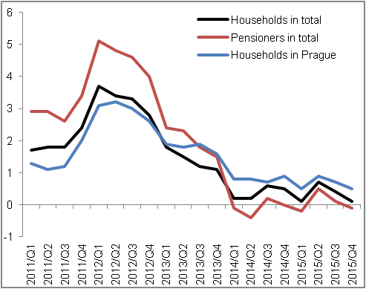 |  | 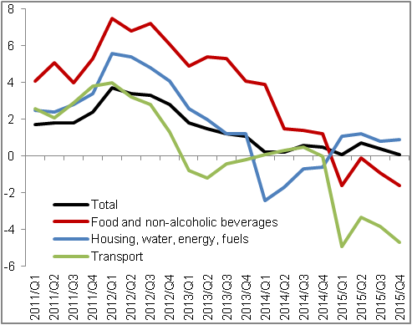
Source: CZSO

Chart 13 | Deflators (not adjusted for seasonal and calendar effects, y/y in %) | Chart 14 | Producer prices (y/y in %, prices in the agriculture on the right axis, other on left axis)
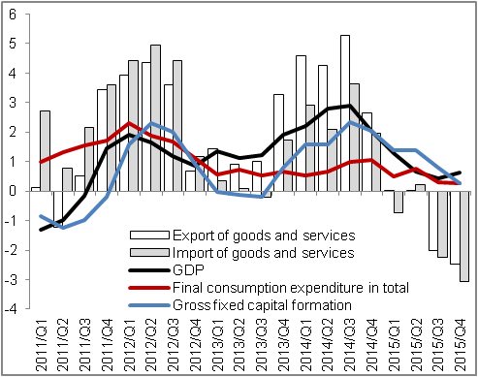 |  | 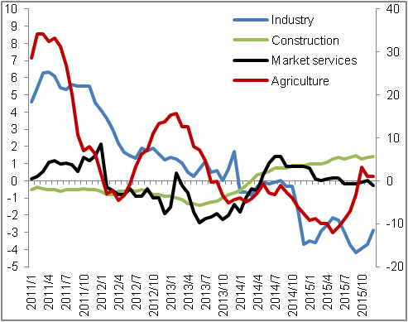
Source: CZSO

Not adjusted for seasonal and calendar effects.

