External Economic Relations
Current account surplus more than quintupled in the last year and was historically the highest, … |  | The current account of the balance of payments ended in surplus a second year in a row. The excess of revenues over outlays in addition more than quintupled on this account compared to year 2014 and reached a record level. The surplus of the current account amounted to 7.5 CZK bn in 2014 (0.2% of GDP) and 41.4 bn in the last year (0.9% of GDP). The surplus of the capital account was also historically the highest, it overtook the 100 bn boundary for the first time (106.1 CZK bn) thanks to the completion of drawing on the EU funds. Some transactions on the financial account also eluded the historical contexts – net outflow of direct investment, excess of portfolio investment inflow over its outflow or the growth of the reserve assets, these are the further records captured in the balance of payments statement.
…all partial balances participated on its improvement with the exception of the trade balance |  | The lower deficit of both primary and secondary incomes (+17.3 CZK bn and +6 bn resp.) and also the more notable surplus of the foreign trade with services (+19.4 bn) worked in the direction of further improvement of the current account. However, the trade balance worsened in the last year, due to a faster increase of imports of goods (+193 CZK bn) against its exports (+184.2 bn), by 8.8 bn. The trends typical for years 2012, 2013 and 2014 – i.e. the continual increase of the primary incomes deficit and lowering of the surplus of the foreign trade with services accompanied by simultaneous increase of the trade balance surplus – thus completely reversed in the last year.
Direct investment inflow into the CR was the weakest since 2003. Its trend in addition weakens already ten years |  | The transactions with abroad recorded on the financial account led to a deficit, similarly to years 2012–2014. The size of this deficit was however completely extraordinary, since it reached 193.8 CZK bn. The Czech companies strengthened their direct investment abroad by 87.3 bn in the last year, investment in the CR were nevertheless less attractive, since foreign direct investors spent only 60.7 bn in the CR. The growth of the foreign investors’ capital in the CR was the smallest since 2003, its trend in addition weakens already since 2006. The financial account deficit was thus caused by the net outflow of direct investment, especially however by the dramatic increase of the reserve assets in the amount of 351.3 CZK bn. These were increased for once due to the continuing interventions of the CNB against the strengthening crown, then also because of the accelerated drawing of finances from the EU funds, which were exchanged into crowns outside the market and thus increased the foreign exchange reserves of the CNB.
Foreign investors purchased securities worth 236.4 CZK bn in the CR in the last year. In that, 117.7 bn was assigned to the purchases of the government bonds |  | The Czech economy received 164.1 CZK bn in the form of portfolio investment balance in 2015. The residents increased the holding of foreign securities by 72.2 CZK bn, the exposure of foreign investors in portfolio investment towards the CR rose by 236.4 bn. The effort of the domestic banks to optimise the structure of the balances at the end of the year was reflected in the investment of foreign investors into their bonds for 148.7 CZK bn, the foreign investors however also purchased massively the government bonds (for 117.7 bn). They preferred a low risk and speculated likely also on the further appreciation of the Czech crown, which could bring them additional yields.
Exports of goods rose based on the data in the national concept by 5.9% in the last year. The drop of goods exports by one third into the Russian Federation however also decreased the total exports into countries outside the EU (-0.4%) |  | The exports of goods increased based on the national concept data by 5.9% in 2015 and reached the value of 3 336 CZK bn. Its dynamics was stronger in H1, when it rose by 7.1%, compared to H2, when it was by 4.7% higher year-on-year. The exporters succeeded to expand especially to the EU markets in the last year, similarly to years 2013 and 2014. The exports of goods into the Union went up by 7.2%, by 7.4% into Germany itself and even by 14.4% to Slovakia. Regarding the value of goods exports into the countries outside the EU, it fell (-0.4%) for the first time since 2009. This decrease was for once connected to the restriction of exports into the Russian Federation, for second to the economic difficulties of this country. The export of goods into Russia slumped by 32.8% year-on-year in the last year and it was already lower by 37.3% compared to year 2012.
Rate of growth of exports into China higher than the dynamics of total exports in years 2009–2013. In the last two years it was however already below average |  | The exports of goods heading to China increased by 20.6% despite the generally weak demand in 2009. It was developing favourably also in years 2010–2013, since it grew much faster than the total exports of goods from the CR. Nonetheless, the Czech exporters did not progress as much on the Chinese market in the last two years – the exports into China increased by 8.7% in 2014 and by 4.4% in 2015, less than was the corresponding additions to total exports of goods in both years.
Exports of motor vehicles rose by 12.7% and by 38% in accumulation for years 2014 and 2015. It was nearly double compared to year 2007 (+87.3%) |  | The dynamic increase of the exports of motor vehicles from year 2014 (+22.5%) did not repeat in the last year. Nevertheless, it remained strong (+12.7%) and roughly double compared to the total increase of the exports of goods. Year 2015 was also favourable for exporters of fabricated metal products (+9.4%), electrical equipment (+6.9%) and rubber and plastic products (+6.6%). From the remaining divisions, whose value of exports exceeds the boundary of 100 CZK bn a year in the long-term, there was only chemicals (-6.8%) and basic metals (-5.5%) exported less in the last year. A slump of the value of exports in case of chemicals occurred due to the effect of a forced shutdown of the part of the production capacities, lower prices of oil however also contributed. It is nevertheless interesting, that the exports of the oil itself and natural gas doubled (+126.1%).
Strong domestic demand was mirrored in the more notable increase of imports over exports |  | Prices of oil and natural gas dropped on the world market in 2015 and were significantly reflected in the value of imports of this good into the Czech Republic (-20.3%). Even so, the total imports of goods into the CR increased by 6.5 %. It rose faster than exports. At the same time, it is apparent from the quarterly data, that it was the consequence of the development in Q1 to Q3, since the rate of growth of imports already lagged behind in Q4. Strong domestic demand, given by the fast growing consumption and investment, pushed up especially the imports from Poland (+11.4%), China (+11.1%) and Germany (+8.3%). The value of goods originating from countries outside the EU increased by 2.9%, the imports from Russia fell by 18.4%.
Interconnectedness of the Czech economy with the EU further increased in the last year |  | The orientation of the CR towards the EU strengthened in 2015. While 83% of total exports of goods from the CR ended in the Union countries in 2014, it was already 84% last year. The weight of goods imported from the EU on total imported goods expanded from 68.1% to 68.9%.
Surplus of foreign trade with goods in the national concept lowered by 7.3 CZK bn in 2015. At the same time, the deficit of the trade with oil and natural gas shrank by 55.5 bn |  | The surplus of the foreign trade with goods in the national concept, i.e. the difference between the exports in the FOB prices and imports in the CIF prices, arrived at 138.7 CZK bn in the last year. Excess of exports over imports shrank by 7.3 CZK bn and the trend of a continual growth of surplus from 2011–2014 halted. The surplus of the trade with the Union expanded to 597.1 CZK bn (by 28.6 bn), the deficit with countries outside the EU increased to 437.7 bn (by 29.3 bn). Oil and natural gas (deficit narrowed by 55.5 bn), motor vehicles (growth of surplus by 27.9 bn) and other transport equipment (growth of surplus by 10.8 bn) experienced the most significant improvement of the balance. Mainly the trade with the tobacco products recorded a worse result than in 2014, moving from the surplus into the deficit. The deficit worsened by 26.8 bn and 15 bn in case of chemicals and basic metals, surplus in machinery and equipment fell by 10.1 bn.

Chart 9 | Current account of balance of payments (in CZK bn) | Chart 10 | Balance of foreign trade with goods in national concept in 2015 (y–y in CZK bn, in FOB/CIF prices, nominally)
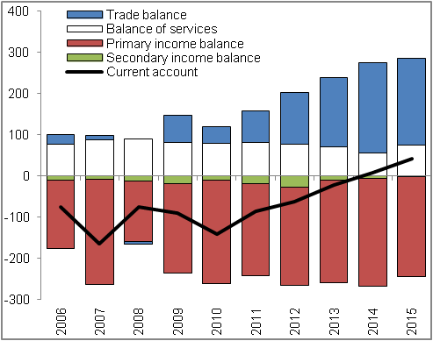 |  | 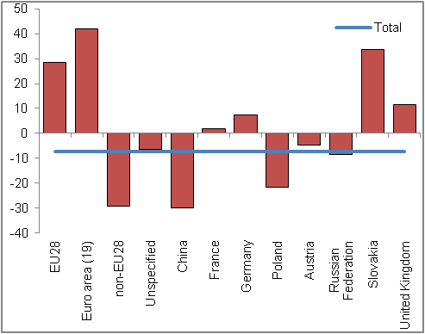
 |  |  |  | Source: CZSO, CNB

Data in the national concept are expressed in nominal terms. The value of exports is captured in FOB prices, i.e. including the costs connected with the transport to the CR boundaries. Import is in CIF prices, i.e. including costs associated with the transportation abroad, up all the way to the CR boundaries.
Deficit of trade with unspecified entities increased to 20.7 CZK bn (by 6.6 bn).

