Overall Economic Performance
The growth of the economy was significantly supported by extraordinary influences in 2015. They however already weakened in the last quarter, … |  | The Czech economy flourished in 2015 and its performance rose the most in the last eight years, i.e. since the peak of the business cycle in 2007. Gross domestic product (GDP) increased by 4.3%, while its dynamics reached at least 4% in each of the quarters. Gross value added grew by 3.8%. Especially the domestic demand shared the most in the economic growth on the expenditure side, mostly the manufacturing and private and public services then had a favourable effect on the supply side. The economy grew in the year-on-year comparison already nine quarters in a row, its dynamics was supported by extraordinary influences in 2015. It was the slump of the oil price on the world market, which lowered the cost of inputs for companies and expenditures on purchases of fuels for households, and also the completion of drawing of finances from the EU funds at the end of the programme period 2007–2013.
… GDP stagnated in quarter-on-quarter comparison and gross value added increased only by 0.5%, the slowest since Q4 2013 |  | The GDP expanded gradually by 2.4%, 1% and 0.7% in the first three quarters of the last year in quarter-on-quarter comparison and the economy was thus slowing down. It even went into stagnation in the last quarter, since the GDP did not change compared to Q3. Even though this development was partially caused by the seasonal adjustment, it was still apparent, that the economy started to decrease its pace. The development of the gross value added also confirmed this conclusion. Its quarter-on-quarter additions were stable in Q1 till Q3, with a range of +1% to +1.2%. The gross value added nevertheless increased only by 0.5% in the last quarter, the least since the end of 2013.
All V4 countries prospered in the last year, the CR fared the best |  | The Czech Republic was among the fastest growing countries in the EU in the last year. Only Malta achieved a higher addition (+6.3%) based on the available data. Year 2015 was successful also for the other countries of the Visegrad group. Poland increased together with Slovakia by 3.6%, Hungary by 2.9%. The lowering number of countries registering a GDP fall was a positive occurrence in a wider context. There were eleven of these countries in 2013, four in 2014 and only one (Greece, -0.3%) in the last year.
Addition to GDP more than double in the CR compared to the EU and nearly triple compared to the euro area |  | The GDP increased more than twice as fast in the CR compared to the EU (+1.8%) in 2015. Compared to the euro area (+1.5%), the domestic growth was nearly triple. The situation from year 2014 was repeated, nevertheless the difference between the rates of growth in the CR compared to the EU and euro area expanded. The domestic economy thus further converged towards these groups in 2015, the pace of its convergence in addition most likely fastened.
Especially the domestic demand was the source of the economic growth in the last year. Investment contributed +1.9 p.p. and consumption of households +1.4 p.p. … |  | All components of demand contributed positively to the growth of the economy in 2015, apart from the foreign trade balance. It worsened due to the impact of stronger pace of imports (+8.1%) compared to exports (+7.2%) and worked towards the decrease of the economic performance of the CR (-0.2 p.p.). Investment (gross fixed capital formation) contributing +1.9 p.p. and final consumption expenditure of households (+1.4 p.p.) were the main sources of growth. Investment had a pro-growth effect on the economy already nine quarters in a row, household consumption eleven. The addition of final consumption expenditure of government was weaker compared to investment and household consumption (+0.7 p.p.), this however occurred due to a lower weight of this demand component. The dynamics of the government consumption itself was the highest since 2003, while the strong growth occurred mostly in Q3, when the transport infrastructure was quite extensively – utilising the EU funds – repaired. Change in inventories stimulating the economy especially at the beginning of the year added +0.6 p.p.
… but after exclusion of import for final use only by +1.4 p.p. and +0.8 p.p. |  | If the import for final use is excluded from the total volume of import into the CR, in other words import, which is not directed to further utilisation in the production process, the additions of final consumption expenditure of households (+0.8 p.p.) and investment (+1.4 p.p.) are significantly smaller. It is because the increase of household consumption and investment was for a large part satisfied from abroad, i.e. by import. It followed especially from higher purchases of motor vehicles and machinery equipment, which it was not possible with respect to variety and specific requests satisfy from the local sources. The contribution of final consumption expenditure of government is lower compared to the classical concept only negligibly (+0.6 p.p.), similarly the change in inventories (+0.5 p.p.). Foreign trade balance, after exclusion of import meant for final use, contributed to the economic growth by +1 p.p.
Higher income of households and high consumer confidence were reflected in the increase of household consumption, … |  | Final consumption expenditure of households increased by 2.9% in 2015, featuring equal year-on-year dynamics in individual quarters (+2.7%, +2.9%, +3%, +2.9%) and fast quarter-on-quarter growth at the beginning and end of the year (+1.1%, +0.5%, +0.4%, +0.9%). They mirrored the increasing nominal household income in the low-inflationary environment. The high consumer confidence also had a favourable effect. In December 2015, it was the highest on the available time series tracing back from 1998 (nevertheless, it was overtaken immediately in January 2016).
… it increased throughout its whole structure for the first time since 2007 |  | Household consumption grew in its entire structure last year for the first time since 2007. Addition to expenditure on durable goods (e.g. motor vehicles) lowered from +10.7% to +7.9%, still it remained very high. The dynamics of expenditure on semi-durable goods went up from +2.9% to +4.2%, the dynamics of expenditure on non-durable goods also increased (from +0.8% to +2.9%). Demand for services, which was weaker in 2014 (-0.5%), already recovered (+1.4%).
The growth of the dynamics of the final consumption expenditure of government in Q3 was the result of extensive infrastructure repairs and maintenance |  | Expansive fiscal policy was mirrored in the large addition of final consumption expenditure of government (+3.4%). In Q3 itself, these expenditure increased even by 4.7% year-on-year. Annual consumption volume exceeded the level from year 2010 (by 2.7%) for the first time. Data for the first nine months show that the expenditure on individual consumption grew faster than those on collective consumption in Q1 and Q2. The relation turned in Q3 and the dynamics of expenditure on collective consumption – with the view to the extensive transport infrastructure repairs and maintenance – dominated.
Nine quarters lasting quarter-on-quarter growth of investment already halted at the end of the last year |  | Investment was the main source of growth of the Czech economy in the last year. Its dynamics was growing till Q3, when it reached +9.6% year-on-year and it was the highest since the end of 2007. Investment increased by 7.5% in total for the whole last year and it was connected to a higher investment activity of non-financial corporations, government as well as households. The dynamics already mildly weakened (to +7.9%) in the last quarter year-on-year, investment even decreased quarter-on-quarter (-0.9%).
Investment into buildings and structures increased by nearly one tenth in the last year. They grew faster last time in 1995 |  | Based on the type classification of gross fixed capital formation, mostly the purchases of transport equipment (+14.9%) increased in 2015, however also higher investment into ICT, machinery and equipment (+5.9%) and two years not monitored growth of investment into the intellectual property products framed the growth of investment of non-financial corporations. Accelerated drawing of money from the EU funds was very strongly reflected in investment into buildings and structures (+9.2%), while its addition was the highest – similarly to the final consumption expenditure of government – in Q3 (+13.6% year-on-year). Households were also very active in the last year and the low interest rates on loans for house purchase assisted this development – investment into buildings for housing grew by 7%.
Surplus of foreign trade with goods and services expanded only by 2.1 CZK bn in nominal terms in 2015, … |  | Surplus of foreign trade with goods and services reached in the concept of national accounts 288.6 CZK bn in nominal terms. The surplus enlarged only by 2.1 CZK bn in comparison to year 2014, the slowest in the last five years. Only the trade with services (+21.3 CZK bn) shared in its growth quite surprisingly, the surplus of trade with goods was lower by 19.2 bn. With respect to individual quarters, the surpluses in the foreign trade were even weaker year-on-year (-9.1 CZK bn) in Q1 to Q3, only the last quarter improved the yearly result (+11.3 bn).
… only thanks to the prevailing positive terms of trade |  | Real gross domestic income,⁶ which reflects on the contrary from the GDP the additional profits or losses from the development of prices in foreign trade, or rather profits or losses from the terms of trade, increased by 4.5% in the last year. It thus increased by 0.3 p.p. faster than the GDP. A significant change occurred in comparison to years 2013 and 2014, since the dynamics of real gross domestic income relative to the GDP was by 0.9 p.p. and 1.2 p.p. higher at that time. While the terms of trade amounted to 101.2% and 101.5% in years 2013 and 2014, they were only 100.4% in the last year.
Manufacturing  as well as services both equally contributed to the economic growth last year. They added +1.9 p.p. and +1.8 p.p., … |  | The economic growth was equally distributed between the manufacturing and the services sector on the supply side. Gross value added of the industry as a whole increased by 5.6% in the last year and participated on the economic growth +1.8 p.p., the manufacturing itself recorded +7.3% and added +1.9 p.p. Other industrial branches – mining and quarrying, energetics, water supply – were declining (-0.1 p.p.). Services hiked up by 3% and contributed +1.8 p.p. to the growth, with the important fact, that a wider spectrum of branches prospered in comparison to 2014. Trade, transportation, accommodation and food service added together +0.4 p.p., the branches with a dominance of public sector (CZ-NACE O to Q) also participated by an equal share on the economic growth. Fast growing information and communication (+7%) contributed +0.3 p.p., the same as the professional, scientific, technical and administrative activities, that are more significant by weight.
… the contribution of construction remained the same as in the preceding year (+0.2 p.p.) |  | The inflow of finances into construction from the EU funds ensured, that this branch was growing by a solid pace also in the last year. The contribution to the total growth did not change and stayed the same as in year 2014 (+0.2 p.p.). Agriculture, forestry and fishing however slowed down due to the high basis associated with a very good harvest and did not share in the growth.

Chart 1 | GDP (constant prices, adjusted for seasonal and calendar effects, in %) | Chart 2 | GDP (constant prices, adjusted for seasonal and calendar effects, y/y in %, right axis) and confidence indicators (2005=100, left axis)
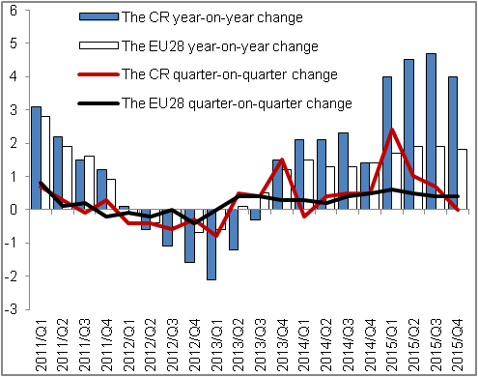 |  | 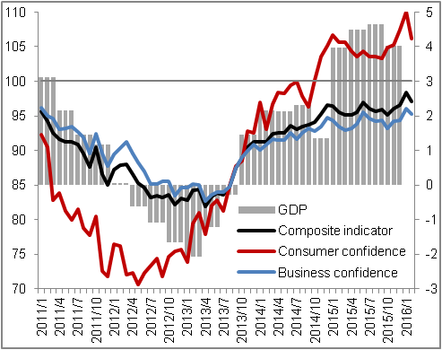
Source: CZSO, Eurostat

Chart 3 | Contributions of expenditure items to GDP change* (constant prices, y/y, contributions in p.p., GDP in %) | Chart 4 | Contributions of branches to change in GVA (constant prices, y/y, contributions in p.p., GVA in %)
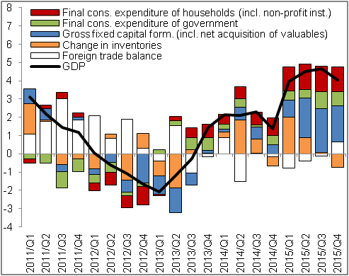 |  | 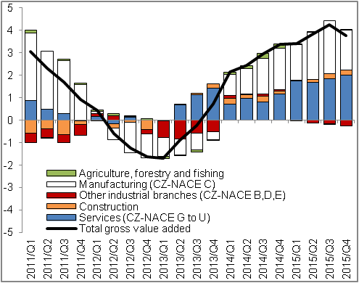
*contributions to GDP change not excluding the import for final use |  |  |  | Source: CZSO

Unless stated otherwise, data related to the GDP and its components are expressed in real terms and adjusted for seasonal and calendar effects. The same is valid for the gross value added.
Seasonal adjustment affected the quarter-on-quarter rates of growth of balance of taxes on products and subsidies on products at the beginning and at the end of the year. The quarter-on-quarter dynamics was affected favourably in Q1 2015 and negatively in Q4. This was reflected in the GDP dynamics, where this balance is included. The dynamics of gross value added was not affected.
Yearly data are not available for Ireland and Luxembourg, however these countries also grew faster than the CR based on data for first three quarters of 2015. GDP dynamics for Ireland and Slovakia is not adjusted for calendar effects.
Contributions to GDP change not excluding the import for final use.
Structure of expenditure is in the domestic concept and is not adjusted for seasonal and calendar effects.
Not adjusted for seasonal and calendar effects.

