Monetary Conditions
The expansiveness of both monetary and fiscal policy affected significantly the growth of the Czech economy in H1 2015 |  | The money supply rose in the Czech economy towards the end of June 2015 the most in the last three years. The M2 aggregate reached 3 461.2 bn crowns, which was by 5.8 % more compared to the same period of 2014. The addition to money supply was thus slightly higher than the nominal year-on-year addition to the nominal GDP (+5.2 %), which meant in this view, opposite from the same period of 2014, a mild expansivity of the monetary conditions. The growth of the monetary supply strengthened more markedly in Q2, the M2 aggregate increased by 3.9 % in the same period of 2014.  Both monetary and budget policy thus in combination with the fiscal expansivity contributed to the significant growth of the Czech economy in H1.
Large increase of non-term deposits of businesses was enabled by high growth of their profits even with considerable strengthening of their investment into the fixed assets… |  | Businesses further accumulate „cash“, if we contemplate with a certain simplification the financial balances on their current accounts this way. 102 bn crowns were added to these overnight deposits of business against June 2014, which is the highest year-on-year addition since the start of monitoring (2002). It shows the significant and growing reserve for financing of the fixed investment, but also the size of the operating capital. Only near 14 bn crowns diminished on the term deposits (deposits with maturity and deposits with redeemable at notice) of businesses, which means that the notable addition on current accounts was created by their large profits. These increased by nearly one tenth based on data for Q1 year-on-year (+9.8 %), i.e. less than in each quarter of year 2014 with a whole year addition of strong 12.4 %, however significantly more in comparison to the stagnation in 2013 (+0.4 %).
. … and confirm the potential for wage increases in the private sector |  | The room for increases of wages for employees of firms as well as financing of investment from their own resources is thus large. It represents in this sense a potential for the growth of the economy not only via the household consumption, but also the investment activity.
People increased their non-term deposits – second largest year-on-year addition since the start of monitoring in 2002… |  | The household deposits followed development in a similar spirit as in case of businesses – the deposits on the giro accounts were higher by 148.3 bn crowns at the end of June 2015 compared to the same period of the previous year (the second highest year-on-year addition since the start of monitoring), while the decrease of funds on the term deposits was also very strong. People withdrew nearly 65 bn crowns from the term deposits and deposits with redeemable at notice compared to June 2014, which again represented the highest year-on-year decrease in the time series since 2002 based on the half-yearly data in year-on-year comparisons.
. … and also alternatives of money deposits given the low interest rates on deposits |  | These proportions prove the lack of attractivity of bank interest rates for clients flowing from the level of basic interest rates in the economy, but partially also the possible tilt of households to alternative forms of saving, as suggested by the development of their property in mutual funds or resources on the accounts of supplementary pensions. Direct investment into securities on the capital markets (especially foreign) could also attract the investors from the ranks of households, enabling yields high above the level of other assets – e.g. the Dow Jones Index increased by 26.4 % on the New York Stock Exchange at the end of June and the DAX Index by 10.5 % on the Frankfurt Stock Exchange, taking into account the movement of the crown foreign exchange, which rendered such investments even more lucrative.
Growing purchasing power as a significant factor of the household deposit increase |  | The growth of the purchasing power of households also impacted the significant addition to household bank deposits (in total for both term and non-terms deposits by 83.4 bn crowns year-on-year) apart from the causes of the financially-investment nature. It was induced by the improvement on the labour market and growth of incomes. The average nominal wage was raised by 2.9 % based on the half-yearly data year-on-year, real wage by 2.5 %, but the median wage of males even by +5.6 % in Q2 due to the structure of their employment oriented to a notable extent on the manufacturing, which grew dynamically.
The relatively low need for external sources of funding still prevails – dynamics of corporate loans increased its pace only mildly from +3.9 % to +5.8 % year-on-year towards the end of June 2015 |  | The total deposits of businesses hiked up roughly the same as the total household deposits year-on-year in H1 (by 88.1 bn crowns, which was the second largest addition since the beginning of monitoring in 2002). This development logically limited the need for external resources. The dynamics of loans offered to businesses did accelerate somewhat (+5.8 % year-on-year against +3.9 % by the end of June 2014), however it still remains relatively low – e.g. when compared with year 2008, when the economy grew in nominal expression by 4.8 %, the financing of firms on the part of banks was markedly more intensive (the loans to businesses increased by 16.7 % and by nearly one fifth in the first half-year).
The additions to the mortgages of households strengthen already since the half of year 2013, the fastest in the last three years year-on-year by the end of June 2015 – on the contrary, the growth of consumption credit was affected only by the organisational change in the financial institutions sector |  | Marked year-on-year increase of consumption credit to households was affected by organizational change causing their increase by 18 bn crowns. Without this change, the provided consumption credit to population including the debit balances on the current accounts would be based on the banking statistics again lower year-on-year. People likely use their resources deposits with banks for the purchases of durable goods. Total balances of consumption credit (210.3 bn crowns at the end of June 2015) represent only 17 % of the total size of banking credit provided to the population.  On the contrary, the housing loans to population increased by 59.1 bn (+6.8 %) to 930.2 bn crowns year-on-year. The reason was the strong addition of provided mortgages (+57.7 bn, i.e. +7.5 %, to 826.1 bn crowns). People were motivated the most by the very low price of funds the banks provided these loans for. Positive expectations associated with the economic development also had their impact and also the improving condition of the household budgets. Balances of building saving loans were however nearly by one billion lower, which confirms the decisive effect of low interest rates of mortgages on the growth of total loans of Czech households for housing.
Margins of commercial banks remain high |  | Low interest rates of banks on new deposit trades were again lower year-on-year at the end of June 2015, both for businesses and for households. Interests on deposits with maturity for households were the exception (+0.39 p. p. to 1.57 % p.a.), still people reduced the balances on these deposits by 28.6 bn crowns against the end of June 2014. Bank margins remain despite relatively weak credit expansion still at high levels – interest rates on provided bank loans added up to 12.57 p. a. in new trades on consumption loans and rates from deposits, in maturities roughly corresponding to these loaned funds, oscillated between 1.4 % till 1.57 % p.a. Banks determined interest on the deposited funds on current accounts of households by the rate of 0.12 % p.a. and to businesses 0.11 % p. a. in June 2015.

Chart 17 | Credit dynamics (y/y in %) | Chart 18 | Deposits of households and businesses (y/y in %)
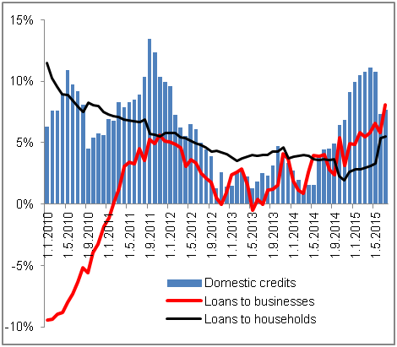 |  | 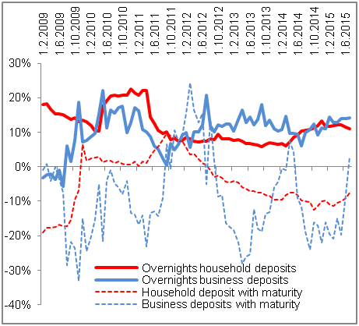
Source: CNB

Merger of the foreign bank branch with the non-bank entity (falling into the category Financial assets intermediaries – other lending) affected the data in the bank and monetary statistics as of 30.6.2015. The balance sum of banks increased one-off by 20 bn crowns, consumer credit to population including the debit balances on the current accounts rose by 18 bn crowns, in that receivables on the credit cards by 8 bn crowns. At the same time, the credit provided to other financial intermediaries decreased by 8.5 bn crowns.

