Labour Market
Favourable development of the Czech economy spills also to the labour market |  | Current trends on the labour market fully correspond to the development of the real economy. Total employment went up in the year-on-year comparison in both quarters of 2015, the numbers of vacant positions also increased. Number of persons seeking employment as well as their share in the total labour force was decreasing. Nominal growth of wages, which was only modest in the last year and at the beginning of year 2015 and did not develop in line with the expectations, already accelerated in Q2.
Total employment increased already by 1.4 % year-on-year in Q2 2015, … |  | Total employment rose by 1.3 % year-on-year in total for the entire H1 of this year and thus it increased the fastest since the 2nd half of the pre-crisis year 2008 (+2.2 %). Additionally it is apparent, that its increments are continually expanding. If the number of employed persons was practically the same in Q2 2014 as in the same period of the previous year, it was already higher by 1.1 % year-on-year in Q1 2015 and even by 1.4 % in Q2.
… especially due to the increase of number of employed in trade, transportation, accommodation and food service, in the manufacturing and in branches with the prevalence of the public sector |  | The increase of employment mingled nearly throughout the entire economy, except for only the financial and insurance activities (which registered by 0.2 thousand workers less on a year ago in Q2 2015), industrial branches apart from the manufacturing (-0.6 thousand) and „traditionally“ already the construction (where the number of employed persons lowered by 9.3 thousand). The two largest branches of the Czech economy (from the view of the number of employed persons) absorbed the most people, that is trade, transportation, accommodation and food service (+29.2 thousand) and the manufacturing (+27.2 thousand). The employment also significantly rose in the group of branches with the predominance of the public sector (public administration, education, health and social work; +10.3 thousand persons).
Continuing higher growth of the number of employees compared to the growth of total employment suggested, that the number of self-employed persons also decreased in Q2 2015 |  | Favourable development of the Czech economy was not reflected only in the growth of the total employment that is in the growth of the number of persons, who have a job. This development also altered its structure. While the number of employees grew, the number of self-employed (i.e. persons, who worked so called for themselves) was declining. These tendencies – whose origin had been most probably lying partially in the transfer of workers from the „svarc system“ back among the classical employees, but partially also in the effort of self-employed to shift into the more certain employee positions – were pointed by the „discrepancy“ between the year-on-year growth of the number of employees and total employment. This discrepancy was apparent already for four quarters and it had rather a tendency to expand. If the increase of number of employees was higher than the growth of the total employment by 0.4 p. p. and 0.3 p. p. in Q3 and Q4 2014, this defined „discrepancy“ already amounted to 0.7 p. p. and 0.6 p. p. in Q1 and Q2 2015.
Hour labour productivity had been growing in the year-on-year comparison already seven quarters in a row |  | The growth of the economy occurred practically with a stable number of hours worked in the last quarter of 2014 and in Q1 2015 (gross value added rose by 3.4 % year-on-year in both quarters, total number of hours worked however nearly did not change). The acceleration of the economy in Q2, when the gross value added grew by 3.8 %, however already demanded a larger time resources (total number of hours worked rose by 2.2 %). If the hour labour productivity (gross value added related to the total number of hours worked) thus increased by very high 3.4 % year-on-year in Q4 2014 and even by 3.6 % in Q1 2015 (that was the strongest growth since the second part of 2010), its dynamics slowed down to +1.5 % in Q2.
Number of vacancies similar to the beginning of deep recession |  | New positions were being created fast and employers did not keep up with filling these by suitable candidates. The number of vacancies was thus growing – there were already 97.0 thousand vacant positions based on the data of the Ministry of Labour and Social Affairs (MLSA) as of the last June 2015, i.e. roughly by 20 thousand more than at the end of Q1 2015. Their number was the highest since November 2008.
Further lowering of the number of unemployed persons will likely be difficult with respect to the differing structure of the supply of labour force compared with the demand structure |  | Differing structure of the job applicants compared to the structure of the vacant positions suggested, that the supply did not match the demand on the labour market. While there were for example 12.8 times more job applicants for administrative positions than vacancies at the end of June (calculated from the MLSA data), the number of applicants for qualified jobs in agriculture, forestry and fishing exceeded the relevant job vacancies 7.5 times and the numbers of applicants for assistant and unskilled jobs 7.0 times. These persons thus founded employment only with difficulties. On the contrary, a low excess of persons searching employment as workmen and servicemen (2.7 times more compared to the relevant job vacancies) or operation of machines and equipment or a mechanician (2.1 times) can signal a high demand for these employees on the part of businesses and their difficulties to find suitable workers.
General unemployment rate lower on a year ago in June 2015. Improvement realised mainly for females |  | General unemployment rate for persons aged 15-64 years, based on the Labour Force Sample Survey (LFSS) and seasonally adjusted, lowered from 5.9 % in January to 5.1 % in June 2015. June share of unemployed in total labour force was lower by 1.1 p. p. year-on-year and suggested, that the number of persons seeking employment fell down by 55.8 thousand. Regarding males, in their case the general unemployment rate amounted to 4.2 % in June and it was lower by 0.9 p. p. year-on-year. In case of females it still remained by roughly 2 p. p. higher (6.2 %), however it fell more than for males year-on-year (-1.4 p. p.).
Situation on the labour market in the CR more favourable compared to the vast majority of the EU countries in Q2 |  | The general unemployment rate in the CR had been low in comparison to the EU countries already for a long time, the position of the domestic economy nevertheless improved even further in this respect during H1 2015. While 5.9 % of labour force aged 15-74 years were seeking employment in the CR in January and it represented the fifth best result among the Union countries, this proportion fell to 5.3 % in April and it was the second best within the whole 28 countries. The CR kept a second position till the end of the quarter, only Germany registered a lower proportion of unemployed on the total labour force in these months.
Year-on-year growth of the average wage increased to +3.4 % in nominal terms in Q2… |  | Average gross monthly wage per full-time equivalent employee, which was raised only by 2.3 % in nominal terms in year-on-year comparison in total for the entire year 2014 and similarly in Q1 of this year, already started to grow more dynamically in Q2 (+3.4 %). It is apparent from more detailed data, that the average wage significantly increased for employees in accommodation and food service activities (+6.1 %) and in construction (+5.1 %), the earnings however notably increased – due to the growth of wages of public employees at the end of 2014 – also for example in the public administration and defence (+5.6 %) and in the human health and social work activities (+5.0 %). The fact, that the wage median (+4.3 % year-on-year) grew faster than the average wage, was a positive aspect of the wage development in Q2. It suggested, that the earnings increased especially for employees with relatively low level of wages and thus can be assumed, that it was connected mostly with the increase of the minimal wage.
...and was also reflected in faster growth of the purchasing power of employees |  | Nominal growth of the average wage year-on-year was already quite strong in Q2 2015 and even a higher inflation rate did not prevent a faster growth of the purchasing power of employees in comparison to Q1. While the real average wage increased by 2.2 % then, it increased by 2.7 % in Q2.

Chart 15 | Number of employed persons and employees (national accounts data, seasonally adjusted, y/y in %) | Chart 16 | Average gross monthly wage, nominal and real (per full-time equivalent employee, y/y in %)
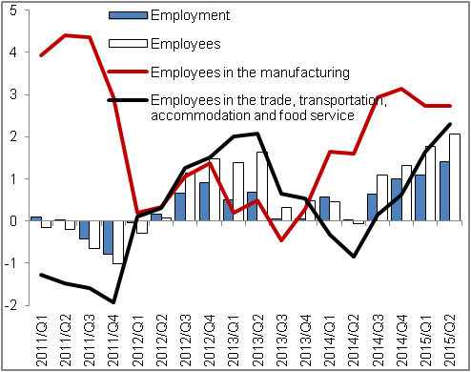 |  | 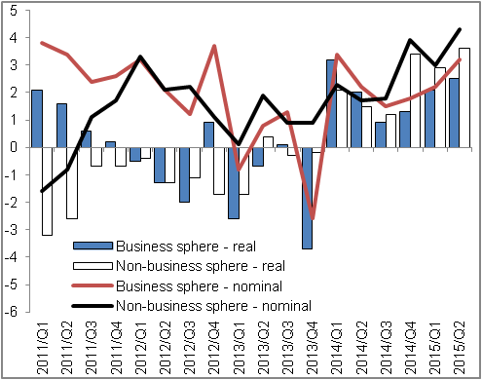
Source: CZSO

Unless stated otherwise, the data are the national accounts data adjusted for seasonal effects.

