Prices
Year-on-year growth of the total price level in the economy further slowed down in Q2 2015 |  | The total price level went up according to the implicit GDP deflator by 0.7 % in the economy year-on-year in Q2 2015. It rose not only less than in Q1 (+1.3 %), but also the slowest since Q3 2011 (when it decreased by 0.1 %). In the context of individual GDP components, the prices of investment (gross fixed capital formation) rose by 1.6 % year-on-year, prices of goods and services – purchased by the government – went up by 1.2 %. Prices of products bought by the households grew only mildly (+0.4 %). While the terms of trade in the foreign trade with services reached positive values (100.4 %) similarly to the previous quarter and worked in the direction of growth of the total price level, the terms of trade in the foreign trade with goods were negative for the first time in the last two and a half years (99.7 %) and slowed down its growth.
The inflation rate, expressed by the year-on-year change in the consumer price index, increased from +0.1 % in Q1 2015 to +0.7 % in Q2. The inflation trend however still remains uncertain |  | The year-on-year growth of the consumer price index, which was moving only slightly above the zero level at the beginning of this year, accelerated in further months and moved away from the „dangerous zone of deflation“. If the prices for consumers grew only by 0.1 % year-on-year in Q1 2015, they were already higher by 0.7 % in Q2. The inflation trend however still remains uncertain, as shown by the latest available data regarding the development of the index from the holiday months. The year-on-year growth of consumer prices again fell – to +0.5 % in July and to +0.3 % in August. The threat of deflation, hovering above the Czech economy especially at the beginning of the year, thus was not yet averted.
It can be assumed, that the price of oil is the main risk for the further inflation development – the barrel of Brent oil was traded on average for 64.1 US dollars in May of this year, however its price fell to 46.6 dollars in August |  | The price of oil on the world commodity markets can be considered the main risk, connected to the further development of inflation in the CR. While the barrel of the Brent oil was traded on average for 64.1 US dollars in May 2015 and its price was lower by 41.5 % in the year-on-year comparison, its price reached only 46.6 dollars already in August and it was lower by 54.2 % compared to the same month of year 2014. The deepening fall of the prices of the animal and animal products (striking the prices of food via the production chain) also presents a risk for inflationary development as well as the continuing deflation in the manufacturing in the euro area (which has an indirect effect on the inflation in the Czech Republic, that is via the prices of imports).
Change in the development of prices of vegetables and fruits, increase of the consumption tax on cigarettes and temporary growth of the price of oil. These were the three key factors standing behind the higher year-on-year growth of prices for consumers in Q2 |  | The higher inflation rate in Q2 2015 compared to Q1 of this year was determined by three key factors. Firstly, the development of prices of vegetables and fruits changed. If the vegetables were cheaper year-on-year on average by 10.5 % and fruits by 6.4 % in the first three months of the year, the prices of vegetables were already raised (+6.0 %) in Q2 as well as the prices of fruits (+4.2 %). Secondly, the consumption tax on cigarettes was increased as of 1. 12. 2014. As the stocks of cigarettes with older tax stamps were sold out (they were allowed to be sold only till the end of February) and replaced by new ones, the price of cigarettes was growing (the item „tobacco“ was more expensive by 5.5 % in Q1 2015 in the year-on-year comparison, but already by 8.8 % in Q2). Thirdly, a temporary turn occurred in the development of the prices of oil in the first half of the year. It started to rise (price of one barrel of the Brent oil rose from the January 47.8 US dollars to May 64.1 dollars) and it was reflected in the mitigation of the year-on-year fall of price of operation of personal transport equipment from -10.2 % to -7.1 % (the expenditures for fuels are represented in these expenditures from more than seven tenths).
More favourable dynamics of the consumer prices not only in the CR in Q2, but also in further twenty two countries of the Union |  | The year-on-year change of HICP increased in the CR from zero in Q1 2015 to +0.7 % in Q2. It represented a significant shift in the context of the European Union countries, however not an unusual shift. Apart from the CR, twenty two countries registered more favourable dynamics of the consumer prices in Q2 2015 compared to the beginning of the year, the euro area as well as the European Union as a whole even broke out of the deflation. It can be assumed, however, that it was only a temporary affair, since the turn in the development of price of oil participated on this more favourable development of prices similarly to the CR. And this turn, as already mentioned, did not last long.
Price of rentals for housing grew only gradually |  | The low rise of consumer prices in the CR was accompanied by a relatively weak increase of the prices of rentals for housing. It is logical, since the dynamics of the consumer prices is often incorporated in the rental contracts as a reference quantity, used to adjust the size of rent. The price of rentals for housing went up by 1.0 % year-on-year in Q1 2015 and by 1.2 % in Q2.
Year-on-year fall of industrial producer prices continued also in Q2 2015. Even though the deflation deepened in trend, … |  | The deflation in industry lasted already one year and a half in Q2 2015. It even deepened with respect to trend. While the depth of the year-on-year fall of the industrial producer prices was always contained within one percentage in the first three quarters of year 2014, it regularly overtook this boundary in the last quarter of 2014 and in Q1 and Q2 of this year. The cause was obvious, the lower prices of oil were reflected in the prices of industrial producers.
...it mitigated between Q1 and Q2 |  | Despite the trend deepening of the industrial producer deflation, a change for the better was apparent between Q1 and Q2 2015. If the industrial producer prices were falling by 3.3 % in the year-on-year comparison in Q1 of this year, the depth of the fall shrank by a percentage point to -2.3 % in Q2. It represented mostly the consequence of the temporary turn in the development of the price of oil, which mitigated the deflation in the segment of producers of coke and refined petroleum products and in case of producers of chemicals and chemical products. The development of prices of producers of beverages also negligibly participated on the smaller deflation of the industrial producers (prices shifted from deflation into growth).
Decline of the growth of prices of transport equipment producers since the end of the last year was the consequence of fading away of the effect of crown depreciation towards the euro |  | Depreciation of crown against the euro, which occurred at the end of 2013 (the crown was losing towards the euro due to the forex intervention of the Czech National Bank on average 5.9 % year-on-year in the last quarter of 2013), significantly increased the dynamics of the prices of producers of transport equipment (these products are traded in euros to a large extent, thus the change of the exchange rate of crown against the euro has on prices – denominated in crowns – a marked impact). By the end of 2014, when the effects of a weaker crown faded away, the growth of prices of producers of transport equipment logically shrank. This year's price dynamics is thus weak. Prices of producers of transport equipment rose by only 0.7 % year-on-year in Q1, they even fell by 0.1 % in Q2.
Surplus of milk on the market pressured its prices down. While they were lower by 10.5 % in the year-on-year comparison in Q1, it was already by 16.6 % in Q2 |  | Prices of agricultural producers kept falling, they were lower roughly by one tenth year-on-year in both Q1 and Q2 (-9.3 %; -10.9 %). Especially the crop products were bought out for lower prices on a year before (-11.0 %; -11.6 %), the acceleration of the price drops was however apparent mostly for the animal and animal products (from -7.6 % to -10.3 %). It was the consequence of the surplus of milk in Europe, which reflected the restrictions on import of agricultural products and food in the Russian Federation, however it also cannot be ruled out, that the lifting of milk quotas also contributed to the surplus of milk on the market (lifting of milk quotas came into effect at the beginning of April 2015).
The growth of prices of construction works accelerated due to the high demand for construction activities on the part of public contractors |  | The strengthening demand for construction activities – especially on the part of the public sector, which tried to complete the drawing of financial resources from the European Union funds – was reflected in the insufficient capacities of construction businesses and in pressures on the growth of prices. If the prices of construction works rose by 0.5 % year-on-year in total for the entire last year, their growth increased its pace to +1.0 % in Q1 2015 and even to +1.3 % in Q2. The development of prices according to the type of construction work also proved, that the prices were pushed up mostly by higher demand of public contractors. While the prices of buildings rose by 0.9 % and 1.1 % in Q1 and Q2, the prices of engineering works increased by 1.1 % and 1.4 % (especially the prices of so called rail tracks increased among the engineering works).
Growth of prices of market services producers shrank to +0.2 % year-on-year in Q2 2015 |  | Disinflation continued in case of producers of market services, in spite of the fact, that the year-on-year growth of prices decreased only mildly between Q1 and Q2 (from +0.3 % to +0.2 %). Prices of land transport services and transport services via pipelines fell by 1.8 % in Q2, other significant segments ascribed a moderate price increase (architectural and engineering services; computer programming, consultancy and related services; telecommunication services). With respect to the relatively little significant by weight – however „intensively monitored“ – employment services (services of job agencies), the price fall deepened from -2.9 % in Q1 to -7.3 % in Q2 in this segment. Anyhow it suggested itself, that this price development was a result of a favourable situation of Czech businesses reflecting in the transfer of agency employees among primary employees, the data of business statistics did not support this. Sales of job agencies increased in real terms by roughly one fifth year-on-year in Q2.
Prices of imports of goods, which fell by 1.5 % year-on-year in Q1 2015, already stagnated in Q2, … |  | Prices of imports of goods were lower by 1.5 % in the year-on-year comparison in Q1 2015, however they already stagnated in Q2. Higher price growth, shift from deflation into growth, a milder deflation alternatively was apparent without exception in all division of SITC (Standard International Trade Classification), especially however in case of mineral fuels. If the prices of imports of mineral fuels were still lower by 25,0 % year-on-year in Q1, the prices of these commodities were losing 19.5 % against the same period of the previous year in Q2. If we take into account, that the exchange rate of crown against the US dollar was weaker on average by 22.5 % year-on-year in Q1 and on average by 23.8 % in Q2, it is obvious, that the moderation of fall of import prices of the mineral fuels can be mostly attributed to the movements in the price of oil.
...the deflation on the side of exports however persisted… |  | Reduction of prices persisted on the side of exports of goods and its depth also remained the same. The prices were lower by half a percentage year-on-year in both Q1 and Q2. Manufactured goods classified chiefly by material (-0.6 %) and chemicals (-1.5 %) were exported abroad for prices below the level of the last year in Q2 2015, among the commodities less significant by volume then also for example the mineral fuels, food and live animals or crude materials. Prices of the most significant goods on the side of exports, that is machinery and transport equipment (they form more than one half of total exports of goods from the CR in the long-term), increased mildly (+0.6 %).
… and terms of trade were negative for the first time after nine quarters |  | Fall of prices of exports of goods in connection to the stagnation of import prices, occurring in Q2, resulted in negative terms of trade (99.5 %). They fell into the negative numbers for the first time in the last two and a half years.

Chart 11 | Consumer prices of individual types of households (y/y in %) | Chart 12 | Prices in selected CPI divisions  (y/y in %)
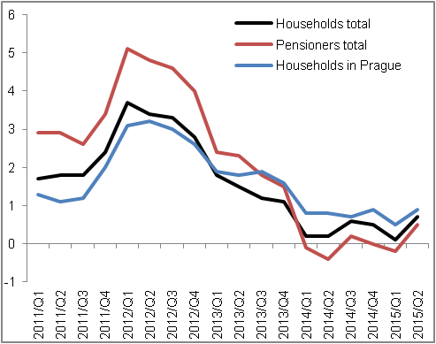 |  | 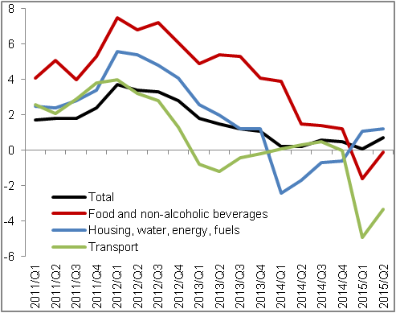
Source: CZSO

Chart 13 | Deflators (adjusted for seasonal and calendar effects, y/y in %) | Chart 14 | Producer prices (y/y in %, agricultural prices on the right axis, other on the left axis)
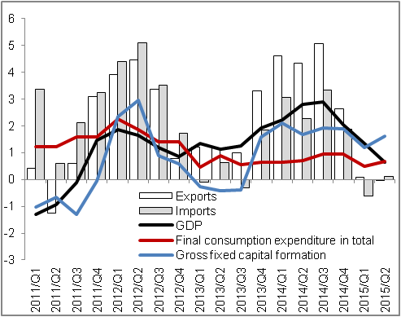 |  | 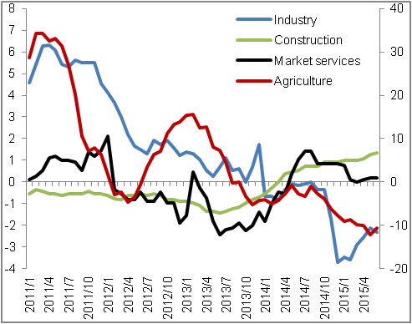
Source: CZSO

Adjusted for seasonal and calendar effects.

