External Economic Relations
Further improvement of external balance by both the record surplus on the current account of the balance of payments and mutual inclusion of surpluses and deficits in their further components |  | Strong growth of the Czech economy was accompanied by further improvement in its external balance in the first two quarters of 2015. Therefore, half yearly result of external economic relations was marked by record surplus on the current account of the balance of payments in the amount of 95.8 bn crowns, which represented 4.4 % of the nominal GDP and 1.5 % in the annualised formulation. The deep deficit on the financial account caused especially by the growth of foreign exchange reserves thus could be „financed“ together with the surplus on the capital account.
Q2 itself historically for the first time with a surplus of the current account due to lower outflow of the primary incomes, … |  | The half-yearly incomes of the current account exceeded its outlays already for the fourth year in a row, however the surplus was recorded for the first time in Q2 itself (3.1 bn crowns). This is usually deficit mainly due to the outflow of the primary incomes (mainly dividends) apparent especially in the second quarters (following the decisions of the shareholders meetings of companies under foreign control). This however occurred to a considerably lesser extent based on the data towards the end of June 2015, when the net outflow of the primary income (-96.7 bn crowns) was only on the roughly three quarters of the comparable level of 2014. In addition, given the actual preservation of the surplus in trade with goods and services in the year-on-year comparison (182 bn crowns, when the services balance of 39.8 bn remained in reality at the level of the average half-yearly surplus of the previous five years) and significant improvement of the balance of the secondary income (mostly thanks to the development in Q1, the half-yearly surplus arrived at 10.6 bn against -2.8 bn crowns of the comparable period of 2014), the excess of revenues of the current account of the balance of payments over its outlays reached in total the historically best half-yearly result.
… when it flew out in dividends from the CR less than in the same period of 2014, reinvestment of earnings were however also slightly lower |  | Outflow of primary income in net expression in total balances of interests, dividends and reinvestment of earnings amounted to 140.1 bn crowns for H1, which was slightly better result compared to the same period of 2014 (155.9 bn crowns), but worse compared to the yearly average of the preceding five years (128.7 bn crowns). The lower outflow of dividends into the parent countries of the foreign investors stood behind this positive year-on-year change, however they also left here fewer reinvestment of earnings year-on-year (50 bn crowns).
Notable deficit of the financial account …. |  | Strong inflow of funds from the European Union budget strengthened the positive balance on the capital account of the balance of payments to record 83.3 bn crowns, so the surplus amounted to 179.2 bn crowns together with the result of the current account. This level overtook the significant outflow of funds, recorded on the financial account of the balance of payments (-174.6 bn) only very mildly.
… was influenced not only by net outflow of funds from the CR both for direct, portfolio as well as other investment, but mostly by marked strengthening of the foreign exchange reserves |  | Adverse development in Q2 – both foreign investors in the CR and domestic entities abroad „withdrew“ their direct investment – led into the net outflow of direct investment from the CR for the half-year (1.7 bn crowns). The entire financial account registered markedly higher deficit result in the noted amount of -174.6 bn crowns together with the net outflow of the portfolio investment (48.6 bn) and also other investment (1.3 bn), however especially due to a considerable growth of the foreign exchange reserves (119.3 bn crowns). (Foreign exchange reserves are incorporated into the financial account newly based on the 6th Edition of the Balance of Payments and International Investment Position Manual, BPM6, they were accounted for separately in the preceding version).
The growth pace of both imports and exports slowed down also due to the effect of the comparative basis; the share of the four strongest product items (i.e. cars and their parts, PCs and electronics, electrical appliances and other machinery and equipment) on total exports from the CR further rose to 52.2 %… |  | The rate of growth of exports from the CR slowed down to +7.4 % year-on-year based on data on foreign trade with goods in the national conception. It was more than double with +15.4 % in the same period of 2014, but it was also affected by a weak comparative basis (its effect but in the opposite direction also worked in H1 2015). The export of vehicles and their parts participated in two fifths on the addition to exports by 115.6 bn crowns. It also enhanced its proportion in the structure of the total exports from the CR to nearly one quarter (24.2 % against 23 % in the same period 2014). It was caused by strong pace of export of vehicles and their parts in H1 2015 (+12.9 %) even though growth was notably lower than in the comparable period of the previous year (+27.6 %). Nevertheless, this export dynamics of vehicles was the strongest of the four main product groups which represent more than one half of the Czech exports.  Exports of other strongest export products grew by a pace lower than average – exports of computer and electronics grew by 7.2 % to 154 bn., electrical appliances by 6.4 % to 138 bn and other machinery and equipment by 3.5 % to 179 bn crowns. These four product items together with the exports of vehicles and their parts in the amount of 408 bn crowns thus expanded their share on the total exports from the CR to 52.2 % from 51.5 % recorded in half of 2014.  „The rest“ of the Czech exports thus weakened with respect to its share, even though the exports of 12 out of 40 product items increased by the rate of growth higher than average (more significantly e.g. paper products, other transportation vehicles and products of other manufacturing industry). On the contrary, the exports of value significant chemical products (-2.1 %), but also medicine (-0.8 %) or textiles (-1.5 %) were lower year-on-year.
The imports of oil and gas lowered the dynamics of imports due to the fall of their prices on the world markets, similarly in case of some other commodities… |  | The somewhat faster rate of growth of imports (+7.6 %) compared to exports (+7.4 %) completes the picture of the relative strong domestic demand. Due to the impact of the year-on-year fall of prices of oil on the world commodity markets, the value of its imports together with the imports of the natural gas fell by nearly one fifth (-19.8 % i.e. by 18 bn crowns). The same reason also contributed to the weakening of the value of imports of other commodities (ore -32 %, coal -3 % or wood -9 %, whose import is however, with respect to the import value, less significant).
… however imports of the largest product items grew above the average |  | Main import items are similar concerning the weight to the main export items due to the effect of the import-export oriented nature of the Czech economy. Their imports into the CR grew by the above average pace year-on-year, which was valid especially for vehicles and their parts (+14 %). These four product items, i.e. cars and their parts, PCs and electronics, electrical appliances and other machinery have represented together 42.4 % of the total imports into the CR in H1 2015, while 39.7 % in the same period of the preceding year. Increase in this share also proves the current boom phase of the business cycle in the Czech Republic.
Nominal surplus of the trade balance above the hundred billion mark, its improvement however the lowest in the previous five years |  | Excess of exports over imports overtook the hundred billion threshold in the national conception for the first time in H1 2015 (102.6 bn crowns). Nevertheless, the improvement of the trade balance (+4.3 bn crowns year-on-year) was the weakest H1 result in the previous five years (the trade balance had been growing during mentioned periods on average by 16.6 bn crowns yearly since 2011). This is also the reason, why the income balance contributed to the current account of the balance of payments surplus only negligibly in H1 2015.
Exports info the EU and euro area led to the strengthening of these territories with respect to the share in total exports, non-European markets were „losing“ |  | Exports increased by 8.4 % into the main target destinations from the CR year-on-year in H1, i.e. identically in the case of the EU 28, to the euro area, Germany and Poland. This development further increased the Czech exports proportion to the EU market by 0.7 p. p. to 83.9 % and to the euro area market by 0.6 p. p. to 65.1 % compared to the same period of 2014.  Destinations of the Czech exports which standing outside the EU, participated by 16 % on total exports against 16.8 % in the H1 2014. The main reason was that exports to Russian Federation fell significantly by 32.6 %, i.e. by nearly 17 bn crowns due to effect of sanctions imposed by EU countries and also due to shrinking of the Russian economy.  Alike, the exports from the CR into Austria has fell (-2.7 %). The slowdown of the Chinese economy did not reflect in the dynamics of the exports from the CR as yet (+15.3 %) given the still low volumes of trades. In H1 2015, their amount 18.2 bn crowns represented only 1.1 % of total exports from the CR. Wider diversification of the Czech exports especially in the direction of the eastern markets thus does not eventuate for now. One of the significant reasons is that the changes in the pace of growth can be seen on global level, especially that economic growth in the developed countries accelerates compared to its weakening in big emerging markets.

Chart 9 | Total exports and imports of goods (y/y in %, 6M moving averages; national conception; current prices FOB/ CIF) | Chart 10 | Year-on-year change in the value of exports into selected countries (half 2015, in %, national conception)
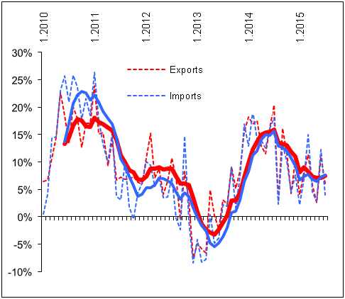 |  | 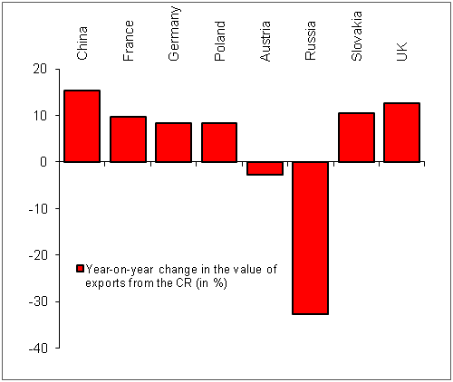
Source: CZSO, own calculations

Balance of goods according to the CZ-CPA (Classification of Products) in the national conception. Exports in FOB prices, imports in CIF prices.

