Overall Economic Performance
The Czech economy prospered. Year-on-year growth of both GDP and gross value added accelerated in Q2 2015, quarter-on-quarter rates of growth remained large |  | Economy of the CR not only continued in the very good result from the beginning of the year in Q2 2015, but it even accelerated. Year-on-year dynamics of the gross domestic product (GDP) expanded from +4.0 % to +4.4 %, the growth of gross value added increased as well (from +3.4 % to +3.8 %). The quarter-on-quarter rates of growth also proved, that the Czech economy was in a good shape. Despite their size shrank (in case of GDP from +2.4 % to +1.0 %, in the concept of the gross value added from +1.2 % to +0.9 %), these rates remained robust and above-average in the context of the development in the last years.
Quarter-on-quarter dynamics of GDP already reflected the actual development of the Czech economy. Year-on-year change of GDP was still however affected by the low comparative basis associated with the increase of the consumption tax on cigarettes from the beginning of year 2014 |  | Expansion of the CR economy was overrated from the view of year-on-year dynamics of GDP in Q2 2015, similarly to Q1 (the difference between the year-on-year GDP growth and gross value added growth in both Q1 and Q2 2015 amounted to 0.6 p. p. in favour of the GDP). „Discrepancy“ in the quarter-on-quarter growth of GDP and gross value added however decreased already (from 1.3 p. p. in Q1 to mere one tenth of the percentage point in Q2). It thus showed, that while the year-on-year growth of GDP was still influenced by the low comparative basis associated with the increase of the consumption tax on cigarettes from the beginning of year 2014 (pre-stocking with these products led to a higher collection of consumption tax at the end of 2013, in 2014 – when the traders drew on the pre-stocking – the collection fell), the quarter-on-quarter dynamics of GDP already reflected the real development of the Czech economy.
The GDP expanded year-on-year by 4.2 % in total for the whole H1, the fastest since the 2nd half of 2007 |  | The GDP expanded by 4.2 % in the year-on-year comparison in total for the whole H1 2015, the Czech economy recorded faster rate of growth last in the second part of year 2007 (+5.3 %). When compared to the 2nd half-year of the last year, GDP increased by 3.2 %. It represented the largest growth between two subsequent half-years since the first six month of the year 2006 (+4.1 %).
Domestic growth was solid also within the context of the EU countries. The real convergence of the Czech economy thus likely continued |  | Economy of the CR thrived and comparison with the development in the individual EU countries proved this fact as well. While the year-on-year GDP growth in the Czech republic was, based on the available data, the third highest among the Union countries in Q1 and the increase of the gross value added also, its position further improved in Q2. Viewed by the GDP change, the domestic economy was placed on the second position; from the point of view of the gross value added, it was even on the first place.  Up-to-date data suggest that the last year's real convergence of the CR to the average level of the Union countries was not a one-off phenomenon. It can be concluded, that it continued.
Especially the final consumption expenditure of households and investment participated on the GDP growth in Q2 2015 (year-on-year), … |  | Not only all four key items of the domestic demand – as at the beginning of the year – but also the result of the foreign trade with goods and services participated on the year-on-year GDP growth in Q2 2015. Contribution of investment (gross fixed capital formation) expanded from +0.8 p. p. in Q1 to +1.5 p. p. in Q2, final consumption expenditure of households also participated on the growth by a strengthened force (+1.4 p. p., +1.5 p. p.). The contribution of final consumption expenditure of government remained at the level of first three months (+0.5 p. p.), the contribution of the change in inventories shrank, however, from the extraordinary +1.9 p. p. to +0.7 p. p. The foreign trade result in real terms, which slowed down the GDP growth for the two preceding quarters, already shared positively on the enhanced performance of the Czech economy (+0.3 p. p.).
…if we however exclude the imports for final use from the total volume of imports, then this way modified result of the foreign trade was the „driver“ |  | If we exclude the imports for final use from the total volume of imports into the CR, whose dynamics has nothing to do with the Czech economy development at all, then the contributions to the year-on-year GDP growth logically change. Investment, whose increase was for a large part saturated by imported products, participated on it only by +1.1 p. p. in this concept in Q2, the contribution of final consumption expenditure of households even reached only +1.0 p. p. Final consumption expenditure of government contributed to the growth of the Czech economy by only a slightly weaker force than in the classical concept (+0.4 p. p.), the contribution of the change in inventories was even the same (+0.7 p. p.). Balance of exports and imports, where imports are lowered by imports for final use, participated on the GDP growth by +1.3 p. p.
Final consumption expenditure of households rose in total for the whole H1 2015 by 3.0 % year-on-year, … |  | The final consumption expenditure of households rose in total for the whole H1 2015 by 3.0 % year-on-year, the fastest since the second half of year 2007. The development in Q2 – when the household expenditure expanded by 3.1 % year-on-year – participated to a larger extent on this result than the development in Q1, when it was higher by 2.8 %.
…thanks both to the expanding household income and still high confidence in the economy |  | The willingness of households to spend was favourably affected by two key factors in the first half of the year. Raised incomes – as suggested by the increasing real average wage and rising employment – were the first one, still high confidence in the Czech economy was the second one (consumer confidence indicator was on a lower lever at the end of Q2 2015 compared to the end of Q1, nevertheless it still remained higher in the year-on-year comparison).
Households expended more especially on durable goods year-on-year in the first half of the year |  | The breakdown of final consumption expenditure of households according to durability shows, that the households strengthened especially the purchases of durable goods in the first half of 2015. They purchased more on these by 9.0 % compared to the previous year in Q1, by 8.7 % more in Q2. However, they also expended more for semi-durable goods (+3.8 %, +5.7 %) and non-durable goods (+2.3 %, +2.7 %). Expenditure on services, which is significant in weight, also grew, but rather only modestly (+1.4 %, +1.8 %).
Fiscal policy still loose |  | The fiscal policy remained expansionary and it showed not only in a stronger investment activity of government, but also in the relatively stable growth rates of final consumption expenditure. While the final consumption expenditure of government was higher year-on-year by 2.7 % in the last quarter of 2014, this expenditure exceeded the last year's level by 2.6 % and 2.5 % in Q1 and Q2 of this year.
Investment rose by 5.9 % year-on-year in Q2 2015, … |  | Investment was one of the two main sources of growth of the Czech economy in Q2 2015. It increased by 5.9 % in the year-on-year comparison, the most dynamically since the beginning of year 2008. The origin of this growth was lying mainly in the large increment to investment between Q1 and Q2 (+3.5 %), not in the low comparative basis.
…however the increase represented for most part a result of extraordinary influences. While on the side of government it was the completion of drawing of the resources from the EU funds, it was an extraordinarily high growth of profits in case of non-financial corporations in the last year |  | Even though the data related to the investment in the individual institutional sectors are not yet available, breakdown of investment by type of capital suggests, that especially the government and non-financial corporations stood behind the very large year-on-year jump of investment in Q2 2015. While the government tried to complete the drawing of the allocated resources from the European Union funds, non-financial corporations reached extraordinarily high profits in the last year and started to utilize them to an increased extent for investment purposes.  Investment into buildings and structures rose by 13.2 % year-on-year in Q2, the most in the available time series from year 1997. Growth of investment into transport equipment shrank in comparison to the beginning of the year (however it remained robust, +10.4 %), growth of investment into the ICT, machinery and equipment on the contrary accelerated (from +1.0 % in Q1 to +2.5 %). Intellectual property products experienced less investment compared to the preceding year (-1.5 %), similarly to Q1 and two previous years. Growing household income together with still prevailing low interest rates of mortgages kept favourably affecting the investment into dwellings (year-on-year +3.4 %).
Change in inventories still positive. Its structure has not changed much either (stock of material and unfinished production grew) |  | The value of inventory stock enlarged in nominal terms by 14.2 bn crowns during Q1 2015 and because their value dropped by 7.9 bn in the same period last year, the inventories became the main driver of the Czech economy growth. The value of inventories kept further growing in Q2 2015 (their value enlarged by 11.9 bn crowns), however since the change in inventories was positive also already in the last year's Q2 (+5.8 bn), its growth effect significantly weakened.
Year-on-year growth of exports of goods and services from the CR further slowed down |  | The economic growth of the euro area countries slowly gained strength, however it was not reflected in the dynamics of domestic exports of goods and services abroad. On the contrary, the growth of Czech exports continually weakened. While the exports was still higher by 11.7 % in Q1 2014 year-on-year (based on the data of national accounts), it was „only“ by 7.0 % in Q2 of this year. Still, it is possible to perceive the result of the increment to exports from the CR as favourable in Q2, since for example the exports from Germany rose „only“ by 6.4 %.
The foreign trade surplus higher in Q2 2015 year-on-year (+2.0 bn crowns in nominal terms) thanks to „services“ |  | Surplus of the foreign trade with goods and services in nominal terms enlarged year-on-year by 2.0 bn crowns in Q2 2015. The source of this growth was surprisingly not the trade with goods (the surplus in goods shrank by 4.1 bn), but the trade with services (+6.1 bn). As the data of the balance of payments show, the increase of the surplus of trade with services occurred mostly due to the improvement of the financial services balance and balance of services connected to transport. Balance of travel services worsened, despite the fact, that large sport events were held in the CR.
From the view of the supply side, the economic growth was spread out quite evenly |  | The manufacturing (+1.8 p. p.) participated from a large part on the growth of the gross value added in Q2 2015 (+3.8 % year-on-year), however, the services significant by volume also participated on the growth of GVA to a similar extent. Here all monitored branches shared in the increase of the performance of the Czech economy, nevertheless especially trade, transportation, accommodation and food service (+0.5 p. p.) and professional, scientific, technical and administrative activities (+0.4 p. p.). Construction – whose performance was favourably affected mostly by large demand for construction activities on the part of public contracting authorities – shared in the growth of the gross value added by +0.2 p. p., agriculture, forestry and fishing by +0.1 p. p. The economic growth was being „dampened“ only by a fall in the segment consisting of mining and quarrying, energetics, water supply (-0.1 p. p.).

Chart 1 |  | GDP (constant prices, adjusted for seasonal and calendar effects, in %) |  | Chart 2 | GDP (constant prices, adjusted for seasonal and calendar effects, y/y in %, right axis) and confidence indicators (2005=100, left axis)
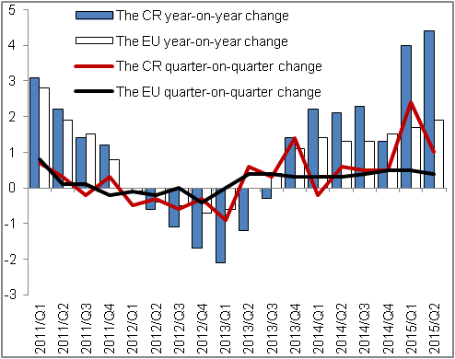 |  |  |  | 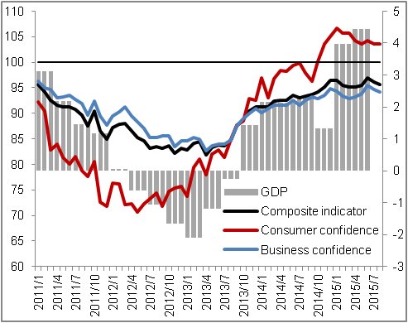
Source: CZSO, Eurostat
Chart 3 | Contributions of expenditure components to GDP change* (constant prices, y/y, contributions in p. p., GDP in %) |  | Chart 4 |  |  | Contributions of branches to GVA change (constant prices, y/y, contributions in p. p., GVA in %)
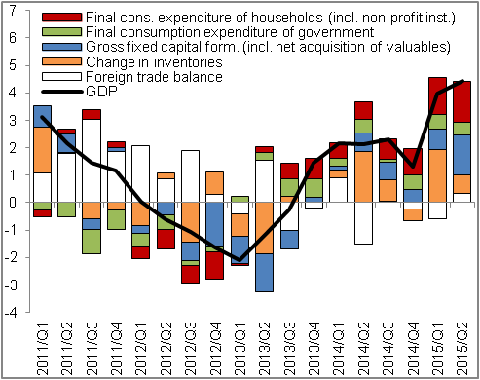 |  |  | 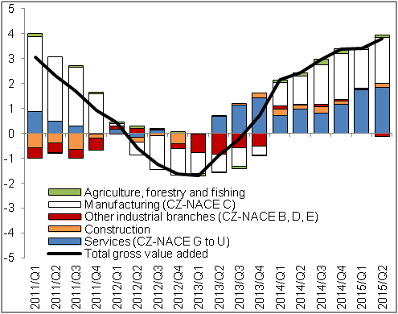
*contributions to GDP change not excluding the imports for final use |  |  |  |  |  |  | Source: CZSO

The data regarding the GDP and its components expressed in real terms and adjusted for seasonal and calendar effects, unless stated otherwise. The same applies for the gross value added.
Contributions to GDP change not excluding the imports for final use.
The data presented are in the so called domestic concept, which captures the outlays of residents and non-residents on the territory of the CR. Data are not adjusted for seasonal and calendar effects.
Breakdown of investment by type of capital. Data are not adjusted for seasonal and calendar effects.

