Monetary Conditions

 | Growth of the stock of money slower to nominal addition to GDP… |  |  | The prevailing historically low level of basis interest rates in the economy and the exchange rate mode affected by the CNB monetary intervention from November 2013 characterised the monetary conditions in H1 2014. The stock of money (according to the M2 aggregate) increased by 3.9 % year-on-year and arrived at 3 270.8 bn crowns at the end of June. Its growth was lower compared to the growth of the nominal GDP (+5.2 %) year-on-year, while the additions were practically the same in Q1 (+5.1 % against +5.2 % in case of nominal GDP).
 | … and the smallest since half of 201 |  |  | Growth of the money stock was thus the lowest addition in the Czech economy since the half of year 2011 (according to year-on-year data monitored always towards the end of each quarter). It was influenced especially by the counter movement of a significant fall of deposits, mainly the firm on one side and the growth of non-term deposits on the other side. A stronger dynamics of credit is missing.
 | Deposits, especially the business deposits are declining – companies likely use them to partially finance their investment, as evident from the gross fixed capital formation dynamics in H1 2014 |  |  | A substantial acceleration of the deposit withdrawals occurred during Q2 itself especially for businesses, which „sucked out“ from the deposits with a notice term nearly 22 bn crowns, i.e. -12.3 % (even though the reduction constituted only 15.4 bn crowns against the same period of the previous year, so the withdrawals on such scale is a relatively new thing in Q2). Given that the credit to companies on the contrary rose by 14.9 bn crowns in Q2 itself (+1.5 % by the end of June compared to levels from the end of march), it can be assumed, that the companies thus financed their with respect to past strong fixed investment mostly from own resources in Q2. These resources were relatively high, since both the cash of companies and their deposits on current accounts were accumulating with very low investment in two years of recession
 | Money in decline also on term deposits of households, but their significant increase on non-term deposits… |  |  | People were withdrawing money from their term deposits (-49.4 bn crowns year-on-year, -21.3 bn crowns quarter-on-quarter) and they had deposited 635.4 bn crowns on these accounts by the end of June. The decline thus accelerated in Q2. The positive development of gross disposable income of households, evident in Q1, has not been apparently yet reflected in their behaviour (+2.6 % year-on-year, when the balance of gross primary incomes increased even by 3.6 %), which could be explained by both the hesitation and uncertainty of households following the materialized recession or also the continuing inequality in the income distribution.
 | … is given apart from other influences likely the most by the interest rate policy of banks – which results together with the effect of withdrawal of deposits in lowering of household incomes from property already several quarters in a row, which consist for most part just of the interest income from deposits |  |  | However, it can especially represent the logical behaviour of households with respect to the interest rate conditions of deposits – the rates on term deposits are so low, that it is more advantageous for the savers to hold money on non-term deposit, which are in addition more liquid (even though the interest rates of non-term deposits of households in banks consisted for new deals of 0.39 % p.a. in Q2, it consisted e.g. for deposits with a notice period over three months even only 0.57 % p.a.). A strong growth of non-term (one-day) deposits of households, which increased by 109 bn year-on-year (+9.1 %) and by 45 bn crowns (+3.6 %) in Q2 itself, proves this assumption. Secondly, the fact, that households incomes from their property, which are dominated by interest income, further fell also in Q1 2014 year-on-year (-3-3 %) following the slump by 8,4 % in the last quarter of 2013, also points to this assumption.
 | Economy grows without the credit expansion – growth of domestic credit affected especially by net credit of government sector |  |  | The increase of credit dynamics, which would correspond to the relatively favourable rate of after-recession recovery – the Czech economy grew faster than the EU economy in H1- , has not eventuated so far. Domestic credit rose by 4.1 % year-o-year. It is the most in the last two years, however this growth can be attributed for the most part to the increase of net credit to the government sector (+6.3 %). The credit to companies as well as households increased less year-on-year, specifically by 3.9 % and 3.6 % respectively (it is even the lowest addition observed in individual quarters in case of households historically year-on-year).
 | Mortgages from banks to population start to rise mildly faster, bank consumer loans also revive somewhat for third quarter in a row… |  |  | Even though the people in the aggregate borrow from banks with a decreasing intensity, with respect to the rates of growth of bank credit provided – the consumer loans from non-bank institutions however gain pace already second quarter in a row -, mortgages to population deepen their pace (+5.7 % year-on-year in Q2), which even increases since autumn 2013. The bank credit to population, whose balances were falling every quarter commencing September 2011 year-o-year, show additions since the last quarter of the past year year-on-year, even though only very modest (+0.3 % in Q2 2014).
 | …together with short-term consumer credit from installment sale companies; loans in the form of financial leasing also start to grow following their slumps |  |  | The non-bank entities also lend to households on consumption, but only short-term (+4.8 % in Q2), while the levels of these loans rise also a third quarter in a row. The levels of loans to households with longer maturity from these intermediaries nevertheless keep falling (the risk is obviously still perceived). It is not valid for the leasing financing (loans in the form of financial leasing also grow already a third quarter in a row).
 | Weak crown influenced the size of net foreign assets |  |  | A strong growth of net foreign assets expressed in crowns, especially the net foreign assets of CNB (+37.2 % year-on-year) relates to the weakening of the Czech crown exchange rate from November 2013.
Chart 19 |  | Household deposits (y/y, in %) |  |  | Chart 20 | Loans to businesses, loans to houholds, Domestic credits in total (y/y, v %)
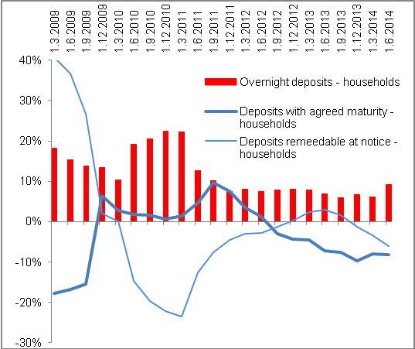 |  |  |  |  | 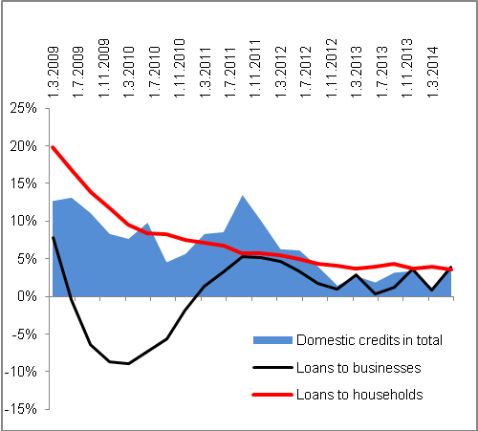
Source: CNB, own calculations

Incl NISH.

