Labour Market

Labour market lost dynamics – addition to aggregate employment only one quarter in half-year 2014 compared to year-on-year addition in half-year 2013…, |  | Aggregate employment increased in the CR economy – in the national accounts conception and using seasonally adjusted data – considerably less in half year of 2014 year-on-year than in the same period of 2013. It can be assumed, that the effect of rising numbers of part-time and temporary jobs, which was typical for the recession years and which put up the aggregate numbers of the employed persons, is possibly waning.  The number of employed persons increased by 30.281 thousand in the CR economy year-on-year during the half-year of 2014 (i.e. +0.1 %), while by 117.898 thousand persons (+1.3 %) in the same period of 2013. The addition to employment eventuated for the most part in Q1 2014 (+26.641 thousand person, i.e. +0.5 %).
… still the aggregate employment in the CR is the highest since the pre-crisis period of 2009 |  | Despite the moderation of increments the Czech economy however employs the most persons since the pre-crisis period more than five years ago – there were 5 145.5 thousand persons employed in total in the CR by the end of Q2 2014. The statistics recorded more last in Q1 2009 (5 179.5 thousand persons).
The labour market acquired only 3.6 thousand persons in the CR in Q2 2014, while it was 26.6 thousand persons year-on-year in the same period of 2013 |  | The loss of dynamics became apparent only in Q2 2014, when the aggregate employment did rise year-on-year, however it was the lowest addition since Q1 2012 – the number of employed increased only negligibly by 3639 persons compared to the same period of 2013. This contrasts sharply with the high year-on-year additions (by 27 thousand up to 66 thousand) of employed persons, which the Czech economy registered since the half of 2013 till this year's first quarter.
Part-time and temporary jobs start to dwindle |  | It can be concluded, that the weaker growth on the labour market was also affected by the fact, that the numbers of persons working part-time did not grow any more. On the contrary, the proportion of part-time jobs fell for the first time after the rising tendency since the beginning of year 2012 according to the Labour Force Sample Survey (LFSS), specifically to 6.4 % out of total number of employed persons in comparison to 6.6 % from the last quarter of 2013. The share of temporary jobs also decreased, the decrease was first observed already in Q4 2013 (10 % out of total number of employees compared to 10.2 % in the preceding quarter) and it continued further also in the first three months of 2014 (9.1 %).  The lowering of number of part-time jobs arose more for the female employment (share of 10.3 % compared to 10.5 % in the last quarter of 2013) than for the employed males (the share stagnated to 3.3 % out of total number of employed persons).
Very high growth of number of employed persons likely influenced by jobs in the form of „svarcsystem“ and immigration of foreign workers in construction year-on-year |  | Employed persons did increase in six out of ten economic activities and their divisions monitored by the national accounts year-on-year, however only in four quarter-on-quarter.  The large increase of employed persons is a surprise in the positive sense of the word in construction quarter-on-quarter (+6 thousand persons seasonally adjusted, i.e. +1.4 % after drops by 1.3 % and 0.5 % in the two preceding quarters). It occurred practically for the first time since the last three months of year 2009. The change of employed persons was positive, even if only negligibly, in this sector year-on-year (+0.3 thousand persons). It is however obvious, that the progressing recovery of construction is to a large extent saturated with respect to employment in this activity in construction in the CR by the growing numbers of other types of jobs than employee contracts – the number of employees actually significantly fell especially year-on-year (-15.7 thousand persons). The repeated increase of the number of workers from abroad likely also plays a role – as shown by the data regarding the immigration into the CR for this year's first half year -, which have larger proportion in construction than in other economic activity in the Czech economy.
Growing numbers of self-employed… |  | It seems, that the trend apparent in construction can be generalised to the whole economy – the firms do not execute much the hiring to „root numbers“. The numbers of employees themselves actually notably decreased year-on-year, by 15.8 thousand persons, while the numbers of employed persons mildly grew (by mentioned 3.6 thousand persons). It means that the rising numbers of self-employed influenced the aggregate employment in the CR economy. According to the LFSS, the numbers of entrepreneurs without employees increased by 5.7 % year-on-year, those with employees increased by 1.4 % year-on-year.
…in contrast to the fall of employees in the economy as a whole |  | With respect to the situation in economic activities, the numbers of persons with the employee status declined more (except for the above mentioned construction) only in the activity cluster of Trade, transport, accommodation, food service activities (-10.9 thousand persons) year-on-year, where the reduction can be anticipated mostly in the trade – the traders look possibly also this way due to the risk of falling margins, how to reduce costs. The division of Other activities also recorded less employees (-1.6 thousand persons), information technologies and telecommunications then a stagnation (-0.1 thousand persons). The industry in total, especially the manufacturing, was hiring employees. Numbers (+2.5 thousand and +6.5 thousand persons resp.) however indicate that the job positions were on the contrary disappearing in the non-manufacturing economic activities.
Jobless persons considerably relatively reduced, labour market reacts to the economic recovery |  | The unemployment rate again fell according to the LFSS seasonally adjusted in Q2 2014 (to 6.3 % of population aged 15-64 years) to a large extent compared to Q1 (the unemployment rate only stagnated in the amount of 7 % then compared to the last three months of 2013 with 6.9 %). The number of employed was lower by 19.1 thousand persons in Q2, by 39.4 thousand persons then year-on-year, which suggests that the reduction of number of persons without job is accelerating. There were by 21.2 thousand persons unemployed longer than one year less year-on-year, which was roughly the same compared to the reduction in Q1 year-on-year. However, the proportion of long-term unemployed rose due to the decrease of the aggregate unemployment (to 43.2 % against 41.1 % from Q1 2014).  Male unemployment rate was falling gradually from 5.6 % in January to 5.1 % in July 2014 during the half-year, the female rate fluctuated more from 8.2 % in January to 7.5 % in July.
Positive development of average gross nominal wage and also the real wage thanks to low inflation of consumer prices |  | Average nominal monthly wage (per recalculated numbers of employees) increased to 25 550 crowns by the end of Q2 and its addition thus arrived at 2.3 % year-on-year (+2.8 % for the half year 2014 year-on-year). The middle value of wages was by more than four thousand crowns lower against the average wage in Q2 (21 385 crowns). Since the movement of consumer prices has been only very weak, the real wage rose by 2.1 % in the CR economy year-on-year.  The average wage rose by 2.5 % in nominal terms in the business sector, in that the most in trade (+3.9 %), mining and quarrying and also in financial and insurance activities (similarly by 2.8 %). The wage rose by 2.3 % in real terms in the business sector. The nominal growth presented 1.7 % in nominal terms and +1.5 % in real terms in the non-business sector.  Employees in the financial and insurance activities received a distinctly higher pay rise (+6.6 %) against the average growth of nominal wage in the business sector (+ 3 %) and non-business sector (+1.9 %) year-on-year.

Chart 15 | Total employment and numbers of employees (y/y in %, seasonally adjusted) | Chart 16 | Nominal and real wage (y/y in %, recalculated numbers, monthly average)
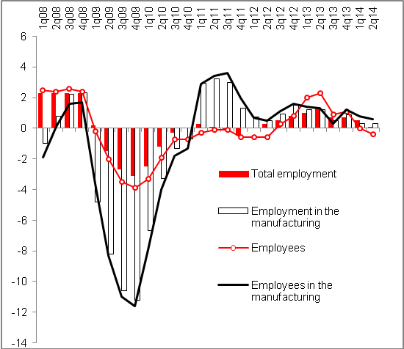 |  | 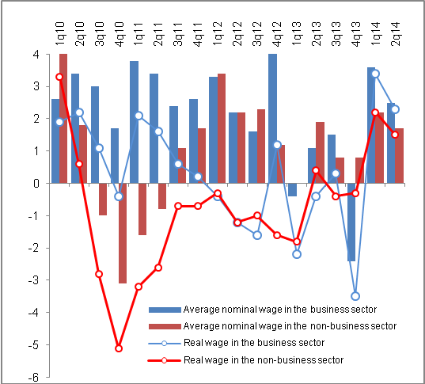

Source: CZSO

