Prices

Aggregate price level in the economy was by 2.5 % higher in year-on-year comparison in Q2 2014. It grew the most in last five years. |  | Aggregate price level in the economy (based on the GDP implicit deflator, seasonally adjusted) increased by 2.5 % year-on-year in Q2, more than in Q1 (+2.2 %). It rose the most in the last five years (by +2.6 % in Q2 2009). Overall growth of prices in the economy was impacted by a favourable development of prices in the foreign trade. Terms of trade improved by 2.1 %, they were higher last at the end of 2009. Prices of goods and services entering the household consumption continued to grow very little (+0.2 %), prices of products acquired by government institutions were raised by one percentage year-on-year. Prices of investment goods increased by 1.1 % year-on-year.
Consumer prices rise remained very low year-on-year |  | The growth of consumer prices remained very weak year-on-year. While the prices rose by 1.1 % in the last quarter of 2013, they grew only by 0.2 % - following a jump lowering of energy prices at the beginning of the year- in both Q1 and Q2 2014. The growth of consumer prices remained at a very low level in spite of higher prices of the imported goods (which also partially have an effect directly on the prices for consumers, especially then on the prices of inputs in the manufacturing companies) and growing pressures on the side of domestic demand, to which the data regarding the consumption and investment pointed at in the first half of the year.
Zero growth of consumer prices lay in the short-term fluctuation of the prices of seasonal goods in 2014 year-on-year |  | The inflation rate, expressed by the addition to the consumer price index to the same month of the previous year, moved only negligibly above the zero value during the first half of 2014, it even directly „attacked“ this psychological boundary in June. However, it occurred only due to a short-term fluctuation in the prices of seasonal goods, the prices for consumers returned back to a mild growth in July.
Prices, according the HICP year-on-year changes, grew less than in the European Union as a whole in the CR in the first half of 2014 |  | Consumer prices grew less than in the EU 28 as a whole in the CR in the first half of 2014. It follows from the harmonised index of consumer prices (HICP). While the prices grew in the aggregate by 0.8 % and 0.7 % in the Union in quarters year-on-year, they grew only by 0.3 % and 0.2 % in the CR. Larger increase of prices was observed compared to the CR in seventeen member countries of the EU in the first three months of 2014, already in twenty in Q2. Still the raised prices remained, in contrast to an array of other countries, in positive values in the CR. Greece faced deflation for a fifth quarter in a row, Bulgaria for a fourth, Cyprus third. The decrease of prices lasted two quarters in Portugal and Slovakia year-on-year. The price reductions also commenced in Hungary in Q2 2014.
Those households, expending a higher proportion of their outlays on energies, especially benefited from the lower domestic energy prices in Q1 and Q2 2014. Households of seniors also belong here. |  | Especially the households of seniors benefited from the lower energy prices (electricity, gas) in the first half of 2014 (they expend on these costs larger proportion of their outlays compared to the average households or households living in Prague). While the expenditures for energies share 15.9 % in the total expenditures of households of seniors (based on the consumer basket of 2012), they share 10.3 % for an average household and only 8.4 % for households living in Prague. While the households in Prague paid for all goods and services by 0.8 % more on a year ago in both first quarters of 2014, the average households then by 0.2 %. The price of total expenditures was on the contrary reduced for households of seniors. They paid for the purchased goods and services by 0.1 % less in comparison to the same period of the preceding year, by 0.4 % less in Q2 2014.
Prices of food and non-alcoholic beverages were raised up only by 1.5 % in Q2 2014 year-on-year, the least in the last four years |  | Consumers paid more for food and non-alcoholic beverages only by 1.5 % in Q2 compared to the same period of the previous year, the least since Q2 2014 (-0.1 %). It was certainly positive news for households, hit by a long-term noticeable rise of food prices. They saved for purchases in individual segments for non-alcoholic beverages (-1.7 %) and fruit (-1.2 %). Vegetables were cheaper (-10 %) due to a marked fall of prices of new potatoes. The households paid a little extra for bakery products and cereals (0.6 %), prices of meat rose by 3.3 %. The prices of milk, cheese and eggs went up the most. These products were more expensive in the aggregate, as a result of raised prices of milk and dairy products across the whole production chain, by more than one tenth.
Growth of prices intensifies in the manufacturing industry year-on-year |  | Deflationary development continued in the segment of industrial producers, caused especially by the cheaper supplies of energies. Prices of industrial producers fell by 0.7 % in Q1 year-on-year, by 0.2 % in Q2. Only the manufacturing industry was instrumental in the milder slump of prices – given the persisting and basically non-changing deflation in the energy industry and the deepening fall of prices in mining and quarrying. The prices only stagnated in the manufacturing industry in the last three quarters of 2013, they started to gain pace in the first half of 2014 (by +1.1 % in Q1 year-on-year, by +1.8 % in Q2). The acceleration of the rate of growth can be possibly attributed in part to the weaker crown, which raised the prices of imported inputs (being subsequently also reflected in the prices of final products), in part to the boosting demand.
Only the producers of basic pharmaceutical products and electrical appliances lowered prices out of the thirteen main segments of the manufacturing industry in Q2 2014 year-on-year |  | The firms processing wood, further then the manufacturing of paper and printing (+4.1 %), put the prices up the most with respect to the structure of the manufacturing industry in Q2. The producers of coke and refined petroleum products significantly increased their prices (+3.9 %) after five quarters of deflation. The manufacturing of motor vehicles kept the dynamics of prices from the previous quarter (by +4.0 % in Q1, by +3.8 % in Q2), where mostly the parts and accessories of motor vehicles became more expensive. Only two groups lowered the prices out of the thirteen main segments of the manufacturing industry (based on Classification of Products CZ-CPA), which was the best result since Q1 2012. Specifically, they were the manufacturers of basic pharmaceutical products (-2.1 %) and manufacturers of electrical equipment (-0.7 %).
Prices of agricultural producers fell less compared to the previous three months in Q2 2014 year-on-year. The fall of prices of vegetable production slowed down, the growth of prices of the animal production strengthened |  | Prices were falling in agriculture already a third quarter in a row, however the deflation moderated. While the prices of agricultural producers were lower by 4.2 % in the last quarter of 2013 year-on-year and by 4.4 % in the first three months of 2014, it was already only by 2.1 % in Q2. The fall of prices of vegetable production slackened, the growth of prices of animal production somewhat increased. Grain was cheaper by 16.5 % in Q2 year-on-year (less was paid for all types of grain), the agriculturers charged less by 4.9 % for the industrial crops. The buyers paid more for vegetables, fruit than year ago, the potatoes were also more expensive.
Prices of construction works increased by 0.5 % in Q2 2014 year-on-year, prices of market services by 0.3 %. The prices of construction works have not been raised the whole seventeen preceding quarters, … |  | Prices of construction works slowly climbed up, based on their trend index, since the half of 2013. The winter with both above average temperatures and precipitations also assisted in their growth, when it enabled to companies finish their jobs also in the winter months alternatively start new jobs earlier than in the spring. The trend of growing prices of construction works was already reflected in the year-on-year growth in Q2, which has not manifested the whole preceding seventeen quarters. The prices of construction works were higher by 0.5 % in comparison to the same period of the previous year. Still the truth remained, that the prices of cost of construction production grow faster than the prices of construction works. The pressure on the margin of construction firms thus mitigated, however it has not been stopped yet.
…eight quarters in the segment of market services |  | The fall of prices of market services year-on-year crossed over to a mild growth in Q2 (+0.3 %). The providers of market services raised their prices for the first time after eight quarters of decreases. The significant land transport and transport via pipelines, whose prices accelerated to 1.7 % in Q2 from 0.6 % in Q1, apparently benefited from the growing performance of the domestic manufacturing industry. The same was also valid for the less significant water transport (whose prices stalled in the first three months of the year, however they already grew by 5.2 % in Q2) and warehousing and support activities for transportation (-4.6 % in Q1, +1.7 % in Q2). The weaker deflation in the segment of telecommunication services also contributed to the growth of market services as a whole. While the prices of telecommunication services were lower by one fifth in Q1 year-on-year, it was already only by 8 % in Q2. The impact of substantial reduction of prices of tariffs, occurring in the first half of 2013, started to gradually wane from the year-on-year changes.
Growth of prices of imported goods weakened in Q2 2014 year-on-year, … |  | Imported goods were more expensive due to a weaker crown in both quarters of 2014 year-on-year (similarly to the end of 2013). Prices of imports were higher by 2.4 % in Q1, by 1.3 % in Q2. It would represent an import of deflation, if it was not for the weaker crown, similarly to the majority of year 2013. The imported deflation would affect the majority of goods, except for among the more significant groups only the food and live animals. It arises from the exchange rate adjusted development of prices in the foreign trade.
… the same was also valid for prices of goods heading from the domestic economy abroad, … |  | The domestic goods directed abroad were more expensive in a year-on-year comparison, nevertheless the rate of growth weakened similarly to the import side. While the export firms were selling for more by 4.1 % in Q1, the export prices were by 3.4 % higher in Q2. All groups of products participated in the slump of the rate of growth apart from other materials and chemicals, whose prices grew more in the second quarter of 2014 than in Q1, and animal and vegetable oils, which reduced prices less compared to Q1.
… still the terms of trade strengthened more compared to the previous three months |  | Terms of trade stayed positive in the foreign trade with goods (they improved by 1.7 % in Q1 year-on-year, by 2.1 % in Q2). Despite the dynamics of growth of both export and import prices weakening between Q1 and Q2, the terms of trade strengthened. The Czech economy benefited from the positive development of prices in the foreign trade already sixth quarter in a row.

Chart 11 | Growth of consumer prices for individual types of households (y/y in %) | Chart 12 | Growth of prices in selected CPI divisions (y/y in %)
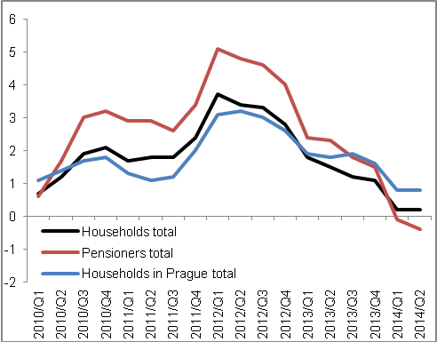 |  | 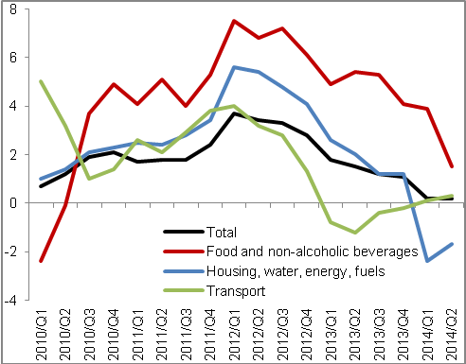

Chart 13 | Deflators (adjusted for seasonal and calendar effects, y/y in %) | Chart 14 | Producer prices (y/y in %, agriculture on right axis, other on left axis)
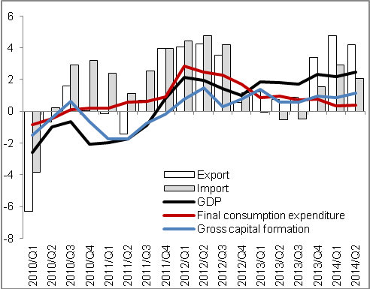 |  | 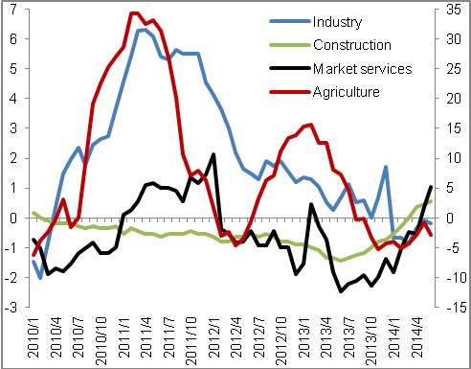
Source: CZSO

