External Economic Relations

External economic relations of the Czech republic do not display any troubles with an economic stability in H1 2014 |  |  |  |  |  | External balance of the CR economy was very good according to the results of the flow of money captured in the balance of payments for H1 2014. All three items of the balance of payments recorded surplus and the positive balance of the current and capital account in total (59.6 bn crowns) was even historically the best half-year result. The current account surplus arrived in relation to the nominal GDP at 1.9 %.  Favourable result on the current account eventuated even despite the income balance deficit – which is the most affected by the outflow of dividends from profits of owners of foreign companies in the CR – , being the second deepest in the time series since 1993. It was because the output balance was very strong. Current account surplus was also assisted by the notable improvement of the current transfers balance (by nearly 20 bn crowns due to the effect of revenues from the EU budget year-on-year).
Again return to current account of balance of payments in surplus, compared to past weaker surplus on the financial account caused by net outflow of portfolio investment |  |  |  |  |  | Financial account surplus was relatively weaker against the comparable periods of years 2013 and 2012, it was caused by a lowered inflow of investment from abroad only to a lesser extent. The outflow of funds in the form of portfolio investment played a major role (in net purchases of both foreign shares and bonds realized by domestic entities). The result of activities of foreign portfolio investment was also the outflow of funds from the CR in contrast to their inflows, which have eventuated since last months of year 2011 (the development is most likely connected to the lower issues of Czech government bonds).
Trade balance with a record half-yearly result… |  |  |  |  |  | Current account of the balance of payments finished in better result for the half-year 2014 compared to the same period of 2013. It was from a mild deficit (-3.9 bn crowns) at that time in a surplus in the amount of 38.2 bn crowns by the end of July 2014. It was especially the result of trade with goods and services balance surplus, i.e. trade balance, whose surplus rose by more than one fifth (+20.9 %) year-on-year to 173 bn crowns. Thus, it had the main share on the recorded favourable external imbalance of the CR economy in H1.
… given the markedly improved performance in trade with goods and services with both imports and exports growth by one fifth year-on-year (much less however quarter-on-quarter) |  |  |  |  |  | The growth of both exports and imports of goods was the strongest by one fifth according to half-year data from the balance of payments year-on-year – however only by +0.8 % and +1.1 % (!) quarters-on-quarter-, since the crisis period of 2009. It also contrasts with the falls of exports and imports in the same period of 2013 year-on-year (-1.7 % and -1.6 % resp.), when the weakened European demand and an absence of domestic revival had a negative effect.
…and a mild growth of services balance surplus |  |  |  |  |  | The balance of tourism as well as transportation improved (revenues +6.7 % and +10.6 % resp. To 70.6 bn and 24.8 bn resp., expenditures +16.2 % and +10.3 % resp. to 48.8 bn and 46.6 bn crowns resp.). The mild deficit of the CR trade in other services improved towards the balancing out of revenues and expenditures in trade with these services from the half-year of 2013 (107 bn and 106.2 bn crowns resp.). The resulting surplus of the services balance then slightly strengthened to 30.3 bn crowns (+7.1 %) for the first half of 2014 year-on-year, which was roughly the average of the previous three years (31 bn crowns). The half-yearly surplus of the services balance however has not reached the values from years 2008-2010.
Dividend outflow apparently very strong in Q2 – half yearly income balance deficit the second deepest since 1993; „wage“ balance with abroad improved according to data for Q1 2014 |  |  |  |  |  | The income balance was however in favourably influenced by the continuing outflow of foreign investors’ profits from their direct investments in the CR. Its deficit arrived at 153 bn crowns, which was the second deepest deficit of the income balance since year 1993. It was not apparent in the Q1 itself – more detailed data are not yet available for Q2 -, on the contrary the dividend outflow was the smallest since 2010 in this quarter. However, the decisions regarding the profits repatriation are made only after the economic results for the previous year are known on the shareholders meeting usually in Q2. It was then, when most likely the significant dividend outflow occurred, which must have also affected the recorded half-yearly result.  It can be observed from the first three months of 2014 given the absence of results for Q2 that the balance significantly improved between revenues from work of nationals abroad and the cost of foreigners labour in the CR (positive balance of +2.7 bn crowns, which did not reach even one bn in the previous two years). Such high surplus was recorded despite the fact, that due to the intensifying immigration into the CR (probably mostly for work) motivated by the revival of the Czech economy, also caused the increase of the cost of labour of foreigners (by nearly 1.6 bn crowns).
Direct investment from abroad declined |  |  |  |  |  | A lower inflow of foreign direct investment into the CR was a negative phenomenon in H1 2014 (by 21.5 bn to 56.2 bn crowns year-on-year), especially for inputs to equity of companies as well as the reinvested profits (drop of 73.5 bn to mere 14.3 bn crowns). Their flows were even larger in both of the preceding recession years for the comparable period, which however could be connected to the price of assets in times of recession (another root can lie in the „re-orienting“ of direct investors to developed European countries with signals of their economies revival, which could be seen in the first months of 2014).  Weaker direct foreign investment into the CR contributed to an essential reduction of the financial account of the balance of payments surplus (7.3 bn against 29.1 bn crowns in the same period of 2013).
Foreign portfolio investors reduced their positions once because of the bond repayments on the part of Czech government together with their lower issues… |  |  |  |  |  | Apparent lower attractiveness of the Czech Republic to foreign investors is not displayed only for direct investment, but especially the portfolio investment. While the inflow of funds in net bond purchases and property securities into the CR exceeded their outflow by 66.4 bn crowns in the half year of 2013, it was exactly the opposite in the same period of 2014 (-65.4 bn crowns).  Such situation occurred in the CR last in year of the monetary crisis (1997), while the outflow of funds in the form of debts was apparent also in years 1996 and 1998 at that time. Current situation can be explained by the fact that a reduction occurred in the issuance of bonds on a large scale by the government sector especially in this year's Q2 in contrast to the preceding six years. Foreign portfolio investors thus not only have less opportunity for purchases, but they also „return“ the already held bonds with ending maturity back to the CR to the debt issuers.
… domestic portfolio investors found very attractive especially the foreign share markets |  |  |  |  |  | Domestic portfolio investors on the contrary buy in net on a grand scale, which enlarges their foreign assets. Their net purchases of foreign shares (26.2 bn crowns) played a role in the outflow of funds from the country in the half-year 2014 (38 bn) and were most likely motivated by strong growths of stock exchange indices. Domestic investors possibly deduced especially in Q2, that this growth – considered by some experts for a „bubble“-, will still continue further.
Balance of item Other investment did not significantly affect the financial account surplus |  |  |  |  |  | With respect to the item of other investment on the financial account of the balance of payments, whose balance has highly influenced the result of this account in the last quarters, the massive transfers of funds within the scales of many tens of billions from the commercial banks in the CR and subsequently back, which caused it, were not so apparent any more – there „arrived“ in net 66 bn crowns for the item of short-term liabilities of commercial banks into the CR in the half-year 2014, net outflow in the amount of 65 bn crowns was recorded in Q1.
 | The rate of growth of exports of four largest items faster for half-year year-on-year than the total exports due to strong dynamics of motor vehicle exports |  |  |  | The total of four main groups of product classifications: motor vehicles (358 bn, exports rise +26.6 % year-on-year), computers and electronic appliances (142 bn, +153.4 %), electrical equipment (129 bn, +13.6 %) and other machinery products (172 bn crowns, +10.1 %) again constituted more than one half of the total exports from the CR – based on the CZSO data related to the foreign trade in the national conception, in current prices in Q1 2014. The growth of their half yearly exports was in total higher compared to the rate of total exports from the CR year-on-year. At the same time, with the exception of exports of computers and electronics, the exports of other three „strong“ items were considerably slower in Q2 (for machinery goods with one-digit dynamics) compared to the pace of Q1. It is also valid for the aggregate exports from the CR.
 | Weakened dynamics of exports across territories in Q2, rate of growth of imports also slowing down |  |  |  | Deceleration of the rate of growth of exports of goods from the Czech Republic indicates a slightly dampened foreign demand in Q2 2014, which has not however manifested only via German economy. Exports from the CR slowed down across territories in Q2 (for exports into countries outside the EU from 7.8 % in Q1 to 4.5 %, to the euro area from 17.8 % to 13.6 %, to Germany from 21.5 % to 16.3 %, to Slovakia from 7% to 5.4 %, to Poland from 12.7 % to 9.3 % and into the United States from 25.4 % to 19.2 %).  The exports increased the most into the United Kingdom for the whole half year of 2014 year-on-year, given their strong economic revival, the exports into the Russian Federation on the contrary dropped due to the development connected with the so called Ukraine-Russia crisis of the political nature.
 | Effect of the depreciated crown exchange rate |  |  |  | Weakening of rates of growth was also apparent for the total imports in Q2 the year-on-year. The loss of their dynamics given the weakened export pace is logical, with the view of strong export import interconnectedness of the Czech economy. The exchange rate also affected the values of both imports and imports via the prices in the foreign trade in the year-on-year comparison, when the CNB monetary intervention artificially depreciated the crown in November 2013.
 | Significant growths also of smaller items in value, fall of energy commodities export |  |  |  | Exports of pharmaceutical products increased out of the “non-machinery” commodities nearly by one half (+49.2 %) in the first half of 2014 year-on-year and the exports of furniture (+22.8 %) or tobacco products (+22.2 %) also rose significantly. The exports of coal and electricity fell (similarly by 15.4 %), affected by the development of prices on the world commodity markets.
Chart 9 |  | Financial account balance and portfolio investment, inflow of direct investment into the CR (in bn crowns) |  |  |  |  | Chart 10 | Export change from the CR year-on-year (selected countries and groupings, half yearly data, change in %)
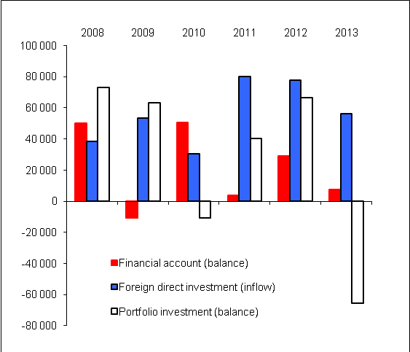 |  |  |  |  |  |  | 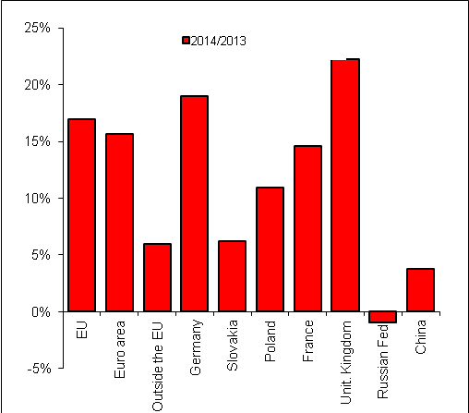  Source: CZSO

