Overall Economic Performance

Gross domestic product growth halted in quarter-on-quarter comparison in Q2 2014, it was by 2.7% higher in year-on-year comparison... |  | Renewed growth of the gross domestic product (GDP) initiated in Q2 2013 and accelerating towards the end of the year, halted in the quarter-on-quarter comparison in Q2 2014. The performance of the domestic economy, as a result of the prevailing effect of the low comparative basis, kept a markedly higher growth compared to the same period of the previous year (+2.9 % in Q1, +2.7 % in Q2, +2.8 % in the aggregate for the whole H1). It was just a year ago – that is in Q2 2013 – when the domestic economy stepped out of its so far longest recession.
… due to the contribution of all significant demand components apart from the foreign trade result |  | All significant demand components with the exception of the foreign trade result contributed to the growth of gross domestic product by 2.7 % in year-on-year comparison in Q2 2014. Gross capital formation as a whole contributed to the growth of GDP already second quarter in a row, specifically by 2.3 p.p. The contribution influenced mostly the fixed capital investment, strengthening already third quarter in a row, newly however the change of the inventory stock (inventory stock was falling milder than in the same period of the previous year) also contributed to the growth of the Czech economy performance opposed to the preceding quarter. Household final consumption expenditure, the main demand component, kept expanding. The same was valid for the final consumption expenditure of government institutions. Household consumption (+1.0 p.p.) contributed to the growth for the fourth quarter in a row, consumption of government institutions (+0.5 p.p.) even sixth quarters in a row. Export and import balance worsened and slowed down the Czech economy in its growth (-1.1 p.p.) in Q2 2014. If import in the year-on-year comparison expanded (due to a strengthening domestic demand) to a similar extent as in the preceding quarter, the rate of growth on the part of export decreased. The reason was a decelerating economic development in the European Union.
Higher dynamics of GVA quarter-of-quarter compared to the GDP in first half of 2014 … |  | Gross value added (GVA), which reflects the economic development better than the gross domestic product itself, continued increasing in the quarter-on-quarter comparison in Q2 2014 (+0.5 %). Higher dynamics of GVA compared to GDP was apparent already in Q1 (HPH +1.4 %, HDP +0.8 %). The decreasing collection of tax on products (including VAT, consumption taxes) reflecting in the lower balance of taxes on products and subsidies on products, which is added to the GDP, was the cause. This was a marked difference compared to the second half of 2013, when the collection of taxes on products rose (even the balance of taxes on products and subsidies on products was improving) and the GDP grew faster than the GVA.
… due to extraordinary influences on the part of supply associated with an uneven taxes on products collection |  | Especially the in advance announced growth of the consumption tax on tobacco products, commencing in the CR at the beginning of 2014, was the reason behind a markedly different development of GVA and GDP. While the tobacco product sellers heightened their stocks in the last six months of 2013 (collected consumption tax was growing, which was increasing the GDP dynamics), they were selling them out in the first half of 2014 (collected consumption tax was decreasing and on the contrary lowering the GDP dynamics).
Economic recovery lost its power in the European Union. Germany decreasing in Q2 2014 quarter-on-quarter, France stagnating, … |  | Economic recovery lost its power in the EU, especially then in countries using the euro – as apparent from the last available data. While the gross domestic product of the whole union of twenty-eight countries was by 0.4 % higher quarter-on-quarter in the last quarter of 2013, its growth slowed down to 0.3 % and 0.2 % resp. in the first two quarters of 2014. Germany, the largest EU economy, shifted from quarter-on-quarter growth of GDP in Q1 2014 (+0.7 %) into a decrease (-0.2 %). France, the second largest EU economy, stagnated the whole first half of 2014. The United Kingdom, the third largest member, was partially saving the situation, with the performance stably increasing by 0.8 % quarter-on-quarter in both quarters.
… the GDP dynamics weakened in Slovakia and Poland |  | The development also in other Union countries, especially in Slovakia and Poland, was essential for the Czech Republic, strongly pro-export oriented country. The expansion of these economies slowed down. In the aggregate, the not so positive results of GDP in the European Union for Q2 2014, but also the possible (mainly then the indirect) impacts of the restrictive measures put on the foreign flows of goods and services in Europe, at the least reduced the strength of the optimistic sentiments with respect to the future domestic development.
The households spent more than in Q2 2014 last by the end of 2011, … |  | The final consumption expenditure of households kept growing in Q2 2014, it strengthened in quarter-on-quarter comparison already for the fourth time (+0.2 %). It was higher by 1.9 % year-on-year, by 1.8 % in total for the whole first half-year. The growing household consumption was consistent with the still heightening consumer confidence in the economy, which nearly reached the level of first half-year of 2008 – as can be seen from the business cycle surveys – in June 2014.
 |  | The growing willingness of households to spend most likely lay in their overall increasing incomes, as signalled by the still improving situation on the labour market. The number of unemployed persons aged 15 and over (according to the LFS) dropped to 327.7 thousand persons and it was the smallest since Q1 2009 (i.e. in last five years and a quarter), at which time the impacts of crisis had not yet fully manifested on the domestic labour market. The number of employed persons was apart from the preceding quarter, favourably affected by a moderate winter, on the contrary the highest since Q1 2009. The average wage grew in real terms by 2.1 % year-on-year in Q2 2014, this growth was not influenced by the extraordinary effects connected with the paid out bonuses in contrast to the previous period any more. Employees in all economic activities earned higher wages compared to the year before.
… they „indulged themselves“ more in especially the durable goods year-on-year |  | Households mainly increased the purchases of durable goods in the first half of 2014. These were, as apparent from the data regarding consumption in the so called domestic conception not seasonally adjusted, higher by 6.6 % year-on-year. Buyers kept utilising the falling prices of these products. Households also spent more for the semi-durable goods (+1.6 %) and services (+2.4 %) than in the first half of 2013. They restrained only the purchases of non-durable goods (-0.3 %), including the significant by weight food.
Government institutions despite the fluctuations of their consumption keep stimulating the economic activity |  | Final consumption expenditure of the government institutions continues to fluctuate notably, as follows from the quarter-on-quarter changes. While its volume expanded by 1.6 % quarter-on-quarter in Q1, it weakened by 0.3 % in Q2. Its trend, however, strengthens already six quarters in a row. The sector of government institutions increased consumption by 2.3 % year-on-year (by 1.3 % in Q1). The final consumption expenditure of government institutions has been expansive already six quarters in a row, i.e. the government institutions stimulate the economy in its growth.
In Q2 2014 year-on-year, addition of investment into fixed capital was the highest since top of boom in 2008, … |  | Investment into the fixed capital (gross fixed capital formation) fell in Q2 2014, probably as a result of high comparable basis in the previous quarter, partially also due to rather unfavourable information newly arriving from abroad. They weakened by 1.5 % compared to Q1 2014. However, the domestic investment was higher by very impressive 6.9 % (by 6.4 % in Q1 2014) compared to the same period of the preceding year, which was the largest addition since the top of boom in 2008. They rose by 6.6 % in total for the whole first half of the year year-on-year.
… investment rose both into technical equipment (transport equipment, machinery and equipment) and base facilities (buildings and structures) |  | As can be seen from the object structure of gross fixed capital formation (non-seasonally adjusted), there was more investment both into the technical equipment, i.e. transportation equipment (+11.0 %) and machinery and equipment (+6.1 %) and the base facilities, i.e. the buildings and structures (+10.6 %) compared to the previous year in Q2 2014. Manufacturing companies shared probably the most in the markedly heightened investment activity, when they benefited from the stronger demand year-on-year. The demand for dwellings (-1.4 %), which is set especially by the households, kept further decreasing. Even the improved situation on the labour market, which apparently led to the increase of their income, has not altered this state – households were still very cautious regarding the investment into the real estate. There was invested into the dwellings only 29.8 bn crowns in nominal terms in Q2, which was by 8.0 bn crowns less compared to the same period of 2008.
Change of the inventory stock despite the continuing „destocking“, contributed to the economic growth in Q2 2014 |  | The value of stocked inventories mildly fell in Q2, as can be observed from the change in the inventory stock (by 0.6 bn crowns in nominal terms against the preceding quarter). Stocks were however falling less than in Q1 2014, when they decreased by 4.9 bn crowns, and with a much smaller intensity compared to the same period of the previous year, when they even slumped by 8.2 bn crowns. The change in the inventory stock contributed to the year-on-year growth of the performance of the CR economy in Q2 2014, due to a lower destocking against the previous year.
Difference between exports and imports increased year-on-year only thanks to positive effect of terms of trade in Q2 2014, the surplus worsened in real terms |  | The surplus of foreign trade with goods and services decreased in real terms year-on-year in Q2 as a result of a higher growth of imports (+11.3 %) compared to exports (+8.9 %) and it contributed to the gross domestic product development in a negative way. The difference between exports and imports however strengthened in the nominal expression, it reached 77.2 bn crowns and it was by 8.3 bn crowns higher on a year before. Its increase occurred due to a positive development of prices in the foreign trade, when the export prices were raised by 4.2 %, the import prices rose only by one half 2.1 %.
Growth of the Czech economy conducted by very good results of manufacturing industry year-on-year in Q2 2014, similarly to both previous quarters |  | Gross value added of the domestic economy increased by 3.3 % in Q2 2014 year-on-year, which was most than the GDP itself. It was the largest addition to performance on the supply side for the last three and a half years. It was especially thanks to the manufacturing industry. Its performance increased, as a result of marked growth of the foreign demand, partially also domestic, by 8.7 % year-on-year. It contributed to the growth of gross value added on the level of whole economy for the third quarter in a row, while its positive influence was gaining pace (while it contributed to the growth 1.1 p.p. in the last quarter of 2013, it was already 2.1 p.p. and 2.2 p.p. resp. in Q1 and Q2 2014). The contribution of the remaining part of industry – mining and quarrying, energy industry, water supply – was in total zero in Q2 2014. Services as a whole, with a proportion in the aggregate performance of the Czech economy roughly of three fifths, also shared in the growth, similarly to the manufacturing industry, nevertheless only by 1.0 p.p. and thus by much less force. While the cluster relatively less significant by volume of agriculture, forestry and fishing was stagnating, the construction whose performance increased already for the third time year-on-year, added the remaining 0.1 p.p.

Chart 1 |  | GDP (constant prices, adjusted for seasonal and calendar effects, in %) |  | Chart 2 |  | GDP (constant prices, adjusted for seasonal and calendar effects, y/y in %, r. a.) and confidence indicators (2005=100, l. a.)
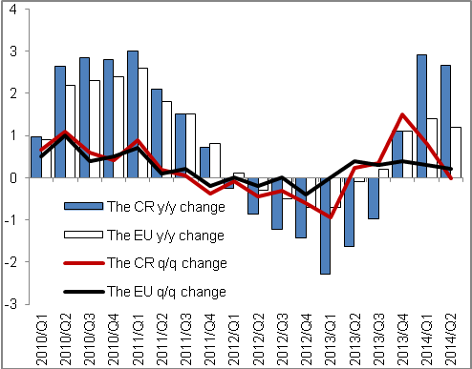 |  |  |  | 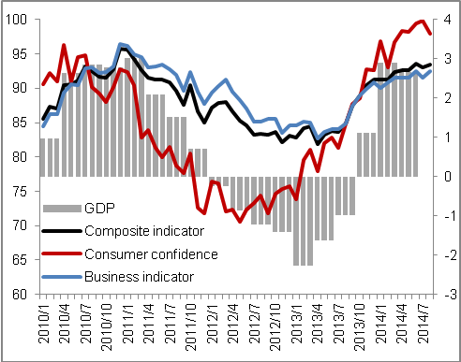
Chart 3 | Contributions of expenditure items to GDP change (constant prices, y/y, contributions in p.p., GDP in %) |  | Chart 4 |  | Contributions of economic activities to change in GVA (constant prices, y/y, contributions in p.p., GVA in %)
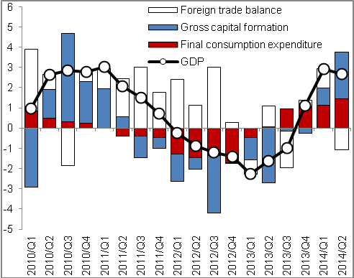 |  |  | 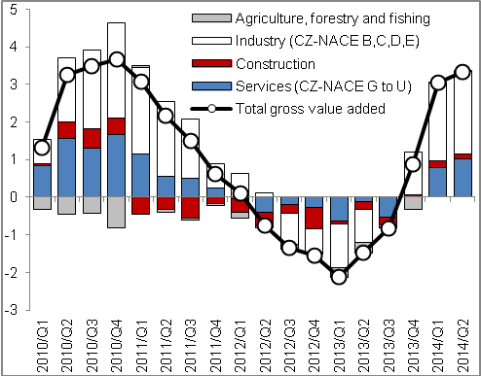
Source: CZSO

In real terms, adjusted for seasonal and calendar effects - unless stated otherwise.
The additions to growth of expenditure of GDP are used including the imports for final use in the subsequent text. If we exclude these imports, the percentage contributions of individual GDP components to its growth are different.
If we exclude the imports for final use, which modify the structure of individual contributions to growth, the effect of gross capital formation to GDP growth would be 1.6 p.p., the contributions of final consumption expenditure of households to economic growth zero, the contribution of the government sector 0.3 p.p. Contribution of the foreign trade in this version, i.e. excluding the imports for final use, would be positive in the amount of 0.8 p.p.
It is related to the purchases of goods and services realised on the CR territory regardless of the fact, whether residents or non-residents expend the funds.

