Labour Market
Employment and the real wage went up accompanied by falling unemployment rate in the economy |  |  |  | The economic growth recovery manifested in the growth of employment accompanied by declining unemployment rate year-on-year. Year-on-year growth was recorded both in the business and non-business sphere in 2014 following two years of real wage reduction in the national economy.
Total employment growth remained on the level of years 2012 resp. 2013 year-on-year, a declined occurred for employees |  |  |  | Total employment (seasonally adjusted data regarding the total employment in the national accounts conception, in physical persons) followed the development in years 2012, resp. 2013, when the dynamics of the year-on-year growth remained on the value of 0.4 %. In case of employees themselves, the growth fell from 0.6 % to 0.2 % in 2014. Total number of workers reached 5 104.9 thousand, in that 4 290.6 thousand persons as employees. It was the highest number of employed persons and employees since 2009 (5 110.1, resp. 4336.1 thousand persons).
Increased number of employed persons was ascertained especially in the professional, scientific, technical and administrative activities, effect of agency employees |  |  |  | Mainly the professional, scientific, technical and administrative activities (by 15 thousand persons), public administration, education, health and social work (by 7.9 thousand persons), manufacturing (by 6.9 thousand persons) and real estate activities (by 4.3 thousand persons) shared in the increased number of employed persons by 21.1 thousand compared to 2013. The largest reduction of employed was in the highest extent observed in financial and insurance activities (by 3.7 thousand persons), other service activities (by 3.2 thousand persons), trade, transportation, accommodation and food service (by 2.4 thousand persons) and agriculture, forestry and fishing (by 1.5 thousand persons) year-on-year.
Number of persons not working on employee contracts grew year-on-year after two years |  |  |  | The total number of employed grew faster than number of employees in 2014. Number of self-employed rose by 12.8 thousand persons in 2014, while the reduction arrived at 7.7 thousand persons in 2013 and 4 thousand persons in 2012. The development was mostly the result of the situation in construction (+10.4 thousand persons), where the construction firms with the wake up of activity very likely reached to „schwarzcsystem” instead of employment hiring. Further it concerns professional, scientific, technical and administrative activities (+7.3 thousand persons), real estate activities (+1.9 thousand persons) and information and communication (+1.8 thousand persons). Completely different development was found especially in the manufacturing (-4.4 thousand persons), where opposite tendencies compared to construction are most likely taking place.
The proportion of other than „standard“ job contracts fell year-on-year |  |  |  | The proportion of part-time jobs fell year-on-year in 2014, since the growth of employees was slower compared to the total number of hours worked year-on-year (0.2 % vs. 0.5 %). Financial and insurance activities and other service activities were the exceptions, with drop of total hours worked higher in comparison to drop of number of employees (by 1.9 p. p., resp. by 1.2 p. p.). The excess dynamics of employees over hours worked arrived at 0.3 p. p. in 2013. Opposite tendency manifested only in trade, transportation, accommodation and food service and other service activities, when the employees grew less than total hours worked by 0.4 p. p., resp. 0.5 p. p.
Labour productivity already rose year-on-year, opposite development in real estate activities and professional, scientific, technical and administrative activities |  |  |  | Labour productivity per hour (relation between gross value added in the economy and number of hours necessary to its creation) increased by 1.6 % year-on-year in 2014, while its mild reduction was recorded year-on-year in 2013 (-0.2 %). Labour productivity per hour increased mostly in financial and insurance activities (+17.1 %) and real estate activities (+6.3 %) in 2013. In 2014, year-on-year decline was ascertained in real estate activities (-4.0 %) and professional, scientific, technical activities (-1.5 %).
Labour productivity per one employee fell only in real estate activities year-on-year |  |  |  | The labour productivity per employee increased even by 2.2 % thanks to lower growth of employed persons compared to gross value added year-on-year in 2014. Decrease of labour productivity per employee was detected only in real estate activities (by 4.6 %). The fall of this indicator was gauged at 0.9 % in 2013. Opposing trend occurred in financial and insurance activities (+16.7 %, construction (+2.8 %), in real estate activities (+2.7 %) and other service activities (+0.8 %) in this year.
Number of job vacancies exceed the level from 2009 |  |  |  | In 2014, the number of job vacancies already did not follow the development from years 2010 to 2013, when their number oscillated in the interval from 33.1 to 39.0 thousand (at the end of the year). According to MLSA, 48.7 thousand job vacancies were available thanks to the economic revival and proactive employment policy by the end of 2014. At the end of 2014 there were already 58.7 thousand, while it was 13 months in a row continued annual growth in their number.
A parallel growth of number of employed and fall of unemployed persons was observed in the economy year-on-year |  |  |  | While the number of employed and unemployed persons (LFSS) aged 15 and more together fell in 2011 and increased concurrently year-on-year in years 2012 and 2013, the number of employed persons already grew (by 0.8 %) year-on-year in 2014 given the fall of number of unemployed (by 12.3 %) year-on-year. General unemployment rate of population aged 15-64 years arrived at 7.0 % in 2013 and the value was 6.2 % in 2014. The same indicator in the age category 15 years and more also amounted to 7.0 % in 2013 and even only 6.1 % in the following year.
General unemployment rate (15-64 years) gradually decreased till October 2014 |  |  |  | General unemployment rate based on monthly seasonally adjusted data for population aged 15-64 years reduced from January 6.7 % to 5.8 % in October, it was practically only stagnation in the rest of year 2014. This development concerned both males and females.
Rate of economic activity continued to grow, it was above the year's average in the second part of the year |  |  |  | Ceaseless growth of the indicator rate of economic activity in the age category of 15-64 years (LFSS) from year 2009 (70.1 %) up to 73.5 % in 2014 confirms the placement of economically inactive persons on the labour market. Its rate reached above the average for the whole year (roughly 74 %) in the second half of the year.
Real wage increased year-on-year following two years of fall, the growth of nominal wage was only slightly higher than the real wage |  |  |  | Real wage increased by 2.0 % in 2014, both in the whole national economy and in the business and non-business sphere. In nominal terms however, the average monthly wage (to recalculated number of employees) increased only slightly more than the real wage (by 2.4 %) thanks to low inflation rate (+0,4 %) in the CR. While the average nominal wage of employees of firms was somewhat higher compared to the wage in the non-business sphere in 2012, it was the opposite in years 2013 and 2014. The government decision regarding the increase of wage tariffs in the non-business sphere from November contributed to the differentiation of wages in 2014.
 | Chart 15 | Total employment and numbers of employees (y/y in %, seasonally adjusted) |  |  | Chart 16 | Nominal and real wage (y/y in %, on recalculated numbers)
 | 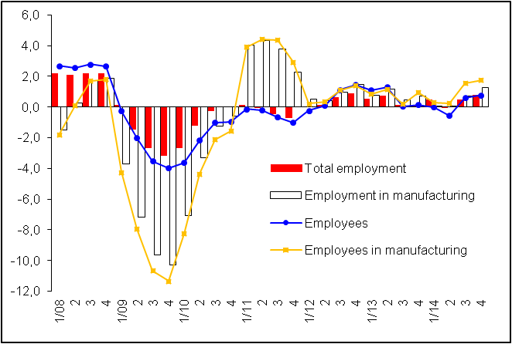 |  |  |  | 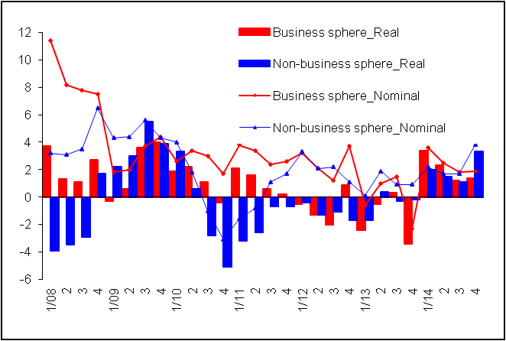
 |  |  |  |  |  | Source: CZSO

Schwarzsystem - misclassification of employees as independent contractors.

