Prices
The favourable development of prices in foreign trade with goods contributed the most to the growth of the total price level in the economy in 2014 (+2.3 %) |  | Total price level in the economy increased in 2014 – gauged by the implicit GDP deflator not seasonally adjusted – by 2.3 %, the most since the year of the deep recession of 2009 (+2.6 %). The positive price development in the foreign trade with goods contributed the most to the raised price level (terms of trade improved by 2.0 %). While the prices of household purchases were raised up by 0.3 % and prices for goods and services entering the government consumption by 1.7 %, investment (gross fixed capital formation) were being acquired for prices 1.6 % higher than a year ago. Adverse development of prices in foreign trade with services slowed down the growth of the price level (terms of trade -1.6 %).
The inflation rate reaching only 0.4 % in 2014 was the lowest for the last eleven years |  | The average rate of inflation dropped to mere 0.4 % in 2014. Not only that the growth of the consumer prices was markedly below the target of the Czech National Bank (CNB), which sets it on the level of 2 %, the prices grew the slowest since 2003 (+0.1 %). The weak growth of prices in 2014 was caused mostly by the long-term disinflation in the euro area, which leaked through the prices of imports into the CR, but also via a good harvest of the agricultural crop. The restrictive measures imposed on the foreign trade in Europe – which were reflected in the excess supply of some commodities on the market – also likely played a role in the low growth of consumer prices. Weaker koruna but also the further recovering domestic demand prevented a more notable reduction of the inflation rate in 2014.
The development of oil and natural gas prices on the world commodity market suggests, that the threat of deflation has not been averted yet |  | It could be assumed from the development of prices of oil and natural gas on the world market in the second half of 2014 and in the first months of 2015, the threat of deflation has not been most likely averted in the CR. If a barrel of oil Brent was traded for roughly 110 American dollars on the world commodities market still at the beginning of July, it was less than 50 at the beginning of 2015, and despite a mild price hike during January and February, the prices kept staying remarkably lower year-on-year. The prices of natural gas followed a similar path, being markedly lower in the first months of 2015. As the low prices of these energy commodities will be absorbed by the production chain, they will be most likely gradually reflected also in the prices for consumers.
The consumer prices grew faster in the euro area compared to the CR in H1 2014, however the relation turned around in the second half of the year |  | While the consumer prices grew faster in the euro area compared to the CR year-on-year in H1 2014, as the harmonised index of consumer prices suggests, the relation turned around in H2. In Q4 2014, when the consumer prices were raised by 0.5 % in the CR year-on-year, by mere 0.2 % in the euro area. Effort of the European Central Bank (ECB) to set in motion the credit market and subsequently also the prices via the record low interest rates, supplying liquidity to banks and purchases of secured bonds from banks, did not bring results. The ECB thus decided to launch a quantitative easing program in January 2015 (and it was launched in March).
While only five EU countries found themselves in deflation in Q1 2014 , it was already eight in the last quarter |  | The growth of consumer prices in the CR fell among the EU countries to the highest in the last quarter of 2014 year-on-year. The prices grew more only in Romania, Austria, Finland, Great Britain, Latvia and Malta. Nevertheless, the year-on-year growth addition did not exceed the 1.5 % boundary in any of these countries. On the opposite more and more countries slumped into deflation. While in Q1 2014 only five Union members recorded a year-on-year fall of the consumer prices, it was six in Q2, already seven in Q3 and even eight in the last quarter.
Prices of food were raised only by 2.3 % in the CR in 2014, the least since 2010, … |  | Growth of prices of food in CR significantly slowed down during 2014. If the prices of food were higher by 4.4 % still in Q1 year-on-year, by 1.9 % in Q2, by 1.7 % in Q3 and only by 1.4 % in the last quarter. For the whole year 2014 the prices of food were raised by 2.3 %, the least since 2010 (+1.7 %).
… a good harvest of the agricultural crop played an important role in the low growth of the prices of food |  | Good harvest of agricultural crop had a direct positive impact on the prices of fruit, which increased only by 0.5 % in 2014, and vegetables, which even fell by 3.7 %, but it was also indirectly reflected in the prices of the bakery products and grain (+0.4 %). Prices of meat in shops were raised by 2.5 % compared to the previous year, the consumers had to pay the most extra for milk, cheeses and eggs (+7.4 %).
Prices of industrial producers headed into deflation in 2014, however price dynamics increased in the manufacturing industry itself, … |  | Industrial producer prices, which strengthened by 0.8 % in 2013, headed into deflation in 2014. They fell by 0.8 %, even despite the fact, that the price dynamics rose from +0.2 % in 2013 to +1.0 % in 2014 in the significant manufacturing industry. What then stood behind the price fall in industry? The deflation in mining and quarrying – which struggled with the falling prices of coal already for a third year – deepened, in addition the prices of supplies of electricity and gas were hike reduced in January.
… it was for once thanks to the continuing economic recovery, for second to weaker koruna, which increased the cost of purchasing the inputs from abroad to companies |  | As apparent from the classification into subdivisions of CZ-CPA, all monitored groups of companies classified as „manufacturing“ raised their prices in 2014. Exceptions were the producers of coke and refined petroleum products (- 1.9 %), which experienced reduced cost for securing the oil supplies in Q4; manufacturers of food products, beverages and tobacco (-0.3 %), which could reduce prices thanks to a good harvest and low buying up prices of agricultural crop; and producers of basic pharmaceutical products (-1.6 %). Regarding the significant groups of firms (in terms of proportion of total performance of the manufacturing industry), manufacturers of transport equipment (+3.5 %) and manufacturers of basic metals and fabricated metal products (+2.4 %) raised their prices the most, companies manufacturing wood products, paper products and companies with printing activities (+ 3.6 %) and manufacturers of textile, clothes and leathers (+ 2.4 %) then among the less significant.
Prices of agricultural producers were reduced by 3.7 % in 2014, milk itself was however traded for prices by 13.1 % higher |  | Agricultural producer prices were reduced by 3.7 % in 2014. Good harvest – which resulted in high weight of crop harvested – pressed down the prices of all monitored types of cereals; vegetable and horticultural products, potatoes, fruit and industrial crops (i.e. rape plant and sunflower) were also sold cheaper year-on-year. The livestock (cattle, pigs, sheep as well as poultry) was bought up cheaper compared to 2013, prices of milk on the contrary increased by 13.1 %. These grew most likely especially as a result of expanding worldwide demand for milk products, already for a second year. The prices of milk were raised by 21.9 % in total for years 2013 and 2014.
Construction firms were likely not able to further shrink their margins and the prices of construction works were raised up by 0.5 % in 2014. They increased for the first time since 2009 |  | Prices in construction, which hit their bottom in half of 2013, also continued in a slow growth in 2014. It follows from the basis index of construction works. Prices increased by 0.5 % in construction in total for the year 2014, the price growth of construction works was observed for the first time since 2009. Firms were most likely not able to shrink their margins anymore and prices of construction works thus increased as the companies experienced rising cost of construction production. The fact, that companies – in the view of growth of value of construction orders and rise of the volume of construction production – already quite thrived in 2014, was not mirrored in the prices of construction works to a larger extent. Intensive competition prevented companies from larger price increases.
Larger demand of manufacturing industry for transportation and warehousing, but also for job agency services, assisted the repeated growth of prices of market services in 2014 |  | Prices of market services rose by 0.3 % in 2014, the growth occurred for the first time after two years. Prices of postal and courier services increased significantly (+ 4.9 %), financial services (apart from insurance and pension funding) became more expensive despite a high competition among financial institutions (+4.6 %), the prices of job agencies services, abundantly utilised by the manufacturing industry in this year, also rose markedly (+4.8 %). Higher performance of the manufacturing industry was also reflected in the larger demand for transportation and warehousing, and consequently also in the prices of these services. Prices of freight transport services by road increased by 2.5 %, freight water transport services even by 3.9 %. Prices of warehousing and support activities for transportation remained the same in total for 2014, however this was given by a markedly diversified development at the beginning and during the rest of the year – as prices of warehousing and support activities for transportation declined by 4.6 % year-on-year in Q1, they were by 1.7 % higher in each of the following quarters.
Import prices of goods declined for the first time after thirteen months year-on-year in December 2014 |  | Year-on-year price growth was imported together with goods thanks to the weaker koruna from abroad throughout the whole year 2014, with the exception of December. Prices of imported goods increased by 1.9 % in total in year 2014, however they decreased by the same amount in December itself. The marked depreciation of koruna against euro stopped having an effect on the import prices as a whole, in addition the decline of import prices of mineral fuels deepened (-20.9 %). The deflation again started to be imported from abroad.
Export prices of goods went up by 3.5 % in 2014, the most in last ten years |  | Export prices of goods went up in total by 3.5 % in 2014, the most in the last ten years. It is apparent, that as to the import side, the forex intervention of the CNB favourably affected prices also here. All goods except for mineral fuels (-5.0 %), food and live animals (-0.2 %), and less significant by value animal and vegetable oils (-3.2 %) were exported for higher prices than a year ago. Crucial commodities in the foreign trade of the CR, i.e. machinery and transportation equipment – which participate roughly by one half on the total exports of goods from the CR - were sold by 3.7 % higher abroad compared to the previous year.
Favourable development of prices in the foreign trade with goods touched all SITC divisions, with the only exception of food and live animals |  | Favourable price development in the foreign trade with goods in 2014 - i.e. faster growth of export prices compared to imports – improved the terms of trade and thus also the result of the foreign trade in the current prices, and consequently also the overall economic performance of the CR. The terms of trade improved by 1.6 %, the most since 2009 (+3.8 %), when „the bubble burst“ on the world market with oil and the Czech economy benefited from the low import prices of this commodity. Positive development of prices in the foreign trade touched all SITC divisions in 2014, with the only exception of food and live animals. Here, the terms of trade worsened already for the third time, specifically by 4.4 %.

Chart 11 | Growth of consumer prices of individual types of households (y/y in %) | Chart 12 | Growth of prices in selected CPI divisions (y/y in %)
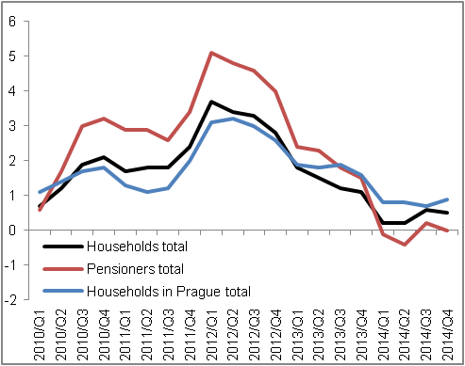 |  | 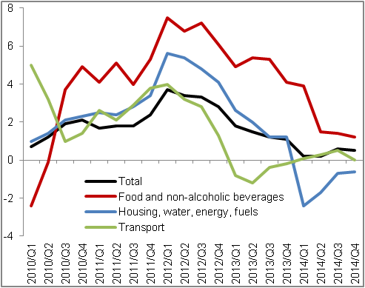
Source: CZSO

Chart 13 | Deflators (adjusted for seasonal and calendar effects, y/y in %) | Chart 14 | Producer prices (y/y in %, agricultural prices on the right axis, other on the left axis)
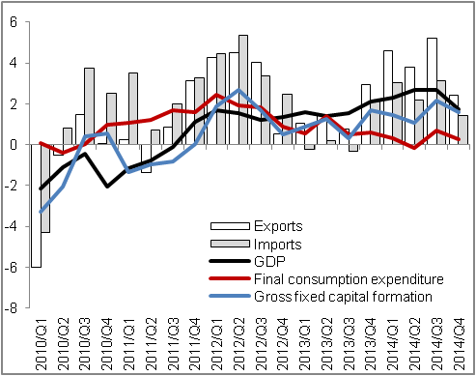 |  | 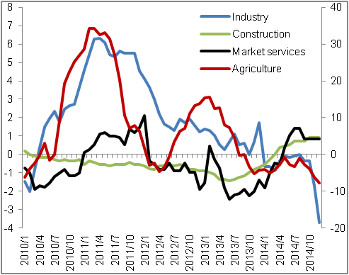
Source: CZSO

