Overall Economic Performance
Czech economy was further reviving during 2014, … |  | The CR economy, which extricated itself out of the recession in Q2 2013, kept further recovering during the year 2014. Its performance was improving – gauged by the quarter-on-quarter change of the gross domestic product (GDP) – without exception throughout the whole year. If in Q1 the GDP increased by 0.3 % and in Q2 as well, it grew identically by 0.4 % in the two remaining quarters. The development of the economy recorded in this way, already favourable, was however underestimated. The pre-stocking with the tobacco products at the end of 2013 leading to increase of the collection of consumption taxes led in fact to the situation, that the balance of taxes on products – which is part of the GDP calculation – considerably increased in the last quarter of 2013 and heightened the dynamics of the GDP growth, nevertheless it was continuously falling during the year 2014 and on the contrary pressed down the GDP dynamics. If we proceed from the quarter-on-quarter changes of the gross value added (GVA), which does not contain this balance and is more suitable for the purpose of capturing the true development, the picture regarding the development of the domestic economy changes for the better. If the GVA increased by 0.7 % quarter-on-quarter in Q1 2014 and identically by 0.5 % in Q2 and Q3, it rose by high 1.1 % in the last three months of the year. As it was evident from the data related to GDP, that the Czech economy kept further reviving in 2014, then it followed from the GVA indicator, that its growth accelerated towards the end of the year.
... GDP formed in 2014 already nearly balanced out its level from 2008 |  | The data for year 2014 confirmed, that the Czech economy already overcame the two years‘ recession. As the GDP dropped in total by 1.4 % in the CR in years 2012 and 2013, the rise by precise 2.0 % in year 2014 more than compensated for this slump. The GDP created in 2014 already nearly balanced out its level from the top of boom in 2008 (it was lower only by 0.2 %).
All main components of domestic demand, apart from change in the inventories, contributed to the GDP growth in 2014. Investment was „the driving force“, … |  | The renewed growth of the gross fixed capital formation, that is investment, contributed the most to the GDP growth in 2014. Its contribution reached 1.2 p.p., it was positive for the first time after two years and the highest since a strong year 2007, when not only the domestic and foreign companies, but also households significantly invested in the Czech economy. Household final consumption expenditure and government final consumption expenditure share in the economic growth less in 2014, however they were growing opposed to investment already for a second year. While the favourable impact of the government consumption slightly weakened (from +0.4 p. p. in 2013 to +0.3 p. p. in 2014), the size of the household consumption contribution notably increased (from +0.2 p. p. to +0.8 p. p.). The remaining components of the demand, that is the change in the inventories (-0.2 p. p.) and the result of the foreign trade (-0.1 p. p.), slowed down the growth of the Czech economy in 2014.
… however if we remove the imports meant for final uses from the total imports, then the result of modified foreign trade participated the most on the Czech economy growth |  | If we exclude the imports meant for final uses from the total volume of imports of goods and services into the CR, since it has in fact nothing in common with the growth of the Czech economy, then the contributions of individual components of demand to the GDP growth change significantly. Investment and final consumption expenditure of households, which are generally satisfied to a large extent by imports – and that was also evident in data for 2014 – contributed in this modified conception by only 0.6 p. p. and 0.2 p. p. respectively. The final consumption expenditure of government also participated on the economic growth less than in the classical conception (+0.2 p. p.), the contribution of the change in inventories did not alter on the contrary, it remained negative (-0.2 p. p.). The foreign trade without imports meant for final uses was thus the main factor in the growth in 2014 (+1.3 p. p.).
Czech economy keeps expanding faster compared to the EU countries and markedly faster than the Euro area |  | The GDP expanded by 1.5 % in the CR in Q4 2014 year-on-year. Although the rate of growth was adversely affected by the high comparative basis of the previous year (linked to the already mentioned imbalance collection of the consumption taxes), the domestic GDP strengthened more than in the EU economy as a whole (+1.3 %) and markedly more than in countries paying by euro (+0.9 %). The Czech economy was expanding faster compared to both economic areas already five quarters in a row.
Economic development was considerably differentiated in the four biggest union economies towards the end of 2014 |  | Only Germany grew faster than the CR out of the four biggest EU economies quarter-on-quarter in Q4 2014 (it recorded based on the available data the fifth largest addition to GDP out of all EU countries (+0.7 %), following a factual stagnation from the two previous quarter), but also The Great Britain (+0.5 %). The GDP growth decelerated from +0.3 % in France in Q3 2014 to mere +0.1 % in the last quarter, Italy – which faced recession in the first three quarters of 2014 – just stagnated.
Improving situation on the labour market transferred into higher incomes for households and consequently also into higher consumption expenditure in 2014... |  | The income situation of Czech households already improved (according to the so far known data) in 2014, following three years 2011, 2012 and 2013, which hit their total incomes hard. Continuing growth of the number of employees, lengthening of the real hours worked, growth of real wages in both the business and non-business sphere, but also for instance the increase of the number of self-employed (especially entrepreneurs) – is only a concise outline of the changes on the labour market, which had a positive effect on the household income in 2014, and were consequently also transferred into higher consumption expenditure. If household final consumption expenditure fell in total by 1.2 % in years 2011-2013, they strengthened by 1.7 % in the year of a renewed growth of the Czech economy 2014. They increased the most in the last six years.
… household final consumption expenditure increased by 1.2 % quarter-on-quarter in Q4 2014 itself, the most since Q1 2010 |  | The household consumption expenditure rose by 1.2 % quarter-on-quarter in Q4 itself, more than corresponded to the average for individual quarters of 2014 and the most since the beginning of year 2010. Not only the announced wage increases of state employees effective from the beginning of November 2014 most likely affected the household expenditure, but also the positive expectations of households with respect to future economy development. The results of business cycle surveys from the end of the year also proved this. The consumer confidence in the economy was already so high in the last three months of 2014, that it „attacked“ at the historically highest confidence level from the turn of the boom years 2006 and 2007.
Easier fiscal policy stimulated the domestic demand via growth of the government consumption also in 2014 |  | Despite the dynamics of final consumption expenditure of government being considerably unbalanced during 2014 (with positive quarter-on-quarter additions in Q2 and Q4 and negative in Q1 and Q3), the growth tendencies prevailed. The government consumption strengthened by 1.6 % for the whole 2014, the easier fiscal policy stimulated the domestic demand already for the second year.
Investment increases in quarter-on-quarter comparison already six consecutive quarters, … |  | The Czech economy growth was for the most part built on the higher demand for investment in 2014. Even though investment was still markedly lower (-10.4 %) in comparison to year 2008 (it was invested historically the highest 1168 bn CZK (in 2010 prices) in the CR), domestic investment activity evidently improved (+4.7 %) against the year 2013. The fact that investment increases progressively and not occasionally can be assessed in a very positive way. The already six quarters lasting quarter-on-quarter growth suggests, that the investment moods are not only positive, but also stable in the CR.
… it was invested especially into ICT, machinery and equipment; buildings and structures; but also housing more than in 2013 |  | As follows from the type classification of the gross fixed capital formation not seasonally adjusted, investment into ICT, machinery and equipment rose the most in 2014 (+7.4 %), however the investment into buildings and structures (+6.4 %) did not – with respect to the recorded dynamics – lag too much behind either. While the higher purchases of ICT, machinery and equipment were justified especially in expanding the production capacities of the manufacturing companies, the growth of investment into buildings and structures can also be attributed to the renewed construction of large infrastructure developments financed from the public funds. Purchases of the transport equipment – which flourished in 2013 – did not strengthen further (-2.8 %), investment into housing (houses and flats), where especially the households put their resources, on the contrary increased (+1.1 %) for the first time since 2010. Higher incomes of households, effort to create financial reserves for the future, but also the very low interest rates on loans for housing were reflected there.
Notable drop of value of inventories in Q1 and Q4 2014 was also projected in the result for the whole year |  | Value of inventories declined in total for the whole year 2014 by 9.3 bn CZK (in nominal terms, not seasonally adjusted) due to marked emptying of stores at the beginning and end of the year. While in Q1 2014 the inventories of tobacco products stored up within the frame of the tax optimization in the previous quarter were gradually dissolved, in Q4 2014 a reduction of inventories of goods and incomplete products occurred thanks to the further strengthening demand.
Foreign trade surplus shrank in constant prices due to a strong growth of domestic demand in 2014, … |  | Renewed economic growth in the euro area together with a weaker koruna, which assisted the competitiveness of the domestic exporters on the world markets, had a very favourable impact on the exports volume of goods and services from the CR abroad. It jumped by 8.8 %, markedly more than in „poor“ year 2013 (+0.3 %), however it was not enough on the addition to the imports volume (+9.6 %), which was boosted by the force of the domestic demand.
… however in the current prices – thanks to the favourable price development in trade with goods - it rose to historic maximum |  | Result of the foreign trade with goods and services rose to the historically highest 292.6 bn CZK in nominal terms in 2014. While the surplus of the foreign trade with services itself shrank by 14.4 bn CZK compared to year 2013, excess of exports of goods over its imports increased by 71.4 bn CZK thanks to the positive terms of trade.
The Czech economy has already surpassed the year 2008 according to the gross value added |  | Total performance of the Czech economy, gauged by the gross value added, increased by 2.6 % in 2014. All industries of the Czech economy together produced goods and services in the volume, which overtook the level of 2008 for the first time. It was higher by 0.5 %.
Manufacturing industry, which is strongly oriented on the foreign demand, together with the services significant by volume contributed the most to the growth of the gross value added in 2014 |  | Manufacturing industry benefiting from the higher demand both abroad and at home already from the half of 2013, contributed by the largest share (+1.5 p. p.) from the view of the supply side to the growth of the CR economy in 2014. The remaining industrial activities in total (CZ-NACE B, D, E) – affected especially by the protracted decline of prices of coal on the world market (mining and quarrying) and a mild winter (energy industry) – slowed down the growth of the economy (-0.1 p. p.). Fine harvest of the agricultural crop was favourably reflected in the performance of the group of activities involving agriculture, forestry and fishing (+0.2 p. p.), the rise of demand for construction activities on part of private persons as well as public clients in the gross value added of construction (+0.1 p. p.). Services as a whole (CZ-NACE G-U), which share in the total performance of the Czech economy roughly by three fifths, participated on the economic growth by 0.9 p. p. force in 2014.

Chart 1 | GDP (constant prices, adjusted for seasonal and calendar effects, in %) | Chart 2 | GDP (constant prices, adjusted for seasonal and calendar effects, y/y in %, right axis) and confidence indicator (2005=100, left axis)
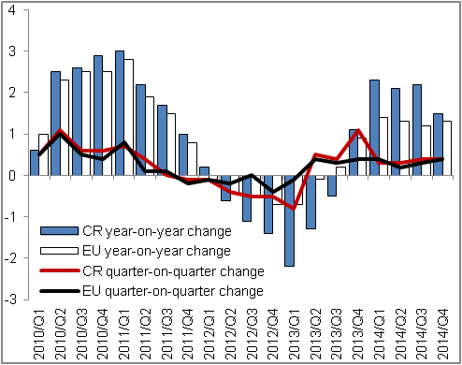 |  | 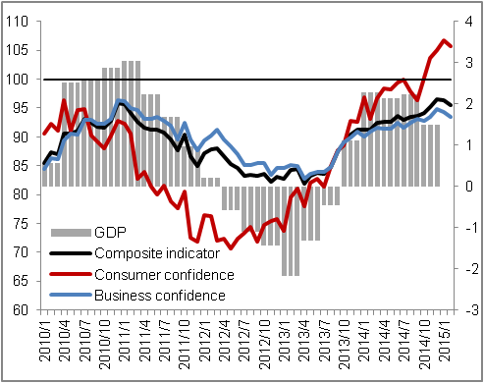
Source: CZSO, Eurostat

Chart 3 | Contributions of expenditure components to GDP change* (constant prices, y/y, contributions in p. p., GDP in %) | Chart 4 | Contributions of branches to GVA change (constant prices, y/y, contributions in p. p., GVA in %)
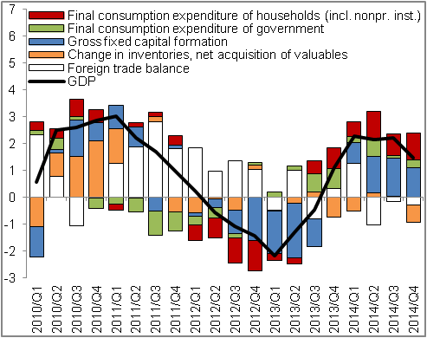 |  | 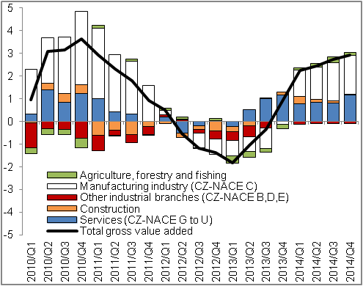
*contributions to GDP change without the exclusion of imports for final uses |  |  |  | Source: CZSO

In real terms, adjusted for seasonal and calendar effects - unless stated otherwise.
Contributions to GDP change without the exclusion of imports for final uses.

