16 February 2024

Number of working persons with lower education was increasing

Employment and unemployment in the Czech Republic as measured by the Labour Force Sample Survey – 4th quarter of 2023
The total employment increased by 81.2 thousand persons, year-on-year (y-o-y). The number of the unemployed, according to the methodology of the International Labour Organization (ILO), increased by 21.1 thousand persons. The number of the economically inactive aged 15+ years decreased by 15.2 thousand.

Employment

In the Q4 2023, the seasonally adjusted average number of employed persons decreased by 1.7 thousand persons, compared to the Q3 2023.

The number of working persons aged 15+ years increased by 81.2 thousand, y-o-y, i.e. by 1.6% to 5 087.5 thousand. The increase is mainly owing to an increment in the number of working males. Their number was by 44.4 thousand higher, y-o-y. The number of working persons aged 45+ years considerably increased, by 92.1 thousand; what was also inconsiderable was an increase of working persons aged 15–29 years whose number grew by 27.7 thousand, year-on-year. In the age category of 30–44 years, a y-o-y decrease in the number of working persons by 38.6 thousand was recorded.

Chart 1: The number of working persons in the national economy and their structure by age group (thousand)
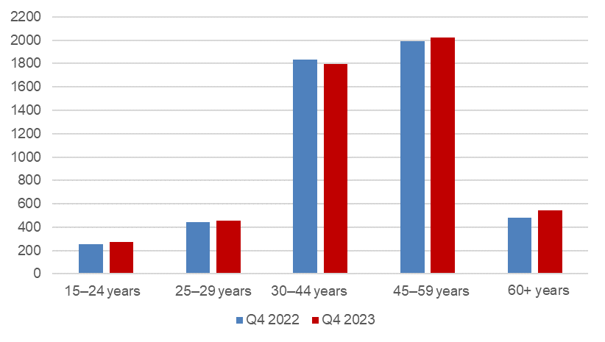
Source: CZSO, LFSS

The number of employees increased by 42.1 thousand persons. The number of the self-employed (without unpaid contributing family workers) increased by 52.5 thousand persons. This overall increase is owing to an increase in the number of the self-employed without employees (own-account workers), namely by 53.8 thousand. The number of the self-employed with employees (employers) stagnated (a decrease by 1.3 thousand).

According to data for the Q4 2023, the development of employment in individual economic activities (CZ-NACE sections) in the Czech Republic was different⁾. In the primary sector of agriculture, forestry and fishing, the number of working persons increased, year-on-year, by 7.1 thousand to 140.7 thousand. In the secondary sector of industry and construction, a slight decrease in the number of working persons was recorded; their number decreased by 18.0 thousand to 1 804.4 thousand. In the tertiary sector of services, y-o-y, the total employment increased by 92.0 thousand to 3 142.4 thousand. In this sector, the number of working persons especially increased in the section of ‘education’ by 35.8 thousand persons and also in the section of ‘professional, scientific and technical activities’ by 22.8 thousand persons. Some sections, on the other hand, recorded a decrease in the number of working persons; in the ‘public administration and defence; compulsory social security’ the number of working persons decreased by 13.6 thousand persons.

Chart 2: The number of working persons in the national economy by economic activity (thousand)

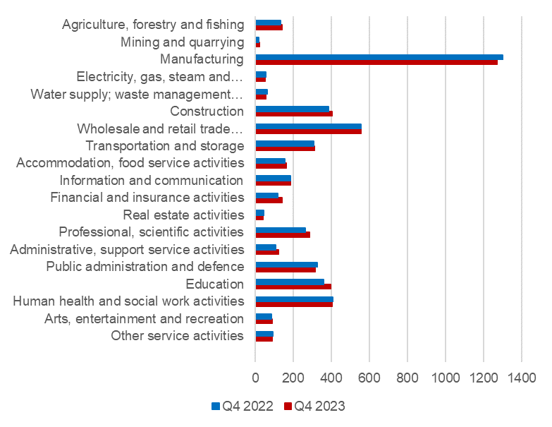
Source: CZSO, LFSS

Along with changes in the structure by economic activity (CZ-NACE section), changes in the structure of working persons by occupation also occurred. According to the Classification of Occupations (CZ-ISCO), the number of working persons increased the most in the major group of professionals (by 68.5 thousand) and in the group of craft and related trades workers (by 32.7 thousand). On the other hand, the biggest decrease occurred in the major group of clerical support workers (by 61.9 thousand).

Chart 3: The number of working persons in the national economy by Classification of Occupations (thousand)
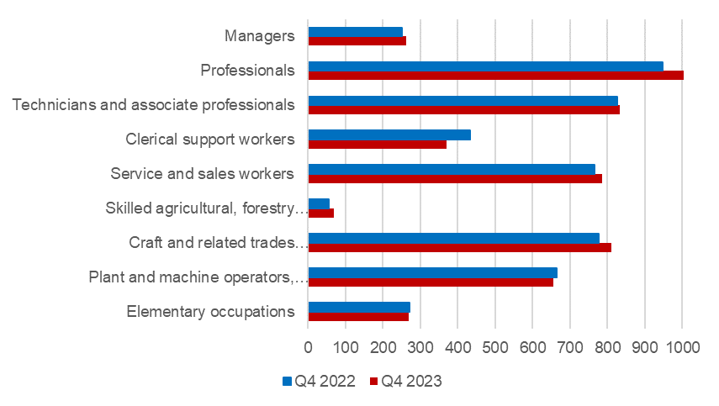
Source: CZSO, LFSS

The development trend in the number of working persons according to the educational attainment is also related to those changes in the employment structure. The highest increase was among working persons with primary education by 32.0 thousand to 237.8 thousand. The number of working persons with secondary education without A-level examination increased by 26.9 thousand to 1 611.2 thousand persons. The number of employed persons with secondary education with A-level examination increased by 19.9 thousand to 1 856.8 thousand. The number of working persons with tertiary education remained almost unchanged, year-on-year (an increase by 2.5 thousand to 1 380.5 thousand persons).

The employment rate (the percentage of working persons in the age group of 15–64 years old) did not change in the Q4 2023 compared to the corresponding period of the previous year and remained at 75.4%. The male employment rate decreased by 0.8 percentage point (p. p.) to 81.5%; the female employment rate increased by 0.7 p. p. to 68.8%.

Unemployment

The seasonally adjusted average number of unemployed persons according to the ILO methodology⁾ increased in the Q4 2023 by 5.3 thousand persons, compared to that in the Q3 2023.
Chart 4: The number of the unemployed in Regions of the Czech Republic (thousand)
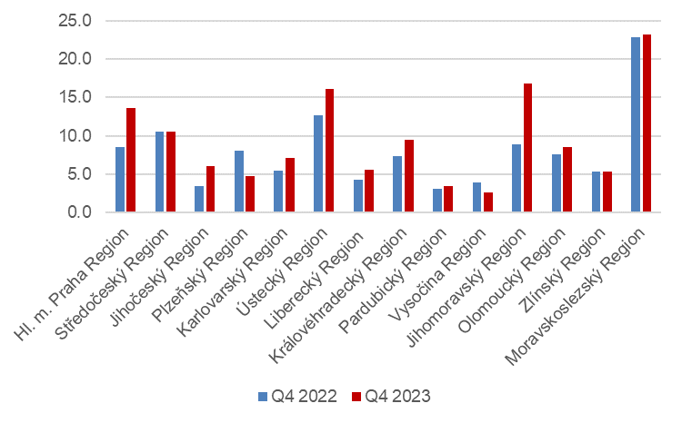
Source: CZSO, LFSS

The total number of the unemployed aged 15+ years increased, year-on-year. The number of the unemployed increased by 21.1 thousand to 133.2 thousand persons. Specifically, it was mainly an increase in the number of the unemployed females by 12.4 thousand to 71.0 thousand. The number of the unemployed males increased by 8.7 thousand to 62.2 thousand.

The number of the unemployed increased the most in the Jihomoravský Region (by 8.0 thousand) and in Prague, i.e. the Hl. m. Praha Region (by 5.0 thousand).

The number of persons unemployed for one year and longer also increased; their number increased in total by 12.2 thousand persons, y-o-y, and reached 42.0 thousand persons. The number of the long-term unemployed males increased by 8.9 thousand, y-o-y, the number of the long-term unemployed females in the Q4 2023 increased by 3.3 thousand compared to the corresponding period of 2022.

Chart 5: The number of the long-term unemployed (for 1 year and longer) and their age structure (thousand)
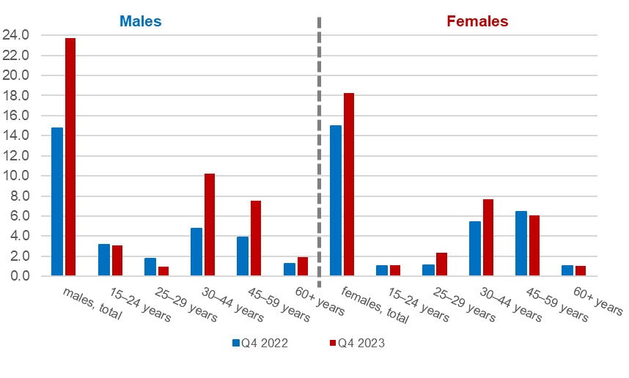
Source: CZSO, LFSS

The general unemployment rate according to the ILO definition in the age group of
15–64 years old (the percentage of the unemployed in the labour force, i.e. in the sum of the employed and the unemployed) increased by 0.4 p. p., year-on-year. The unemployment rate was 2.6% in the Q4 2023 and in the corresponding period of the previous year it was 2.2%.

Chart 6: Unemployment rate of the 15–64 years old in Regions of the Czech Republic (%)
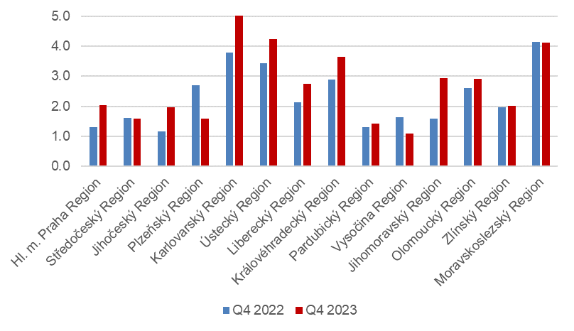
Source: CZSO, LFSS

In terms of a regional comparison, the general unemployment rate of the 15–64 years old was the highest in the Karlovarský Region (5.1%), in the Ústecký Region (4.3%), and in the Moravskoslezský Region (4.1%). The biggest decrease in the unemployment rate was in the Plzeňský Region (by 1.1 p. p. to 1.6%). The Vysočina Region had the lowest unemployment rate in Czechia (1.1%).

Economic inactivity

The number of economically inactive persons aged 15+ years was by 15.2 thousand lower, year-on-year, and amounted to 3 444.5 thousand. The number of economically inactive females decreased by 13.5 thousand; the number of economically inactive males was by 1.7 thousand lower than a year ago.

In the sample survey, data are also collected on persons who do not work and do not seek a job in an active manner and therefore do not comply with the ILO conditions for the unemployed, yet they state that they would like to work. In the Q4 2023, the number of such persons was 81.1 thousand persons, i.e. by 34.3 thousand persons more than in the corresponding period of 2022. The number of persons who are willing to work, however, they are not able to start in a potential job immediately, is relatively high. Only 14.1 thousand of the persons are able to start in a job within a fortnight, at the latest.

Methodological change in the LFSS

As of the 2nd quarter of 2023, as announced in advance, the methodology of the weighting scheme and grossing up changed (details in Czech only). The employment rate of persons aged 15–64 years would be 76.5% in the Q4 2023 after having used the old weights; the female employment rate would be 70.7% and the male employment rate would be 82.0%. The unemployment rate of persons aged 15–64 years would be 2.6% with the old weights; the female unemployment rate would be 3.1% and the male unemployment rate would be 2.2%. The number of the economically inactive aged 15+ years would be 3 427.7 thousand (1 367.2 thousand males and 2 060.4 thousand females). When using the new weighing scheme and grossing up, the absolute numbers of working persons and of the unemployed have decreased and the number of the economically inactive has slightly increased. The employment rate has thus slightly decreased. The unemployment rate remained the same when using the old and the new weights.

Note:
Recalculation to the same population structure
The Labour Force Sample Survey (LFSS) is carried out in selected dwelling households. Collective accommodation establishments are not included in the survey. The data found were weighted to the population of the Czech Republic based on the results of the demographic statistics as at the end of the given year; estimates of the number of persons living outside private households were subtracted from the population totals of the demographic statistics.

Authors:
Marta Petráňová, phone number: (+420) 274 054 357, e-mail: marta.petranova@czso.cz
Gabriela Strašilová, phone number: (+420) 567 109 071, e-mail: gabriela.strasilova@czso.cz
Unit for Labour Forces, Migration, and Equal Opportunities

⁾ Data for the economic activities (CZ-NACE sections) may be influenced by the employed methodology of the Labour Force Sample Survey (LFSS). The survey only covers persons living in dwellings (flats), i.e. private households. Data on persons living in collective accommodation establishments are not measured; these establishments often give accommodation to foreign nationals.
⁾ The ILO methodology defines the unemployed as persons who during the reference period were without a job, did not work an hour for pay or remuneration, and were in an active manner seeking a job they would be able to join within fortnight at the latest. This methodology is uniform for all EU Member States and provides internationally comparable data. It has to be taken into consideration that the definition of “the unemployed” by the ILO differs from the definition of “job applicants kept in the register of the labour offices” of the Ministry of Labour and Social Affairs.

