10 August 2023

Development of international trade in goods price indices in the Q2 2023

In the Q2 2023, compared to the Q1 2023, export prices decreased by 2.2%. In the year-on-year (y-o-y) comparison, export prices decreased by 1.8% in the Q2 2023. Import prices decreased by 4.5% in the Q2 2023 compared to the Q1 2023. In the y-o-y comparison, import prices decreased by 7.6% in the Q2 2023. The terms of trade reached the value of 102.4% in the Q2 2023 compared to the Q1 2023. In the year-on-year comparison, the terms of trade reached the value of 106.3% in the Q2 2023.

**Export prices**

**Quarter-on-quarter** (q-o-q; the Q2 2023 compared to the Q1 2023), they decreased by 2.2%. Prices decreased in all monitored SITC1 groups. The following prices decreased the most: prices of ‘mineral fuels, lubricants and related materials’ by 12.8% (especially prices of electric current and petroleum products), prices of ‘crude materials, inedible, except fuels’ by 5.9% (especially prices of oil-seeds and oleaginous fruits), prices of ‘food and live animals’ by 4.3% (mainly prices of cereals and cereal preparations), ‘chemicals and related products’ by 3.5% (especially prices of plastics), and ‘manufactured goods classified chiefly by material’ by 1.9% (mainly prices of manufactures of metals).

**Year-on-year**, in the Q2 2023, they decreased by 1.8% (in the Q1 2023 they increased by 6.3%). The biggest decrease of prices was in ‘crude materials, inedible, except fuels’ by 25.5% (mainly prices of metal scrap), ‘chemicals and related products’ by 9.4% (especially prices of plastics and organic chemicals), and ‘food and live animals’ by 4.7% (mainly prices of cereals and cereal preparations). Prices of ‘beverages and tobacco’ grew by 18.4% and prices of ‘mineral fuels, lubricants and related materials’ by 2.3% (prices of electric current and gas).

**Import prices**

**Quarter-on-quarter** (the Q2 2023 compared to the Q1 2023), they decreased by 4.5%. Prices of ‘mineral fuels, lubricants and related materials’ decreased by 22.2% (primarily prices of gas, petroleum and petroleum products, and electric current), prices of ‘chemicals and related products’ by 4.7% (especially prices of plastics), prices of ‘crude materials, inedible, except fuels’ decreased by 4.6% (primarily prices of crude rubber), and prices of ‘manufactured goods classified chiefly by material’ by 2.4% (mainly of non-ferrous metals). Only prices of ‘miscellaneous manufactured articles’ increased by 0.6% and prices of ‘beverages and tobacco’ by 0.4%.

**Year-on-year**, in the Q2 2023, they decreased by 7.6% (in the Q1 2023 they increased by 3.2%). The biggest decrease of prices was in ‘mineral fuels, lubricants and related materials’ by 32.0% (primarily prices of petroleum and petroleum products, gas, and electric current), prices of ‘crude materials, inedible, except fuels’ decreased by 15.8% (primarily prices of metalliferous ores and metal scrap), and prices of ‘chemicals and related products’ decreased by 10.9% (especially prices of plastics). Prices of ‘beverages and tobacco’ grew by 22.2%, prices of ‘food and live animals’ by 6.4% (mainly prices of vegetables and fruit), and prices of ‘miscellaneous manufactured articles’ by 5.9%.

**The terms of trade**

**Quarter-on-quarter** (the Q2 2023 compared to the Q1 2023), they reached the value of 102.4%. The highest positive value of the terms of trade was recorded by ‘mineral fuels, lubricants and related materials’ (112.1%), the lowest negative value was reached by ‘food and live animals’ (96.8%).

**Year-on-year**, in the Q2 2023, they increased to the value of 106.3% (in the Q1 2023 the value was 103.0%) and for the second quarter they remained in the positive values – see the Chart No 2. The highest positive value of the terms of trade was recorded by ‘mineral fuels, lubricants and related materials’ (150.4%) and the lowest negative value of the terms of trade was reached by ‘crude materials, inedible, except fuels’ (88.5%).

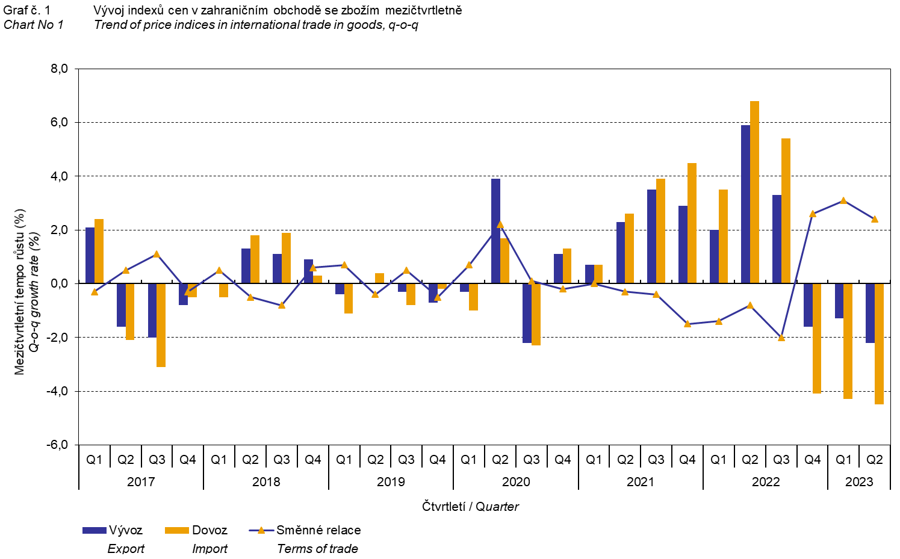

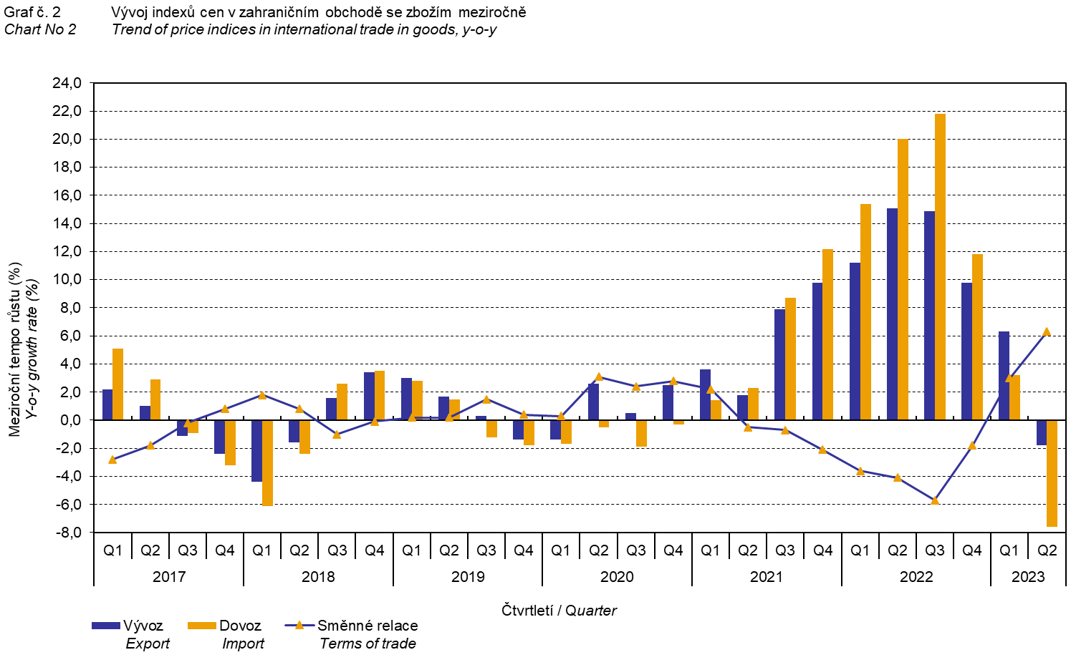

The international trade in goods (change of ownership) price development was also significantly influenced by the CZK exchange rate to the major foreign currencies. **The q-o-q** exchange rate **index** includes two most important currencies in terms of the Czech Republic's international trade, i.e. EUR and USD. Q-o-q indices of the CZK exchange rate to these currencies were weighted by the respective weight, which pertains to those foreign currencies in the export price index and in the import price index.

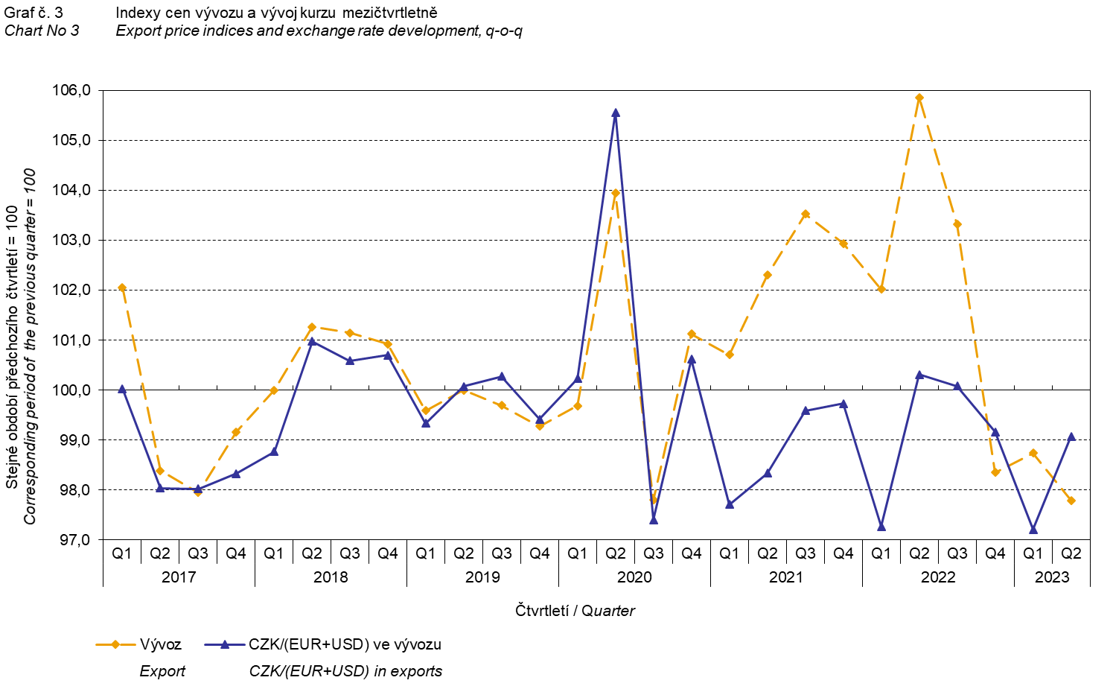

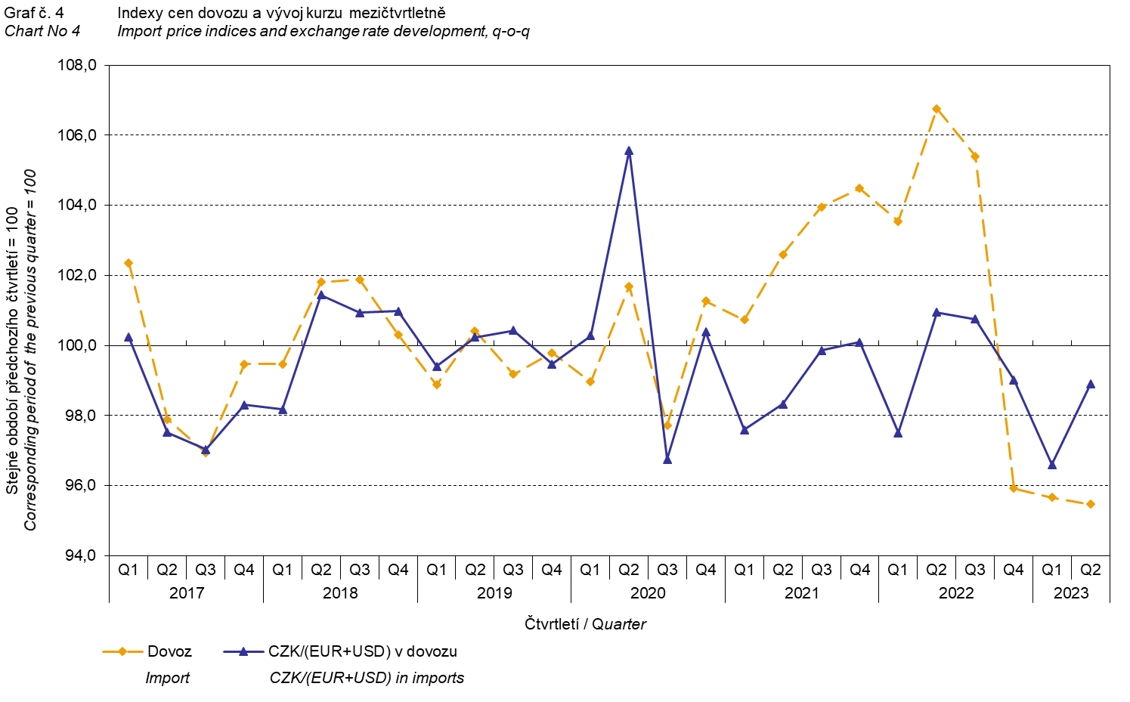

It is apparent from the Chart No 3 and the Chart No 4 above that in both exports and imports, international trade in goods prices have a relation to exchange rate impacts. Contracts with foreign entities are usually concluded for a longer period of time and the longer the contract period is, the stronger the relation to exchange rates is.

# International trade in goods price indices, year-on-year, adjusted for exchange rate influence

The Czech Statistical Office also calculates year-on-year international trade in goods price indices adjusted for effects of exchange rate. It is carried out as follows: prices in foreign currencies reported in the current month are **converted** to Czech crowns **by the exchange rate** of the same month **of the previous year**. Then they are used for the weighted mean calculation together with prices reported in CZK. This exchange rate adjusted base price index of a month is related to the non-adjusted base price index of the corresponding month of the previous year and thus the year-on-year adjusted price index for a month is calculated.

Adjusted quarter-on-quarter price indices have been calculated similarly since 2017. **Differences between adjusted and non-adjusted price indices may be considerable**; they are obvious in the Chart No 6 and the Chart No 7, for example, in the Q1 2018 or in the Q2 2021.

The employed method does not enable to make a 100% exchange rate adjustment because not all trade transactions made in foreign currencies are also reported in foreign currencies; the proportion does not exceed 30%. From the aforementioned it follows that **at the full exchange rate adjustment, differences** between the published price indices and the exchange rate adjusted price indices **would** probably further **increase**.

The exchange rate adjusted indices described above can also be used to make the exchange rate adjusted breakdown of increments of price indices. The Table 1 shows **the** **published and the exchange rate adjusted breakdown of increments** of export and import price indices, supplemented by the most important two-digit code groups of the SITC 7. The breakdown illustrates well how many percentage points each of the groups “exchange rate contributed” to the index.

# It is generally true that the exchange rate effect decreases the value of price indices in international trade in goods if CZK is strengthening to foreign currencies in total. Conversely, the exchange rate effect pushes the price indices up if CZK is weakening to foreign currencies in total.

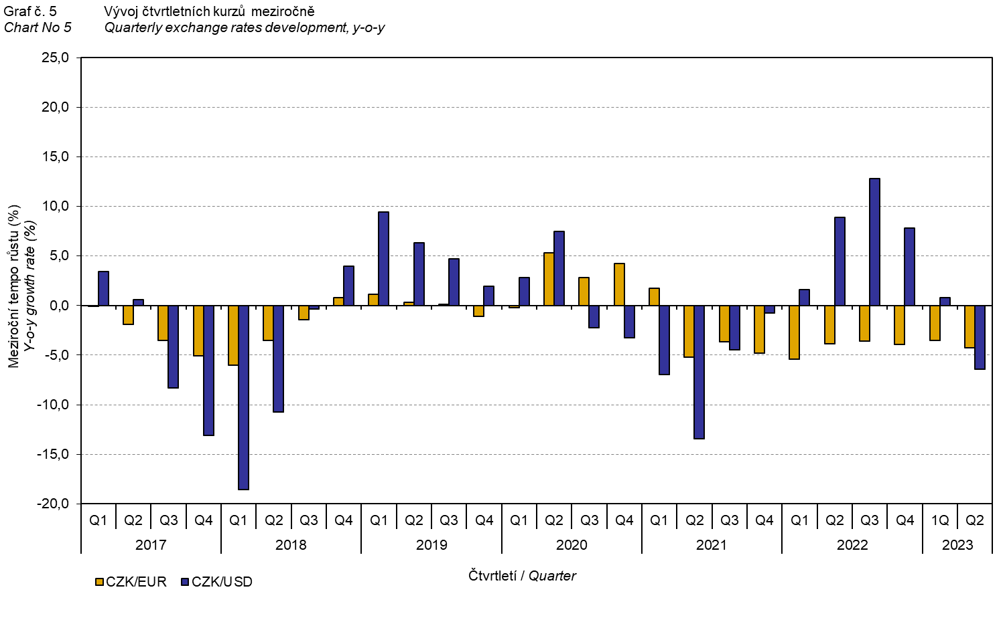

It is apparent from the Chart No 6 and the Chart No 7 below how significant the exchange rate influence on the value of the export and import price indices was.

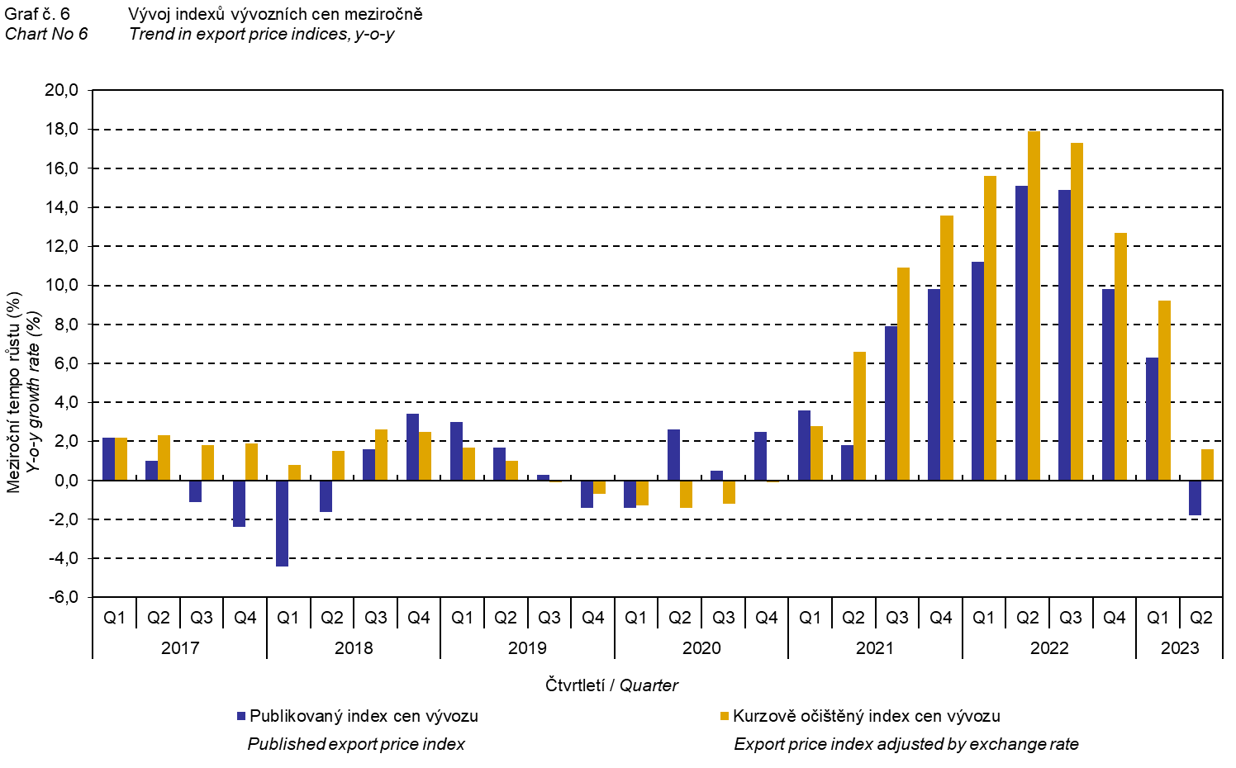

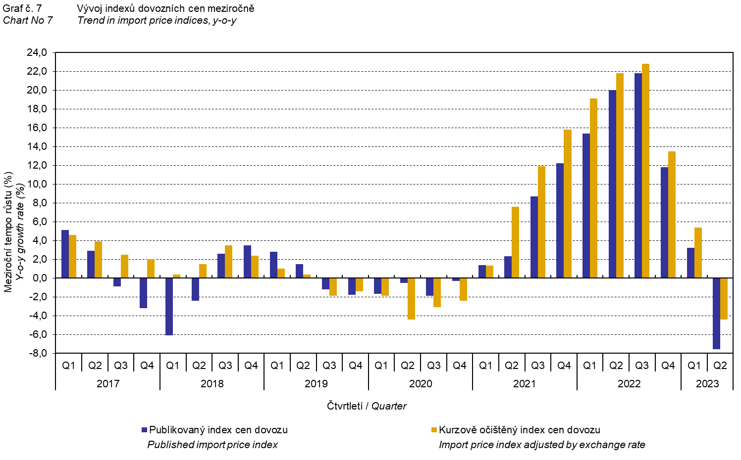

The Chart No 8 shows the exchange rate influence on the value of the year-on-year terms of trade.

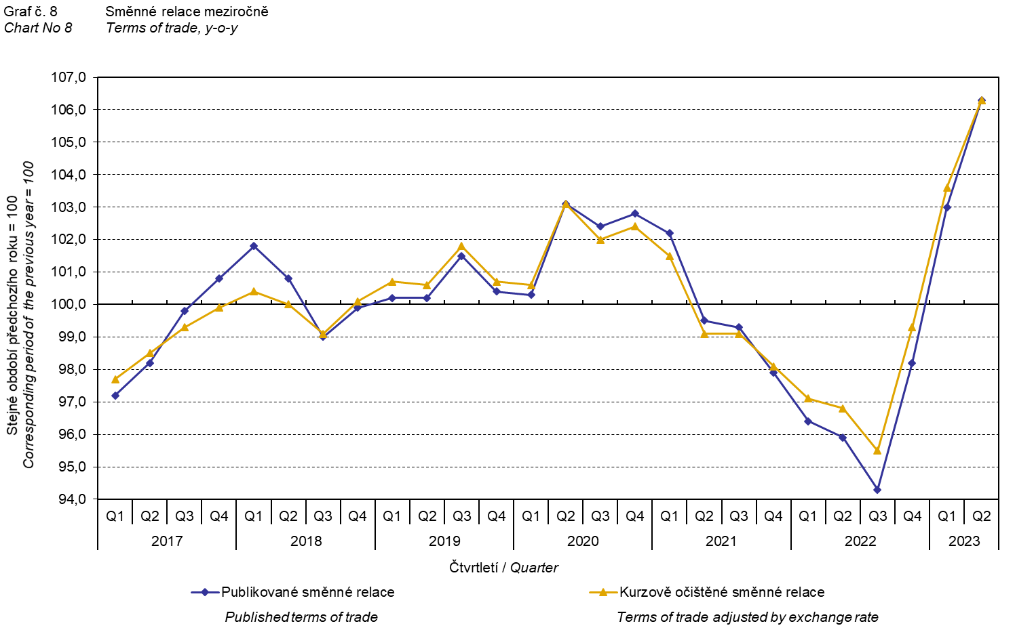

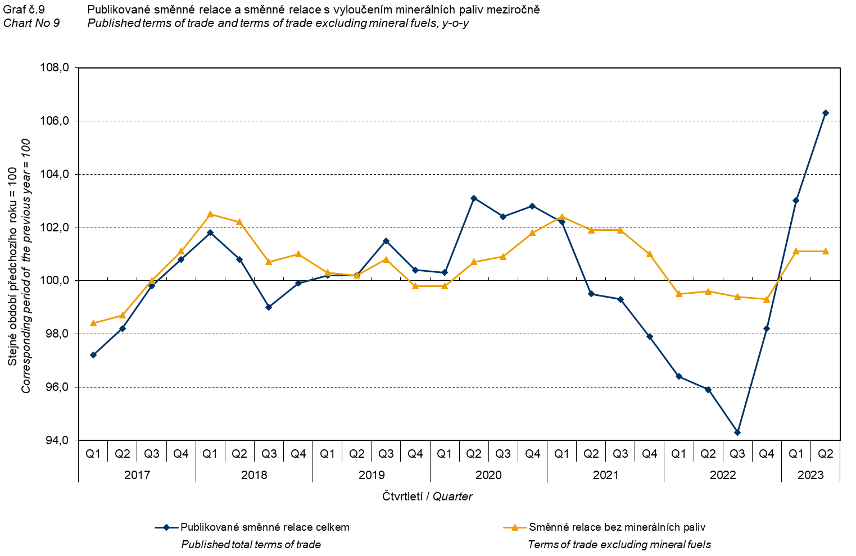

The Chart No 9 shows the development of the value of the terms of trade when the group of ‘mineral fuels, lubricants and related materials’ is excluded from monitoring. In this chart, the effect of ‘mineral fuels, lubricants and related materials’ can be observed; it has an influence on the total value of the y-o-y terms of trade. Since the Q1 2021, ‘mineral fuels, lubricants and related materials’ were decreasing the value of the terms of trade; however, in the Q1 2023, there was a turnabout and ‘mineral fuels, lubricants and related materials’ started to increase the value of the terms of trade. Naturally, it is related to the world market price development, especially petroleum prices. Import prices, which, compared to export prices, have a higher proportion of crude materials, respond in a more sensitive way to price turbulences. Therefore, the terms of trade are usually increasing when prices of crude materials are decreasing, and, vice versa, when prices of crude materials are increasing, the terms of trade are decreasing.

# Final summary

In the Q2 2023, the exchange rate effect decreased both the export price index and the import prices index, year-on-year. Import prices decreased more than export prices and therefore the terms of trade reached positive values. After elimination of the exchange rate effect, the terms of trade reached the same value as the published terms of trade. Values free of the exchange rate effect correspond to the exchange rate adjusted indices – see the Charts Nos. 6, 7, and 8.



The closing table gives published **non-adjusted** international trade in goods price indices. 

*Note: For internal reasons, the Czech decimal comma is used instead of the English decimal point as a decimal separator in tables and charts of this analysis.*

**Elaborated by:** Hana Lapáčková, Prices Statistics Department

phone number: (+420) 274 052 709, e-mail: hana.lapackova@czso.cz