3. Agricultural holdings in IFS 2020 broken down by quartile
Agricultural holdings in quartiles by utilised agricultural area
If we divide the agricultural holdings participating in the Integrated Farm Survey 2020 into quartiles according to their utilised agricultural area, there are approximately 7 230 holdings in each quartile. Their average area accounts for 1.5 ha in the first quartile, 9.2 ha in the second quartile, 31.3 ha in the third quartile and 441.3 ha in the fourth quartile.
Holdings in the first quartile utilise only 0.3% of agricultural area, 0.2% of arable land, and 0.3% of permanent grassland; none of them grow hop-gardens. They reach larger shares of the total area in the case of vineyards (13.2%) and orchards (6.5%). By contrast, holdings in the fourth quartile utilise 91.3% of agricultural area, 94.6% of arable land, 93.9% of hop-gardens, and 84.3% of permanent grassland, while their shares of vineyards and orchards are 56.5% and 59.8% respectively. For all the crops mentioned, those in the third quartile always have the second highest share of the total and those in the second quartile the third highest; the only exception to this rule are vineyards, which are one percent lower in the second quartile than in the first quartile.

Graph 27: Shares of crops by quartile – agricultural holdings, total
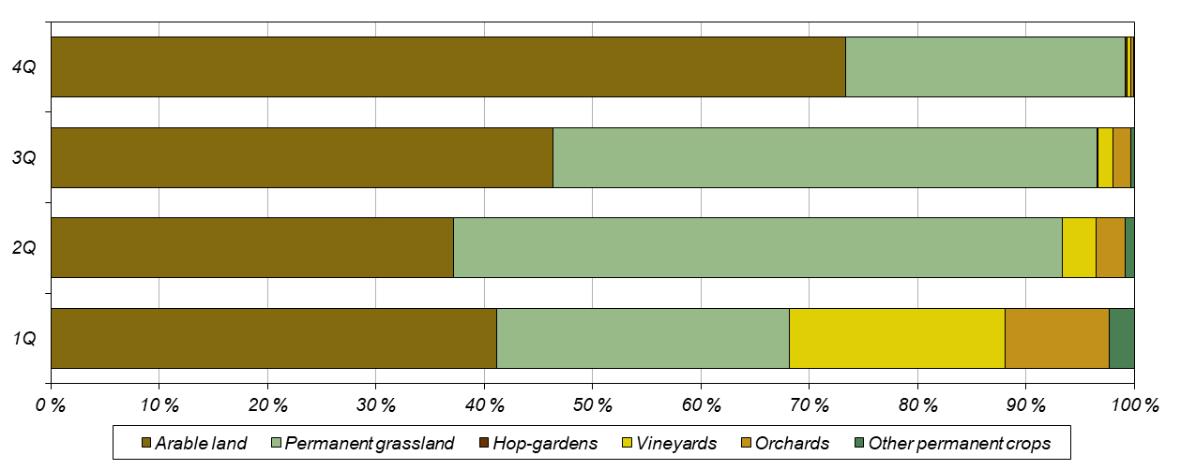
For selected crops on arable land applies that their share of total area is the lowest in the first quartile and increases towards the fourth quartile. However, the shares of area of potatoes and vegetables in the first three quartiles are higher than the corresponding shares of arable land; therefore, it can be said that smaller holdings are dealing with their growing more than with other types of crops.
The cattle numbers in each quartile correspond significantly to the above distribution of utilised agricultural area. Holdings in the first quartile account for 1.2% of total cattle numbers, 0.2% of dairy cows, and 0.7% of other cows. In contrast, the fourth quartile accounts for 90.8% of the cattle, 98.2% of dairy cows, and 83.6% for other cows. The same is true for sheep, which account for 6.2% in the first quartile and 38.2% in the fourth quartile. For both cattle and sheep, holdings in the third quartile are again at the second position and the holdings in the second quartile at the third position, although as for raising of sheep, the third quartile differs from the fourth quartile only by less than five percent. The situation is somewhat different in raising of goats as it is is more concentrated in smaller holdings and the proportions of their numbers in the quartiles are fairly even. Holdings in the first quartile keep 21.2% of the goats, those in the fourth quartile 26.9%, and the highest proportion, 28.0%, was recorded in the third quartile.
The situation is quite different in raising of pigs and poultry, where holdings with no agricultural land, and therefore those in the first quartile, make a major contribution. Although most pigs (47.3 %) are kept by holdings in the fourth quartile, holdings in the first quartile account for only slightly less (42.9 %). Similarly, the largest number of sows is kept by holdings in the fourth quartile (47.5%), followed by holdings in the first quartile (43.0%). In poultry farming, the holdings in the first quartile (60.5% of the poultry numbers) outnumber holdings in the fourth quartile (26.3%). For hens, the proportions are 65.3% of the stocks in the first quartile and only 16.6% in the fourth quartile; for broilers, 57.2% of the stocks are kept in holdings from the first quartile and 34.9% in holdings from the fourth quartile.

Graph 28: Livestock in quartiles – agricultural holdings, total
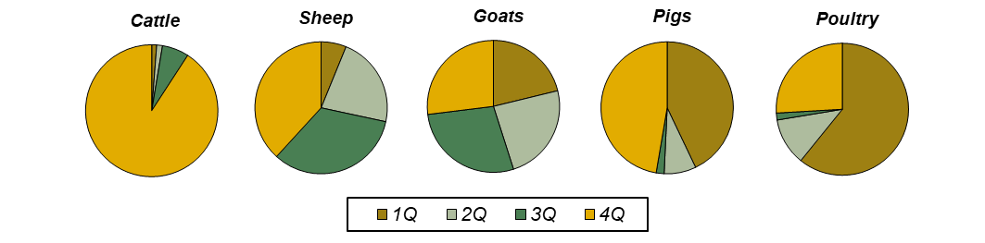
Unsurprisingly, agricultural workers are concentrated the most in the fourth quartile (64.5% of persons), with the first quartile is at the second position (14.0%). Similar proportions apply to both the regularly employed workers (59.5% in the fourth quartile and 15.6% in the first quartile) and the irregularly employed workers (77.3% in the fourth quartile and 10.7% in the first quartile). The share of regularly employed workers in the total is the highest in the second quartile (83.4%) and the lowest in the fourth quartile (65.0%).

Holdings of natural persons in quartiles by utilised agricultural area
There are approximately 6 160 holdings of natural person per quartile by area of utilised agricultural area surveyed in IFS 2020. Holdings in the first quartile have an average area of 1.2 ha, those in the second quartile 7.7 ha, those in the third quartile 22.8 ha, and those in the fourth quartile 137.5 ha.
Holdings in the first quartile utilise only 0.7% of agricultural area, 0.5% of arable land, and 0.4% of permanent grassland; none of them grow hop-gardens. Their orchards (11.1 %) account for a larger share of the total area and their vineyards (29.3%) account for the largest share of the total area of all quartiles. By contrast, holdings in the fourth quartile utilise 81.3% of agricultural land, 86.4% of arable land, 75.2% of permanent grassland, and 88.9% of hop-gardens, while their shares of orchards and vineyards are 39.5% and 26.1%, respectively. For all the crops mentioned, those in the third quartile always have the second highest share of the total and those in the second quartile the third highest; the only exception to this rule are vineyards, which are concentrated the most in the first quartile followed by the fourth one and least numerous in the third quartile.

Graph 29: Shares of crops by quartile – holdings of natural persons
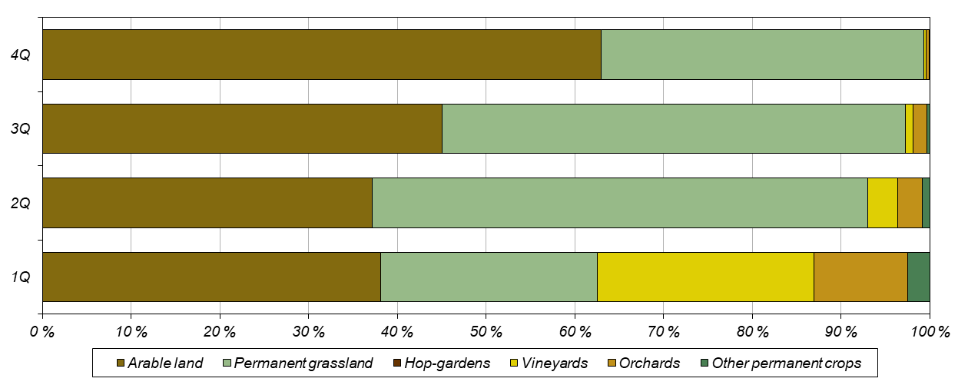
Again, for selected arable crops applies that their share of total area is the lowest in the first quartile and increases towards the fourth quartile. The shares of areas of potatoes and vegetables in the first three quartiles are higher than the corresponding shares of arable land and it can therefore be said that smaller holdings are dealing with their growing more than with other types of crops.
The cattle numbers in each quartile correspond significantly to the above distribution of utilised agricultural area. The first quartile accounts for 1.6% of total cattle, 0.8% of dairy cows, and 0.9% of other cows. In contrast, the fourth quartile accounts for 79.0% of the cattle, with 89.0% for dairy cows and 80.4% for other cows.
A similar situation was recorded for sheep, of which 5.1% are kept by holdings in the first quartile and 41.8% by holdings in the fourth quartile. For both cattle and sheep, holdings in the third quartile are again at the second position and holdings in the second quartile at the third position. The situation is somewhat different in raising of goats, which is more concentrated in smaller holdings, and the proportions of their numbers in the quartiles are fairly even. Holdings in the first quartile keep 20.1 % of the goats, those in the fourth quartile 23.6 %, and those in the second quartile the most, 28.9 %.
The largest proportion of pigs (67.3%) is kept by holdings in the fourth quartile, with the second largest proportion (14.6%) being kept by holdings in the first quartile, i.e. mainly those farming without land. Similarly, the largest number of sows are kept in holdings in the fourth quartile (68.0%), followed by those in the first quartile (15.9%). In poultry farming, holdings in the first quartile (54.4% of the stock) outnumber holdings in the fourth quartile (30.0%). For hens, the proportions are 42.5% of the numbers for holdings in the first quartile and 26.4% for holdings in the fourth quartile. As for broilers, 67.2% of the numbers are concentrated in holdings in the first quartile and 22.8% in holdings in the fourth quartile.

Graph 30: Livestock in quartiles – holdings of natural persons
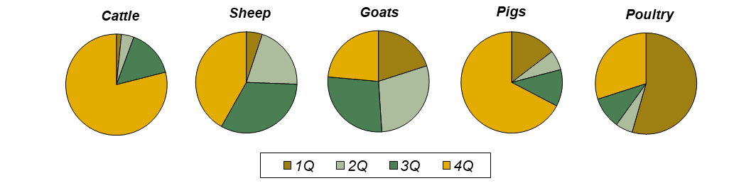
Agricultural workers are, again, most concentrated in the fourth quartile (34.7% of persons) and their shares are fairly even in the other quartiles. The share of persons regularly employed shows a similar trend (30.5% in the fourth quartile), while the share of irregularly employed persons increases with the size of the holding (from 5.9% in the first quartile to 64.4% in the fourth quartile). The share of regularly employed workers in the total number of workers is the highest in the first quartile (97.0%) and the lowest in the fourth quartile (76.7%).

Holdings of legal persons in quartiles by utilised agricultural area
There are approximately 1 065 holdings of legal persons in each quartile by utilised agricultural area. Holdings in the first quartile have an average area of 8.4 ha, those in the second quartile 88.5 ha, those in the third quartile 479.4 ha, and those in the fourth quartile 1 723.5 ha.
Holdings in the first quartile utilise only 0.4% of the agricultural area, 0.2% of arable land, 0.8% of permanent grassland, and 1.0% of hop-gardens. They have a slightly larger share of the total area in the case of orchards (6.7%) and vineyards (8.9%). By contrast, holdings in the fourth quartile utilise 75.0% of agricultural area, 79.7% of arable land, 61.5% of permanent grassland and 51.2% of hop-gardens; their shares of orchards and vineyards are 32.3% and 23.2%, respectively. For all the crops mentioned, except vineyards and orchards, those in the third quartile always have the second highest share of the total and those in the second quartile the third highest share; those in the second quartile have the largest shares of vineyards and orchards.

Graph 31: Shares of crops by quartile – holdings of legal persons
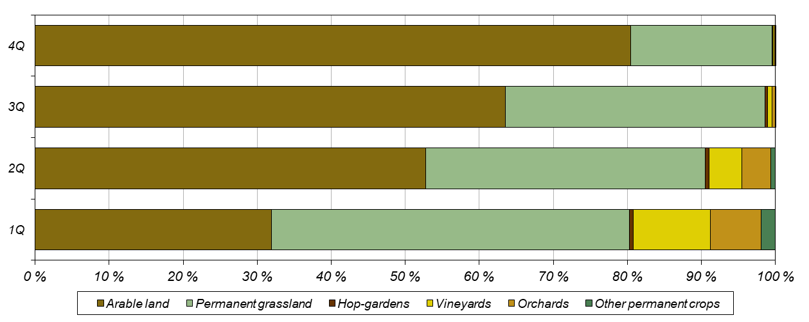
Again, the shares of selected arable crops are the lowest in the first quartile and increase towards the fourth quartile. However, similarly to holdings of natural persons, the shares of vegetable areas are higher than the corresponding shares of arable land in the first three quartiles; in holdings of natural persons, similar results were recorded for aromatic, medicinal, and culinary plants, while this trend is not so clear for potatoes.
Cattle numbers in each quartile again follow the distribution of utilised agricultural area. The first quartile accounts for 1.2% of cattle totals, 0.1% of dairy cows and 0.8% of other cows. In contrast, holdings in the fourth quartile keep 78.9% of cattle, 89.6% of dairy cows and 50.8% of other cows. Both sheep and goats are reared mostly by holdings from the second quartile (37.3% of sheep and 49.7% of goats). The lowest proportion of sheep (16.5%) was found in the first quartile and the lowest proportion of goats (11.7%) in the fourth quartile.
The importance of holdings with no agricultural land, i.e. those belonging to the first quartile, is crucial for pig and poultry farming. The largest proportion of pigs (52.2%) is kept by holdings in the first quartile, and the second largest proportion is kept by holdings in the fourth quartile (42.9%). Similarly, the largest number of sows was found in the first quartile (51.5%), followed by the fourth quartile (43.4%). In poultry farming, the first quartile (73,7 % of the numbers) again completely outweighs the fourth quartile (21,4 %); for hens, the shares are 83,5 % of the numbers in the first quartile and 11,7 % in the fourth quartile, and for broilers 63,9 % of the holdings in the in the first quartile and 32,4 % in the fourth quartile.

Graph 32: Livestock in quartiles – holdings of legal persons
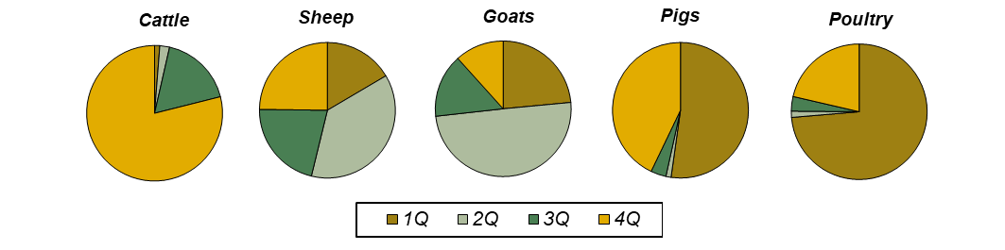
Workers in agriculture are concentrated the most in the fourth quartile (59.7% of persons), with the fewest in the second quartile (10.1%). The same is true for both the regularly employed workers (65.6% in the fourth quartile and 7.8% in the second quartile) and the irregularly employed workers (51.4% in the fourth quartile and 12.7% in the second quartile). The share of regularly employed workers in the total is the highest in the fourth quartile (67.3%) and the lowest in the second quartile (47.0%).

