2. Regional evaluation of IFS 2020 results

Regional results for the IFS 2020 are available at: https://www.czso.cz/csu/czso/integrated-farm-survey-regions-2020.
Out of 28 909 agricultural holdings in 2020, the largest proportion farmed in Jihomoravský Region (19.9%) and the second largest share in Středočeský Region together with Hlavní město Praha Region (13.2%). Natural persons represented more than 88% in Jihomoravský Region and Moravskoslezský Region, and, on the contrary, only 76.9% of holdings in Karlovarský Region.
The largest part of the utilised agricultural area belonged to farmers from Středočeský Region together with Hl. m. Praha Region (16.1%) and Jihočeský Region (12.0%). The highest average area per holding was recorded for holdings of natural persons in Ústecký Region (80.9 ha) and Karlovarský Region (78.4 ha) and for holdings of legal persons in Vysočina Region (754.0 ha) and Pardubický Region (732.9). In contrast, the lowest average area was recorded for holdings of natural persons in Jihomoravský Region (14.2 ha) and Zlínský Region (24.3 ha) and for holdings of legal persons registered in Liberecký Region (356.2 ha).

Graph 17: Average utilised agricultural area per one holding and the share of own land
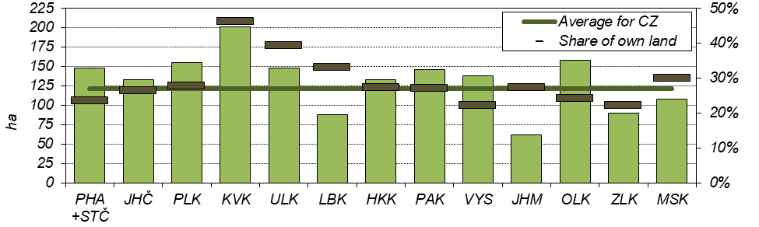
Distinct differences among regions were found in the ownership of the utilised agricultural land. In Karlovarský Region, the share of own land reached almost one half of the UAA (46.3%) while in all other regions it accounted for one fifth (22.1% for Vysočina Region and 22.2% for Zlínský Region) to 39.3% for Ústecký Region. Even larger differences were recorded among holdings of natural persons: they owned 32.3% of the UAA in Zlínský Region and, on the contrary, 63.9% of the UAA in Karlovarský Region. Holdings of legal persons owned the largest part of the UAA in Karlovarský Region (38.8%) and the smallest one in Vysočina Region (13.6%).

Fig. 1: Share of own land in agricultural holdings
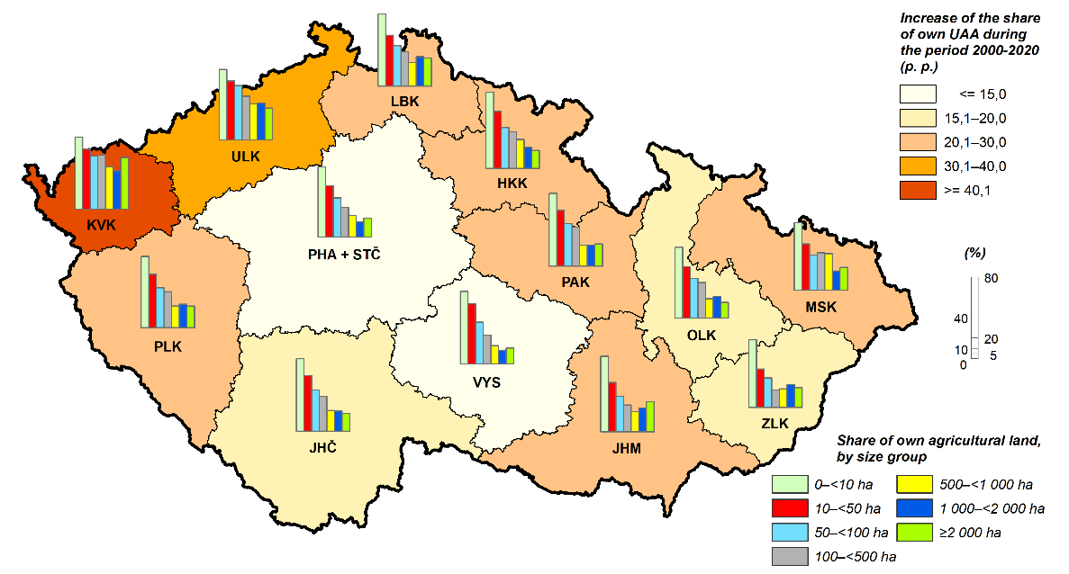
Organic production methods were applied in the largest range in Karlovarský Region where nearly one half (46.2%) of holdings dealt with organic farming on three fifths (58.6%) of the UAA. The smallest share of holdings applying organic production methods was found in Jihomoravský Region (5.9% of holdings) and the smallest share of UAA under organic production methods in Středočeský Region together with Hl. m. Praha Region (4.3% of the UAA).

Fig. 2: Organic farming
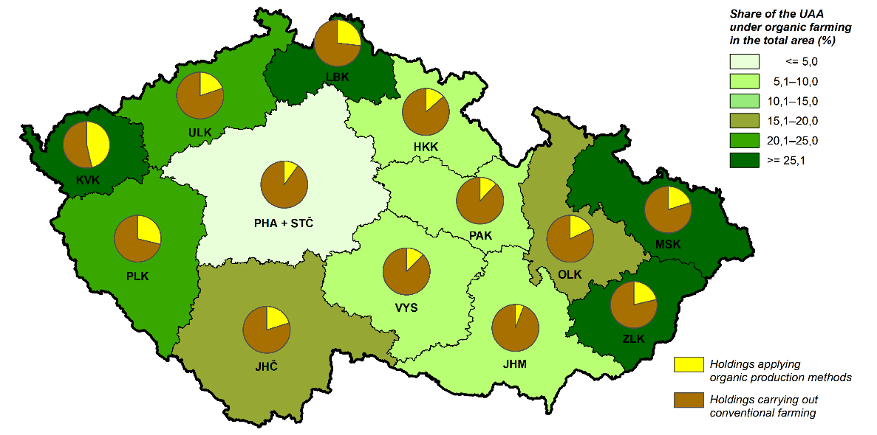

In general, arable land dominated (70.8%) on the UAA with some exceptions: in Karlovarský Region and Liberecký Region the majority of the UAA was covered by permanent grassland (66.1% and 60.8%, respectively) and a smaller part by arable land (33.8% and 37.8%, respectively). The largest share of arable land was recorded in Jihomoravský Region (88.2%) and Středočeský Region together with Hl. m. Praha Region (86.2%) where the shares of permanent grassland were the smallest (6.5% and 12.9%, respectively). Growing of permanent crops was important only locally. Vineyards comprised 4.2% of the UAA in Jihomoravský Region and less than 1% in all other regions except Karlovarský Region. Hop gardens grew on 1.5% of the UAA in Ústecký Region and orchards represented 1.1% of the UAA in Liberecký Region and 1.0% of the UAA in Zlínský Region.

Graph 18: Share of arable land
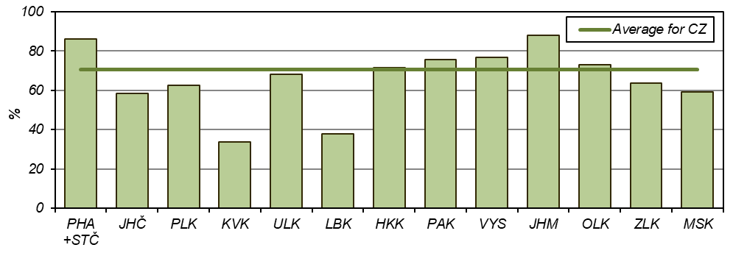

Cereals were the crop group most frequently planted on arable land in all regions; their greatest share was recorded in Jihomoravský Region (61.9%) and Ústecký Region (59.9%), and the smallest one for Vysočina Region (47.3%) and Pardubický Region (49.6%). Cereal areas consisted of wheat in one half (Olomoucký Region, 50.2%) to almost three quarters (Ústecký Region, 71.3%) of their area. In Jihomoravský Region, maize for grain was an important crop (49.3% of the total area of maize). Growing of potatoes was concentrated in Vysočina Region (35.0% of the total area of potatoes) and in Středočeský Region together with Hl. m. Praha Region (25.1%). Středočeský Region together with Hl. m. Praha Region was the region with the largest shares of rape (23.5%), poppy (18.7%), vegetables (34.8%), and strawberries (35.7% of their area). Plzeňský Region was specialised in medicinal, aromatic and culinary plants (17.1% of their total area), Jihomoravský Region dominated in growing of sunflower seed (68.7% of its area), and Moravskoslezský Region focused on flowers and ornamental plants (29.0% in of their total area).

Graph 19: Share of cereals in arable land
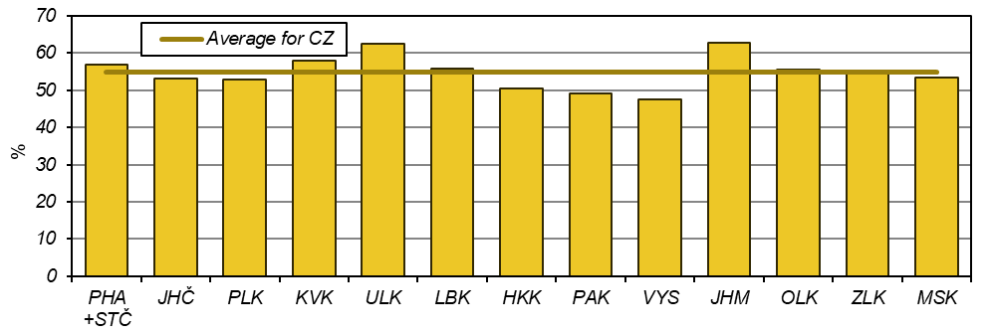

Permanent grassland was the most frequent type of land use in organic crop production with the only exception of Jihomoravský Region where it represented only one fifth (22.0%) of the UAA under organic farming while organically farmed arable land covered 70.4% of the UAA under organic farming. The largest share of permanent grasslands was in Liberecký Region (92.6%) where arable land comprised only 6.4% of the UAA under organic production methods. More than one half of all permanent grasslands were farmed organically in Karlovarský Region (79.3% of their area), Ústecký Region (67.1%), Zlínský Region (60.4%), Moravskoslezský Region (57.4%), Olomoucký Region (55.5%), and Liberecký Region (51.7%). Orchards were organically farmed mostly in Karlovarský Region (92.8% of their area) and Vysočina Region (64.2%). Orchards covered 2.4% of the organically farmed UAA in both Jihomoravský Region and Středočeský Region together with Hl. m. Praha Region.
The largest share of arable land where organic production methods were applied was recorded in Karlovarský Region (18.1% of its arable land area). The most frequent crops on arable land organically farmed were cereals (from 25.2% of arable land organically farmed in Liberecký Region to 53.7% in Plzeňský Region), plants harvested green (from 28.6% for both Plzeňský Region and Jihomoravský Region to 69.8% for Liberecký Region), and in Plzeňský Region and Jihomoravský Region also industrial crops (9.6% and 9.3%, respectively, of arable land organically farmed).

Graph 20: Share of permanent grassland in the UAA under organic production
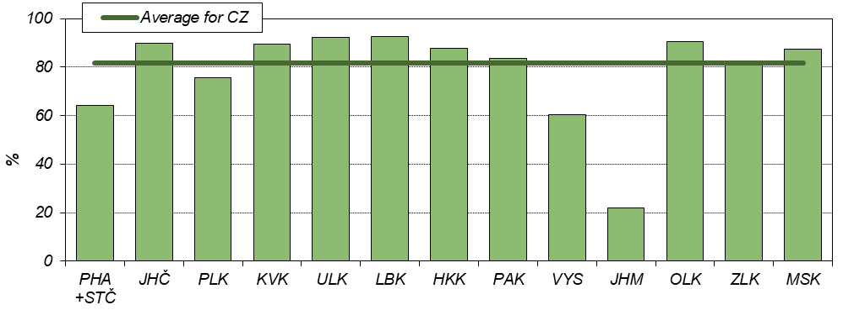

As for raising of cattle, there were distinct differences among regions. The largest shares in cattle totals were recorded for Jihočeský Region (15.9%) and Vysočina Region (15.4%), but both these regions differed in cattle types: the largest number of dairy cows was concentrated in Vysočina Region (20.3% of their total number) while of other cows in Jihočeský Region (20.1% of their total number). In Vysočina Region, the cattle density was the highest both for cattle totals (60 head per 100 ha of the UAA) and for dairy cows (20 head per 100 ha of the UAA) while the highest value for other cows (18 head per 100 ha of the UAA) was reached in Karlovarský Region. The lowest densities were recorded in Jihomoravský Region for cattle totals (18 head per 100 ha of the UAA) and for other cows (1 head per 100 ha of the UAA) and in Ústecký Region for dairy cows (1 head per 100 ha of the UAA).

Graph 21: Raising of cattle
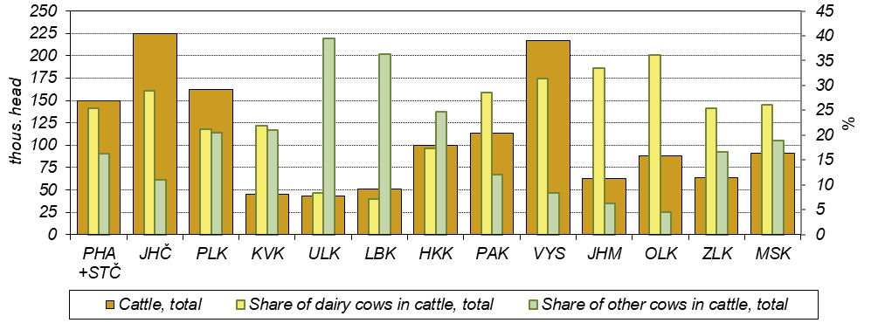

Raising of pigs was concentrated in Vysočina Region (20.5%) and in Středočeský Region together with Hl. m. Praha Region (15.8%) while only 1.7% of pigs was recorded in Moravskoslezský Region. Pig density was the highest in Karlovarský Region (254 head per 100 ha of arable land) and in Liberecký Region (252 head per 100 ha of arable land) and the lowest in Moravskoslezský Region (21 head per 100 ha of arable land).

Graph 22: Pig density (head per 100 ha of arable land)
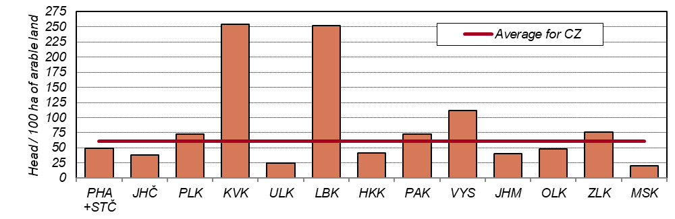

Holdings dealing with raising of poultry were located mainly in Středočeský Region together with Hl. m. Praha Region (19.9% of the total number in CZ), especially ones dealing with raising of broilers (27.3%). Chicken for breeding were kept the most in Plzeňský Region (27.6%), and hens in Pardubický Region (27.7%). The lowest share of poultry was recorded in Liberecký Region (0.4%). The highest poultry density was in Plzeňský Region (2 200 head per 100 ha of arable land) and the lowest one in Vysočina Region (163 head per 100 ha of arable land). The level of 1 000 head per 100 ha of arable land was surpassed also for hens in Pardubický Region and Plzeňský Region (1 342 head and 1 073 head / 100 ha of arable land, respectively) and broilers in Karlovarský Region (1 048 head per 100 ha of arable land) and Jihomoravský Region (1 007 head per 100 ha of arable land).

Graph 23: Raising of poultry
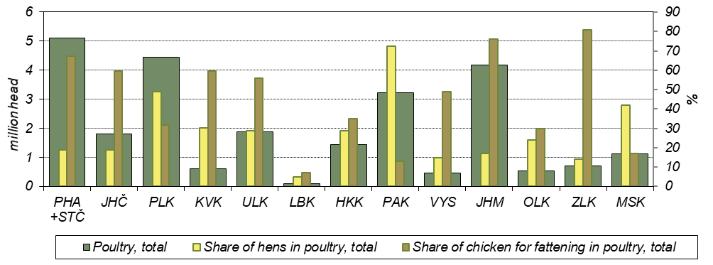

The highest shares of sheep were recorded in Jihočeský Region (14.2% of their total number). The lowest share, only 4.1%, was kept in Olomoucký Region. Sheep density was the highest in Liberecký Region and Zlínský Region (both 12 head per 100 ha of the UAA). Goats were raised mostly in Středočeský Region together with Hl. m. Praha Region (17.6% of their total number). For the sake of interest, it can be noted that the majority (54.2%) of deer reared on farms belonged to holdings from Pardubický Region.
Organically reared animals represented an important part of livestock in several regions. It concerned especially Karlovarský Region, where 63.6% of cattle (23.6% of dairy cows and 75.6% of other cows), 73.6% of sheep, and 74.6% of goats were raised at organic farms. The highest share of organically reared poultry was recorded in Liberecký Region (7.5%) and of pigs in Jihomoravský Region (only 0.3%). The lowest proportions of organically reared cattle were recorded in Jihomoravský Region (3.2%) and of sheep and goats in Pardubický Region (7.8% and 4.6%, respectively).

Graph 24: Dairy cows organically reared Graph 25: Sheep organically reared
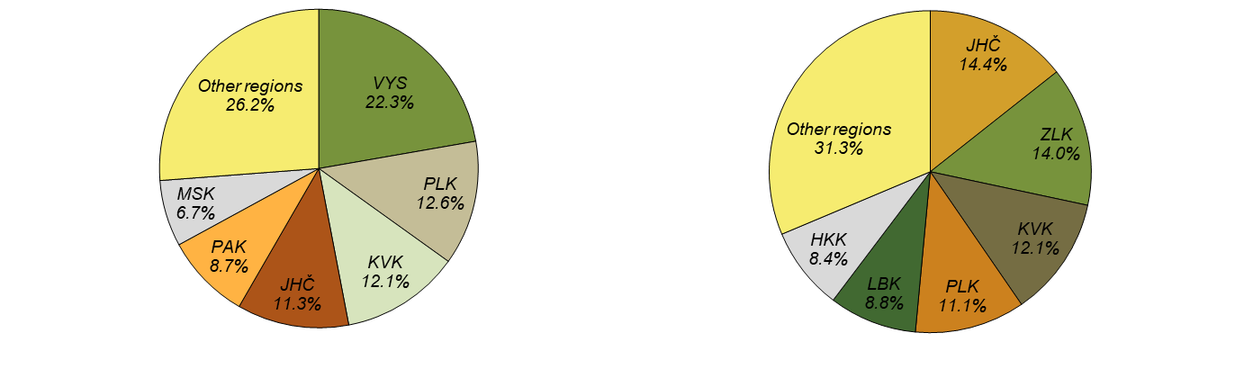
Fig. 3: Shares of livestock organically reared
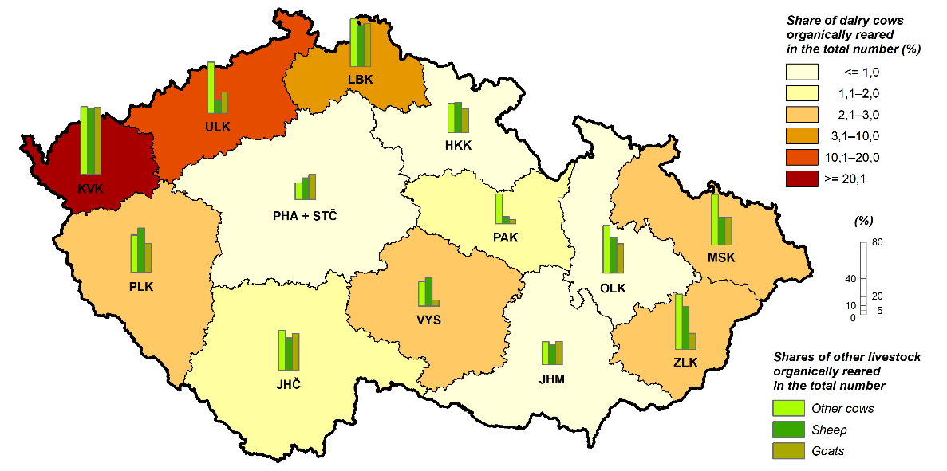
The largest proportion of working persons in agriculture was concentrated in Jihomoravský Region (16.1%) and Středočeský Region together with Hl. m. Praha Region (13.9%). The largest share of labour force regularly employed on labour force, total, was recorded in Jihomoravský Region (78.0%) and Karlovarský Region (77.9%); the lowest one in Ústecký Region (45.9%). The highest number of workers per one holding was in Pardubický Region (8.7 persons) and in Olomoucký Region and Ústecký Region (both 8.5 persons), the lowest one in Liberecký Region (4.3 persons). The average number of workers per 100 ha of the UAA ranged from 2.6 persons in Karlovarský Region to 7.9 persons in Jihomoravský Region. The share of women in persons regularly employed was the highest in Jihomoravský Region (36.6%) and Ústecký Region (35.0%) and the lowest in Plzeňský Region (29.6%) and Jihočeský Region (30.2%).
The share of Annual Work Units (AWU) in the total number of working persons was the highest in Karlovarský Region (65.0%). Ústecký Region and Jihomoravský Region differed from all other regions with the share lower than a half – only 40.1% and 47.5%, respectively.

Graph 26: Working persons per 100 ha of the utilised agricultural area
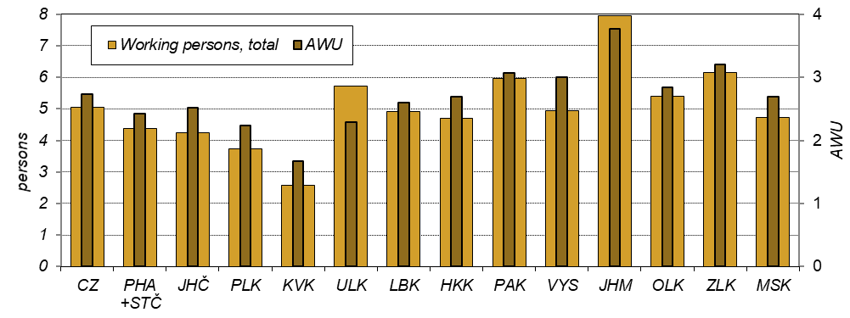

Labour force not regularly employed (i.e. working on the basis of a contract for work or for services) was most common in Středočeský Region together with Hl. m. Praha Region (7 230 persons) and Ústecký Region (6 248 persons). One person worked on average 166 hours; this number ranged from 126 hours in Pardubický Region to 236 in Karlovarský Region. Other persons working in agriculture were those employed not directly by agricultural holdings (self-employed persons or persons employed by job agencies). The largest number of persons of both sub-categories worked in Středočeský Region together with Hl. m. Praha Region (1 019 persons). The average number of hours worked by persons employed not directly by agricultural holdings was 595 hours, ranging from 378 hours in Ústecký Region to 1 136 hours in Pardubický Region.

