Adjustment of the methodology for calculating the Consumer Confidence Indicator from January 2022

To maintain international comparability, the Czech Statistical Office has been adjusting the calculation of the Consumer Confidence Indicator in conformity with the harmonized methodology of the European Commission since January 2022.
The purpose of the business survey among consumers is to collect information on households' spending and saving intentions and in this context to assess how consumers perceive the factors influencing these decisions (their current / expected financial situation, the development of consumer prices, the development of unemployment, and others).
All 15 surveyed questions are harmonized according to the methodology of the European Commission and for the above purpose they can be divided into four topics: 1) the households' financial situation, 2) the general economic situation, 3) savings and 4) intentions with regard to major purchases.
The Czech Statistical Office (CZSO) uses the obtained answers, among other things, to calculate the harmonized Consumer Confidence Indicator (CCI), which in conjunction with the sub-sectoral business confidence indicators enters into the calculation of the harmonized Economic Sentiment Indicator (ESI).
The European Commission's Directorate-General for Economic and Financial Affairs (DG ECFIN) has published Consumer Confidence Indicators (CCI) since the 1970s and evaluates the suitability of its design at irregular intervals, especially in response to external impulses from users and partner institutions. After the last change in the composition of the questions entering the calculation of the indicator, which was made in 2001, the CCI consisted of the following four questions/indicators:
- How do you expect the financial position of your household to change over the next 12 months? It will… (get a lot better; get a little better; stay the same; get a little worse; get a lot worse; don’t know),
- How do you expect the general economic situation in this country to develop over the next 12 months? It will… (get a lot better; get a little better; stay the same; get a little worse; get a lot worse; don’t know),
- How do you expect the number of people unemployed in this country to change over the next 12 months? The number will… (increase sharply; increase slightly; remain the same; fall slightly; fall sharply; don’t know),
- Over the next 12 months, how likely is it that you save any money? (very likely; fairly likely; not likely; not at all likely; don’t know).
Since 2001, significant structural and geographical changes have taken place in the EU economy. And although the composition of the questions set in 2001, at least at the level of EA and EU27, continues to track reference indicator, i.e. household final consumption expenditure rather well, the analyzes carried out showed that, in particular, the results at the level of individual Member States lag behind their potential.
To assess the analytical potential of the current CCI construction, DG ECFIN carried out an analysis in 2018 comparing the current indicator with five alternative combinations of harmonized questions. The comparison relies on five analytical blocks 1) correlation analysis in relation to the reference indicator, 2) ability to track the directional change of the reference indicator, 3) predictive ability of a selected variant against the reference indicator (nowcast + forecast), 4) volatility analysis and 5) potential impact on ESI.
The combination of questions about consumers’ personal finance with their expectations in relation to the overall economic situation proved to be the most suitable for the consumer confidence indicator, in most respects outperforming the current indicator and other analyzed alternatives (for more see DG ECFIN A revised Consumer Confidence Indicator).
The resulting CCI is the arithmetic average of the seasonally adjusted balances (in percentage points) of the answers to the following questions:
- How has the financial situation of your household changed over the last 12 months? It has… (got a lot better; got a little better; stayed the same; got a little worse; got a lot worse; don’t know),
- How do you expect the financial position of your household to change over the next 12 months? It will… (get a lot better; get a little better; stay the same; get a little worse; get a lot worse; don’t know),
- How do you expect the general economic situation in this country to develop over the next 12 months? It will… (get a lot better; get a little better; stay the same; get a little worse; get a lot worse; don’t know),
- Compared to the past 12 months, do you expect to spend more or less money on major purchases (furniture, electrical/electronic devices, etc.) over the next 12 months? I will spend… (much more; a little more; about the same; a little less; much less; don’t know).
Since January 2022, the time series published on the CZSO website have already contained the revised values of the Consumer Confidence Indicator as well as the Economic Sentiment Indicator. Impact on balances and on the published CCI and ESI basic indices is quantified in the file impact_of_the_adjustment_of_the_cci_calculation_on_the_relevant_time_series.xlsx.
The developments in the balances and basic indices of the Consumer Confidence Indicator before and after the change in the composition of the questions can be seen in the graphs in Annex 1, the impact on the Economic Sentiment Indicator in Annex 2 below.

Annex 1 Development of balances and basic indices of the Consumer Confidence Indicator before the change in the composition of the questions (blue series) and after the change (red series)

Graph 1 Seasonally adjusted balances of the Consumer Confidence Indicator

Graph 2 Basic indices of the Consumer Confidence Indicator (average 2003-2021=100)

Annex 2 Development of balances and basic indices of the Economic Sentiment Indicator before the change in the composition of the questions entering the CCI (blue series) and after the change (red series)

Graph 3 Balances of the Economic Sentiment Indicator
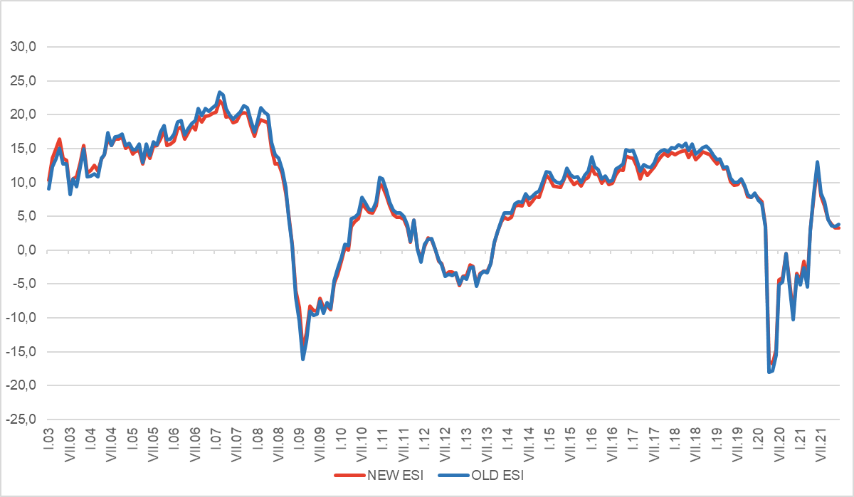

Graph 4 Basic indices of the Economic Sentiment Indicator (average 2003-2021=100)

