10 February 2023

Development of international trade in goods price indices in the Q4 2022 and in the year 2022

In the Q4 2022, compared to the Q3 2022, export prices decreased by 1.6%. In the year-on-year (y-o-y) comparison, export prices increased by 9.8% in the Q4 2022. Import prices decreased by 4.1% in the Q4 2022 compared to the Q3 2022. In the y-o-y comparison, import prices increased by 11.8% in the Q4 2022. The terms of trade reached the value of 102.6% in the Q4 2022 compared to the Q3 2022. In the year-on-year comparison, the terms of trade reached the value of 98.2% in the Q4 2022. In the average for the whole year 2022, compared to the year 2021, export prices increased by 12.7%, import prices by 17.2%, and the terms of trade amounted to 96.2%.

**Export prices**

**Quarter-on-quarter** (q-o-q; the Q4 2022 compared to the Q3 2022), they decreased by 1.6%. The following prices decreased the most: prices of ‘mineral fuels, lubricants and related materials’ by 9.1% (prices of electric current, petroleum products, and coal), ‘crude materials, inedible, except fuels’ by 7.3% (mainly wood and waste paper), and ‘chemicals and related products’ by 4.0% (especially organic chemicals and plastics). Only prices of ‘beverages and tobacco’ increased by 4.3% and prices of ‘food and live animals’ by 2.0% (mainly sugars). Prices of ‘machinery and transport equipment’ remained unchanged.

**Year-on-year**, in the Q4 2022, they increased by 9.8% (in the Q3 2022 it was by 14.9%). The highest increase of prices was in ‘mineral fuels, lubricants and related materials’ by 64.3% (prices of electric current, gas, petroleum products, and coal), ‘food and live animals’ by 20.8% (mainly prices of cereals, dairy products and birds' eggs), and ‘manufactured goods classified chiefly by material’ by 14.0% (mainly prices of manufactures of metals, iron and steel). Only prices of ‘crude materials, inedible, except fuels’ decreased by 1.6% (primarily prices of metal scrap and wood).

**In the average for the whole year 2022**, compared to the year 2021, they increased by 12.7% (for the year 2021, they increased by 5.8%). The following were increasing the most: prices of ‘mineral fuels, lubricants and related materials' by 120.1% (prices of electric current, coal, petroleum products, and gas), ‘food and live animals’ by 21.3% (mainly prices of cereals), and ‘manufactured goods classified chiefly by material’ by 18.9% (chiefly prices of manufactures of metals). Prices did not decrease in any of the surveyed groups of SITC 1.

**Import prices**

**Quarter-on-quarter** (the Q4 2022 compared to the Q3 2022), they decreased by 4.1%. Prices of ‘mineral fuels, lubricants and related materials’ decreased by 20.0% (primarily prices of petroleum and petroleum products, gas, electric current, and coal), prices of ‘crude materials, inedible, except fuels’ decreased by 7.7% (primarily prices of metalliferous ores, metal scrap, and wood), and prices of ‘chemicals and related products’ by 3.1% (especially plastics). Prices of the following increased: ‘beverages and tobacco’ by 4.7%, ‘miscellaneous manufactured articles’ by 2.4%, and ‘food and live animals’ by 1.8%.

**Year-on-year**, in the Q4 2022, they increased by 11.8% (in the Q3 2022 it was by 21.8%). The highest increase of prices was in ‘mineral fuels, lubricants and related materials’ by 46.8% (prices of gas, petroleum and petroleum products, electric current, and coal), ‘food and live animals’ by 21.5% (mainly prices of meat and meat preparations), ‘beverages and tobacco’ by 20.6%, and ‘miscellaneous manufactured articles’ by 11.6%. Prices did not decrease in any of the surveyed groups of SITC 1.

**In the average for the whole year 2022**, compared to the year 2021, they increased by 17.2% (for the year 2021, they increased by 6.1%). Prices of the following increased the most: prices of ‘mineral fuels, lubricants and related materials’ by 104.4% (prices of petroleum and petroleum products, electric current, gas, and coal), ‘manufactured goods classified chiefly by material’ (mainly iron, steel, and manufactures of metals) and ‘beverages and tobacco’ increased both by 16.6%, and ‘food and live animals’ by 14.7% (mainly prices meat and meat preparations). Prices did not decrease in any of the surveyed groups of SITC 1.

**The terms of trade**

Quarter-on-quarter (the Q4 2022 compared to the Q3 2022), they increased to the value of 102.6%. The highest positive value of the terms of trade was reached by ‘mineral fuels, lubricants and related materials’ (113.6%), the lowest negative value was recorded by ‘miscellaneous manufactured articles’ (96.3%).

Year-on-year, in the Q4 2022, they increased to the value of 98.2% (in the Q3 2022 the value was 94.3%) and for the seventh quarter they remained in the negative values – see the Chart No 2. The lowest negative values of the terms of trade were reached by ‘beverages and tobacco’ the same as ‘crude materials, inedible, except fuels’ (both 92.3%), the highest positive value of the terms of trade was recorded by ‘mineral fuels, lubricants and related materials’ (111.9%).

In the average for the whole year 2022, compared to the year 2021, they reached the value of 96.2% (in 2021, they amounted to 99.7%), which was the lowest value since 2000.

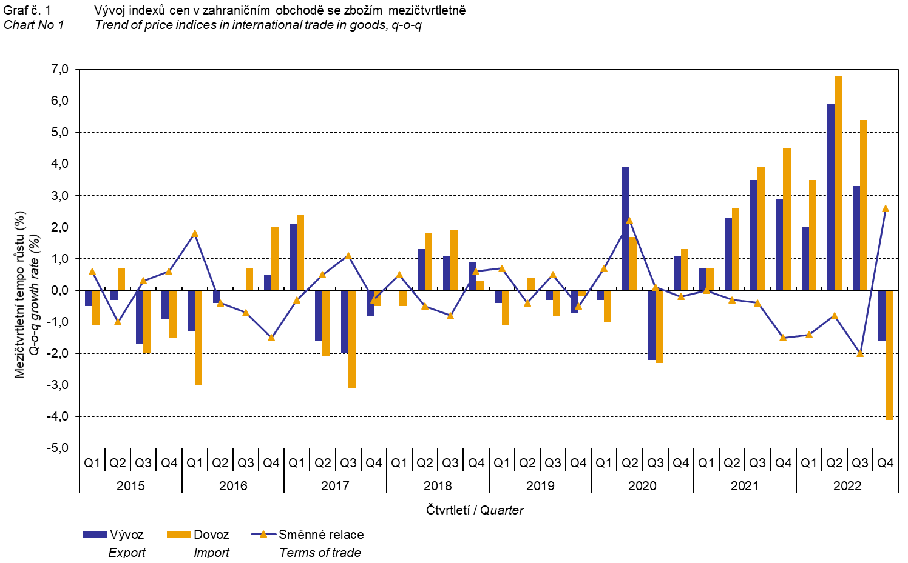

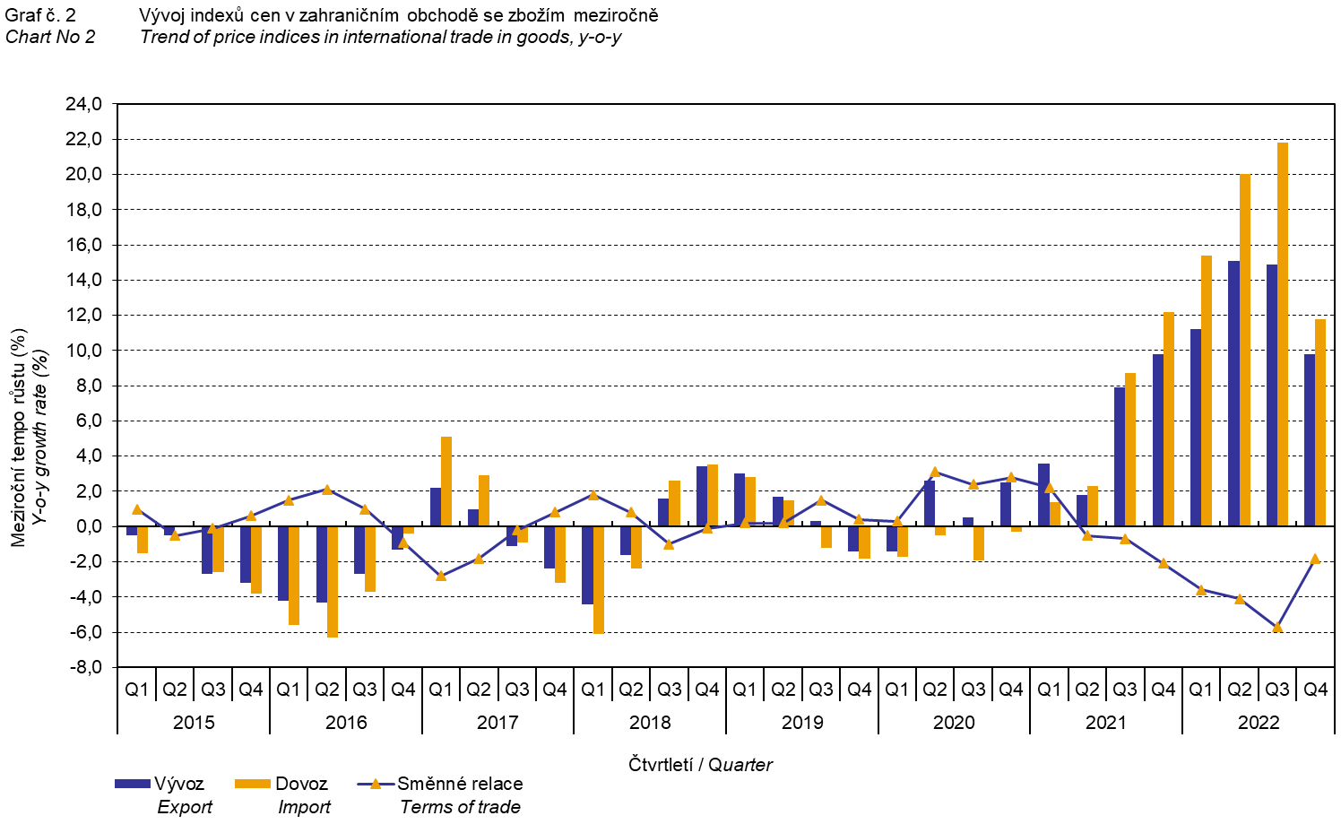

The international trade in goods (change of ownership) price development was also significantly influenced by the CZK exchange rate to the major foreign currencies. **The q-o-q** exchange rate **index** includes two most important currencies in terms of the Czech Republic's international trade, i.e. EUR and USD. Q-o-q indices of the CZK exchange rate to these currencies were weighted by the respective weight, which pertains to those foreign currencies in the export price index and in the import price index.

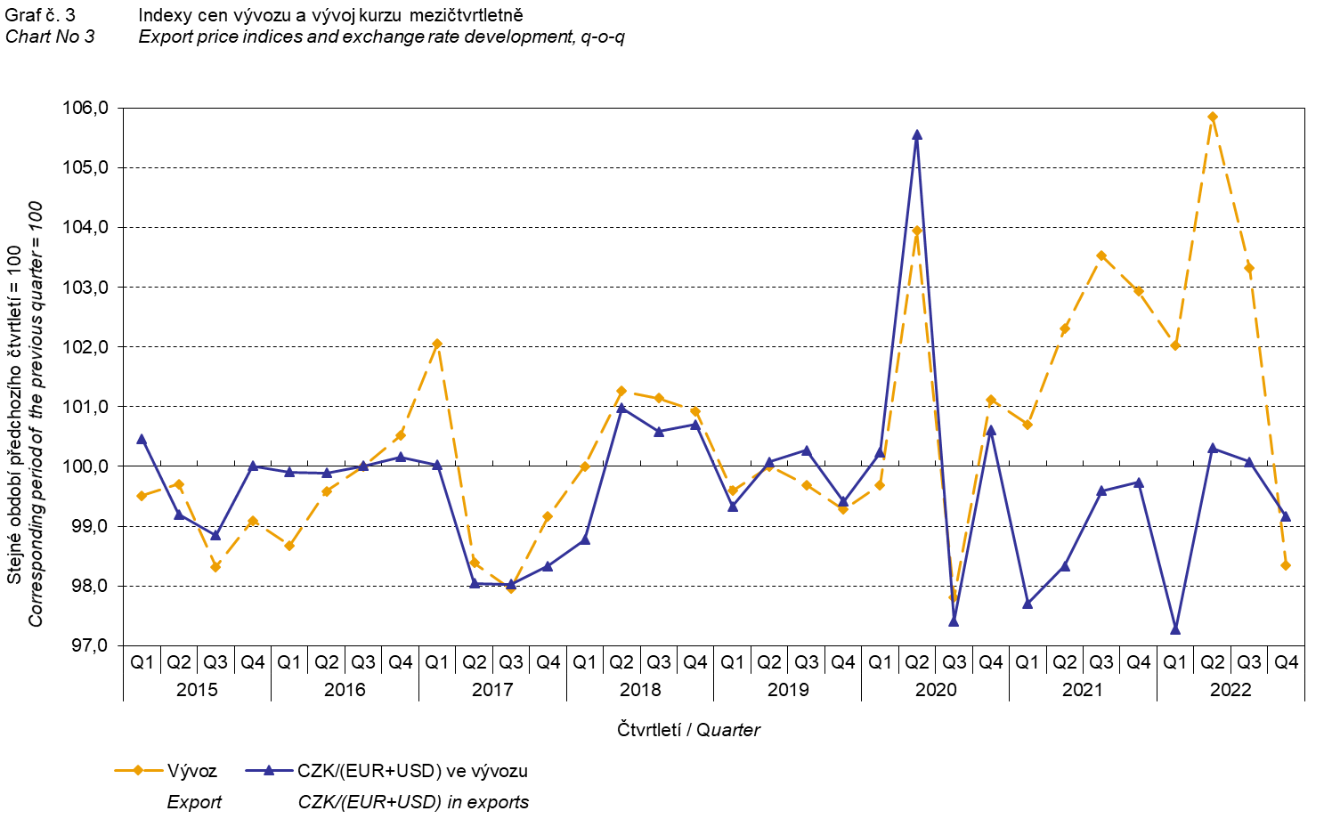

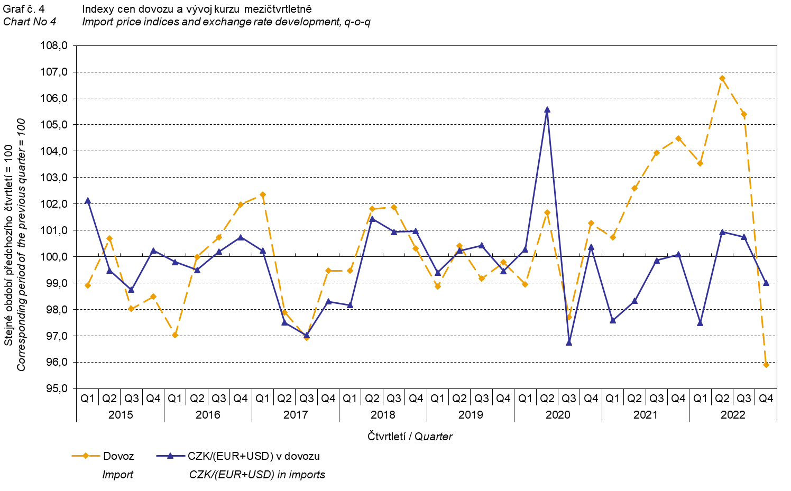

It is obvious from the Chart No 3 and the Chart No 4 above that in both exports and imports, international trade in goods prices have a relation to exchange rate influences. Contracts with foreign entities are usually concluded for longer periods of time and the longer the contract period is, the stronger the relation to exchange rates is.

**International trade in goods price indices, year-on-year, adjusted for exchange rate influence**

The Czech Statistical Office also calculates year-on-year international trade in goods price indices adjusted for effects of exchange rate. It is carried out as follows: prices in foreign currencies reported in the current month are **converted** to Czech crowns by the **exchange rate** of the same month **of the previous year**. Then they are used for the weighted mean calculation together with prices reported in CZK. This exchange rate adjusted base price index of a month is related to the non-adjusted base price index of the corresponding month of the previous year and thus the year-on-year adjusted price index for a month is calculated. Adjusted quarter-on-quarter price indices have also been calculated similarly since 2017. **Differences between adjusted and non-adjusted price indices may be considerable**; they are clear from the Chart No 6 and the Chart No 7, for example, in the Q2 2021.

The employed method does not enable to make a 100% exchange rate adjustment because not all trade transactions made in foreign currencies are also reported in foreign currencies; the proportion does not exceed 30%. From the aforementioned it follows that **at the full exchange rate adjustment, differences** between the published price indices and the exchange rate adjusted price indices **would** probably further **increase**.

The exchange rate adjusted indices described above can also be used to make the exchange rate adjusted breakdown of increments of price indices. The Table 1 gives the **published and exchange rate adjusted breakdown of increments** of export and import price indices, supplemented by the most important two-digit code groups of the SITC 7. The breakdown illustrates well how many percentage points each of the groups “exchange rate contributed” to the index.

# In general it holds true that the exchange rate effect decreases the value of price indices in international trade in goods if CZK is strengthening to foreign currencies in total. Conversely, the exchange rate effect pushes the price indices up if CZK is weakening to foreign currencies in total.

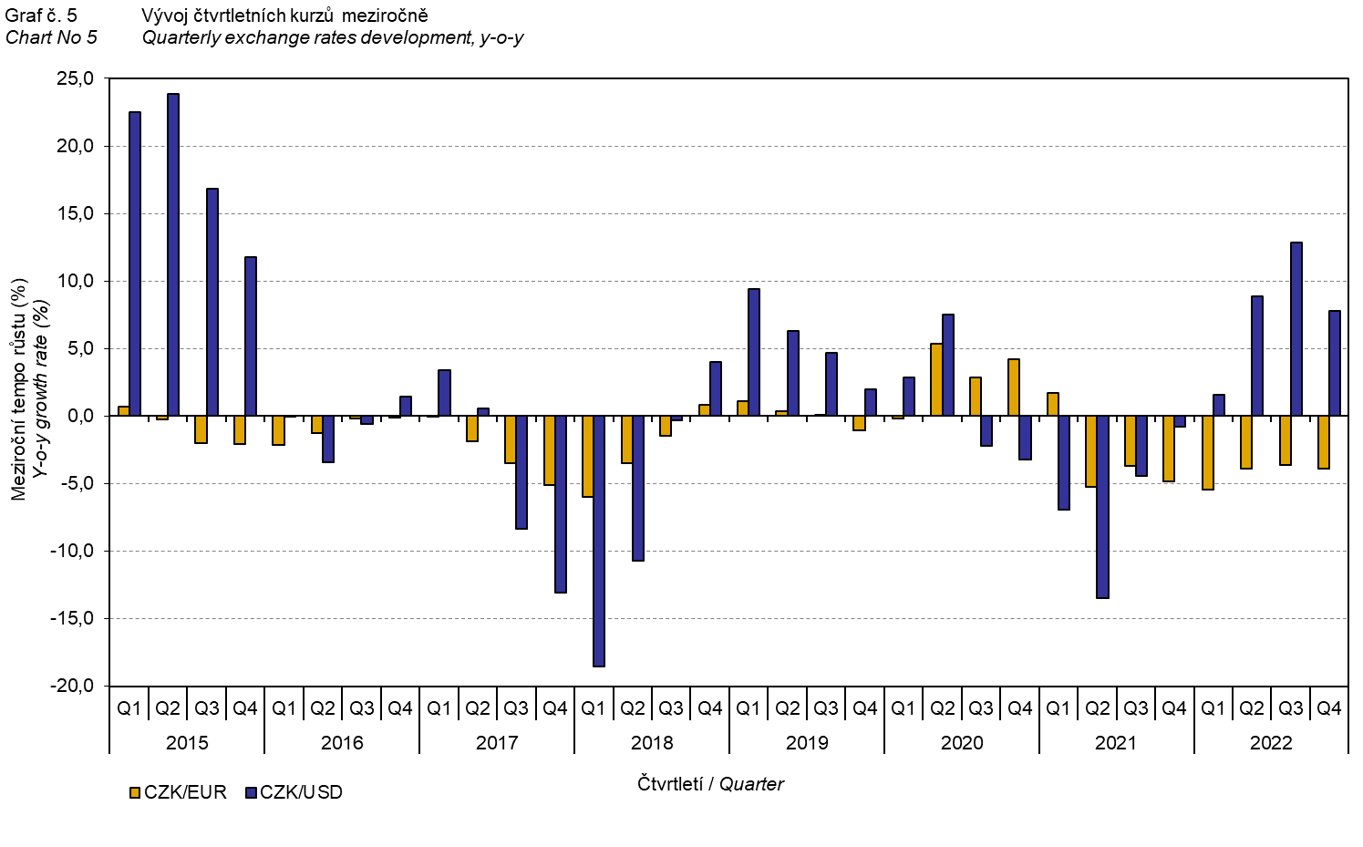

It is apparent from the Chart No 6 and the Chart No 7 below how significant the exchange rate influence on the value of the export and import price indices was.

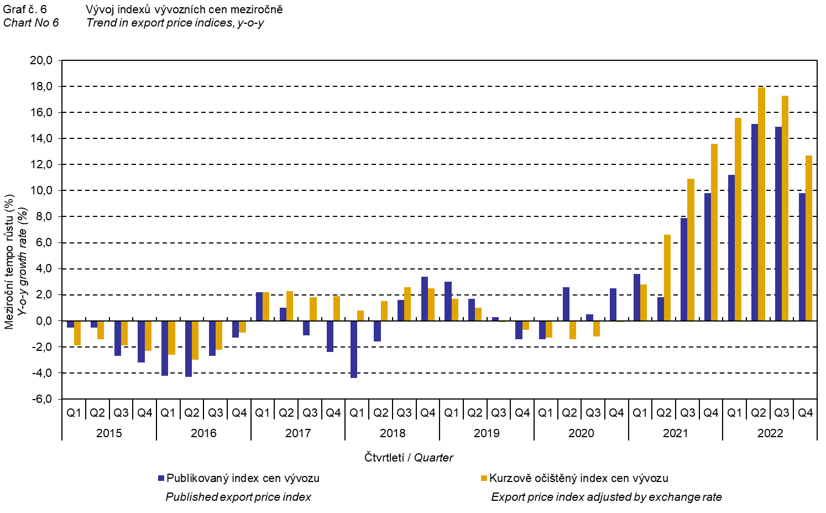

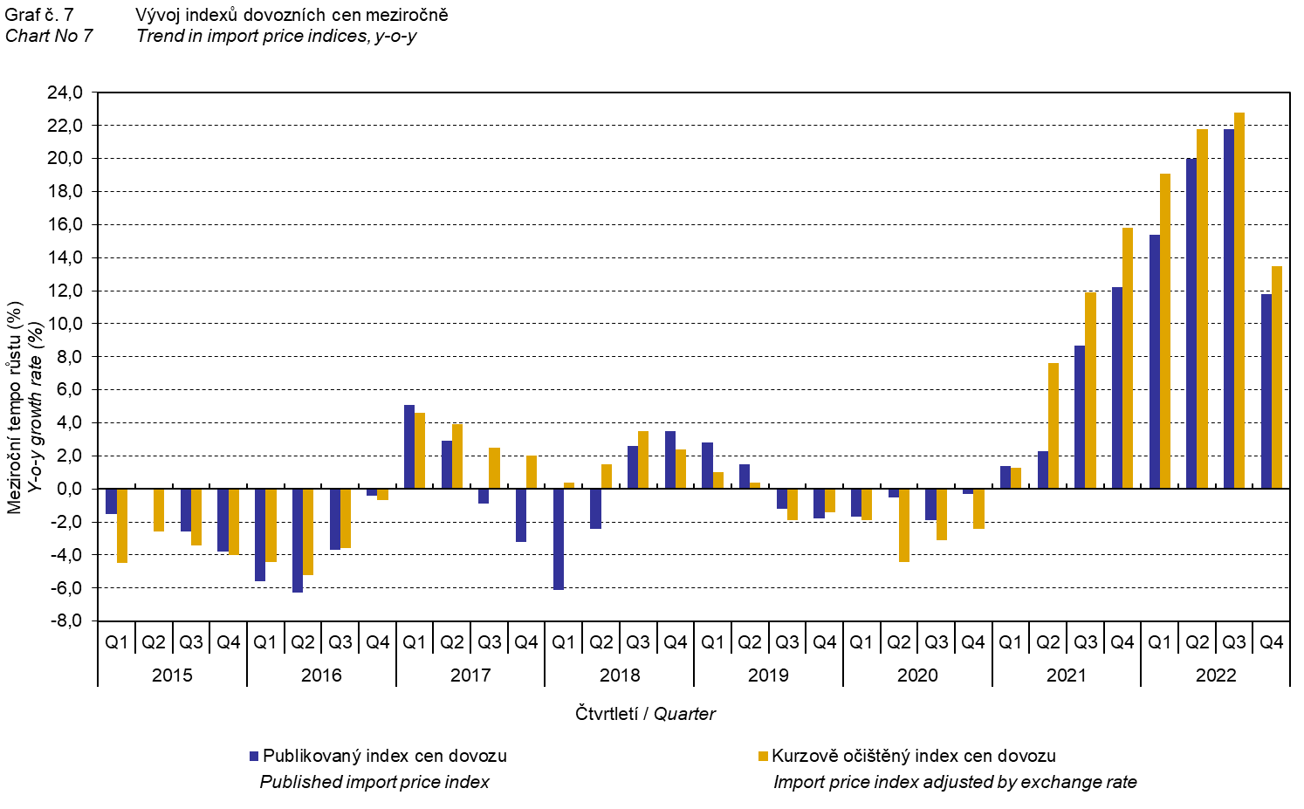

The Chart No 8 shows the exchange rate influence on the value of the year-on-year terms of trade.

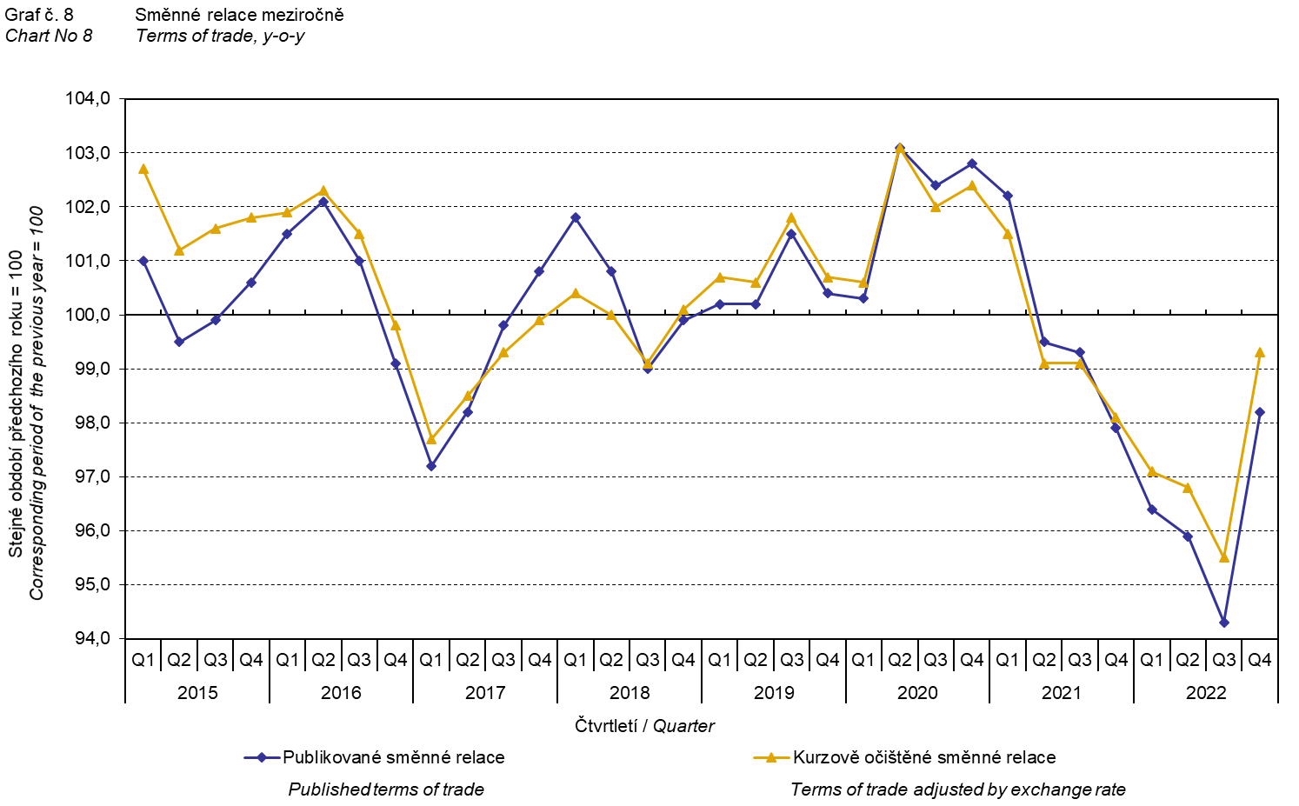

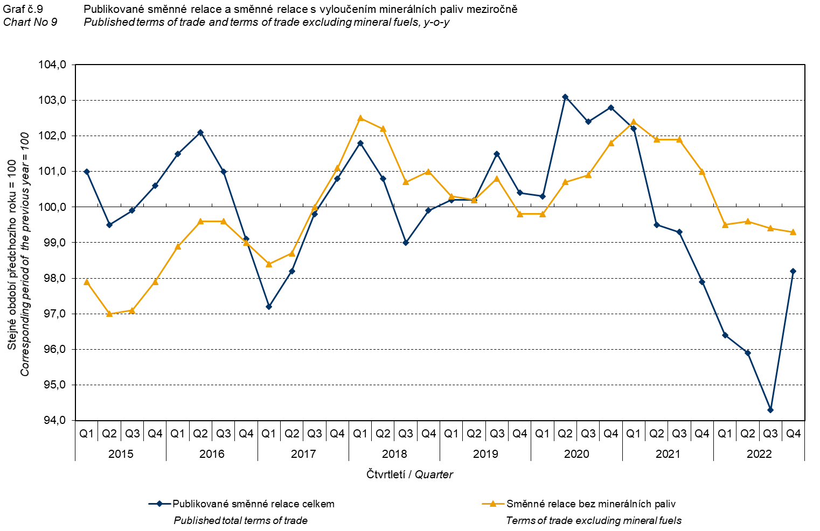

The Chart No 9 shows the development of the value of the terms of trade when the group of ‘mineral fuels, lubricants and related materials’ is excluded. In this chart, the effect of ‘mineral fuels, lubricants and related materials’ can be observed; it has an influence on the total value of the y-o-y terms of trade. Since the Q3 2019, ‘mineral fuels, lubricants and related materials’ were increasing the value of the terms of trade; however, there was a turnabout in the Q1 2021 and ‘mineral fuels, lubricants and related materials’ started to decrease the value of the terms of trade. Understandably, it is related to the world market price development, especially as for petroleum prices. Import prices, which, compared to export prices, have a higher proportion of crude materials, respond in a more sensitive way to price turbulences and therefore the terms of trade are usually increasing when prices of crude materials are decreasing, and, vice versa, when prices of crude materials are increasing, the terms of trade are decreasing.

# Final summary

The exchange rate effect decreased both the export price index and the import prices index, in the Q4 2022, year-on-year. Import prices were increasing faster than export prices and therefore the terms of trade reached negative values. The terms of trade increased to 98.2% in the Q4 2022 (in the Q3 2022, they decreased to 94.3%, which was the lowest value since the Q2 2000). After elimination of the exchange rate effect, the terms of trade were higher than the published terms of trade; despite that they remained in negative values. Values free of the exchange rate effect correspond to the exchange rate adjusted indices – see the Charts Nos. 6, 7, and 8.



The closing table gives published **non-adjusted** international trade in goods price indices. 

*Note: For internal reasons, the Czech decimal comma is used instead of the English decimal point as a decimal separator in tables and charts of this analysis.*

**Elaborated by:** Hana Lapáčková, Prices Statistics Department

phone number: (+420) 274 052 709, e-mail: hana.lapackova@czso.cz