10 August 2022

International trade price indices development in the Q2 2022

In the Q2 2022, compared to the Q1 2022, export prices increased by 5.9%. In the year-on-year (y-o-y) comparison, export prices increased by 15.1% in the Q2 2022. Import prices increased by 6.8% in the Q2 2022 compared to the Q1 2022. In the y-o-y comparison, import prices increased by 20.0% in the Q2 2022. The terms of trade reached the value of 99.2% in the Q2 2022 compared to the Q1 2022. In the year-on-year comparison, the terms of trade reached the value of 95.9% in the Q2 2022.

**Export prices**

**Quarter-on-quarter** (q-o-q; the Q2 2022 compared to the Q1 2022), they increased by 5.9%. The following prices increased the most: prices of ‘mineral fuels, lubricants and related materials’ by 19.8% (especially prices of petroleum products, coal, and gas), prices of ‘crude materials, inedible, except fuels’ by 13.8% (especially prices of wood), and prices of ‘food and live animals’ by 12.6% (mainly prices of cereals). Prices did not decrease in any of the surveyed major SITC groups.

**Year-on-year**, in the Q2 2022, they increased by 15.1% (in the Q1 2022 it was by 11.2%). The highest increase of prices was in ‘mineral fuels, lubricants and related materials’ by 151.3% (prices of electric current, petroleum products, gas, and coal), prices of ‘crude materials, inedible, except fuels’ increased by 36.6% (mainly prices of wood and metal scrap), prices of ‘food and live animals’ by 26.0% (mainly prices of cereals), prices of ‘manufactured goods classified chiefly by material’ increased by 24.8% (mainly prices of iron and steel and manufactures of metals), and prices of ‘chemicals and related products’ increased by 17.3%. Prices did not decrease in any of the surveyed SITC 1 groups.

**Import prices**

**Quarter-on-quarter** (the Q2 2022 compared to the Q1 2022), they increased by 6.8%. Prices of ‘mineral fuels, lubricants and related materials’ increased by 20.9% (primarily prices of petroleum and petroleum products and gas), prices of ‘crude materials, inedible, except fuels’ increased by 14.8% (primarily prices of metalliferous ores and wood), prices of ‘food and live animals’ by 7.6% (primarily prices of meat and meat preparations), and prices of ‘manufactured goods classified chiefly by material’ increased by 7.1% (primarily prices of iron and steel, non-ferrous metals, and manufactures of metals). Prices did not decrease in any of the surveyed groups.

**Year-on-year**, in the Q2 2022 they increased by 20.0% (in the Q1 2022 it was by 15.4%). The highest increase of prices was in ‘mineral fuels, lubricants and related materials’ by 134.0% (primarily prices of gas, petroleum and petroleum products, electric current, and coal), prices of ‘manufactured goods classified chiefly by material’ increased by 23.0% (primarily prices of iron and steel, non-ferrous metals, and paper), prices of ‘crude materials, inedible, except fuels’ increased by 17.5% (primarily prices of wood), and prices of ‘chemicals and related products’ increased by 15.8% (especially prices of plastics). Prices did not decrease in any of the surveyed groups.

**The terms of trade**

**Quarter-on-quarter** (the Q2 2022 compared to the Q1 2022), they increased to the value of 99.2%. The lowest negative value of the terms of trade was reached by ‘beverages and tobacco’ (98.3%), the highest positive value was recorded by ‘food and live animals’ (104.6%).

**Year-on-year**, in the Q2 2022, they decreased to the value of 95.9% (in the Q1 2022 the value was 96.4%) and for the fifth quarter they remained in the negative values – see the Chart No 2. The lowest negative values of the terms of trade were reached by ‘beverages and tobacco’ (89.7%) and the highest positive value of the terms of trade was recorded by ‘crude materials, inedible, except fuels’ (116.3%).

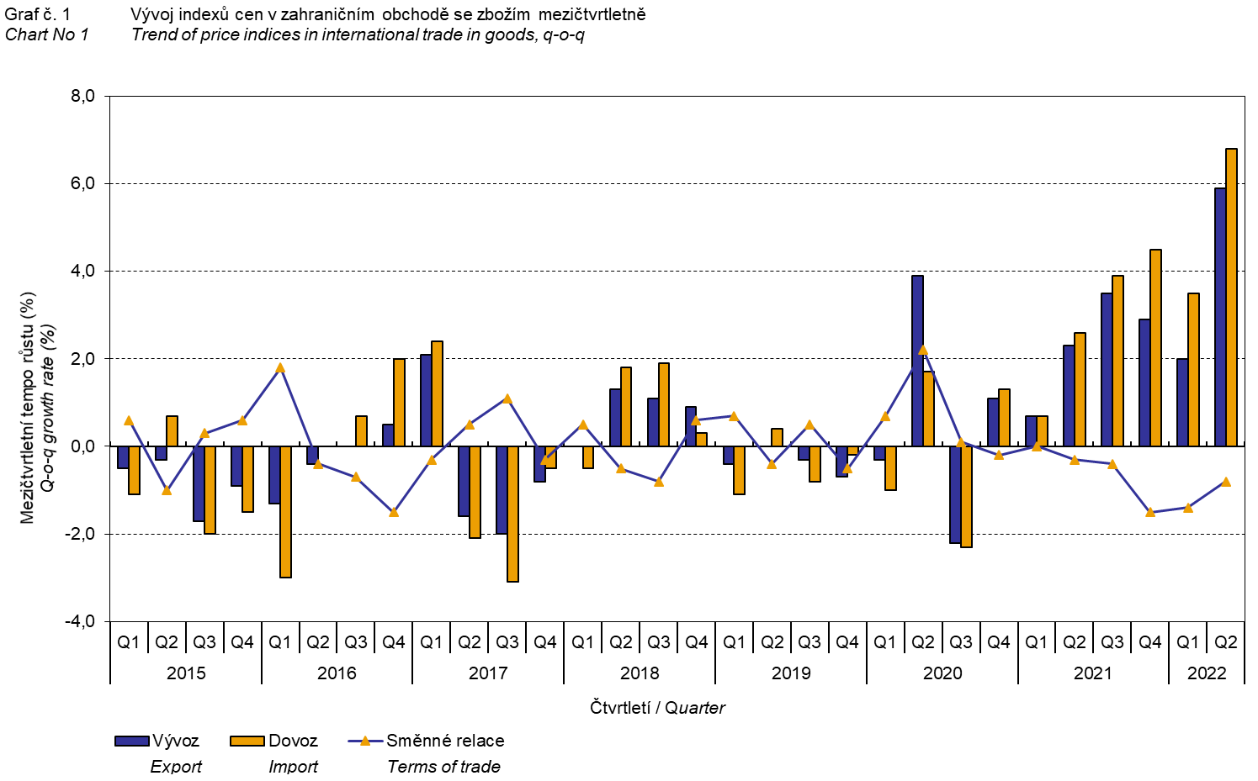

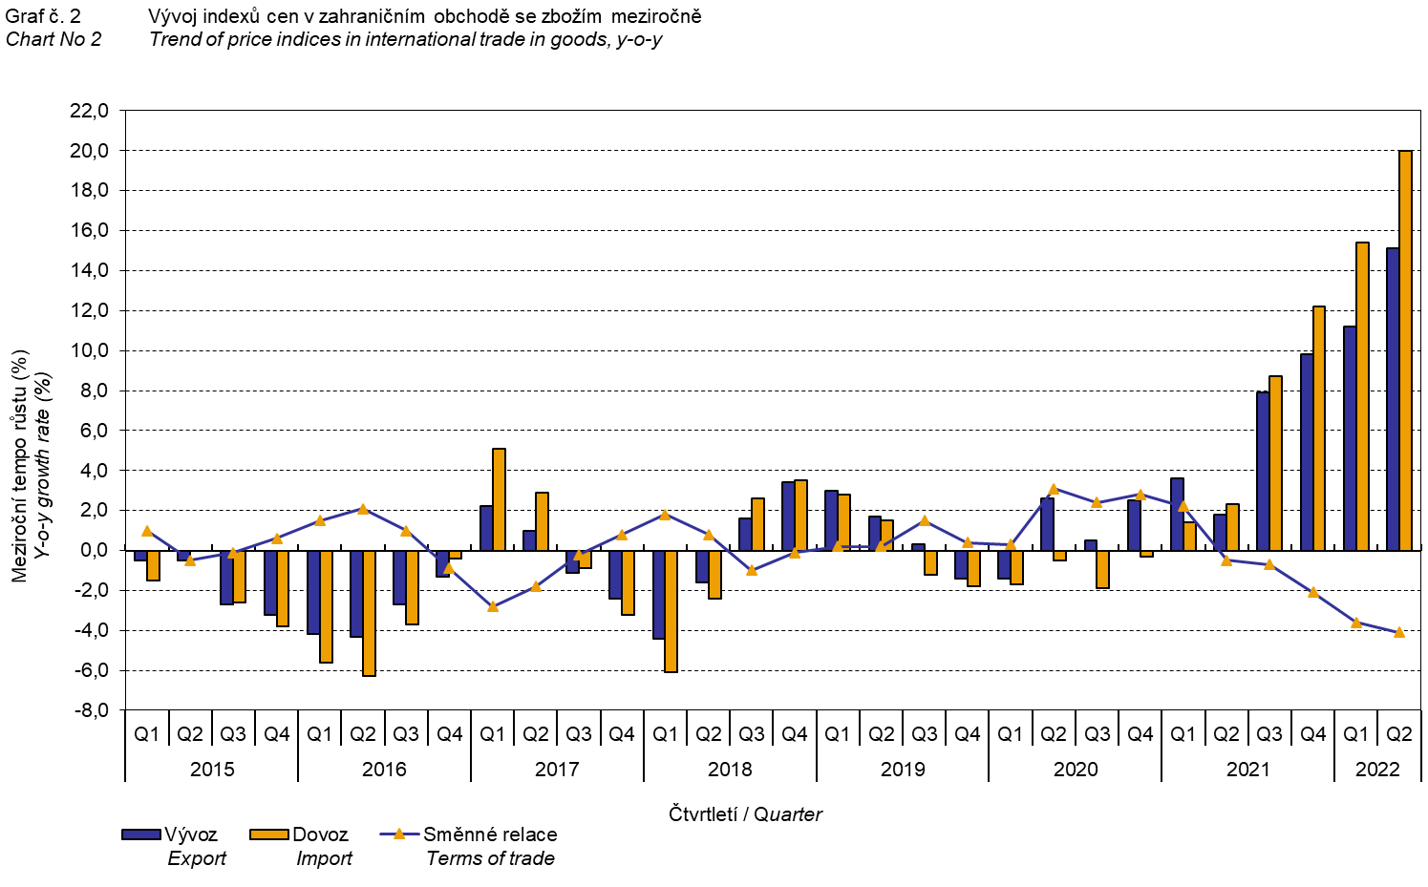

The international trade in goods (change of ownership) price development was also significantly influenced by the CZK exchange rate to the major foreign currencies. **The q-o-q** exchange rate **index** includes two most important currencies in terms of the Czech Republic's international trade, i.e. EUR and USD. Q-o-q indices of the CZK exchange rate to these currencies were weighted by the respective weight, which pertains to those foreign currencies in the export price index and in the import price index.

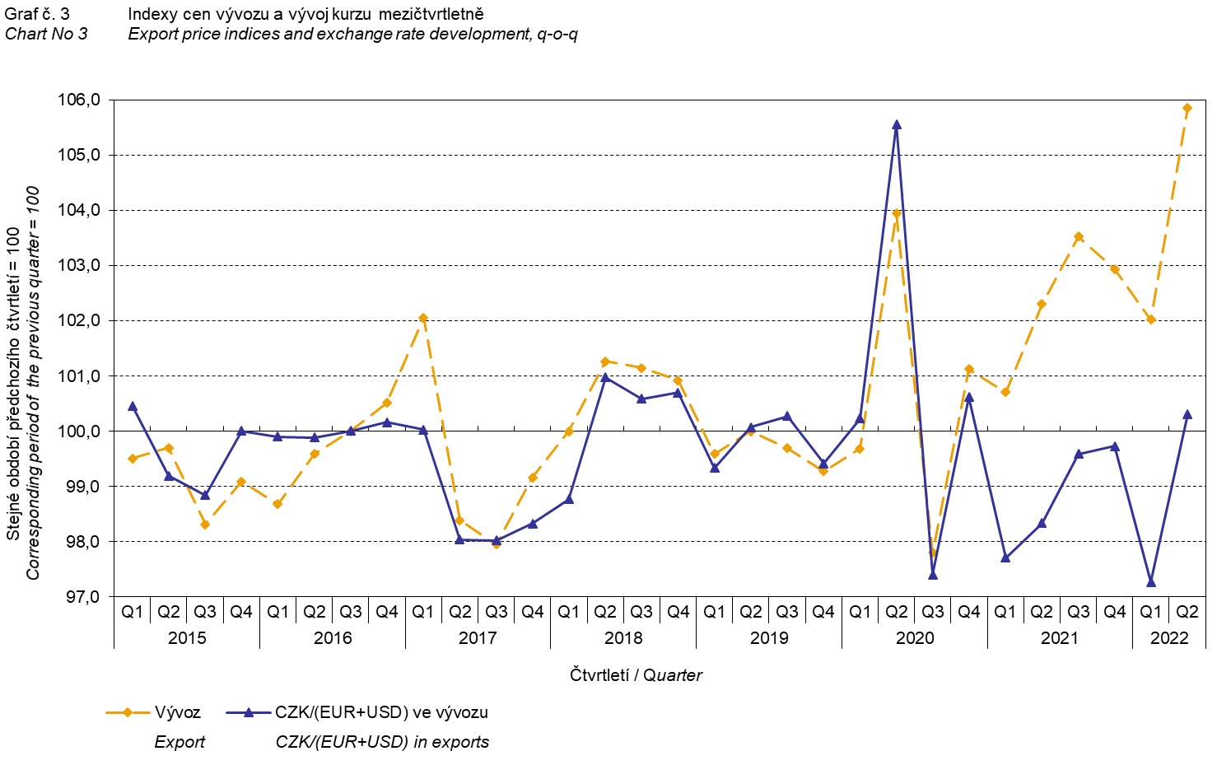

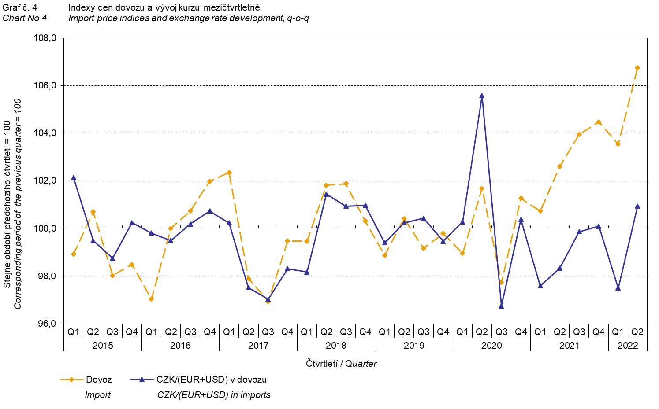

It is apparent from the Chart No 3 and the Chart No 4 above that in both exports and imports, international trade in goods prices have a relation to exchange rate impacts. Contracts with foreign entities are usually concluded for a longer period of time and the longer the contract period is, the stronger the relation to exchange rates is.

# International trade in goods price indices, year-on-year, adjusted for exchange rate influence

The Czech Statistical Office also calculates year-on-year international trade in goods price indices adjusted for effects of exchange rate. It is carried out as follows: prices in foreign currencies reported in the current month are **converted** to Czech crowns **by the exchange rate** of the same month **of the previous year**. Then they are used for the weighted mean calculation together with prices reported in CZK. This exchange rate adjusted base price index of a month is related to the non-adjusted base price index of the corresponding month of the previous year and thus the year-on-year adjusted price index for a month is calculated. Adjusted quarter-on-quarter price indices have been calculated similarly since 2017. **Differences between adjusted and non-adjusted price indices may be considerable**; they are obvious in the Chart No 6 and the Chart No 7, for example, in the Q2 2021.

The method employed does not enable to make a 100% exchange rate adjustment because not all trade transactions made in foreign currencies are also reported in foreign currencies; the proportion does not exceed 30%. From the aforementioned it follows that **at the full exchange rate adjustment, differences** between the price indices published and the exchange rate adjusted price indices **would** probably further **increase**.

The exchange rate adjusted indices described above can also be used to make the exchange rate adjusted breakdown of increments of price indices. The Table 1 gives the **published and exchange rate adjusted breakdown of increments** of export and import price indices, supplemented by the most important two-digit code groups of the SITC 7. The breakdown illustrates well how many percentage points each of the groups “exchange rate contributed” to the index.

# It is generally true that the exchange rate effect decreases the value of price indices in international trade in goods if CZK is strengthening to foreign currencies in total. Conversely, the exchange rate effect pushes the price indices up if CZK is weakening to foreign currencies in total.

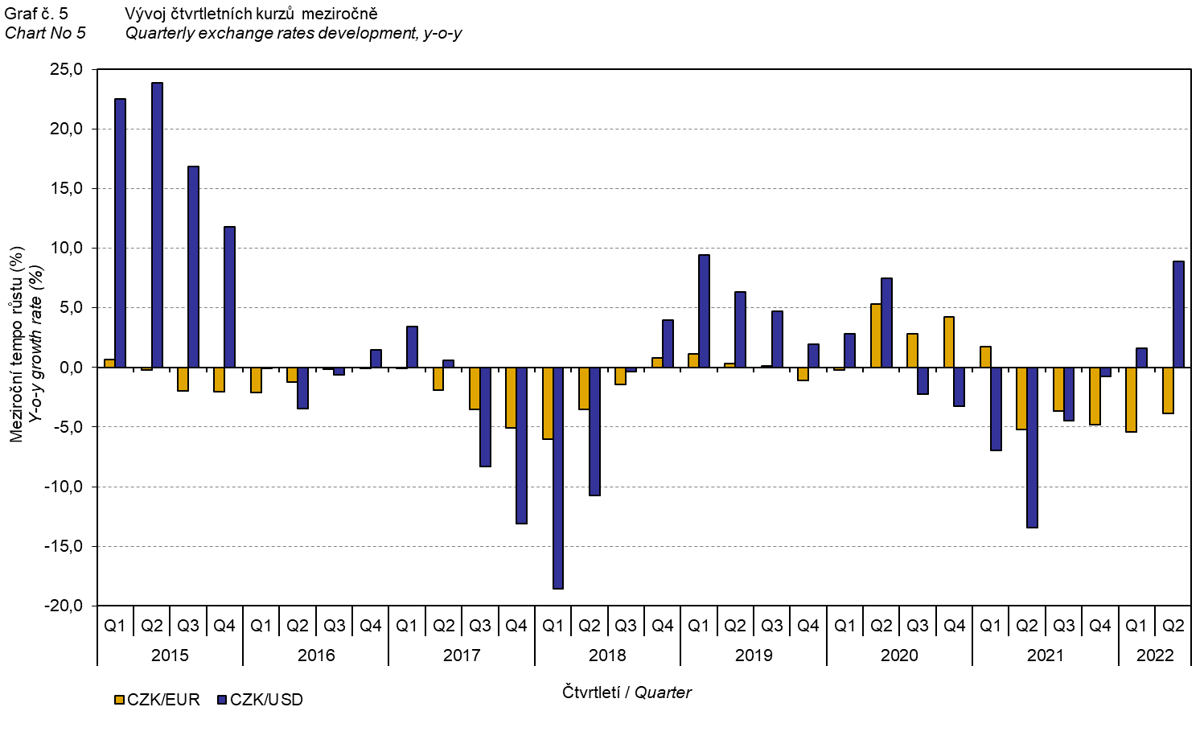

It is apparent from the Chart No 6 and the Chart No 7 below how significant the exchange rate influence on the value of the export and import price indices was.

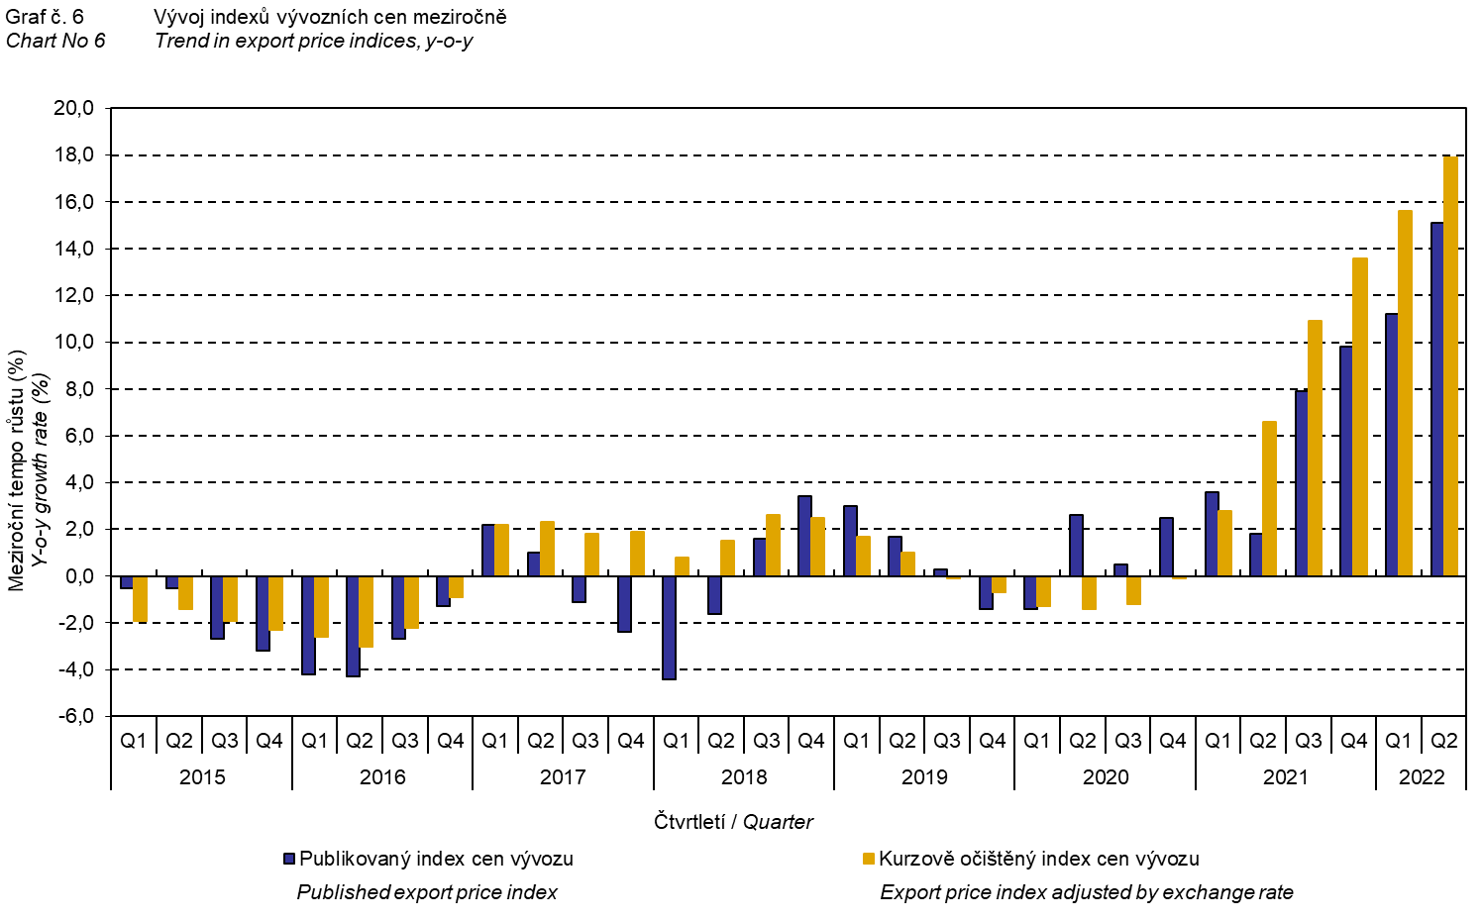

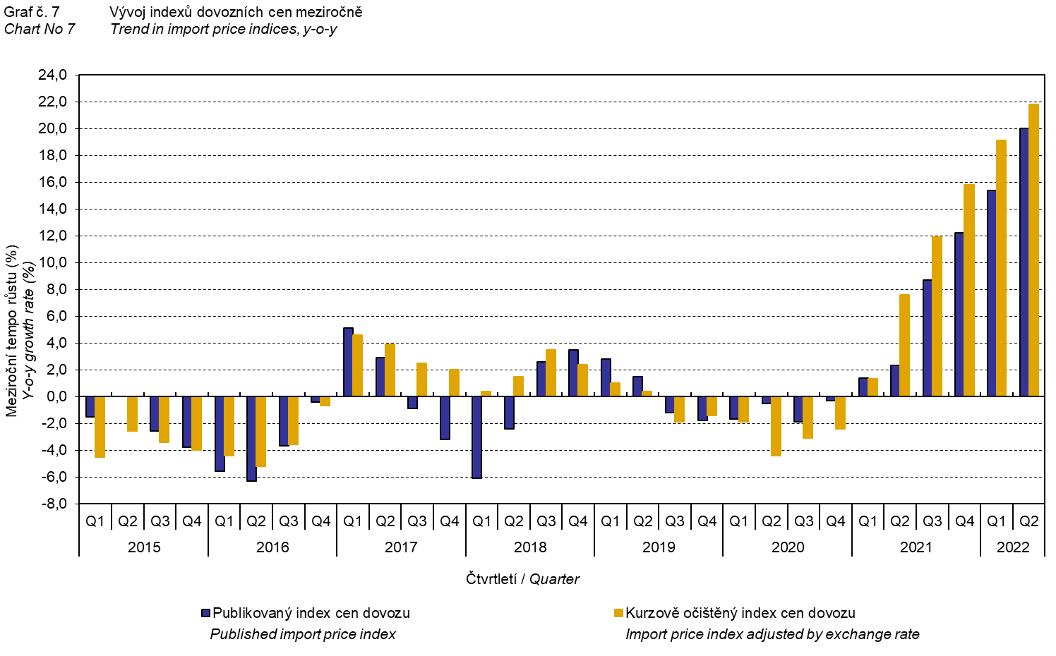

The Chart No 8 shows the exchange rate influence on the value of the year-on-year terms of trade.

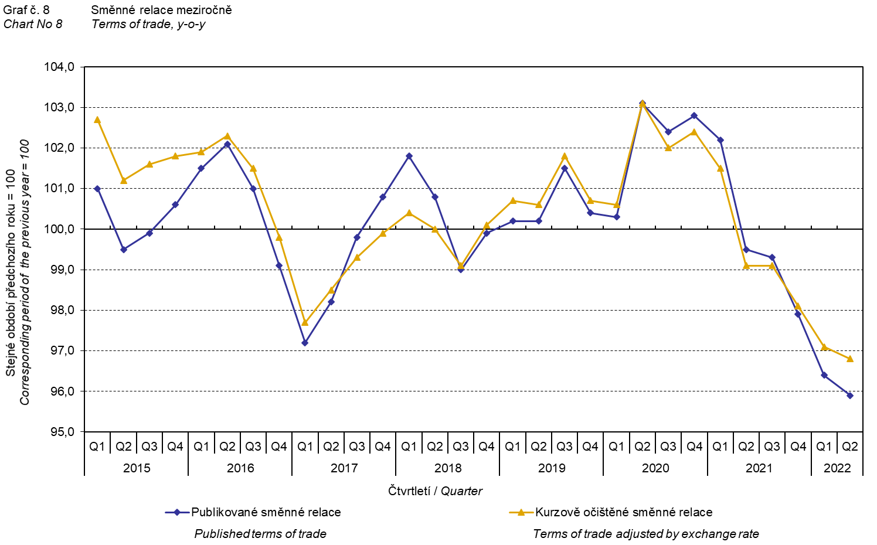

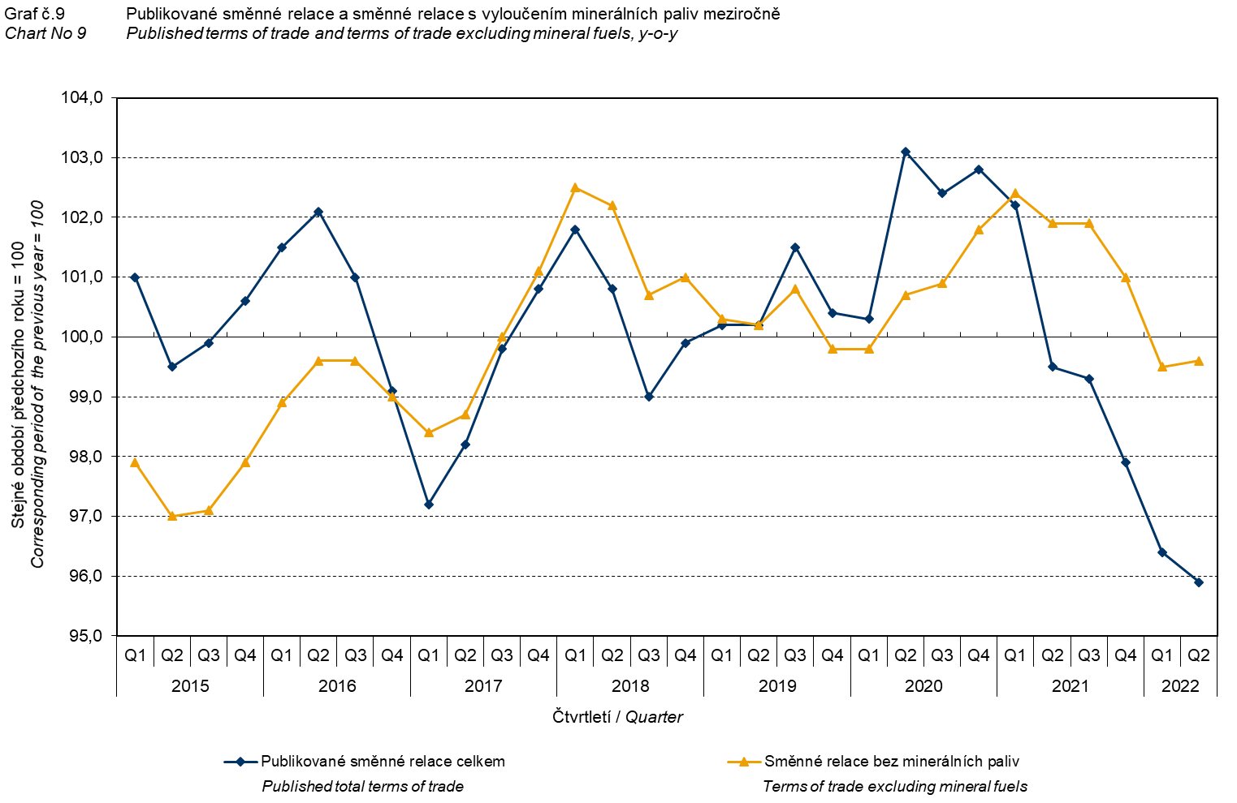

The Chart No 9 shows the development of the value of the terms of trade when the group of ‘mineral fuels, lubricants and related materials’ is excluded. In this chart, the effect of ‘mineral fuels, lubricants and related materials’ can be observed; it has an influence on the total value of the y-o-y terms of trade. Since the Q3 2019, ‘mineral fuels, lubricants and related materials’ were increasing the value of the terms of trade; however, in the Q1 2021 there was a turnabout and ‘mineral fuels, lubricants and related materials’ started to decrease the value of the terms of trade. Naturally, it is related to the world market price development, especially as for petroleum prices. Import prices, which, compared to export prices, have a higher proportion of crude materials, respond in a more sensitive way to price turbulences. Therefore, the terms of trade are usually increasing when prices of crude materials are decreasing, and, vice versa, when prices of crude materials are increasing, the terms of trade are decreasing.

# Final summary

In the Q2 2022, the exchange rate effect considerably decreased both the export price index and the import prices index, year-on-year. Import prices were increasing faster than export prices and therefore the terms of trade reached negative values. After elimination of the exchange rate effect, the terms of trade were higher than the published terms of trade; despite that, they remained in negative values. Values free of the exchange rate effect correspond to the exchange rate adjusted indices – see the Charts Nos. 6, 7, and 8.



The closing table gives published **non-adjusted** international trade in goods price indices. 

*Note: For internal reasons, the Czech decimal comma is used instead of the English decimal point as a decimal separator in tables and charts of this analysis.*

**Elaborated by:** Hana Lapáčková, Prices Statistics Department

phone number: (+420) 274 052 709, e-mail: hana.lapackova@czso.cz