Press release

31 March 2021
How can I tell that I really got counted?
How can a respondent tell in the Online Census that he/she successfully filled in and sent the electronic census form (questionnaire)? The system will inform him/her about it by displaying an announcement about successful submission of the form.
“After you successfully send the electronic census form (questionnaire), an announcement about your successful submission will appear on your screen. It will contain, among other things, the precise date and time of sending (submission) and also a unique code generated in the form of the number of the census form sent. By displaying of the announcement it is guaranteed that the system has received the census form for further processing,” Jolana Voldánová, 2021 Census spokeswoman, says.

If you want to, for personal reasons, you can print the page with the announcement (for example, by using the Ctrl + P keyboard shortcut) or you can take a screenshot. The system does not send an announcement about the successful submission to your e-mail address for security reasons as well as due to personal data protection. If somebody has not received the announcement after having sent the census form, it means that his/her internet connection was probably lost during the sending (submitting) of the census form. If that is the case, he/she then has to open a new census form and fill in the data again. However, the system makes it possible to save the form on an ongoing basis, which may help, for example, users with a worse internet connection.

“If somebody is not sure whether he/she really got counted and sent the census form successfully, he/she can do it again. You can also do that in case you realise that you have made a mistake when filling in the census form by providing a wrong piece of data. When you send more census forms, the last one will be the one which is valid,” Jolana Voldánová points out.

It will be possible to get counted in a safe way by means of the electronic census form (questionnaire) on the website www.scitani.cz or in the mobile application throughout the entire period of the Census up until 11 May.
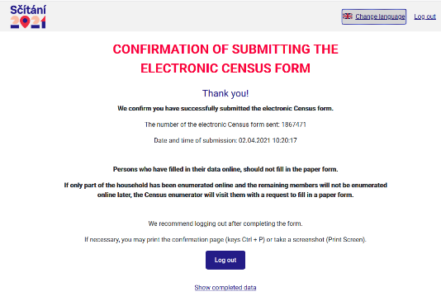
Contact:
Jolana Voldánová
2021 Census spokeswoman
Mobile phone number: +420 704 659 357
e-mail: jolana.voldanova@scitani.cz

