12 October 2020

Development of consumer price indices in the Q3 2020

The total consumer price level increased by 0.8% in the Q3 2020 compared to the Q2 2020. Consumer prices increased by 3.3% in the Q3 2020, year-on-year (y-o-y), which is by 0.2 percentage point (p. p.) less compared to the Q2 2020.

The **quarter-on-quarter** (q-o-q) development of consumer prices in the Q3 2020 was influenced mainly by a price increase in recreation and culture', ‘transport’, 'alcoholic beverages and tobacco'. The increase in prices in 'recreation and culture' was mainly due to an increase in prices of package holidays by 19.6%. In 'transport', prices of fuel and oil prices increased by 5.3% and of car prices by 3.1%. In 'alcoholic beverages, tobacco', prices of tobacco and tobacco products increased by 6.0%, prices of spirits were higher by 1.2%, wines by 0.1%, beer by 0.4%. An opposite influence, i.e. on decrease in the overall consumer price level was mainly due to a price decrease in ‘food and non-alcoholic beverages’, where prices of vegetable went down by 18.0%, of which prices of potatoes by 31.1%. Prices of bread and cereals were lower by 0.6%, meat by 0.9%, fruit by 4.3%. Prices in the group milk, cheese, eggs decreased by 1.1%. The average month-on-month change in the aggregate consumer price index in the Q3 2020 was –0.1%, in the Q2 2020 it was 0.3%.

Consumer price indices (previous quarter = 100)

|  |  |  |  |  |  |
| --- | --- | --- | --- | --- | --- |
|  | 2019 | | 2020 | | |
| DIVISION | Q3 | Q4 | Q1 | Q2 | Q3 |
| TOTAL | 100.6 | 100.4 | 101.8 | 100.3 | 100.8 |
| Food and non-alcoholic beverages | 100.0 | 101.4 | 103.5 | 101.5 | 97.6 |
| Alcoholic beverages and tobacco | 100.2 | 100.4 | 103.7 | 102.2 | 103.7 |
| Clothing and footwear | 97.0 | 104.3 | 100.0 | 102.2 | 98.1 |
| Housing, water, electricity, gas and other fuels | 100.6 | 100.9 | 101.5 | 100.1 | 100.2 |
| Furnishings, household equipment and routine household maintenance | 100.5 | 100.9 | 100.5 | 101.3 | 100.5 |
| Health | 100.4 | 99.3 | 100.2 | 101.9 | 101.3 |
| Transport | 99.8 | 99.8 | 100.2 | 96.7 | 103.1 |
| Communication | 99.5 | 98.0 | 98.6 | 99.6 | 100.0 |
| Recreation and culture | 104.5 | 96.0 | 103.1 | 98.6 | 104,7 |
| Education | 101.2 | 102.5 | 100.3 | 100.1 | 100.8 |
| Restaurants and hotels | 101.3 | 101.1 | 101.8 | 100.8 | 101.1 |
| Miscellaneous goods and services | 100.6 | 100.3 | 101.7 | 100.8 | 100.5 |

Consumer prices rose by 3.3%, **year-on-year (y-o-y), in the Q3 2020 compared to the Q2 2019**, i.e. by 0.2 percentage point less than in the Q2. This development was mainly influenced by a slowdown in the price decline in the ‘transport’ and an acceleration in growth in the ‘alcoholic beverages and tobacco’. An opposite influence, i.e. slower rise in prices was mainly due to price developments in ‘food and non-alcoholic beverages’ and in ‘housing’.

Changes in the price development in the Q3 2020 reflected in acceleration of the y-o-y growth of the market prices to 3.3% (in the Q2 2020 they grew by 3.1%). The growth of regulated prices in the Q3 2020 was 3.4% the same as in the Q2 2020.

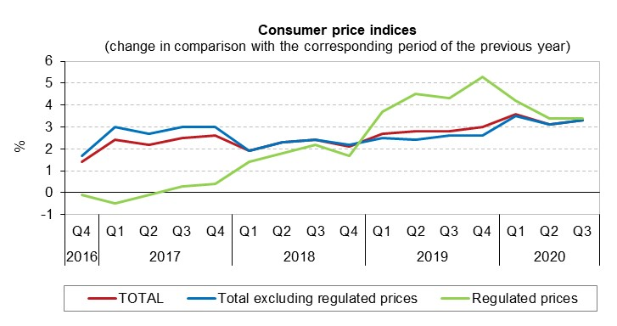

The biggest influence on the acceleration of price level growth occurred in 'transport', where prices of cars went up by 7.0% (in the Q2 2020 they rose by 3.4%).Prices of fuels and lubricants for personal transport equipment went down by 14.0% (in Q2 2020 drop by 9.2%). The price of unleaded petrol Natural 95 was CZK 27.67 and the price of diesel oil was CZK 27.16 in September.

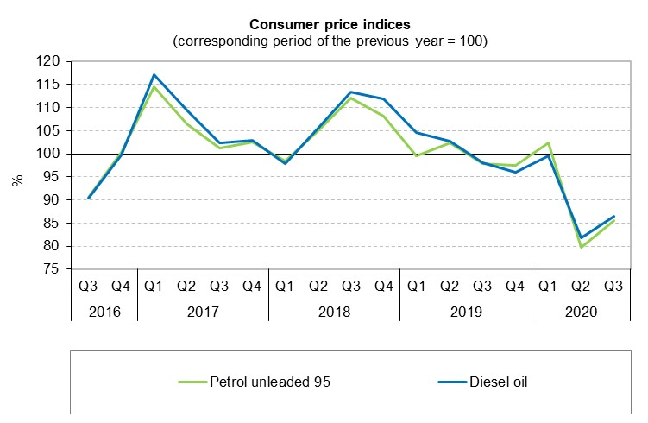

In ‘**alcoholic beverages, tobacco**’ prices of tobacco products went up by 14.0%. Prices of spirits increased by 9.5%, wine by 1.4% and beer by 4.5%.

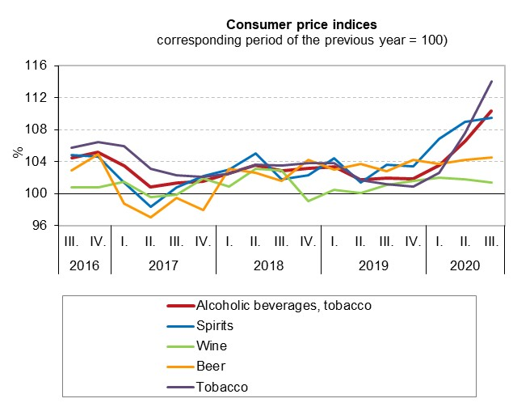

The slowdown in the growth of the price level was mainly influenced by prices in the ‘**food and non-alcoholic beverages**’. Prices of meat increased by 6.2% (increase by 10.8% in Q2), of which prices of pork by 4.0% and smoked meat and sausages by 8.7%. Fish prices increased by 0.2%. Prices in the group milk, cheese, eggs increased by 0.6% year-on-year in Q3 (increase by 2.2% in Q2), of which prices of cheese and curd by 2.7%. Prices of long life UHT milk decreased by 2.6% (increase by 3.4% in Q2). Yoghurt prices fell by 4.1% year-on-year (decrease by 2.6% in Q2). Egg prices increased by 5.3%. Prices of oils and fats were lower by 0.2%, of which prices of butter by 5.3%. Sugar prices went up by 13.2%. Prices of bread were higher by 1.6% and prices of flours and other cereals by 6.7%. Prices of fruit increased by 21.9%. Prices of non-alcoholic beverages went up by 3.2%, while prices of coffee were lower by 0.6%.

Prices of vegetable were lower by 4.1%, of which potatoes by 11.4% (increase by 0.8% in Q2).

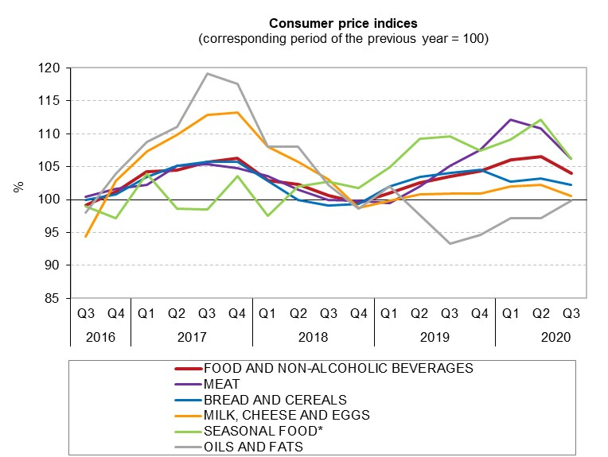

* Seasonal foods include fish and seafood, fruits and vegetables.

In **'housing, water, electricity, gas and other fuels'**, prices of electricity rose by 7.6% and prices of natural gas and town gas by 0.4%. Prices of actual rentals for housing rose by 2.5%, charges for water supply and sewage collection increased 1.7% and 1.5%, respectively. Prices of heat energy decreased by 1.2%. Imputed rentals for housing (own housing costs) increased by 1.9% (+2.6% in the Q2).

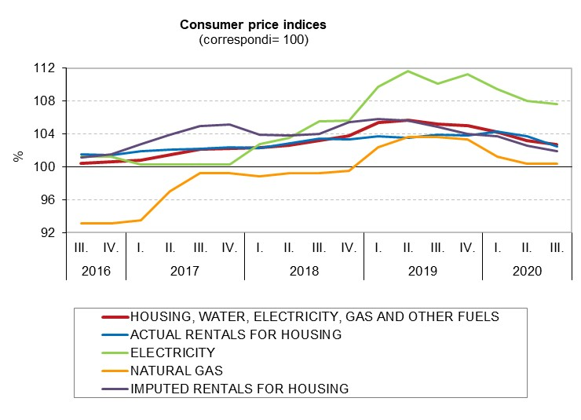

In **'clothing and footwear'**, prices of garments increased by 5.8% and prices of shoes and other footwear by 1.7%.

In '**restaurants and hotels**', prices in catering services increased by 5.5% and prices of accommodation services by 1.1%.

In **'miscellaneous goods and services'**, prices of financial services went up by 0.9%. Prices of personal care increased by 4.1%.

The aforementioned fluctuations in consumer prices resulted in a rise in prices of **goods in total** by 3.6% and prices of **services** by 2.8%

**Harmonized index of consumer prices in the EU27**

According to Eurostat data, the y-o-y change of the average harmonized index of consumer prices (HICP) in the EU27 was 0.8% in July 2020 and 0.4% in August. In the Czech Republic (CR), the y-o-y increase in the HICP was 3.6% in July and 3.5% in August. According to preliminary calculations, the HICP in the CR rose by 3.3%, y-o-y, in September. It is clear from the chart below that the HICP in the CR has been higher than the same indicator in the EU since January 2019 and the difference between the figures for the CR and for the EU has been gradually increasing. In August 2020, the y-o-y HICP decreased in 13 EU Member States, the figures ranged from –2.9% in Cyprus to +4.0% in Hungary.

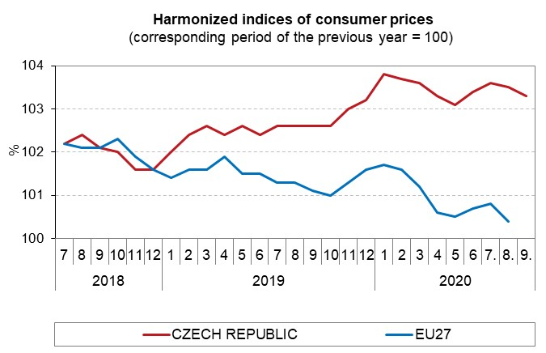

**Development of the consumer price index by ECOICOP division:**

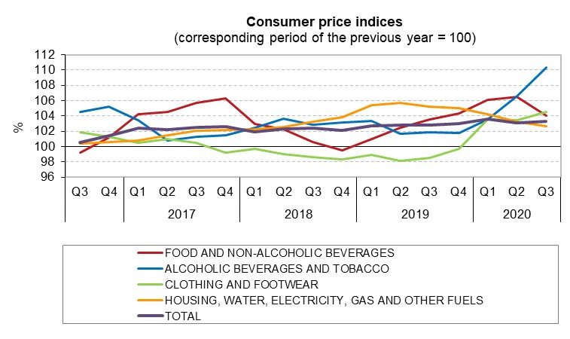

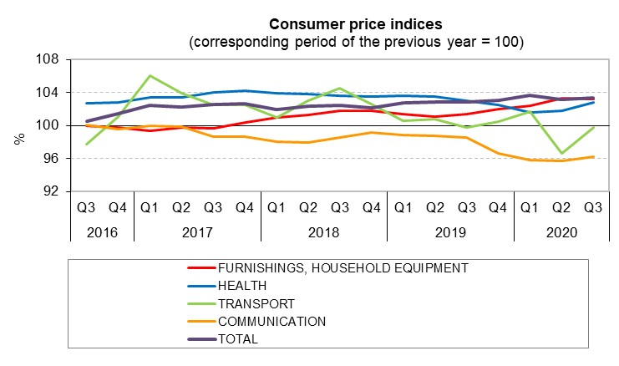

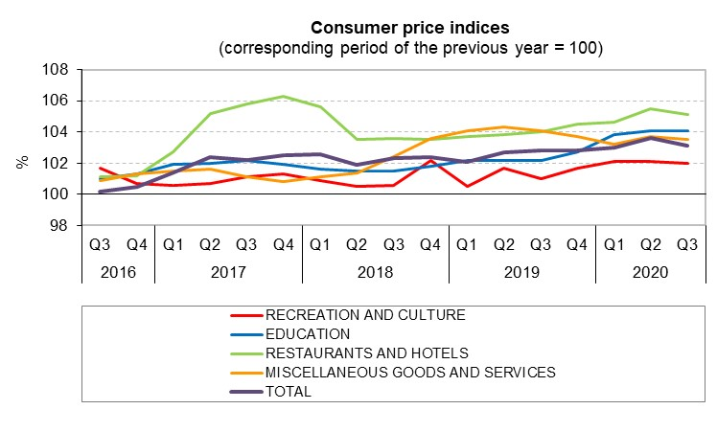

**Consumer price indices in the Q3 2020**



Elaborated by Consumer Prices Statistics Unit of the CZSO

Contact:

Jiří Trexler

Consumer Prices Statistics Unit

E-mail: [jiri.trexler@czso.cz](mailto:jiri.trexler@czso.cz)

Phone: (+420) 274 054 137