12 February 2021

International trade price indices development in the Q4 2020 and in the year 2020

In the Q4 2020, compared to the Q3 2020, export prices increased by 1.1% and import prices by 1.3%. The terms of trade reached the value of 99.8%. In the year-on-year (y-o-y) comparison, export prices increased by 2.5%, import prices decreased by 0.3%, and the terms of trade reached the value of 102.8% in the Q4 2020.

**In the average for the whole year 2020, compared to the year 2019, export prices increased by 1.1%, import prices decreased by 1.1%, and the terms of trade reached the value of 102.2%**

# Quarter-on-quarter comparison

Export prices increased by 1.1%, quarter-on-quarter (q-o-q), in the Q4 2020, compared to the Q3 2020. The following prices increased the most: prices of ‘crude materials, inedible, except fuels’ by 5.4%, ‘mineral fuels, lubricants and related materials’ by 5.0%, ‘food and live animals’ by 1.9%, and prices of ‘manufactured goods classified chiefly by material’ and ‘machinery and transport equipment’ increased the same by 1.1%. Prices decreased in none of the monitored groups of the SITC classification.

Import prices in the Q4 2020, compared to the Q3 2020, increased by 1.3%, q-o-q. The highest increase of prices was in ‘mineral fuels, lubricants and related materials’ by 11.7% (mainly prices of natural gas), ‘crude materials, inedible, except fuels’ by 3.0%, ‘beverages and tobacco’ by 2.2%, and ‘manufactured goods classified chiefly by material’ by 1.6%. Only prices of ‘food and live animals’ decreased by 1.6%.

The terms of trade in the Q4 2020, compared to the Q3 2020, decreased to the value of 99.8%. The lowest negative values of the terms of trade were recorded by ‘mineral fuels, lubricants and related materials’ (94.0%), ‘beverages and tobacco’ (98.2%), and ‘miscellaneous manufactured articles’ (99.1%). Positive values of the terms of trade were reached by ‘food and live animals’ (103.6%), ‘crude materials, inedible, except fuels’ (102.3%), and ‘machinery and transport equipment’ (100.9%).

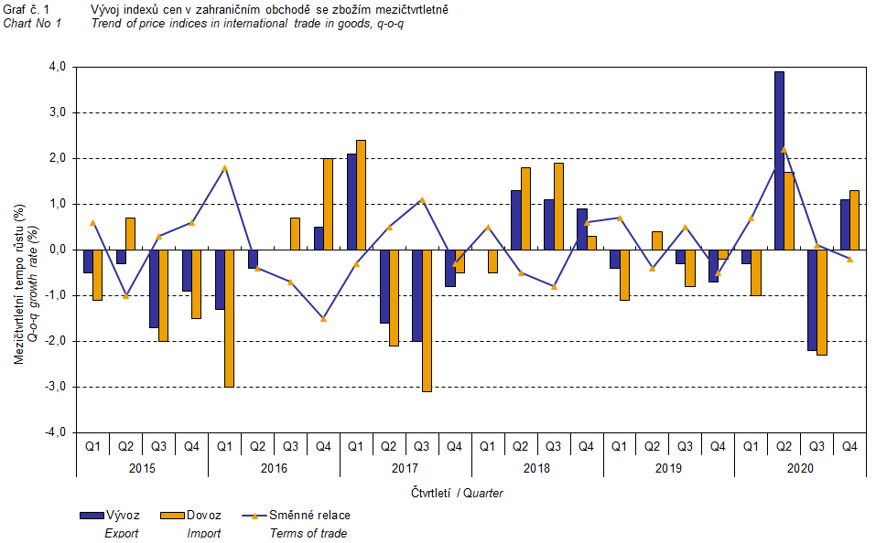

The international trade in goods (change of ownership) price development was also significantly affected by the CZK exchange rate to the major foreign currencies. The q-o-q exchange rate index includes two most important currencies from the Czech Republic's international trade point of view, i.e. EUR and USD. Q-o-q indices of the CZK exchange rate to these currencies were weighted by the weight, which pertains to those foreign currencies in the export price index and import price index, respectively.

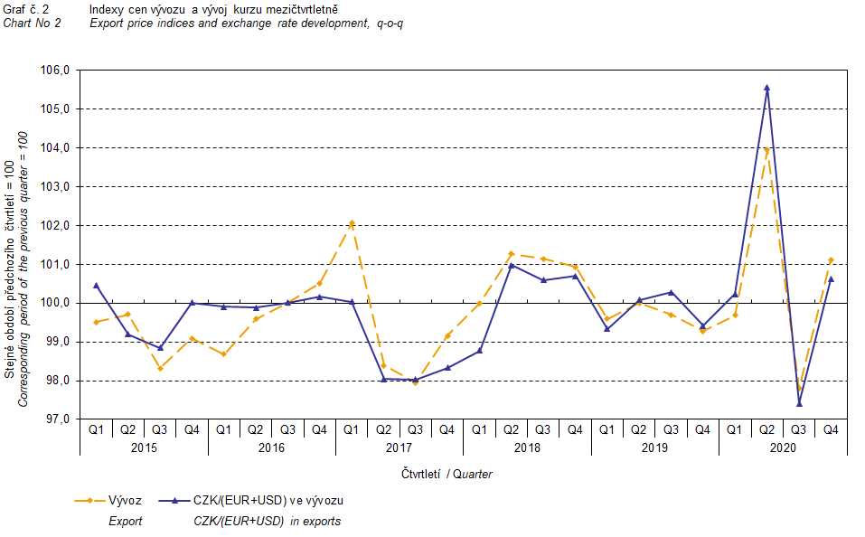

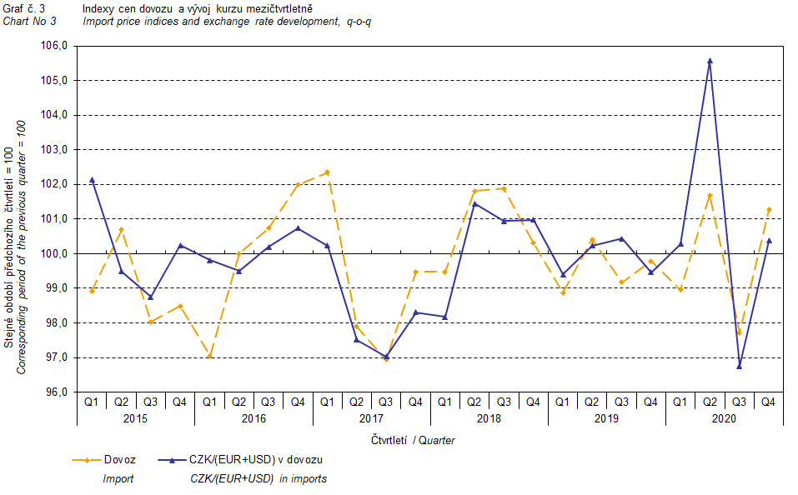

It is apparent from Chart No 2 and Chart No 3 above that in both exports and imports, international trade in goods prices have a relation to exchange rate impacts. Contracts with foreign entities are usually concluded for a longer period and the longer the contract period is, the stronger the relation to exchange rates is.

# Year-on-year comparison

In the Q4 2020, export prices increased by 2.5%, y-o-y (in the Q3 2020 by 0.5%, y-o-y). The following prices were increasing the most: prices of ‘beverages and tobacco’ by 5.6%, prices of ‘food and live animals’ by 4.2%, and prices of ‘machinery and transport equipment’ by 3.9%. Conversely, decreasing were prices of ‘mineral fuels, lubricants and related materials’ by 10.2% (especially prices of petroleum products) and prices of ‘chemicals and related products’ by 2.1%.

Import prices in the Q4 2020 decreased by 0.3%, y-o-y (in the Q3 2020 they dropped by 1.9%, y-o-y). Prices of the following decreased: ‘mineral fuels, lubricants and related materials’ by 18.8% (primarily prices of petroleum and petroleum products), ‘food and live animals’ by 1.3%, and prices of ‘chemicals and related products’ by 0.1%. The most increasing prices were those of ‘beverages and tobacco’ by 2.5%, ‘miscellaneous manufactured articles’ by 2.1%, and prices of ‘machinery and transport equipment’ by 1.6%.

The terms of trade reached the value of 102.8%, year-on-year, in the Q4 2020 (in the Q3 2020 they were at the value of 102.4%, y-o-y) and remained in positive values, see Chart No 4 below. The highest positive values of the terms of trade were reached by ‘mineral fuels, lubricants and related materials’ (110.6%), ‘food and live animals’ (105.6%), and ‘crude materials, inedible, except fuels’ (103.2%). Negative values of the terms of trade were recorded only for ‘chemicals and related products’ (98.0%).

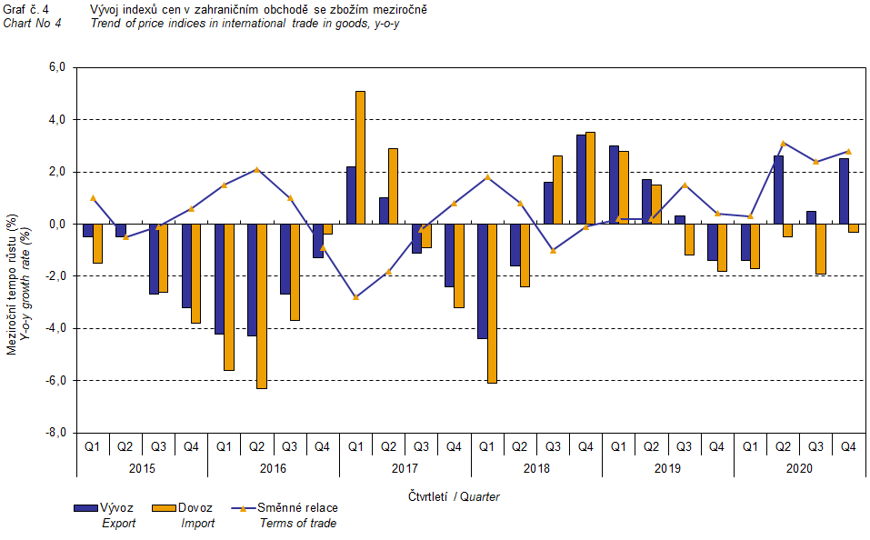

# Development in the year 2020

**In the average for the whole year 2020**, compared to the year 2019, **export prices** increased by 1.1%, y-o-y (in 2019 they increased by 0.9%, y-o-y). **Import prices** decreased by 1.1%, y-o-y (in 2019 they increased by 0.3%, y-o-y).

In**export prices**, as for more important groups, prices increased for ‘food and live animals’ by 3.5%, ‘miscellaneous manufactured articles’ by 2.9%, and prices of 'machinery and transport equipment’ by 2.8%. Prices of the following decreased the most: 'mineral fuels, lubricants and related materials' by 15.8% (primarily prices of petroleum products) and prices of 'crude materials, inedible, except fuels' by 6.4%.

In**import prices**, highest price decreases occurred in 'mineral fuels, lubricants and related materials' by 24.6% (primarily prices of petroleum and petroleum products), in 'crude materials, inedible, except fuels' by 3.5%, and in 'chemicals and related products’ by 2.4%. Conversely, highest price increases were in ‘food and live animals’ by 3.6%, ‘machinery and transport equipment’ by 2.2%, and ‘miscellaneous manufactured articles’ by 1.8%.

The **terms of trade** reached in total in 2020 the value of 102.2% (in 2019 they were 100.6%).

# International trade in goods price indices, year-on-year, adjusted for exchange rate influence

The Czech Statistical Office also carries out calculations of year-on-year international trade in goods price indices adjusted for effects of exchange rate. Prices in foreign currencies reported in the current month are **converted** to Czech crowns by the **exchange rate** of the same month **of the previous year**. Then they are used for the weighted mean calculation along with prices reported in CZK. The year-on-year adjusted price index for a month is then calculated the way that this exchange rate adjusted base price index of a month is related to the non-adjusted base price index of the corresponding month of the previous year. Similarly, adjusted quarter-on-quarter price indices have been calculated since 2017. **Differences between adjusted and non-adjusted price indices may be considerable**; they are obvious in Chart No 6 and Chart No 7, for example, in the Q2 2020.

The method employed does not enable to make a 100% exchange rate adjustment because not all trade transactions made in foreign currencies are also reported in foreign currencies; the share does not exceed 30%. From the aforementioned it follows that, **at the full exchange rate adjustment, differences** between the price indices published and the exchange rate adjusted price indices **would** probably further **increase**.

The aforementioned exchange rate adjusted indices can be used also to make the exchange rate adjusted breakdown of price indices increments. Table 1 gives the **published and exchange rate adjusted breakdowns of increments** of export and import price indices, expanded by the most important two-digit code groups of the SITC 7. The breakdown illustrates well how many percentage points each of the groups “exchange rate contributed” to the index.

In general, it is true that the exchange rate effect decreases the value of price indices in international trade in goods if CZK is strengthening to foreign currencies in total. Conversely, the exchange rate effect pushes the price indices up if CZK is weakening to foreign currencies in total.

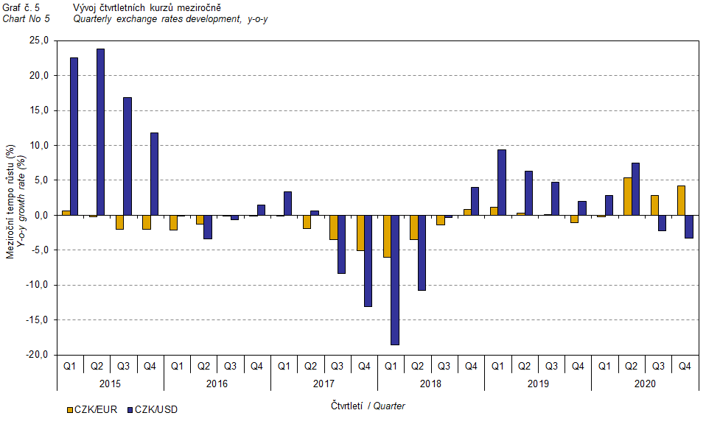

It is apparent from Chart No 6 and Chart No 7 below how significant the exchange rate influence on the value of the export and import price indices was.

# 

# 

Chart No 8 shows the exchange rate influence on the value of the year-on-year terms of trade.

# 

# 

Chart No 9 shows the development of the value of the terms of trade when the group of ‘mineral fuels, lubricants and related materials’ is excluded. It can be observed in the chart that the effect of ‘mineral fuels, lubricants and related materials’ was increasing the overall value of the y-o-y terms of trade until the Q4 2016. In the Q1 2017, the situation turned around and ‘mineral fuels, lubricants and related materials’ started to have a downward effect on the value of the terms of trade, which continued until the Q1 2019. In the Q2 2019, as an exception, ‘mineral fuels, lubricants and related materials’ had no effect on the terms of trade value. Since the Q3 2019, ‘mineral fuels, lubricants and related materials’ started to raise the terms of trade value again. Naturally, it is related to the world market price development, especially in crude oil prices. Import prices, which, compared to export prices, have a higher proportion of crude materials, respond in a more sensitive way to price turbulences. Therefore, when prices of crude materials go up, the terms of trade, as a rule, go down, and, vice versa, when prices of crude materials decrease, the terms of trade grow.

# Closing summary

In the Q4 2020, the exchange rate effect increased the export price index and slackened the decrease of the import prices index, year-on-year. Export prices were increasing, y-o-y, whereas import prices were decreasing; therefore, the terms of trade reached positive values. After elimination of the exchange rate effect, the terms of trade were lower than the published terms of trade, but remained positive. Values free of the exchange rate effect correspond to the exchange rate adjusted indices, see Charts No 6, 7, and 8.



The closing table gives published **non-adjusted** international trade in goods price indices.

# 

Note: For internal reasons, the Czech decimal comma is used instead of the English decimal point as a decimal separator in tables and charts of this analysis.

**Elaborated by:** Vladimír Klimeš, Prices Statistics Department

phone number: (+420) 274 054 102, e-mail: [vladimir.klimes@czso.cz](mailto:vladimir.klimes@czso.cz)