10 November 2020

International trade price indices development in the Q3 2020

In the Q3 2020, compared to the Q2 2020, export prices decreased by 2.2% and import prices by 2.3%. The terms of trade reached the value of 100.1%. In the year-on-year (y-o-y) comparison, export prices increased by 0.5%, import prices decreased by 1.9%, and the terms of trade reached the value of 102.4% in the Q3 2020.

# Quarter-on-quarter comparison

Export prices decreased by 2.2%, quarter-on-quarter (q-o-q), in the Q3 2020, compared to the Q2 2020. The following prices decreased the most: prices of ‘crude materials, inedible, except fuels’ by 3.7%, prices of ‘chemicals and related products’ by 3.3%, and prices of ‘manufactured goods classified chiefly by material’ also by 3.3%. Only prices of ‘mineral fuels, lubricants and related materials’ increased by 13.4% (mainly prices of electricity and of petroleum products).

Import prices in the Q3 2020, compared to the Q2 2020, decreased by 2.3%, q-o-q. The highest decrease of prices was in ‘crude materials, inedible, except fuels’ by 5.0%, ‘food and live animals’ by 3.9%, and prices of ‘machinery and transport equipment’ by 3.4%. Only prices of ‘mineral fuels, lubricants and related materials’ recorded an increase by 14.8% (primarily prices of petroleum and petroleum products).

The terms of trade in the Q3 2020, compared to the Q2 2020, reached the value of 100.1%. Positive values of the terms of trade were reached by ‘crude materials, inedible, except fuels’ (101.4%), ‘machinery and transport equipment’ (101.2%), and ‘food and live animals’ (100.7%). The lowest negative values were recorded by ‘mineral fuels, lubricants and related materials’ (98.8%), ‘chemicals and related products’ (98.9%), and ‘manufactured goods classified chiefly by material’ (99.2%).

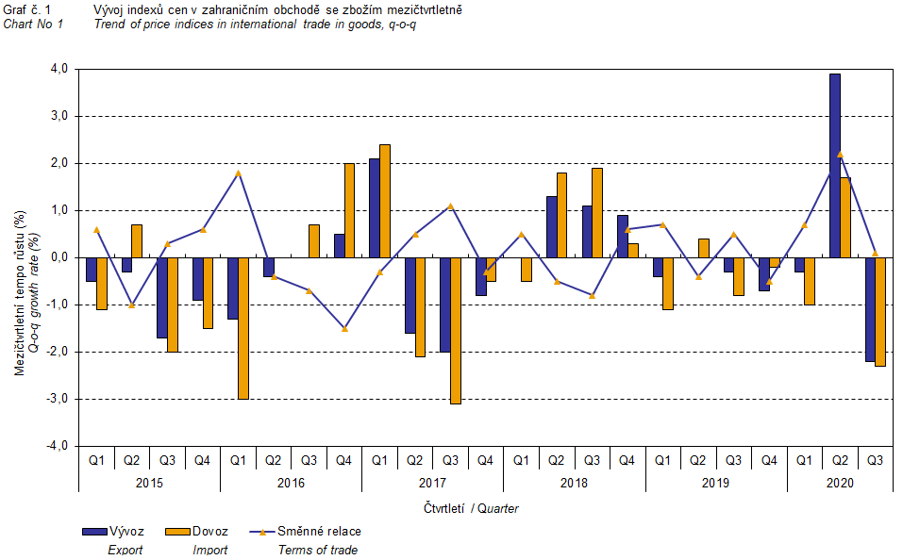

The international trade in goods (change of ownership) price development was also significantly affected by the CZK exchange rate to the major foreign currencies. The q-o-q exchange rate index includes two most important currencies from the Czech Republic's international trade point of view, i.e. EUR and USD. Q-o-q indices of the CZK exchange rate to these currencies were weighted by the weight, which pertains to those foreign currencies in the export price index and import price index, respectively.

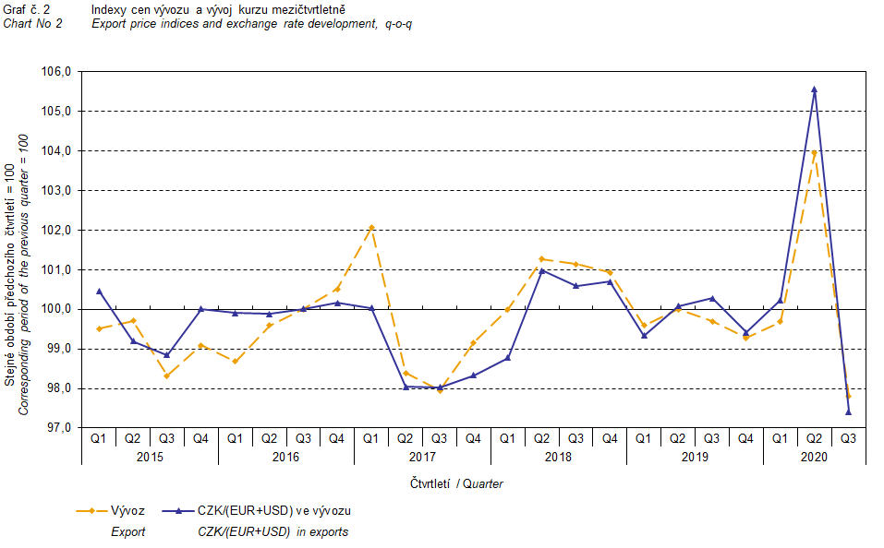

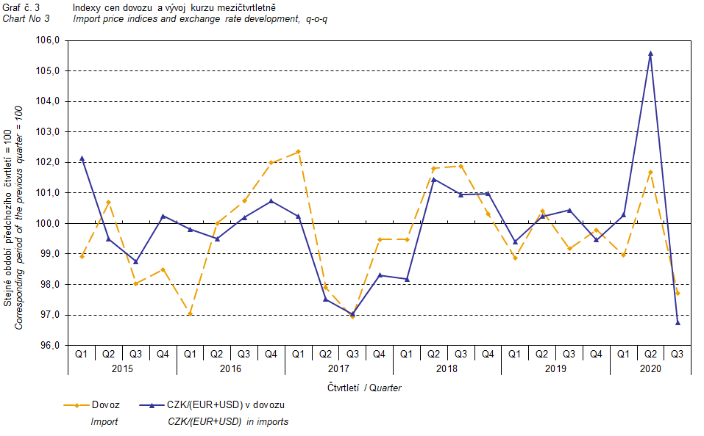

It is apparent from Chart No 2 and Chart No 3 above that in both exports and imports, international trade in goods prices have a relation to exchange rate impacts. Contracts with foreign entities are usually concluded for a longer period and the longer the contract period is, the stronger the relation to exchange rates is.

# Year-on-year comparison

In the Q3 2020, export prices increased by 0.5%, y-o-y (in the Q2 2020 by 2.6%, y-o-y). The following prices were increasing the most: prices of ‘beverages and tobacco’ by 5.2%, prices of ‘food and live animals’ by 3.1%, and prices of ‘machinery and transport equipment’ by 2.6%. Conversely, decreasing were prices of ‘mineral fuels, lubricants and related materials’ by 14.6% (especially prices of petroleum products), prices of ‘crude materials, inedible, except fuels’ by 6.2%, and prices of ‘chemicals and related products’ by 4.5%.

Import prices in the Q3 2020 decreased by 1.9%, y-o-y (in the Q2 2020 they dropped by 0.5%, y-o-y). The deepest decreases were in prices of ‘mineral fuels, lubricants and related materials’ by 26.7% (primarily prices of petroleum and petroleum products), prices of ‘crude materials, inedible, except fuels’ by 8.3%, and prices of ‘chemicals and related products’ by 2.6%. Prices of ‘food and live animals’ increased by 2.4%, prices of ‘machinery and transport equipment’ by 1.5%, and prices of ‘miscellaneous manufactured articles’ by 1.4%.

The terms of trade reached the value of 102.4%, year-on-year, in the Q3 2020 (in the Q2 2020 they were at the value of 103.1%, y-o-y) and remained in positive values, see Chart No 4 below. The highest positive values of the terms of trade were reached by ‘mineral fuels, lubricants and related materials’ (116.5%), ‘beverages and tobacco’ (106.9%), and ‘crude materials, inedible, except fuels’ (102.3%). Negative values of the terms of trade were recorded only for ‘chemicals and related products’ (98.0%).

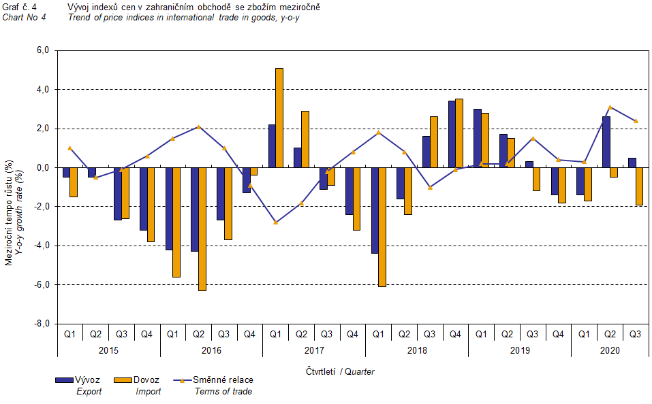

# International trade in goods price indices, year-on-year, adjusted for exchange rate influence

The Czech Statistical Office also carries out calculations of year-on-year international trade in goods price indices adjusted for effects of exchange rate. Prices in foreign currencies reported in the current month are **converted** to Czech crowns by the **exchange rate** of the same month **of the previous year**. Then they are used for the weighted mean calculation along with prices reported in CZK. The year-on-year adjusted price index for a month is then calculated the way that this exchange rate adjusted base price index of a month is related to the non-adjusted base price index of the corresponding month of the previous year. Similarly, adjusted quarter-on-quarter price indices are calculated since 2017. **Differences between adjusted and non-adjusted price indices may be considerable**; they are obvious in Chart No 6 and Chart No 7, for example, in the Q2 2020.

The method employed does not enable to make a 100% exchange rate adjustment because not all trade transactions made in foreign currencies are also reported in foreign currencies; the share does not exceed 30%. From the aforementioned it follows that, **at the full exchange rate adjustment, differences** between the price indices published and the exchange rate adjusted price indices **would** probably further **increase**.

The aforementioned exchange rate adjusted indices can be used also to form the exchange rate adjusted breakdown of price indices increments. Table 1 gives the **published and exchange rate adjusted breakdowns of increments** of export and import price indices, expanded by the most important two-digit code groups of the SITC 7. The breakdown illustrates well how many percentage points each of the groups “exchange rate contributed” to the index.

In general, it is true that the exchange rate effect decreases the value of price indices in international trade in goods if CZK is strengthening to foreign currencies in total. Conversely, the exchange rate effect pushes the price indices up if CZK is weakening to foreign currencies in total.

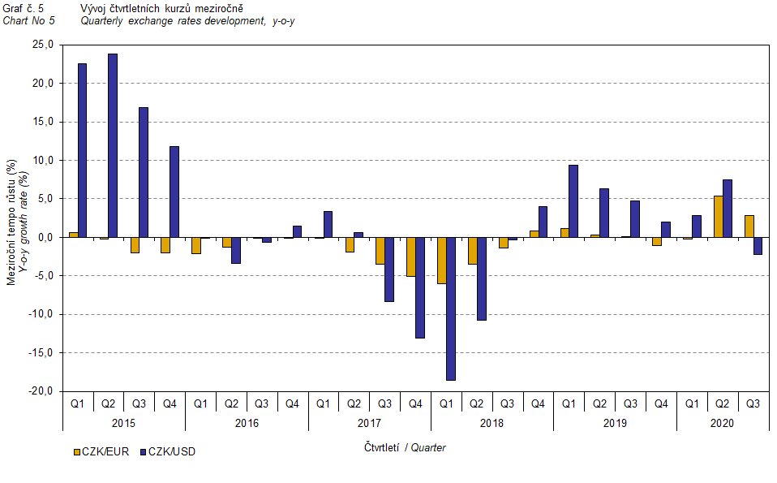

It is apparent from Chart No 6 and Chart No 7 below how significant the exchange rate influence on the value of the export and import price indices was.

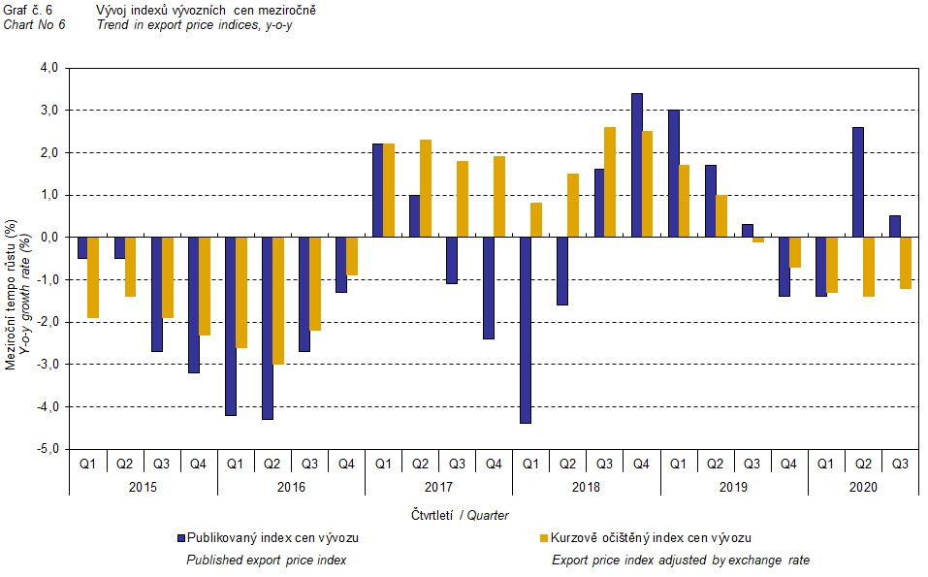

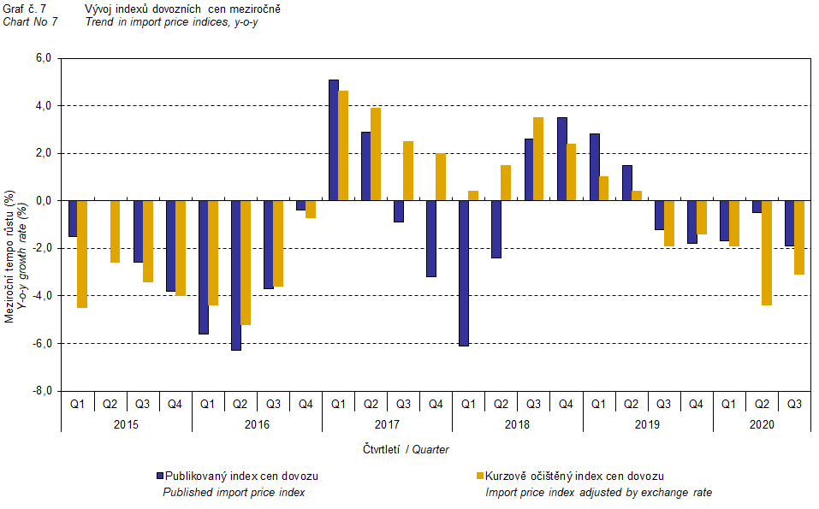

Chart No 8 shows the exchange rate influence on the value of the year-on-year terms of trade.

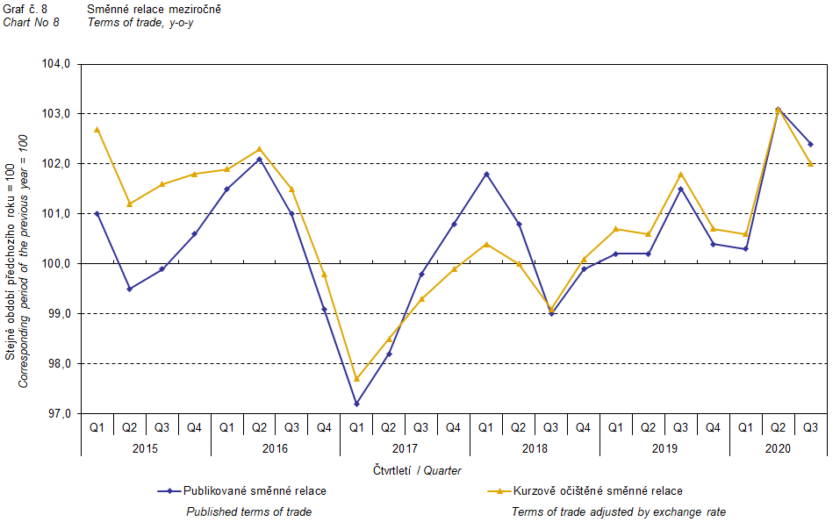

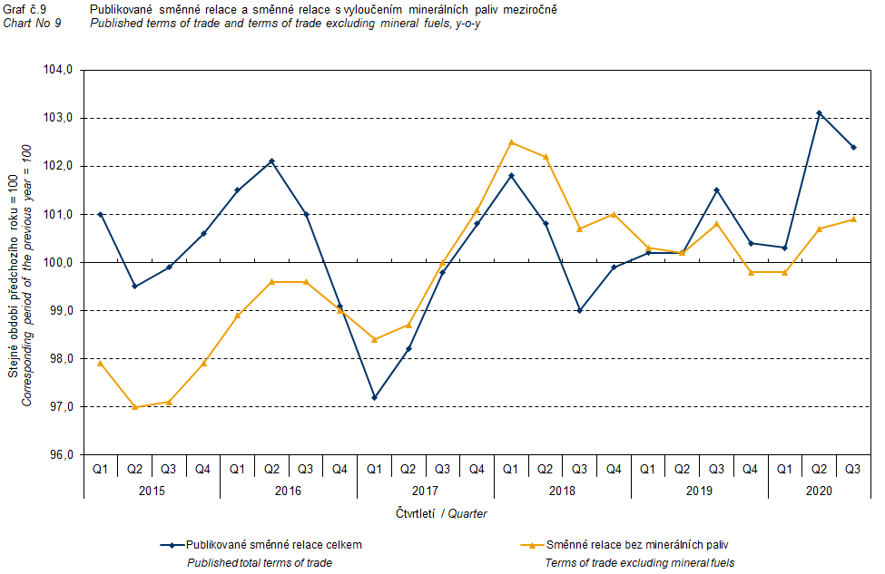

Chart No 9 shows the development of the value of the terms of trade when the group of ‘mineral fuels, lubricants and related materials’ is excluded. It can be observed in the chart that the effects of ‘mineral fuels, lubricants and related materials’ were increasing the overall value of the y-o-y terms of trade until the Q4 2016. In the Q1 2017, the situation changed and ‘mineral fuels, lubricants and related materials’ started to have a downward effect on the value of the terms of trade, which continued until the Q1 2019. In the Q2 2019, as an exception, ‘mineral fuels, lubricants and related materials’ had no effect on the terms of trade value. Since the Q3 2019, ‘mineral fuels, lubricants and related materials’ started to raise the terms of trade value again. Naturally, it is related to the world market price development, especially in crude oil. Import prices, which, compared to export prices, have a higher proportion of crude materials, respond in a more sensitive way to price turbulences. Therefore, when prices of crude materials go up, the terms of trade, as a rule, go down, and, conversely, when prices of crude materials decrease, the terms of trade grow.

# Closing summary

In the Q3 2020, the exchange rate effect increased the export price index and slackened the decrease of the import prices index, year-on-year. Export prices were increasing, y-o-y, while import prices were decreasing; therefore, the terms of trade reached positive values. After elimination of the exchange rate effect, the terms of trade were lower than the published terms of trade, but remained positive. Values free of the exchange rate effect correspond to the exchange rate adjusted indices, see Charts No 6, 7, and 8.



The closing table gives published **non-adjusted** international trade in goods price indices.



Note: In tables and charts, the publication uses the Czech decimal comma, instead of the English decimal point, as decimal separator for internal reasons.

**Elaborated by:** Vladimír Klimeš, Prices Statistics Department

phone number: (+420) 274 054 102, e-mail: [vladimir.klimes@czso.cz](mailto:vladimir.klimes@czso.cz)