12 August 2019

External Trade Price Indices Development in Q2 2019

In Q2 2019, compared to Q1 2019, export prices did not change and import prices increased by 0.4%. The terms of trade reached the value of 99.6%. Compared year-on-year, in Q2 2019 export prices and import prices grew by 1.7% and 1.5%, respectively, and the terms of trade reached the value of 100.2%.

# Quarter-on-Quarter Comparison

Export prices in Q2 2019, compared to Q1 2019, did not change, quarter-on-quarter (q-o-q). Prices of 'miscellaneous manufactured articles', 'chemicals and related products’, and 'machinery and transport equipment’ increased by 0.7%, 0.6%, and 0.1%, respectively. The deepest decline was recorded for prices of 'crude materials, inedible, except fuels', followed by 'mineral fuels, lubricants and related materials', and 'manufactured goods classified chiefly by material' by 2.1%, 1.4%, and 0.5%, respectively.

Import prices in Q2 2019, compared to Q1 2019, increased by 0.4%, q-o-q. Prices for ‘food and live animals’, 'mineral fuels, lubricants and related materials', and 'machinery and transport equipment’ grew by 2.7%, 1.7%, and 0.6%, respectively. Prices for 'chemicals and related products’, 'miscellaneous manufactured articles', and 'manufactured goods classified chiefly by material' declined by 0.8%, 0.4%, and 0.2%, respectively.

The terms of trade in Q2 2019, compared to Q1 2019, reached the value of 99.6%. Negative values of the terms of trade were recorded, namely, for 'crude materials, inedible, except fuels' (95.4%), 'mineral fuels, lubricants and related materials' (97.0%), and 'machinery and transport equipment’ (99.5%). Positive values of the terms of trade were recorded especially for 'chemicals and related products’ (101.4%) and for 'miscellaneous manufactured articles' (101.1%).

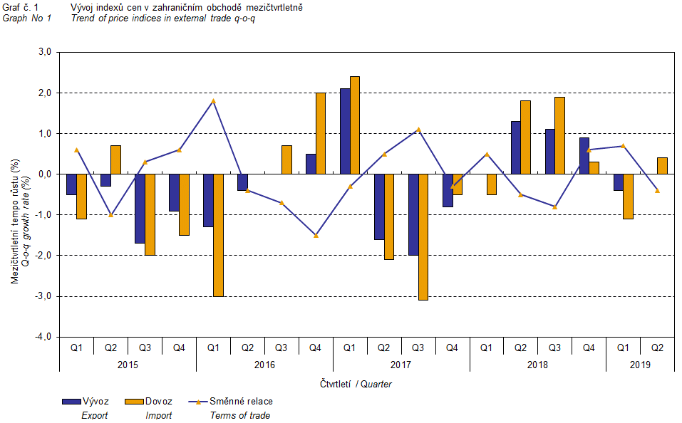

The external trade price development was also significantly affected by the CZK exchange rate to the major foreign currencies. The q-o-q exchange rate index includes two most important currencies from the Czech Republic’s external trade point of view, i.e. EUR and USD. Q-o-q indices of the CZK exchange rate to these currencies were weighted by the weight, which pertains to those foreign currencies in the export price index and import price index, respectively.

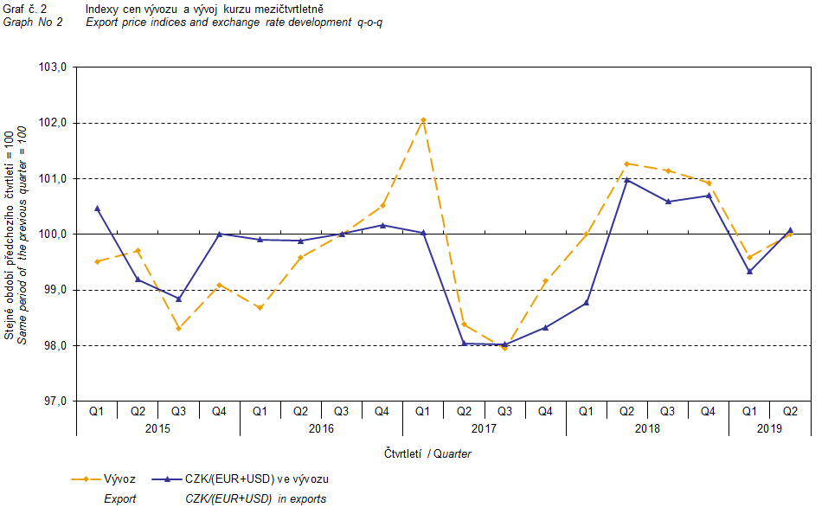

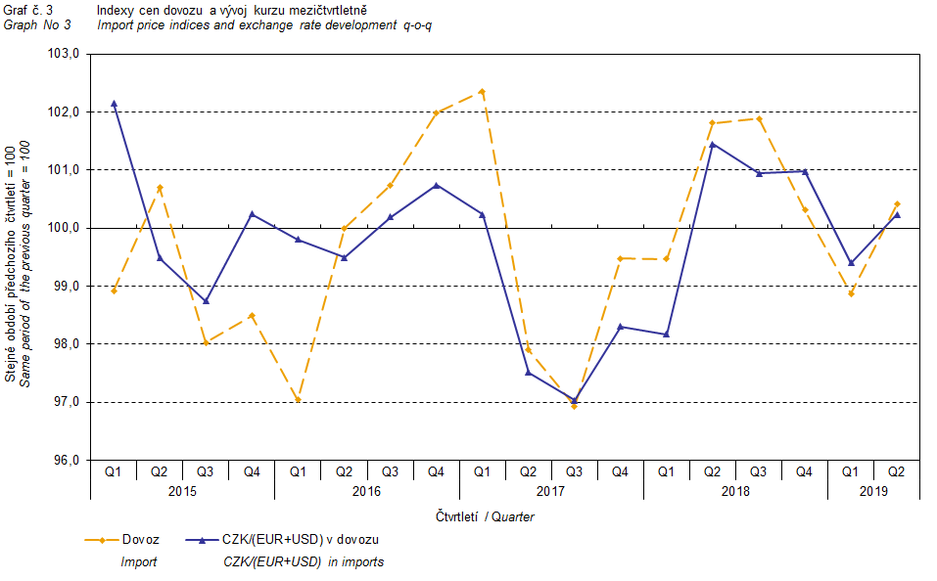

It can be seen from the aforementioned Graphs No 2 and 3 that in both cases of imports and exports, external trade prices have a strong relation to exchange rate impacts. Contracts with foreign entities are, as a rule, signed for a longer period of time and the longer the contract period is, the stronger the relation to exchange rates is.

# Year-on-Year Comparison

Export prices in Q2 2019 increased by 1.7%, year-on-year (y-o-y) (in Q1 2019 they grew by 3.0%, y-o-y). Prices of 'miscellaneous manufactured articles', ‘food and live animals’, 'manufactured goods classified chiefly by material', and 'machinery and transport equipment’ increased by 4.3%, 3.5%, 1.4%, and 1.4%, respectively. The only prices which recorded   
a decline by 1.5% were those of 'crude materials, inedible, except fuels'.

Import prices in Q2 2019 rose by 1.5%, y-o-y (in Q1 2019 they grew by 2.8%, y-o-y). The highest growth was recorded for prices of 'crude materials, inedible, except fuels', followed by those of ‘food and live animals’, and 'machinery and transport equipment’ by 8.7%, 3.1%, and 2.4%, respectively. Prices of ‘beverages and tobacco’ and 'manufactured goods classified chiefly by material' declined by 5.0% and 0.1%, respectively.

The terms of trade in Q2 2019 to reach the value of 100.2%, year-on-year (in Q1 2019 they were at the value of 100.2%, y-o-y as well) and remained in positive values, see Graph No 4 below. Positive values of the terms of trade were recorded namely for 'miscellaneous manufactured articles' (104.0%), 'manufactured goods classified chiefly by material' (101.5%), and 'mineral fuels, lubricants and related materials' (101.4%). The lowest negative value of the terms of trade was recorded for 'crude materials, inedible, except fuels' (90.6%), which were followed by 'machinery and transport equipment’ (99.0%).

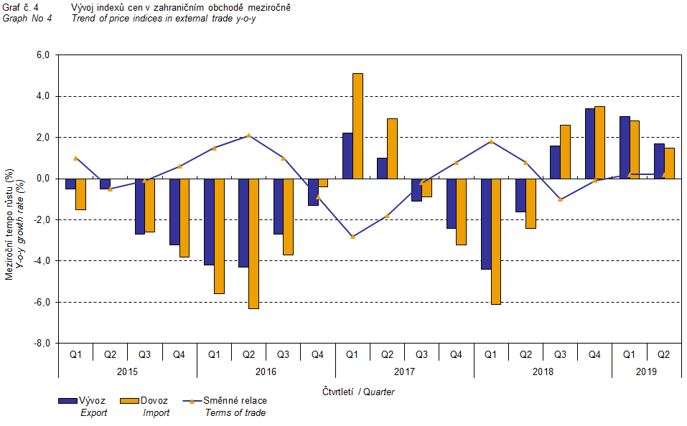

# External Trade Price Indices, Year-on-Year, Adjusted for Exchange Rate Influence

The Czech Statistical Office (CZSO) also carries out calculations of year-on-year external trade price indices adjusted for effects of exchange rate. The method is prices in foreign currencies reported in the current month are **converted** into Czech crowns by the **exchange rate** of the same month **of the last year**. Then they are used for the weighted mean calculation along with prices reported in CZK. The year-on-year adjusted price index for a month is then calculated the way that this exchange rate adjusted base price index of a month is related to the non-adjusted base price index of the same month of the last year. Adjusted quarter-on-quarter price indices are calculated in an analogous way since 2017. **Differences among adjusted and non-adjusted price indices may be substantial**. They can be clearly seen in Graphs No 6 and 7 for Q1 2018, for instance.

The method employed does not enable, for many practical reasons, to carry out 100% exchange rate adjustment because all trade transactions concluded in foreign currencies are not reported in foreign currencies. This share is up to 30%. It follows from the aforementioned, that **at the full exchange rate adjustment differences** in between the price indices published and the exchange rate adjusted price indices **would be** **probably** **even larger**.

The aforementioned exchange rate adjusted indices can be used to form the exchange rate adjusted breakdown of price indices increments. Table 1 gives the **published and exchange rate adjusted breakdowns of increments** of export and import price indices, expanded to the most important two-digit code groups of the SITC 7. These breakdowns illustrate, in a good manner, how many percentage points each of the groups “exchange rate contributed” to the index.

It holds in general, that the effects of exchange rate decrease the value of price indices in external trade if CZK is strengthening to foreign currencies in total. Conversely, the effects of exchange rate push the price indices up if CZK is weakening to foreign currencies in total.

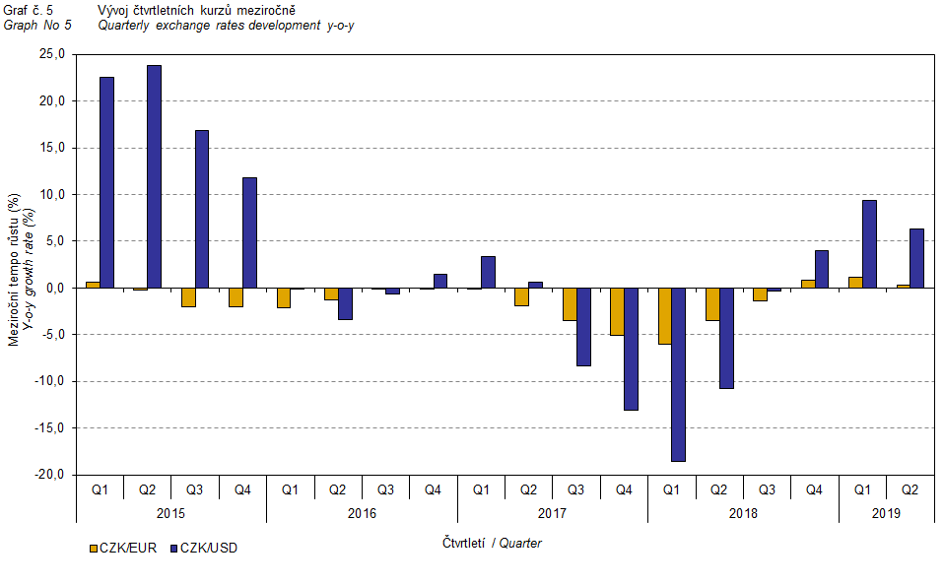

It is obvious from the following Graphs No 6 and 7, how significant was the exchange rate impact on the value of export and import price indices.

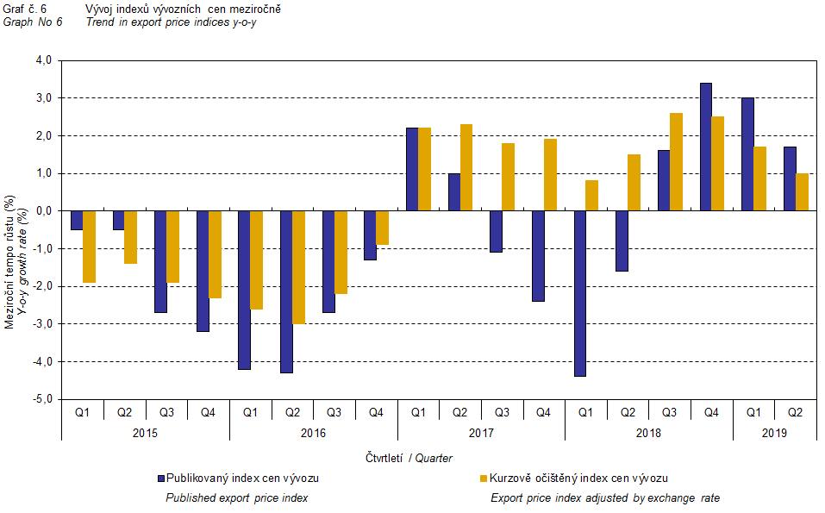

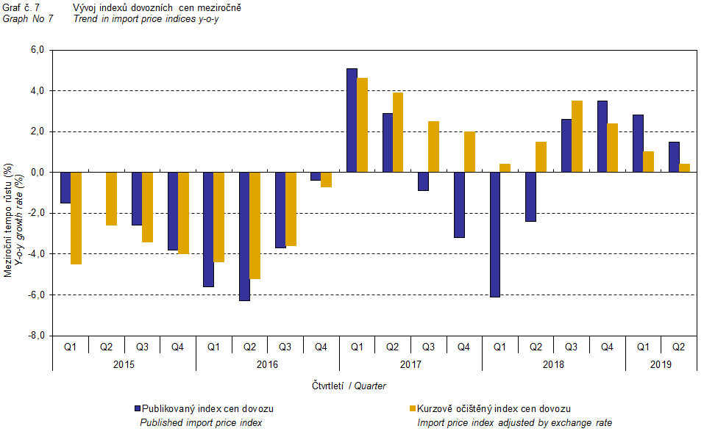

Graph No 8 shows exchange rate influence on the value of the year-on-year terms of trade.

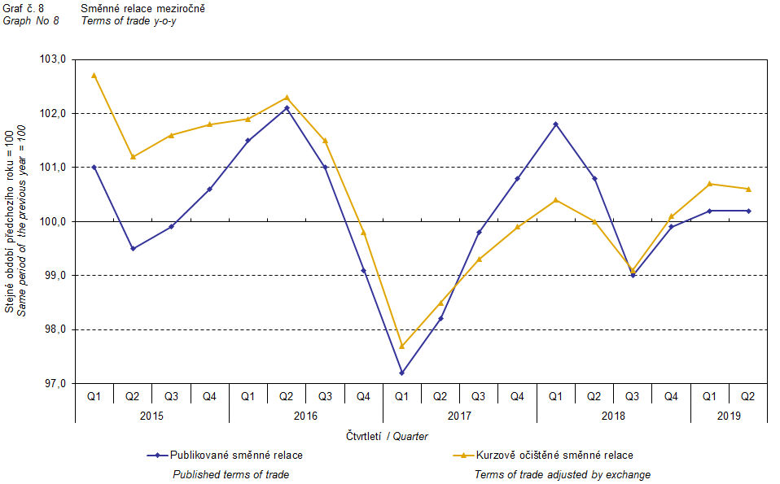

Graph No 9 demonstrates how the value of the terms of trade would develop if the observed groups of goods would not include that of 'mineral fuels, lubricants and related materials'. It can be observed in the graph that the effects of 'mineral fuels, lubricants and related materials' were increasing the overall value of the y-o-y terms of trade till Q4 2016. In Q1 2017 the situation began to reverse and 'mineral fuels, lubricants and related materials' have had a downward effect on the value of the terms of trade, which continued till Q1 2019. In Q2 2019, exceptionally, 'mineral fuels, lubricants and related materials' had no effect on the terms of trade value. It is, of course, related to the world market price development, especially in crude oil. Import prices, which, compared to export prices, include a higher proportion of crude materials, respond in a more sensitive way to price turbulences and therefore when prices of crude materials go up, the terms of trade, as a rule, go down, and, conversely, when prices of crude materials fall, the terms of trade grow.

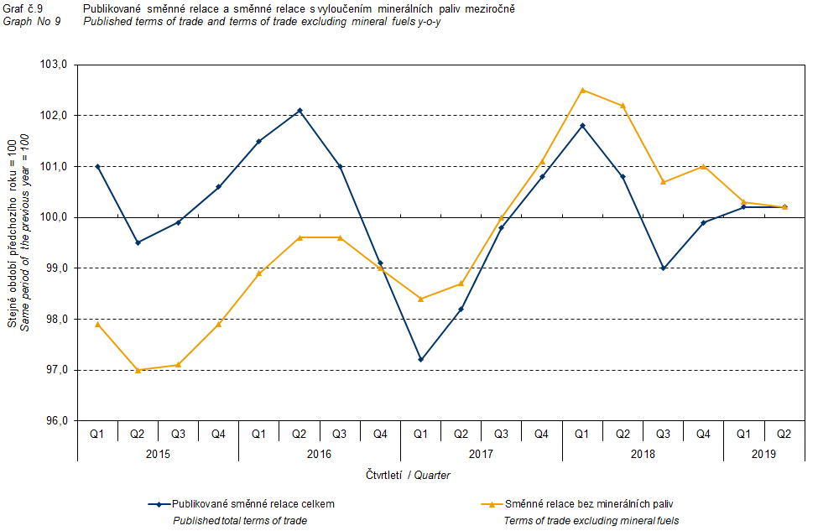

# Closing Summary

The exchange rate effects in Q2 2019 boosted a growth in export and import price indices, year-on-year. Export prices grew year-on-year at a pace higher than that of import prices, and therefore the terms of trade attained positive values. If exchange rate unadjusted, the terms of trade would reach a positive value anyway. Values free of the exchange rate effects correspond to exchange rate adjusted indices, see Graphs No 6, 7, and 8.



Closing table gives published external trade price indices **without adjustment**.



Note: In tables and graphs the publication uses the Czech decimal comma, instead of the English decimal point, as decimal separator for internal reasons.

**Developed by:** Vladimír Klimeš, Prices Statistics Department

phone: (+420) 274 054 102, e-mail: [vladimir.klimes@czso.cz](mailto:vladimir.klimes@czso.cz)